Planning date: 05 – 02 – 2023
Teaching date: 06 – 02 – 2023
Period 61: Unit 7: RECIPES AND EATING HABITS
Lesson 7: LOOKING BACK & PROJECT
I. OBJECTIVES: By the end of the lesson, Ss will be able to:
1. Knowledge:
a. Vocabulary: Revision
b. Grammar: Quantifiers & modal verbs in conditional sentences type 1
2. Competences:
- be able to recall the knowledge learnt through the unit.
3. Qualities:
- be interested in ways of preparing and cooking food.
II. TEACHING AIDS:
1. Materials: Textbooks, plan
2. Equipment: A laptop connected with TV, textbooks
III. PROCEDURES:
Stages/Time | Contents | Notes
Warm up & Lead –in  2’  Activity 1  7’  5’  6’  Activity 2  5’  7’  Activity 3  6’  4’  Homework:  3’ | I. VOCABULARY  1. Match the words in A with their description or definition in B.  Key: 1. d 2. e 3. g 4. b  5. a 6. c 7. h 8. f  2. Write a verb for a cooking method under each picture. The first letter has been provided.  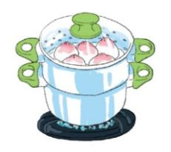    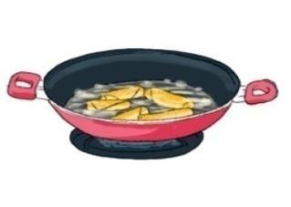  A. s …… B. d………. C. s …….  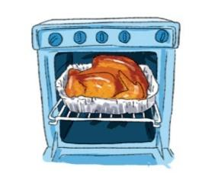  D. b…… E. r……….. F. g……………    G. s………. H. s…………….  Key: A. steam B. deep-fry C. stir-fry  D. bake E. roast F. grill  G. slimmer H. Stew  3. Fill each blank with a word/ phrase in the box. There is one extra word.  Key: 1. hamburger 2. sushi 3. deep-fry  4. steam 5. stew  II. GRAMMAR  4. Circle the correct answer  Key: 1. slice 2. sticks 3. any- some  4. bag 5. clove 6. Bunch  5. Complete the second sentence with your own ideas. Use the modal verbs provided  Suggested answers:  1. …………., you might become overweight.  2. ………, you can go to the cinema with your friend.  3. He should eat less sweets ……….  4. She must eat less rice and bread …………..  5. ………., you can cook many delicious dishes.  III. COMMUNICATION  6. Rearrange the lines to make a complete conversation  Key:  1. B 2.E 3. F 4.I 5. A 6.H 7.I 8.C 9.G 10.D  * PROJECT  - Do the Project  - Revise the lesson  - Prepare for Unit 8: Getting started | -Greetings  -Lead in new lesson: to revise the lesson  -Have Ss do this exercise individually and then compare their answers with a partner. Call on Ss to read out loud their answers.  -Ask Ss to complete the words individually.  -Check Ss’ answers as a class. Call on two Ss to write their answers on the board.  -Ask Ss to do this exercise individually. Have some Ss read out their answers.  -Have Ss do this exercise individually. Check the answers as a class.  -Ask Ss to explain their choice.  -Ask Ss to write the sentences individually. Have two Ss write the sentences on the board. Ask other Ss to give comments. Correct the sentences  -Have Ss rearrange the lines to make a complete conversation, first individually and then share their answers with a partner. Ask some pairs to read out loud the conversation.  -Lead Ss to do the Project at home and present their work next period

