Planning date: 31 – 01 – 2023
Teaching date: 01 – 02 – 2023
Period 59: Unit 7: RECIPES AND EATING HABITS
Lesson 5: SKILLS 1
I. OBJECTIVES: By the end of the lesson, Ss will be able to:
1. Knowledge:
a. Vocabulary: learn some words related to dishes and ways of preparing and cooking food.
b. Grammar: Quantifiers & modal verbs in conditional sentences type 1
2. Competences:
- be able to read for general and specific information about the eating habits of Japanese people and talk about the eating habits of Vietnamese people.
3. Qualities:
- know how to describe the ways of preparing and cooking food
II. TEACHING AIDS:
1. Materials: Textbooks, plan
2. Equipment: A laptop connected with TV, textbooks
III. PROCEDURES:
Stages/Time | Contents | Notes
Warm up & Lead –in  8’  Pre-reading  5’  While-reading  5’  Post-reading  8’  Pre-speaking  5’  While speaking  5’  Post speaking  2’  Homework:  3’ | A  B  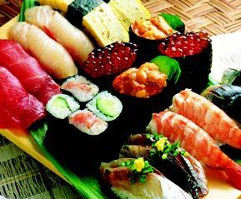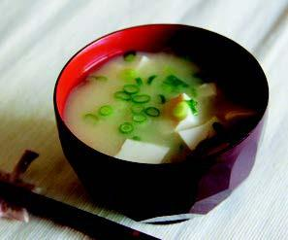  C  D  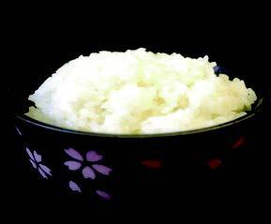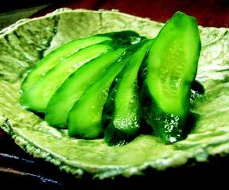  Suggested answers  1.Picture A: different types of sushi  Picture B: miso soup  Picture C: a bowl of rice  Picture D: sliced cucumber/ pickled cucumber  I. READING  * Vocabulary:  - raw (adj): sống  - component (n): thành phần  - pickle (n): dưa chua  - staple (n): lương thực chính  - characteristic (n): đặc điểm  - horseradish (n): cải ngựa  - pickled ginger (n): gừng ngâm  *Check vocabulary: Rub out and remember  * Now read an article about Japanese eating habits. Match the headings (1-3) with the paragraphs (A-C).  1. The art of arranging dishes  2. The habit of having raw food and simple sauces  3. Components in a typical Japanese meal  Key: A. 3 B. 2 C.1  * Read the article again and answer the questions  Key:  1. They like raw food and do not use sauces with a strong flavour.  2. They cut fresh fish.  3. Both can be served with soy sauce.  4. There are four (rice, miso soup, main dishes, pickles)  5. Rice is the staple food and is very nutritious.  6. Because the dishes are presented in different bowls and plates, and are arranged carefully according to a traditional pattern.  II. SPEAKING  4. Work in groups. Discuss the eating habits of Vietnamese people. You can use the following questions as cues.  * Present your group’s discussion  5. Imagine that you take part in an international competition in which competitors talk about the eating habit of their own country. Present your group’s ideas about Vietnamese eating habit.  - Do exercises in workbook: Section Reading  - Prepare for Skills 2 | -Greetings  -Ask Ss to work in pairs to discuss the questions.  1.What can you see in each picture?  2.Have you ever tried the dishes in the pictures? If so, how did you find them?  -Lead inthe new lesson: Japanese eating habits and some dishes.  -Help Ss understand the meanings of the vocabulary  (Explanation)  (Synonym)  (Picture)  (Translation)  (Translation)  (picture)  (Explanation)  -Ask Ss to read the headings quickly, then read the paragraphs and match them with the headings. Ask Ss to compare their answers with a classmate.  -Have Ss read the article again to answer the questions. Ss can underline parts of the text that help them with the answers. Ask Ss to work in pairs to share their answers and give evidence when giving answers to the teacher.  -Have Ss work in groups to discuss the eating habits of Vietnamese people. Ss use the questions provided as cues.  -The representative of each group presents their group’s work.  -Ss work individually.

