Planning date: 10 – 01 – 2023
Teaching date: 11 – 01 – 2023
Period 56: Unit 7: RECIPES AND EATING HABITS
Lesson 2: A CLOSER LOOK 1
I. OBJECTIVES: By the end of the lesson, Ss will be able to:
1. Knowledge:
a. Vocabulary: learn some words related to dishes and ways of preparing and cooking food.
b. Grammar: Quantifiers & modal verbs in conditional sentences type 1
2. Competences:
- use lexical items related to dishes and ways of preparing and cooking food and ask statement questions with the correct intonation.
3. Qualities:
- know how to describe the ways of preparing and cooking food
II. TEACHING AIDS:
1. Materials: Textbooks, plan
2. Equipment: A laptop connected with TV, textbooks
III. PROCEDURES:
Stages/Time | Contents | Notes
Warm up  5 mins  Preparation  7 mins  Practice  5 mins  5 mins  5 mins  5 mins  production  3 mins  5 mins  Homework:  5mins | *Write some words related to preparing and cooking food  Example: boil  I. VOCABULARY  1. Write a food preparation verb from the box under each picture  - whisk (v) : đánh trứng, kem  - slice (v) : thái lát  - grate (v) : nạo  - dip (v) : nhúng  - chop (v) : chặt, cắt  - spread (v) : phết  - sprinkle (v) : rắc  - marinate (v) : ướp  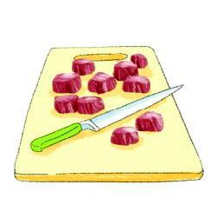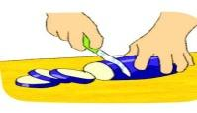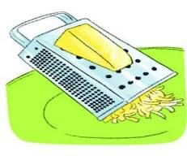  A. chop B. slice C. grate  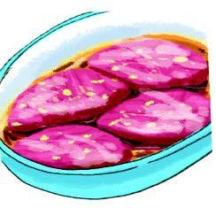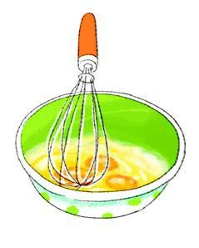  D. marinate E. whisk F. dip  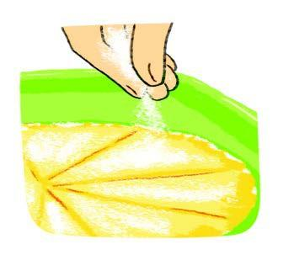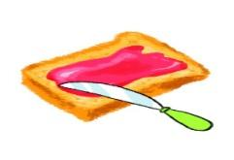  G. sprinkle H. spread  2. Complete the sentences with the correct form of the verbs in 1.  Key:  1. chop, Slice 2. grates, sprinkles 3. Marinate  4. whisk 5. Dip 6. spread  3. Match each cooking verb in A with its definition in B  Key:  1.g 2. f 3. h 4. c  5. e 6. a 7. d 8. B  4. a. What can you see in the pictures? Do you know what dish these ingredients are used for ?  Key: tomato sauce, onion, cheese, apple, bacon, pizza base 🡪 pizza  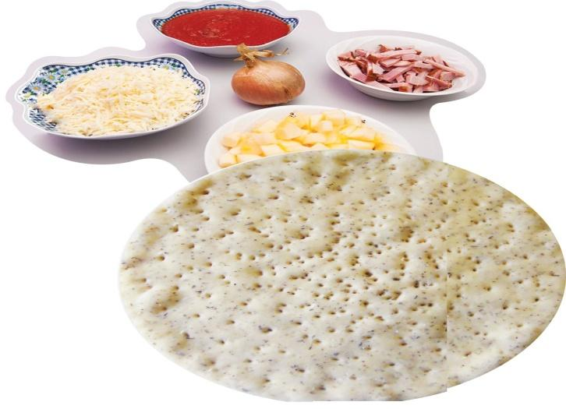  b. Complete the instructions below with the verbs in 1 and 3. One verb is used twice  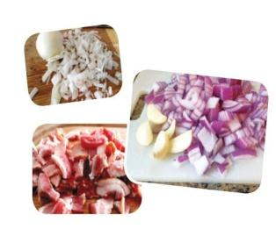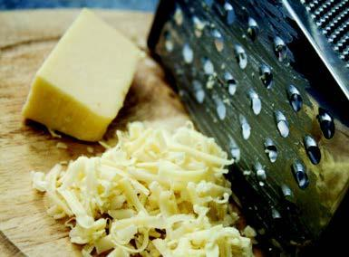  1. Chop the onion, 2. Grate the cheese.  Bacon and an apple.  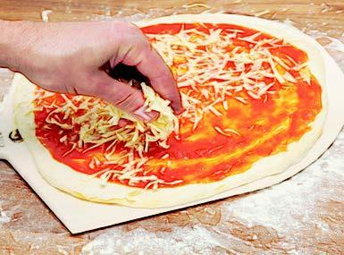  3. Spread the tomato 4. Sprinkle the cheese on sauce on the pizza base. The pizza base.  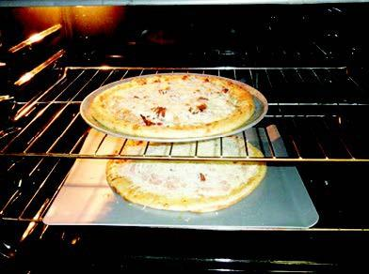  5. Spread the chopped 6. Bake the pizza in the onion, bacon and apple oven for about 10 minutes  on top.  II. PRONUNCIATION  Tones in statements used as questions  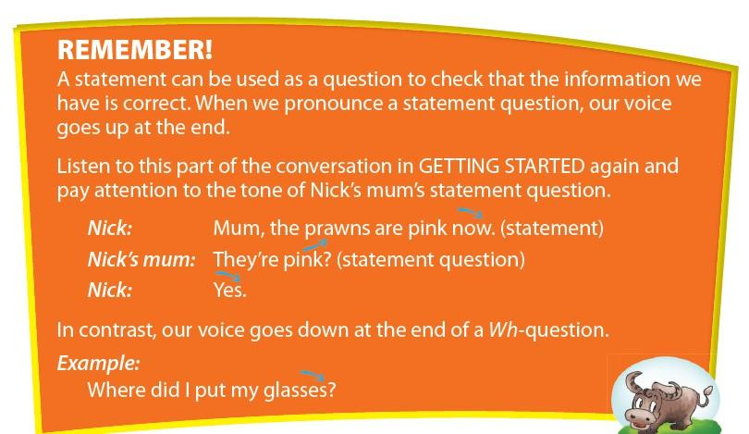  5. Listen to the conversation. Draw 🡮 or 🡭 at the end of each line. Practice the conversations with a partner.  1. A:  B: … an apple  A: An apple ?  B: …..an apple  2. A:  B:  A:  B:  3. A:  B:  A:  B:  A:  -Do exercise 6  -Learn new words by heart  -Prepare for A closer look 2 | -Ask Ss to write the words on the board.  -T and the whole class comment.  -T gives marks  -Have Ss work individually to do this exercise and then compare their answers with a classmate. Elicit the answers from Ss and quickly write them on the board. Have Ss explain the meaning of each verb in English or Vietnamese.  -Correct Ss’ answers.  -Ask Ss to work in pairs to do this exercise.  -Check the answers as a class.  -Have Ss do this exercise individually and then compare their answers with a partner. Check and confirm the correct answers.  -Ask Ss to answer the two questions. Elicit their answers. Ask them if they have ever eaten or made a pizza. If yes, ask them to describe the process of making one briefly.  Have Ss complete the instructions individually and then compare their answers with a partner. Check the answers as a class.  -Explain to Ss the meaning of ‘statement’ and ‘statement question’  -Play the part of the conversation in Getting started and ask Ss to pay attention to the intonation of the sentences. Ask them to give comments.  -Answer any questions from Ss, and ensure that Ss understand the information.  -Have Ss read through the three conversations. Play the recording for Ss to draw appropriate arrow to indicate the intonation of each sentence. Have Ss compare their answers in pairs.  -Correct the mistakes.  -Lead Ss to do this exercise at home

