Planning date: 10– 01 – 2023
Teaching date: 11 – 01 – 2023
Period 55: Unit 7: RECIPES AND EATING HABITS
Lesson 1: Getting Started
My favourite salad
I. OBJECTIVES: By the end of the lesson, Ss will be able to:
1. Knowledge:
a. Vocabulary: learn some words related to dishes and ways of preparing and cooking food.
b. Grammar: Quantifiers & modal verbs in conditional sentences type 1
2. Competences:
- use lexical items related to dishes and ways of preparing and cooking food.
3. Qualities:
- know how to describe the ways of preparing and cooking food.
II. TEACHING AIDS:
1. Materials: Textbooks, plan
2. Equipment: A laptop connected with TV, textbooks
III. PROCEDURES:
Stages/ Time | Contents | Notes
Warm up & Lead –in  3 mins  Presentation  7 mins  Practice  8mins  3 mins  5 mins  5 mins  3 mins  4 mins  Production  4 mins  Homework:  3mins | *Chatting:  What are your favourite dishes?  What are recipes and eating habits?  1. Listen and read  * Vocabulary:  - prawn salad (n): salad tôm  - ingredient (n): thành phần  - celery (n): cần tây  - mayonnaise (n): xốt ma-i-on-ne  - starter (n): món khai vị  - versatile (adj): đa dụng  - chop (v): cắt, chặt  - peel (v): gọt vỏ, bóc vỏ  *Check vocabulary: Rub out and remember  a. Can you find a word that means:  Key:  1. starter 2. versatile 3. drain  4. peel 5. chop 6. combine  b. Find all the words related to the topic of food in the conversation. Put them in the word web.  Key:  Ingredients: salt, pepper, prawns, mayonnaise, celery, lemon juice, spring onions  Preparing and cooking: add, wash, boil, combine, chop, peel, drain, mix  c. Answer the questions.  Key:  1. Nick’s mum  2. Because it’s simple and delicious  3. In the summertime.  4. They are versatile, and you can use lots of different ingredients in a salad.  5. Nick’s mum boils and drains the prawns. Nick washes the celery, peels the prawns and mixes the ingredients. Mi washes the spring onions, chops the celery and spring onions, and mixes the ingredients.  6. Because he is finding it difficult to wait for one hour.  2. Write the name of each dish in the box under each picture  Key:  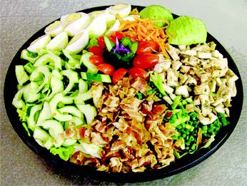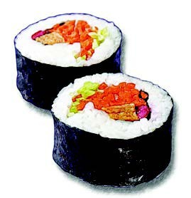  A. Cobb salad B. sushi  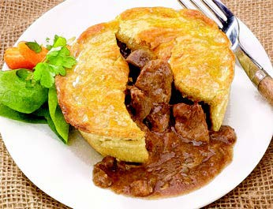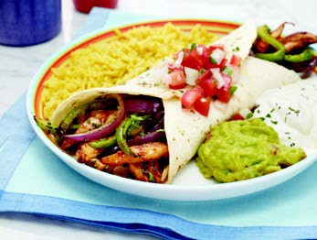  C. steak pie D. fajitas  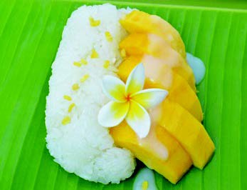  E. lasagne F. mango sticky rice  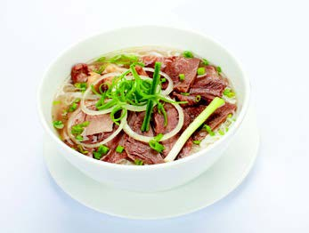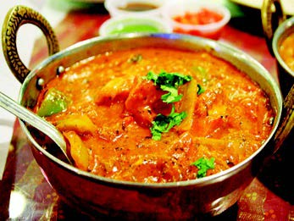  G. beef noodle soup H. curry  3. a. In pairs, discuss which country from the box is associated with each dish in 2  Key:  A. The USA B. Japan  C. The UK D. Mexico  E. Italy F. Thailand  G. Viet Nam H. India  b. Fill in each blank with the name of a dish in 2  Key:  1. Lasagne 2. curry 3. steak pie  4. Fajitas 5. sushi  4. FOOD QUIZ  Suggested answers:  1.beef  2.prawn, potato  3.cheese, butter, ice cream  4.strawberry, lychee, cherry, pomegranate  5.broccoli, spinach. Lettuce, celery, kohlrabi  -Learn new words by heart  -Read the dialogue and exercises again  -Prepare for A closer look 1 | -Greetings  -Ask Ss to answer the questions.  -Use Ss’ answers to lead in new lesson.  -Present vocabulary.  (explanation)  (explanation)  (picture)  (picture)  (explanation)  (translation)  (picture)  (picture)  -Ask Ss to read these words  -Ask Ss to practice reading the dialogue (group work)  -Ss work individually to find the given meanings in the dialogue. Then have Ss compare their answers with their partners before discuss as a class.  Ask Ss to read the Watch out! Box.  -Ask Ss to work in pairs and compare the word webs. Call on one pair to write their answers on the board.  -Have Ss read the questions to make sure they understand them. Ask them firstly to answer the questions without the dialogue again. Have Ss exchange their answers with a classmate. Now ask them to check their answers by reading the dialogue again. Ask for Ss’ answers.  -Have Ss look at the pictures. Tell Ss that in the box are some dishes from different countries in the world. Ask Ss to write these dishes under the pictures, and then compare their answers in pairs  Play the audio for Ss to check and repeat the answers  -Have Ss work in pairs to discuss what country in the box is associated with each dish in 2. Check and confirm the correct the correct answers.  -Tell Ss to complete the sentences with the names of the dishes in 2. The complete sentences will give Ss information about the dishes. Call on two Ss to write their answers on the board.  -Ask Ss to work in groups to do the quiz. The group which has the answers the fastest is invited to read out their answers.

