Date of preparing: 5/5/2024
Date of teaching: 7/5/2024

Period 95 UNIT 12 ROBOTS

Lesson 1 – Getting started

I. OBJECTIVES:
1. Knowledge: By the end of the lesson, students will be able to:
- use the lexical items related to the topic robots and daily activities;
- use the vocabulary and structures to talk about what a robot can do.
* Vocabulary: robot (n), do the dishes (vph), iron (v), useful (adj), put sth away (vph),
repair (v), broken (adj)
* Grammar:
2. Competences: Listening , speaking and reading
3. Educational aim: :
II. TEACHING AIDS:
- Grade 6 textbook
- sachmem.vn
III. PROCEDURES:
Content | Teacher’s and Ss’activities
Activity 1 – Warm up
Aims: To introduce the topic.
* Guessing word:  Suggested answer:  R O B O T S  - Where are Nick, Phong and Dr Adams?  - What are they talking about?  - Have you ever been to a show before?  Suggested answers:  - They are at a robot show.  - They are talking about robots.  Yes, I have been to a motor show. / No, I haven’t. But I want to be at a show in the future. | - Teacher divides the class into two big groups.  - Teacher draws a 6-letter word puzzle on the board.  - Each group will take turns guessing a letter in the puzzle and get 10 points for a correct letter.  - The group finding out the correct word before all letters are written will get 50 points.  - The group with more points will be the winner.  - Teacher asks student to open the textbook and draws students’ attention to the title of the conversation and the picture in the textbook and asks them questions like:
Activity 2 – Presentation
Aims: To introduce the vocabulary appearing in the text.
Vocabulary  - robot (n): [picture]  - do the dishes (vph): [picture]  - iron (v): [picture]  - useful (adj) that can help you to do or achieve what you want  - put sth away (vph) to put something in the place where it is kept because you have finished using it  - repair (v) to fix something that is damaged  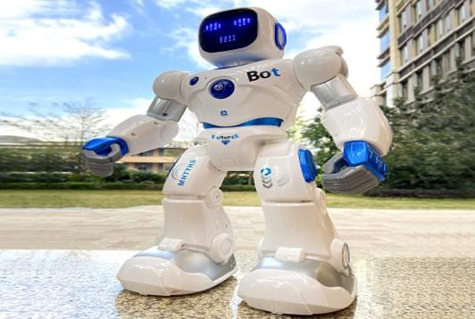  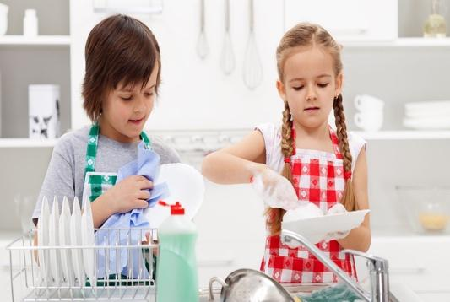  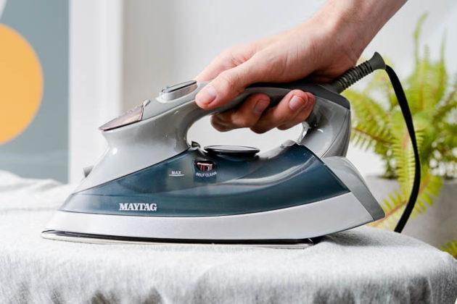  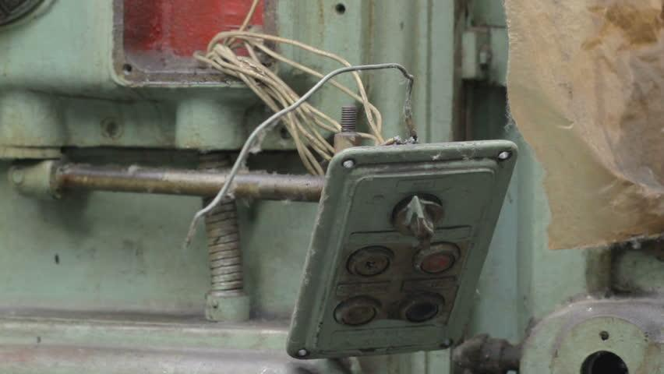 | Teacher introduces the vocabulary by:  - providing the pronunciation of the words  - providing the definition or picture of the words
Activity 3 – Practice
Aims: To practice the targeted language and the background knowledge of the topic Robots.
To help students understand the text.
To help students further understand the text.
To develop students’ knowledge of the vocabulary about daily activities.
Task 1: Listen and read. (p. 58) | - Teacher plays the recording, asks students to underline the words that are related to the topic of the unit while they are listening and reading.  - Teacher can play the recording more than once.  - Students listen and read.  - Teacher invites some pairs of students to read the dialogue aloud.
Task 2: Complete the sentences, using the adjectives in the box. (p. 59)  Answer key:  - useful  - fast  - strong  - smart  - heavy | - Teacher asks students to work independently to fill each blank with the adjective in the box from the conversation.  - Teachers may instruct them how to do the exercise and model with the first sentence:  1. Read the sentence with the blank and try to work out the meaning of the whole sentence  2. Find the adjective in the box that can fit the blank meaningfully.  - Teacher asks students to share their answers before discussing as a class.  - Teacher checks their answers as a class.
Task 3: Read the conversation again and tick T (True) or F (False). (p. 59)  Answer key:  1. T 2. F 3. T  4. F 5. T | - Teacher has students look at the statements in this activity and tells them how to do it by telling them the strategies to do the exercise:  - Read the statement  - Underline the key words  - Read the text and pay attention to the key words  - Decide if each sentence is true or false  - Teacher sets the time limit.  - Students work independently.  - Teacher allows students to share their answers before discussing as a class.  - Teacher invites some pairs to give their answers and confirms the correct ones. Teacher may ask students to correct the false sentences.
Task 4: Match the activities with the pictures. (p. 59)  Answer key:  1. b 2. c 3. e  4. d 5. f 6. A | - Teacher has students quickly match each activity with the picture in pairs  - Teacher asks some students to read out their answers and write the answers on the board.  - Teacher checks as a class.  - With weaker classes, teacher can ask for translation of the activities to make sure they understand. With stronger class, teacher may ask some additional questions, e.g. Can you iron clothes/make meals…? Who often makes meals in your family?
Homework
Prepare A closer look 1 | T asks Ss to prepare A closer look 1

Date of preparing: 7/5/2024
Date of teaching: 9/5/2024

Period 96 UNIT 12 ROBOTS

Lesson 1 – A closer look 1
I. OBJECTIVES:
1. Knowledge: By the end of the lesson, students will be able to:
- use the vocabulary and structures to talk about what a robot can and cannot do;
- pronounce and recognize the falling tone in statements.
* Vocabulary: understand (v); pick (v); water (v); guard (n); delicious (adj); helpful (adj)
* Grammar:
2. Competences: Listening , speaking and reading
3. Educational aim: :
II. TEACHING AIDS:
- Grade 6 textbook
- sachmem.vn
III. PROCEDURES:
Content | Teacher’s and Ss’activities
Activity 1 – Warm up
Aims: To activate students’ prior knowledge and vocabulary related to the topic.
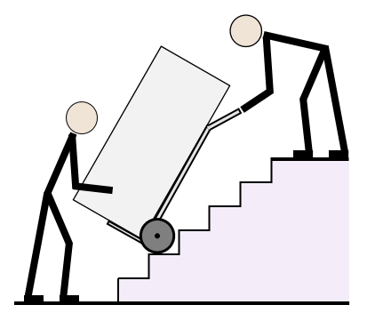      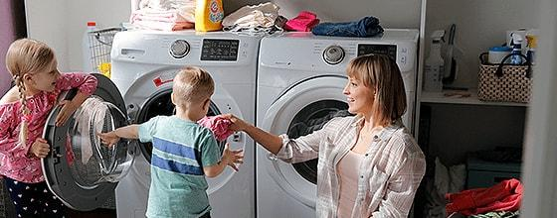  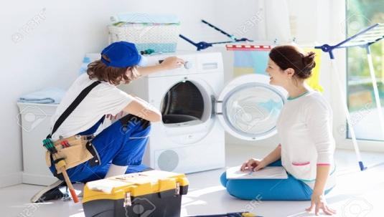  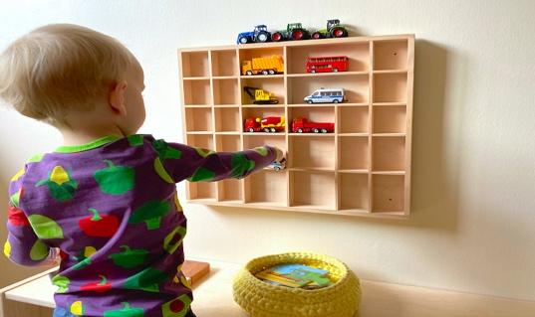 | * Matching:  - Teacher divides students into 4 groups and delivers a set of 6 pictures about daily activities.  - Teacher asks students to work in groups and match the names of daily activity with suitable pictures.  - The fastest group will say “Bingo” and stick their work on board.  - Teacher checks the answers, asks the class to read out loud the activities and gives a small gift to the winning group.
Activity 2 - Presentation
Aim: To teach students some more words related to the topic.
To help students indentify how to say statements with correct tone.(falling tone)
VOCABULARY  - understand (v) to know or realize the meaning of words, what somebody says, etc.  - pick (v): [picture]  - water (v): [picture]  - guard (n): [picture]  - delicious (adj) – [synonym]: yummy/tasty  - helpful (adj) – [synonym]: useful    pick    water    Guard | Teacher introduces the vocabulary by:  - providing the definition of the words.  - providing the synonyms of the words.  - providing the pictures of the words.
PRONUNCIATION  Suggested answer:  - We go to school every morning.  - I can do the washing.  3. My father repairs a broken machine. | - Teacher briefly explains to the student that we use falling tones at the end of a statement.  - Teacher provides an example of a statement and models the falling tone of the statement.  - Teachers ask students to provide some more examples of statements.
Activity 3 – Practice
Aim: To revise/ teach the names of other human daily activities.
To help students practice telling about people’s abilities, using the modal can/can’t and the phrases they have learnt in Task 1.
To give students further practice on asking and answering about abilities, using the modal can and daily activities.
To help students identify how to say statements in the correct tone.
Task 1: Match the verbs in column A to the words or phrases in column B. (p. 60)  Answer key:  1. c 2. a 3.b  4. e 5. d | - Teacher has students quickly match the verbs in column A to the words/phrases in column B individually. Explain the words/ phrases if necessary.  - Teacher plays the recording for students to check their answers. Pause the recording after each phrase and ask them to repeat chorally and correct their pronunciation if necessary.
Task 2: Work in pairs. Tell your partner the activities in 1 you can or can’t do. (p. 60)  Examples:  - I can do the washing but I can’t work as a guard.  - I can water plants but I can’t understand your feelings. | - Teacher helps students remember the use of can to talk about ability in the present and have some students give examples.  - Students work in pairs do the same sharing.  - Teacher may go around to help weaker students.  - Teacher calls some pairs to share their answers with the whole class.  - Teacher gives feedback and corrections (if necessary).
Task 3: Work in pairs. Read, ask and answer questions. (p. 60)  Model answer:  A: Can V10 do the washing?  B: Yes, it can.  A: Can V10 repair a broken machine?  B: No, it can’t. | - Teacher models the activity with a more able student. Remind students that they only use the information from the table to ask and answer about what the robot V10 can or can’t do.  - Students work in pairs, ask and answer about what the robot V10 can or can’t do.  - Teacher calls some pairs to practice in front of the class and gives feedback.
Task 4: Listen and repeat the sentences.  (p. 60) | - Teacher plays the recording and asks students to listen and repeat the statements. Remind students of the falling tone.  - Teacher ask some students to read out the statements and invite comments from other students.
Task 5: Listen and practice saying the statements in the paragraph. (p. 60) | - Teacher has students say the statement in the paragraph on pairs: one reads out the statements and the other gives comments.  - Teacher plays the recording for students to listen and compare with how their partners have pronounced.  - Teacher asks some students to perform in front of the class.  - Other students give comments  - Teacher gives more comments if needed.
Homework
Prepare A closer look 2 | T asks Ss to prepare A closer look 2.
Date of preparing: 8/5/2024
Date of teaching: 10/5/2024

Period 97 UNIT 12 ROBOTS

Lesson 3 – A closer look 2

I. OBJECTIVES:
1. Knowledge: By the end of the lesson, students will be able to know how to use superlative adjectives: short adjectives correctly.
* Vocabulary:
* Grammar: The superlative of adjectives : The + short adj + est
2. Competences: Listening, speaking and reading
3. Educational aim: :
II. TEACHING AIDS:
- Grade 6 textbook
- sachmem.vn
III. PROCEDURES:
Content | Teacher’s and Ss’activities
Activity 1 – Warm up
Aims: To activate and anticipate students’ knowledge of superlative adjectives.
Set of words:  - the tallest  - the shortest  - the biggest  4.the smallest | * Game: Sentence racing.  - Teacher divides the class into 4 groups.  - Teacher delivers a set of word cards which contains superlative adjectives of short adjectives to each group.  - Teacher models a sentence first. (e.g. Minh is the tallest in my class.)  - Students will have to work in groups to create as many correct sentences from the word cards as possible.  - The group with more correct sentences will be the winner.  - Teacher draws students’ attention to superlative adjectives in the sentence they have made and leads in the lesson.
Activity 2 – Presentation
Aim: To introduce the superlative of short adjectives.
1. Superlative adjectives: short adjectives:  * Form:  The + short adj + est  * Use: Superlative adjectives are used to compare more than three people or things, expressing the highest degree.  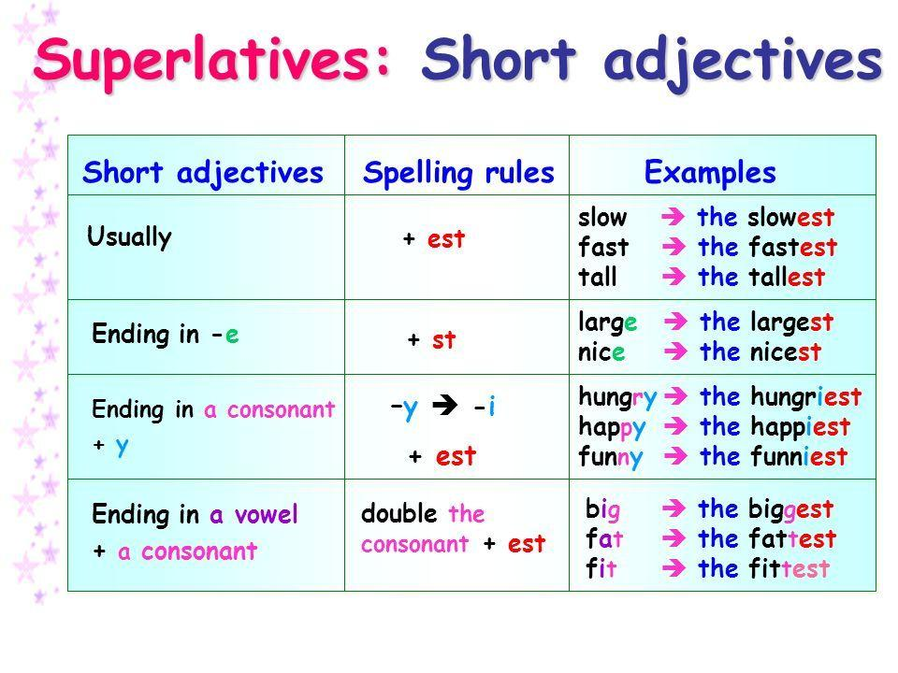 | - Teacher briefly explains the form and use of superlative adjectives:  - Teacher notices the way to construct the superlative of short adjectives in English:
Activity 3 – Practice
Aim: To help students practice forming the correct form of superlative adjectives.
To help students practice the superlative of adjectives and revise the comparative of adjectives.
To give students further practice on using superlative adjectives.
Task 1: Write the superlative form of the adjectives in the table. (p. 61)  Answer key:  Adjectives Superlative form  fast fastest  tall tallest  noisy noisiest  nice nicest  hot hottest  light lightest  quiet quietest  heavy heaviest  large largest | - Teacher asks students to read the instruction and tells them what they should do. (With a weaker class, do the first word as an example).  - Teacher asks students to do the exercise individually and then compare their answers with a classmate.  - Teacher checks the answers as a class.
Task 2 + 3: Complete the sentences with comparative or superlative form of the adjectives. (p. 61, 62)  * Questions in the game:  1. Bonbon can move 10 tons; it’s the (strong) _________ of all.  2. This robot can understand all of what we say. It’s the (smart) __________ in the robot show.  3. He is the (tall) ____________ in our class; he is about 1.8m tall.  4. This is the (small) ___________ of all home robots; we can put it in our bag.  5. This robot is only 200 dollars. It’s the (cheap) ____________ in our shop.  6. My brother has a (tidy) ____________ room than me.  7. The (hot) _____________ desert of all is Sahara and it’s in Africa.  8. Travelling by plane is (fast) ____________ than going by car.  9. Who is the (tall) _____________ in your family?  10. I think dogs are (smart) _____________ than cats.  Answer key:  - strongest  - smartest  - tallest  - smallest  - cheapest  - tidier  - hottest  - faster  - tallest  10. smartest | - Teacher uses questions in Exercise 2 + 3 (p. 61, 62) to create questions in the Quizizz game.
Task 4: Work in pairs. Look at the information of three robots: M10, H9 and A3 and talk about each of them, using superlative adjectives. (p. 62)  MODEL DISCUSSION:  A: A3 is the tallest of the three robots.  B: M10 is the youngest of the three robots.  A: A3 is the heaviest of the three robots.  B: H9 is the cheapest of the three robots. | - Teacher asks students to look at the information in exercise 4 and explains what they have to do.  - Teacher models the activity with a more able student and reminds students that they only use the information from the table to describe the three robots using superlative adjectives.  - Teacher may explain the meaning of the words age, weight, height, price and asks students to elicit the adjectives they can use to describe each row.  - Students work in pairs to say sentences comparing three robots.  - Teacher moves around to offer help if needed.  - Teacher calls some pairs to perform in front of the class.
Homework
Prepare Communication | - T asks Ss to prepare Communication

Date of preparing:12/5/2024
Date of teaching: 14 /5/2024

Period 98 UNIT 12 ROBOTS

Lesson 4 – Communication

I. OBJECTIVES:
1. Knowledge: By the end of the lesson, students will be able to:
- express agreement and disagreement;
- talk about what a robot can do.
* Vocabulary: agreement and disagreement expressions
* Grammar:
2. Competences: Listening , speaking and reading
3. Educational aim: :
II. TEACHING AIDS:
- Grade 6 textbook
- sachmem.vn
III. PROCEDURES:
Content | Teacher’s and Ss’activities
Activity 1 – Warm up
Aims: To activate students’ knowledge of what a robot can do.
* Spider web:  Suggested answer:  A robot can:  - do the dishes  - iron  - water plants  - work as a guard  … | - Teacher draws a spider web on the board with the word A ROBOT CAN in the middle.  - Teacher asks students to name as many activities a robot can do as possible.  - Students give their answers.  - Teacher writes down the answers on the board.  Teacher leads students into the lesson by telling that what they are going to learn how to express agreement and disagreement in English.
Activity 2 – Everyday English
Aim: To introduce ways to express agreement and disagreement in English.
Expressing agreement and disagreement  Task 1: Listen and read the dialogues. Pay attention to the highlighted sentences. (p. 63)  Agreement and disagreement expressions:  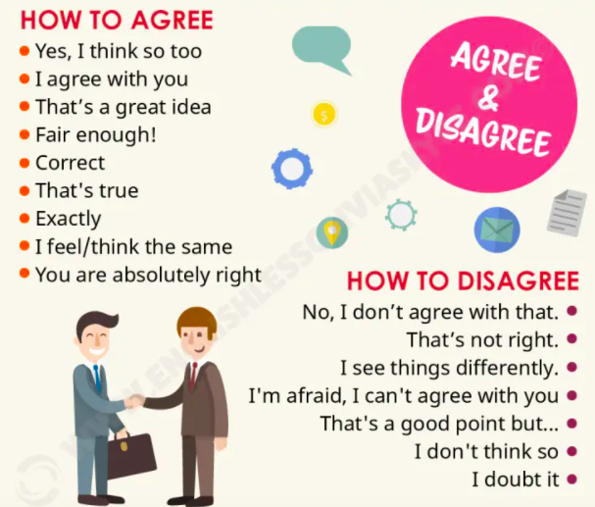 | - Teacher plays the recording and asks students to look at the dialogues and read it while listening. Ask students to pay attention to the highlighted sentences.  - Teacher elicits the structures to express agreement and disagreement from students (I agree/ disagree with…).  - Students practice the dialogues in pairs.  - Teacher calls some pairs to practice the dialogues in front of the class.  - Teacher asks students to provide some more expressions of agreement and disagreement they know.
To help students practice expressing agreement and disagreement.
Task 2: Work in pairs. Express your opinions about the statements. (p. 63) | - Teacher asks students to read the instruction and given statements, decide whether they agree or disagree with the statements.  - Students work in pairs to make similar dialogues, using the structures for expressing agreement and disagreement.  - Teacher moves around to observe and provide help.  - Teacher calls some pairs to practice in front of the class and comment on their performance.
Activity 3 – Speaking
To help students practice using some grammar points and vocabulary related to the topic.
Task 3: Listen to the radio programme from 4Teen News. Fill the blanks with the words you hear. (p. 63)  Answer key:  Key:  1. understand  2. smartest  3. put  4. water  5. guard | - Teacher asks students to look at the conversation and guess words can be filled in the blanks.  - Teacher plays the recording for the first time and asks students to listen and fill in the blanks.  - Teacher asks students to share their answers in pairs and plays the recording again for students to check their answers.  - Teachers asks some students to role play the radio programme again, paying attention to the use of the words of daily activities.
Homework
Prepare Skills 1 | T asks Ss to prepare Skills 1.

Date of preparing: 12/5/2024
Date of teaching: 14/5/2024

Period 99 UNIT 12 ROBOTS

Lesson 5 - Skills 1

I. OBJECTIVES:
1. Knowledge: By the end of the lesson, students will be able to:
- develop reading skill for general and specific information;
- identify different features of different types of robots;
- use what they have learnt to practice describing what a robot can do.
* Vocabulary: literature (n), subject (n), improve (v), look after (phv); space station (nph), planet (n)
* Grammar:
2. Competences: Listening , speaking and reading
3. Educational aim:
II. TEACHING AIDS:
- Grade 6 textbook
- sachmem.vn
III. PROCEDURES:
Content | Teacher’s and Ss’activities
Activity 1 – Warm up
Aims: To activate students’ prior knowledge and vocabulary related to the topic and introduce the topic of reading.
* Questions in the game:    1. What type of robot is that?  A. Home robot  B. Space robot  C. Teacher robot  D. Doctor robot    2. What type of robot is that?  A. Worker robot  B. Space robot  C. Teacher robot  D. Doctor robot    3. What type of robot is that?  A. Home robot  B. Worker robot  C. Teacher robot  D. Doctor robot  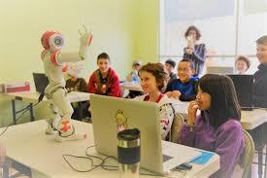  4.What type of robot is that?  A. Home robot  B. Space robot  C. Teacher robot  D. Doctor robot    5.What type of robot is that?  A. Home robot  B. Space robot  C. Teacher robot  D. Worker robot  Answer key:  1. B 2. D 3. B 4. C 5. A  1. What robots are you interested in? Why?  Suggested answers:  1. I am interested in home robots because they can help my mom do the housework. | T divides the class into 2 groups.  Ss listen and choose the correct answer.  - Teacher leads students into the lesson by asking students the question:
Activity 2 - Pre-Reading
Aim: To provide students with some lexical items before reading the text.
(Pre-teach vocabulary):  - literature (n) [picture]    - subject (n) [picture]    - improve (v): [definition] to become better than before  - look after (phv): [synonym] take care of  - space station: (nph) [picture]    - planet : (n) [picture]   | - Teacher introduces the vocabulary by:  - providing the synonym of the words;  - providing the pictures of the words;  - providing the definition of the words.
Activity 3 – While -Reading
Aim: To develop reading skills for general and specific information.
Task 2: Read the text and choose the best answer to each of the questions. (p. 64)  Answer key:  1. B 2. C 3. C 4. C  Task 3: Read the text again and fill the table. (p. 64) | * Keywords in multiple choice questions:  - Teacher asks students to go through the questions (1 – 4) to make sure that they understand them and know what information is being asked.  - Students underline the key word(s) in each question to locate the answer in the reading text  - Teacher asks students to read the text and answer the questions. The fastest student who gives the correct answers will get mark 10.  - Teacher asks students to scan the text again and find the detailed information to complete the table.  - Teacher asks students to note down where they have found the information.  - Students compare their answers with peers.  - Teacher checks students' answers as a class.
Activity 4 - Pre-Speaking
Aim: To help students form the ideas for their speaking.
Task 4: Work in groups. Discuss what you think robots can do in the five places. (p. 64) | - Teacher divides the class into 5 groups and assigns each group a place in Task 4.  - Teacher provides each group with a piece of A2 paper and some markers.  - Teacher asks students to work in groups, discuss what robots can do in the place they are assigned and note the ideas they have discussed on the paper.  Teacher goes around and offers help if needed.
Activity 4 - While-Speaking
Aim: To help students use what they have learnt so far to talk about what robots can do in the place they are assigned.
Task 5: Present your discussion (p. 64). | - Teacher invites some groups to share their discussion and makes sure they speak in full sentences.  - Students share their discussion with the whole -class.
Homework
Prepare Skills 2 | T asks Ss to prepare Skills 2.

Date of preparing:12/5/2024
Date of teaching: 14/5/2024

Period 100 UNIT 12 ROBOTS

Lesson 6 – Skills 2

I. OBJECTIVES:
1. Knowledge: By the end of the lesson, students will be able to:
- listen for specific information about what a robot can do;
- write a paragraph about the robot they want to have.
* Vocabulary:
* Grammar:
2. Competences: Listening, speaking and writing
3. Educational aim:
II. TEACHING AIDS:
- Grade 6 textbook
- sachmem.vn
III. PROCEDURES:
Content | Teacher’s and Ss’activities
Activity 1 – Warm up
Aims: To activate students’ prior knowledge of different types of robots.
* Brainstorming:  Space robot  Doctor robot  Worker robot  Teacher robot  Home robot  Suggested answers:  - Space robot: build space stations, take measurements, collect samples, take pictures of planets, ect.  - Doctor robot: look after sick people, do the surgery, help the doctors, ect.  - Worker robot: build houses, move heavy things,  -Teacher robot: help children study, teach English, literature, maths and other subjects, help children improve English pronunciation, ect.  -Home robot: cook meals, clean the house, do the washing, iron clothes, ect. | - Teacher sticks 5 icons on the board, and divides the class into 5 big groups.  - Each group will be assigned a type of robot.  - Teacher asks students to brainstorm all abilities that the robot can have.  - The group having the most suitable answers is the winner.
Activity 2 – Pre listening
Aim: To help students have ideas of what the conversation is about.
Task 1: Listen to the conversation and tick the phrases you hear. (p. 65)  Answer key:  - look after sick people - understand what we say - build the very high buildings - teach many subjects - move heavy things 4 | - Teacher asks students to underline key words in each of five given phrases and guess which phrases will appear in the conversation.  - Teacher plays the recording and asks students to tick next to the phrase they hear from the conversation.  - Teacher calls some students to share their answers and confirms the correct ones.
Activity 3: While – listening
Aim: To help students develop listening skill for specific information (T / F).
Task 2: Listen and tick True or False. (p. 65)  * True – False prediction:  Answer key:  1. F (Robots can do quite a lot today.)  2. T  3. T  4. T  5. F (No, not everything. They can’t understand our feelings or play football.) | - Teacher asks students to go through the statements (1 – 5) to make sure that they understand and know what information they have to catch for the answers.  - Students underline the key word(s) in each statement and guess whether they are True or False individually.  * Listen and decide True or False:  - Teacher plays the recording.  - Teacher asks students to listen and tick the answers.  - Teacher asks students to compare their answers with the predictions made previously.  - Teacher calls on some students to read aloud their answers and correct the false one(s).  - Teacher checks students' answers as a class.
Activity 4 – Pre-writing
Aim: To help students prepare ideas for their writing.
Task 3: Imagine a robot you would like to have and make notes about it. (p. 65)  Model notes:  1. Name of your robot Mimi  2. Type of robot Home robot  3. Where it can work At my house  4. What it can do for you Help my Mum do the housework: clean the house, wash dishes and cook meals. | - Teacher asks students to make notes on a robot they want to design (its name, type of robot, where it can work and what it can do).  - Remind them that they do not have to write full sentences and they can use abbreviations.  - Teacher goes around and helps if needed.  - Students work in pairs and share their notes with their partners.
Activity 5 – While – writing
Aim: To help students practice writing a paragraph about the robot they would like to have.
Task 4: Write a paragraph of 50-60 words about the robot you would like to have. (p. 65) | - Teacher introduces some structures to write about the robot:  * Name:  My robot’s name is…  I would like to have a robot named…  I would name my robot …  * Type:  It is a …  * Where it can work:  It can work at…  … is an ideal place for it.  * What it can do:  My robot can…  My robot is able to…  Teacher asks student to use the given structures and the information they have noted in task three to write a paragraph about the robot they want to have.
Homework
Prepare Looking back and project | T asks Ss to prepare Looking back and project

Date of preparing:15/ 5 /2024
Date of teaching: 17/ 5 /2024

Period 101 UNIT 12 ROBOTS

Lesson 7 – Looking back & project

I. OBJECTIVES:
1. Knowledge: By the end of the lesson, students will be able to:
* Vocabulary:
* Grammar:
2. Competences: Listening, speaking and reading
3. Educational aim:
II. TEACHING AIDS:
- Grade 6 textbook
- sachmem.vn
III. PROCEDURES:
Content | Teacher’s and Ss’activities
Activity 1 – Warm up
Aims: To revise the vocabulary related to the topic and lead in the next part of the lesson.
  1. _________ the clothes  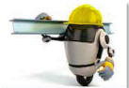  2. ________ heavy things    3. ____________ fruit    4. do the ___________    5. __________ the dishes  Answer key:  1. iron 2. move  3. pick 4. washing 5. do | - Students complete each sentence appearing on the screen.  - Teacher gives complements or good marks to the winner of the game.
Activity 2 – Looking back
Aim: To help students revise phrases related to daily activities.
To help students revise the form and use of superlative adjectives.
Task 2: Fill in the blanks with the verbs from the box. (p. 66)  Answer key:  1. work  2. make  3. repair  4. understand  5. waters | - Teacher encourages students to complete the task individually.  - Students exchange their textbook to discuss the answers.  - Teacher asks one student to write the answers on the board.  - Teacher gives feedback as a class discussion.
Task 3: Use the correct form of the adjectives in brackets to complete the paragraph. (p. 66)  Answer key:  1. smartest  2. smallest  3. lightest  4. strongest  5. cheapest | - Teacher asks students to do the task individually first.  - Teacher then allows students to check their answers with a partner.  - Teacher calls some students to write down the answers on the board.  - Teacher gives feedback as a class discussion.
Task 4: Complete the sentences with the superlative form of the adjectives in the brackets. (p. 66)  Answer key:  1. highest  2. largest  3. longest  4. widest  5. hottest | - Teacher asks students to complete the task individually.  - Students exchange their textbook to discuss the reasons about their answers.  - Students should record their original answers to guide their self-assessment later.  - Teacher gives feedback as a class discussion.
Homework
Prepare Review 4

