Date of preparing:27/02/2024
Date of teaching: 29/02/2024

Period 69

UNIT 9: CITIES OF THE WORLD
Lesson 1: Getting Started – What nice photos!
I. OBJECTIVES:
1. Knowledge: By the end of the lesson, Ss will be able to:
- use the lexical items related to the topic Cities of the World;
- use the vocabulary and structures to describe cities and landmarks.
* Vocabulary: landmark (n), rainy (adj), crowded (adj), beautiful (adj), exciting (adj)
* Grammar:
2. Competences: Speaking, listening, reading
3. Educational aim: Positive about the cities.
II. TEACHING AIDS:
- Grade 6 textbook,
III. PROCEDURES:

Content | Teacher’s and Ss’activities
- Activity 1 - Warm up
Aim: To set the context for the listening and reading text and to introduce the topic of the unit.
Matching  Match the pictures with the correct names:  Ha Noi, Ho Chi Minh City, Hue, Tuy Hoa  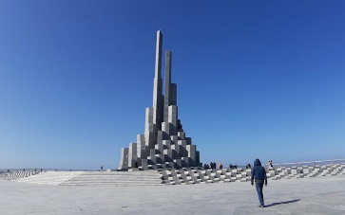  - 2.  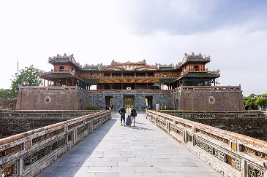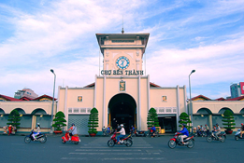  3. 4.  Answer:  - Tuy Hoa, 2. Ha Noi, 3. Hue, 4. HCMCity | T asks Ss to look at the pictures on the screen and then match the name of the city which each picture.  T-Ss.
Activity 2 – Presentation
Aim: To intruduce the vocabulary apprearing in the text.
Vocabulary  - landmark (n):  - exciting (adj): interesting (adj)  - rainy (adj): [picture]  - crowded (adj): [picture]  - beautiful (adj): [picture]    rainy    crowded  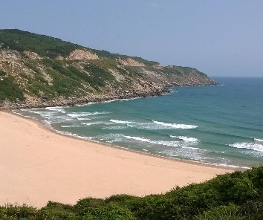  beautiful | - Teacher introduces the vocabulary by:  + showing the pictures illustrating the words.  + providing the synonym of the words.  Checking vocabulary: Matching
Activity 3 – Practice
Aim:
- To practice the targeted language (adjectives) and the background knowledge of cities in the world. (Task 1)
- To help students identify the location of the cities mentioned in the conversation on a map.(Task 2)
- To help students focus on the use of adjectives to describe cities. (Task 3)
- To help students visualize some landmarks of the cities mentioned in the conversation. (Task 4)
Task 1: Listen and read.  1. What cities can you recognize from the photos?  ? What cities are mentioned in the dialogue? | - Teacher sets the context for the listening and reading text:  + Teacher asks students to look at the title of the conversation and the picture.  + Teacher asks them some brainstorming questions like.  - Teacher encourages students to give their answers, but do not confirm whether their answers are right or wrong.  - T asks Ss to look at the book, listen to the dialogue and find the cities mentioned in the dialogue.  - Students listen and read.  - Teacher invites some pairs of students to read the dialogue aloud.  - Teacher has students name the cities mentioned in the dialogue.
Task 2: Write the names of the cities in the correct places.  Answer key:  - London  - New York  - Sydney | - Teacher asks students to look at the photos and the text in order to find the answers.  - Students work independently.  - Teacher allows students to share their answers before discussing in front of the class.  - Teacher asks students to support their answers or encourages them to provide more information about the 3 cities.
Task 3: Read the conversation again and match the cities with the adjectives describing them.  Answer key:  - Sydney:  c – exciting  d – beautiful  - London:  - a – rainy  - New York:  - b – crowded  - e – interesting | - Teacher has students read the conversation again, match the names of the cities and the adjectives given.  - Students work in pairs.  - Teacher asks students to support their answers or encourages them to provide more adjectives to describe the 3 cities.
Task 4: Match the cities with their landmarks.  Answer key:  - Ha Noi – c  - London – d  - New York – a  4. Sydney – b | - Students can work in pairs to complete this task.  - After matching the cities with their landmarks, students discuss with each other to find the names of the landmark either appearing in the pictures or in the cities.
Activity 4 – Production
Aim: To give students a fun time revising what they have learnt so far in the lesson.
Task 4 (Cont.): Match the cities with their landmarks.  Ex:  S1: Where is Ha Noi?  S2: It’s in Vietnam.  S1: What is it like?  S2: It’s small but beautiful. | - After matching the cities with their landmarks, students work in pairs, choose a city and then make questions and answers about it.  - Feedback.
Activity 5 – Homework
Aim: To prepare vocabulary for the next lesson: A closer look 1.
- Prepare new words in Unit 9 - A closer look 1. | - T reminds Ss to practice the dialogue at home, learn vocabulary and prepare new words in Unit 9 - A closer look 1

Date of preparing:03/03/2024
Date of teaching: 05/03/2024

Period 70

UNIT 9: CITIES OF THE WORLD
Lesson 2: A closer look 1
I. OBJECTIVES:
1. Knowledge: By the end of the lesson, Ss will be able to:
- use the lexical items related to the topic Cities of the World;
- use the vocabulary and structures to talk cities and landmarks;
- pronounce and recognize the sounds /əʊ/ and /aʊ/.
* Vocabulary: 1. sunny (adj), 2. delicious (adj), 3. stall (n), 4. palace (n), 5. street food (nph), 6. floating market (nph)
* Grammar:
2. Competences: Listening , speaking and reading
3. Educational aim:
II. TEACHING AIDS:
- - Grade 6 textbook
- sachmem.vn
III. PROCEDURES:
Content | Teacher’s and Ss’activities
Activity 1 – Warm up
Aims: To activate students’ prior knowledge and vocabulary related to the topic, the targeted vocabulary and its pronunciation.
Name the pictures  Answer key:  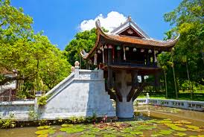  One Pillar Pagoda  /pəˈɡəʊdə/    Twin Tower  /taʊər/  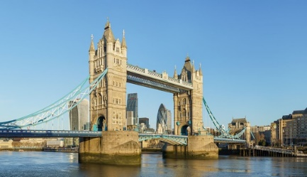  Tower Bridge  /taʊər/    Sydney Opera House  /haʊs/ | - Teacher divides students into 4 groups and delivers a set of 4 pictures about famous landmarks in the world.  - Teacher shows pictures one by one and asks students to raise hands to give the correct names and spelling of the landmarks.  - The fastest group raising their hands will get the chance to answer first.  - Teacher gives 10 points for the group that gives the correct answers.  - The group getting the highest points will be the winner.
Activity 2 – Presentation
Aims:
- To teach students some adjectives describing a city. (Vocabulary)
- To help students have concept and identify the sounds /əʊ/ and /aʊ/.(Pronunciation)
Vocabulary:  - sunny (adj): [antonym]  -> rainy  - delicious (adj): [synonym]  -> tasty  - stall (n): [picture]  - palace (n): [picture]  - street food (nph): [picture]  - floating market (nph): [picture]    stall    palace | - Teacher introduces the vocabulary by:  + providing the synonym or antonym of the words;  + providing the pictures of the words.
Pronunciation: /əʊ/. /aʊ/  Suggested answers:  - /əʊ/: cold, close, drove, low, slow, show.  - /aʊ/: how, now, loud, cloud, sound, house. | - Teacher introduces 2 sounds /əʊ/ and /aʊ/ to students and lets them watch a video about how to pronounce these two sounds.  - Teacher asks students to give some words they know containing these sounds.
Activity 3 – Practice
Aims:
- To help students use the adjectives in Task 1 in a context. (Task 1,2)
- To teach students some words/phrases related to a city. (Task 3)
- To help students identify and practise the /əʊ/ and /aʊ/ sounds. (Task 4)
- To help students practice the sounds /əʊ/ and /aʊ/ in sentences. (Task 5)
Task 1: Fill each box with an adjective.  Answer key:  - City: old, exciting  - Food: tasty, delicious  - People: friendly, helpful  - Weather: rainy, sunny | - Teacher asks students to use the given words to fill in the suitable boxes in 2 minutes.  - Students do the task.  - Teacher calls some students to give their answers.  - Teacher gives feedback and corrections (if necessary).
Task 2: Complete the sentences with the words in Task 1.  Answer key:  1. sunny  2. old  3. exciting  4. friendly  5. tasty/delicious | - Teacher asks students to work in pairs and use the word in Task 1 to complete the sentences.  - Students work in pairs and do the task.  - Teacher calls some pairs to share their answers with the whole class.  - Teacher gives feedback and corrections (if necessary)
Task 3: Write the words and phrases under the correct pictures.  Answer key:  - Palace  - Floating market  - Street food  4. Stall | - Teacher asks students to match the given words and phrases with correct pictures.  - Students work independently.  - Teacher allows students to share their answers before discussing as a class.  - Teacher asks some students to share the answers and gives corrections (if necessary)
Task 4: Listen and write the words in the correct column. Then listen and repeat.  Answer key:  /əʊ/ /aʊ/  boat, postcard, coast, pagoda house, town, tower, crowded | - Teacher asks students to read and write the words in correct column.  - Students work individually.  - Teacher plays the recording for students to listen, repeat and check their answers.
Task 5: Listen and repeat. Pay attention to the underlined words. | - Teacher plays the recording for students to listen and asks students to repeat the sentences after they listen.  - Students listen and repeat the given sentences.
Activity 4 – Production
Aims: To give students chance to apply what they have learnt.
Game: Whispering  Suggested sentences:  - The house is very old.  - I visited a famous floating market.  - He lives in an old house. | - Teacher divides the class into 4 big groups and asks students to stand in four lines.  - The member in the last place will make a sentence containing at least a word and a sound they have learnt; then, whisper the sentence to the next member of the group. They will continue until the member in the first place and this member will say the sentence aloud.  - The fastest group will win the game.
Activity 5 – Homework
Aim: To revise what they have learnt and prepare for the next lesson.
- Find 5 more words with the sound /əʊ/ and 5 more words with the sound /aʊ/. Write them down and practice pronouncing the words.  - Learn vocabulary.  - Prepare A closer look 2, page 29 | T reminds Ss to do homework.

Date of preparing: 04/ 03/2024
Date of teaching: 06 / 03 /2024

Period 71 UNIT 9 CITIES OF THE WORLD

Lesson 3 A closer look 2

I. OBJECTIVES:
1. Knowledge: By the end of the lesson, students will be able to know how to use possessive adjectives and possessive pronouns correctly.
* Vocabulary:
my, your, his, her, its, our, their; mine, yours, his, hers, its, ours, theirs
* Grammar: possessive adjectives, possessive pronouns.
2. Competences: Listening , speaking and reading
3. Educational aim:
II. TEACHING AIDS:
- - Grade 6 textbook
- sachmem.vn
III. PROCEDURES:
Content | Teacher’s and Ss’activities
Activity 1 – Warm up
Aims:
Activity 2 - Presentation
Aims:
To help students revise the use of possessive adjectives.
To help students revise the use of possessive pronouns.
1. Possessive adjectives:  Task 1: Match the sentences with the pictures, paying attention to the underlined part in each sentence.  Answer key:  1 – d  2 – e  3 – b  4 – a  5 – c  Suggested answers:  my, your (singular), your (plural), his, her, its, our, their | - Teacher has students complete the matching activity individually.  - Teacher then asks students to exchange their textbooks to check their friends’ answers.  - Teacher draws students’ attention to the underlined words and to confirm the use of possessive adjectives:  “A possessive adjective is used only when there is a noun following it.”  - Teacher then asks students to work in pairs to provide all possessive adjectives except for the ones in the sentences.
2. Possessive pronouns:  Suggested answer:  “This book is mine, not yours.”  Anticipated answers:  mine, yours (singular), yours (plural), his, hers, its, ours, theirs  - Teacher has students work in groups of 4 to create a chart/mind map showing all possessive adjectives and possessive pronouns including their relation.  Suggested answers:  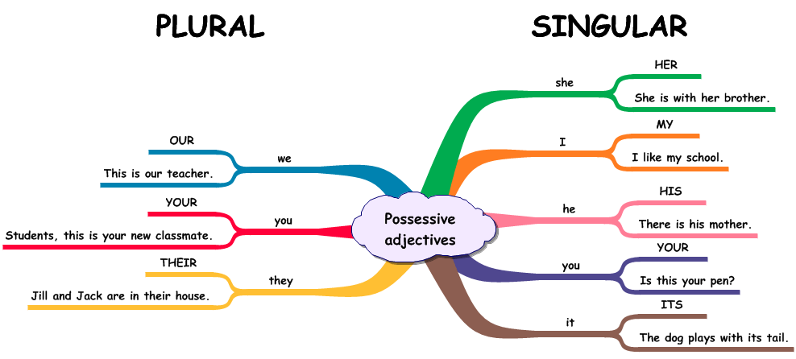  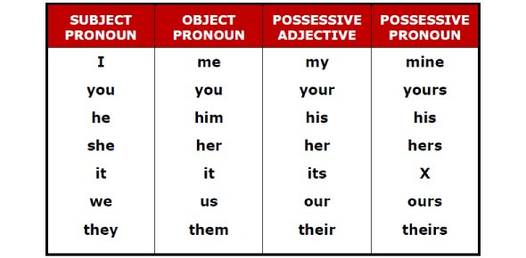 | - Teacher draws students’ attention to the underlined words in the following sentence, and encourage them to say the sentence in a different way that does not change the meaning of it.  “This book is my book, not your book.”  - Teacher gives feedback and confirms the use of possessive pronouns:  “A possessive pronoun is used alone, without a noun following it.”  - Teacher then asks students to work in pairs to provide all possessive pronouns except for the ones in the sentence.
Activity 3 - Practice
Aims:
To give students opportunities to use possessive adjectives correctly in context. (Task 2)
To help students determine the correct possessive pronoun representing a phrase. (Task 3)
Task 2: Complete the sentences with the correct possessive adjectives.  Answer key:  - My  - your  - Their  - Her  - Our | - Teacher has students work on the exercise individually before they compare answers with each other.  - Teacher gives feedback as a class discussion.
Task 3: Complete the sentences with the correct possessive pronouns.  Answer key:  - mine  - theirs  - yours  - his  5. ours | - Teacher has students work on the exercise individually before they compare answers with each other.  - Teacher gives feedback as a class discussion.
Activity 4 – Production
Aims: To help students distinguish and use correctly possessive adjectives and possessive pronouns. (Task 4,5)
* Questions in the game:  - Australia is a strange country. All of _____ big cities are along the coast.  A. it’s B. its  C. it is D. it  - Our city is very crowded. How about _________?  A. you B. your  C. yours D. you are  - I love my football club. Does Phong like ______?  A. his B. him  C. he is D. he  - ______ street is short and narrow.  A. Our B. We  C. Us D. Ours  - They cannot find _____ city map anywhere.  A. their B. them  C. theirs D. they  - The book is ________, but you are welcome to read it.  A. my B. mine  C. yours D. yours  - _______ bike is dirty, and I can’t tell what colour is it.  A. Your B. Yours  C. You D. You are  - Your country is much bigger than _________.  A. our B. their  C. ours D. yours  - _______ dog is so friendly. It never barks.  A. They B. Them  C. Their D. Theirs  10. _______ not easy to find your way in a strange city.  A. It B. It’s  C. Its D. There  Answer key:  1. B  2. C  3. A  4. A  5. A  6. B  7. A  8. C  9. C  10. B | T asks Ss to choose the best answer for each question.  Games. / Who is faster?  Groupwork.
Activity 5 – Homework
Aims: Reactivate the knowledge that students have gained in the game.
Do Exercise 4 and Exercise 5, write the answers on the notebooks. | T reminds Ss to do homework.

Date of preparing: 05/03/2024
Date of teaching: 07/03/2024

Period 72 UNIT 9 CITIES OF THE WORLD

Lesson 4 Communication

I. OBJECTIVES:
1. Knowledge: By the end of the lesson, students will be able to:
- make an exclamation with What to express their appreciation or surprise;
- recognise and have knowledge about some famous landmarks in big cities.
* Vocabulary:
* Grammar: What + (a/an) + adj + noun!
2. Competences: Listening , speaking and reading
3. Educational aim: :
II. TEACHING AIDS:
- - Grade 6 textbook
- sachmem.vn
III. PROCEDURES:
Content | Teacher’s and Ss’activities
Activity 1 – Warm up
Aims: To introduce the topic.
* Pictures describing:    Suggested answers:  A green city  High buildings  A beautiful city  A beautiful sky | - Teacher shows the picture of a city and asks students describe as many things in the picture as possible.  - Students give their answers.  - Teacher checks the answer.  Teacher leads students into the lesson by telling about what they are going to learn: “We are going to learn how to express exclamation with what and city land marks”.
Activity 2 - EVERYDAY ENGLISH
Presentation

Aims: To introduce exclamations with What.
* Expressing exclamations with What  Three exclamations:  1. What a nice day!  2. What a clear sky!  3. What tall buildings!  Suggested answers:  They all begin with What followed by a noun phrase. An exclamation mark (!) is usually put at the end.  Structure: What + (a/an) + adj + noun!  *Note: use a/an with countable nouns which are singular. | - Teachers write down three exclamations on the board and asks students to find the similarity/similarities among the three exclamations.  - Students read the exclamations and find out the similarity/ similarities among them.  - Teacher calls some students to share their opinions.  - Teacher gives more explanations and writes down the structure of an exclamation with What.
Practice
Aims: To practice making exclamations with What.
Task 1: Work in pairs. Look at the picture and say what you think by using exclamation with What.  Answer key:  1. What happy and beautiful children!  2. What a colourful and nice picture!  3. What sunny and beautiful weather!  4. What a small and cute boy!  5. What beautiful and colourful apple trees! | - Teacher asks students to work in pairs and take turns to make exclamations from the picture using the suggestions.  - Students do the task in pairs.  - Teacher calls some pairs to say their exclamations in front of the class.  - Teacher gives feedback and corrections (if necessary).
Production
Aims: To apply the knowledge about exclamation with What.
Game: Sentence race  - List of nouns:  cities  food  weather  girl | - Teacher prepares some pieces of paper with some nouns written on that.  - Teacher divides the class into 2 big groups and gives each group a piece of A3 paper.  - A representative of each group will take turns to choose a piece of paper and read aloud the word for the whole group to listen. Then, the group will have 2 minutes to write down as many exclamations with What as possible using the chosen word.  - The group with more correct answer will be the winner.
Activity 2 - * CITY LANDMARKS
Name recognizing
Aims: To help students get used to some famous landmarks in big cities.
Task 2: Work in pairs. Write the names of the landmarks under the correct pictures.  - 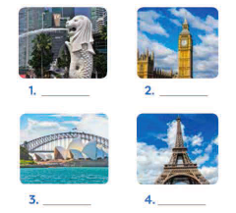  Answer key:  - Merlion  - Big Ben  - Sydney Opera House  4. Eiffel Tower | - Teacher shows the photos of the four landmarks of different cities and asks students what they are. If students do not know their name in English, allow them to use Vietnamese.  - Teacher asks students to work in pairs, read the names in the boxes (make sure that they pronounce the names correctly) and write the correct name under the pictures of the landmarks.  - Students share the answer with the whole class.  - Teacher checks and elicits from students any information they know about the landmarks.
Understanding
Aim: To help students recognise each landmark through its description
Task 3: Write the names of the landmark in Task 2 for the descriptions.  Answer key:  - Big Ben  - Sydney Opera House  - Eiffel Tower  4. Merlion | - Teacher asks students to read the descriptions about the four landmarks and sets the time limit for reading task.  - Students work individually and write the names of the landmarks under the correct descriptions.  - Teacher calls some students to give their answers and checks.
Checking knowledge
Aim: To check how much students know about different cities and their landmarks.
Game: Lucky number  Answer key:  1. B  2. A  3. C  4. A | - Teacher divides the class into 2 big groups.  - Each group will take turns to choose a number and answer the question in each number. There will be 4 questions in Exercise 5 page 31.  - If the answer is correct the group will receive 10 points. If no, the other group will have chance to answer the question and get 5 points.  - There will be one lucky number that gives the group 10 points without answering the question.  - The group with higher scores will win the game.
Homework
Aim: To prepare for the next lesson Skills 1
Choose a city (Berlin, Bangkok,…) and find out the information about the city (the weather, the food, landmarks,…). | T reminds Ss to do the homework.

Date of preparing: 10/03/2024
Date of teaching: 12/03/2024

Period 73 UNIT 9 CITIES OF THE WORLD

Lesson 5 Skills 1

I. OBJECTIVES:
1. Knowledge: By the end of the lesson, students will be able to:
- develop reading skill for general and specific information;
- identify different features of a place;
- use what they have learnt to talk about a city.
* Vocabulary: fantastic (adj), perfect (adj), rent (v), helmet (n), traditional (adj), landscape (n)
* Grammar:
2. Competences: Listening , speaking and reading
3. Educational aim:
II. TEACHING AIDS:
- - Grade 6 textbook
- sachmem.vn
- Google meet: nxb-zgmd-ecp
III. PROCEDURES:
Content | Teacher’s and Ss’activities
Activity 1 – Warm up
Aims: to introduce the topic of reading.
* Discussing  Task 1: Look at the postcard and discuss.  Questions:  - When do people write a postcard?  - What do they often write on a postcard?  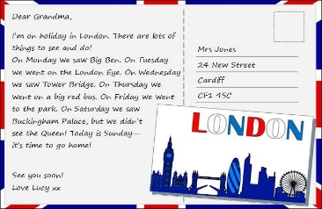  Suggested answers:  1. When they are away from home, often on holiday or business. They want to tell their family or friends what they see and do, and how they feel about their time here.  2. The sender often writes about his/her stay in a city or country. | - Teacher shows the picture of a postcard and asks students to discuss 2 questions:  - Teacher invites some students to share their discussion and accepts reasonable answers.
Activity 2 – Pre-reading
Aims: To provide students with some lexical items before reading the text.
* Vocabulary  - fantastic (adj) [synonym] -> great  - perfect (adj) [synonym] -> ideal  - rent (v) [definition]: pay money to use something  - helmet (n) [picture]  - traditional (adj) [synonym] -> modern (adj)  - landscape (n) [picture]  - 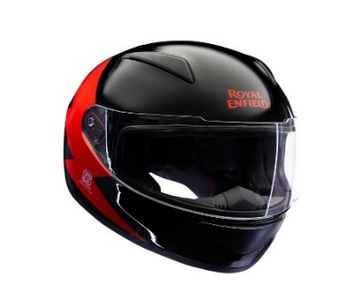  helmet  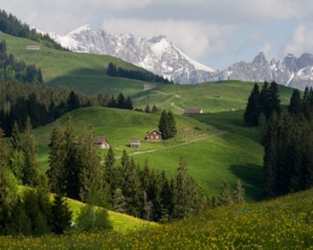  landscape | - Teacher introduces the vocabulary by:  + providing the synonym or antonym of the words;  + providing the pictures of the words;  + providing the definition of the words.
Activity 3 – While -reading
Aims: To develop reading skill for general and specific information.(Task 2)
To identify different features of a place (Task 3)
Task 2: Read the postcard and answer the questions.  * Key words in multiple choice questions:  Answer key:  1. B 2. A 3. B 4. C | - Teacher asks students to go through the questions (1 – 4) to make sure that they understand them and know what information is being asked.  - Students underline the key word(s) in each question to locate the answer in the reading text.  - Teacher introduces the strategy for multiple choice questions:  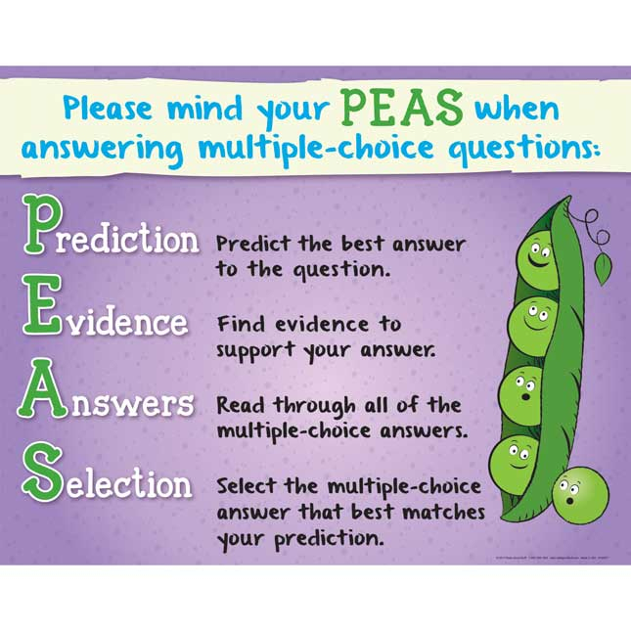
Task 3: Read the text and match the places with the things they have.  Answer key:  1. b,c  2. a,d,e | - Teacher asks students to read the text again and do the matching  - Teacher sets the time.  - Teacher checks students answers as a class.
Activity 4 – Pre – speaking
Aims: To help students form the ideas for their speaking.
Task 4: Choose a city you know. Discuss and answer the questions.  - What city is it?  - What is it like? (the weather, the food ...)  - What can you see and do there?  - How do you feel about it? | - Teacher gives a cue, Tokyo  - Teacher asks students to discuss and makes notes of the information they want to share with the class.  - Teacher asks students to refer to the questions as suggestions for their notes or they can do it in their own way.
Activity 5 – While - speaking
Aims: To help student use what they have learnt so far to talk about a city.
I’m going to tell you about Tokyo – the capital of Japan. It is an exciting and busy city. The weather here is cool and windy. The food is delicious but expensive. I like Sushi best. I can see beautiful cherry blossoms and visit many famous temples. I feel excited. | Ss present their talk.
Homework
Aim: To prepare for the next lesson Skills 2.
- Talk about the city you like best.  - Prepare Unit 9 Skills 2. | Teacher asks students to search for information about Bangkok (the weather, the people, the food, landmarks,…).

Date of preparing: 11/03/2024
Date of teaching: 13/03/2024

Period 74 UNIT 9 CITIES OF THE WORLD

Lesson 6 Skills 2

I. OBJECTIVES:
1. Knowledge: By the end of the lesson, students will be able to:
- listen for specific information about a description of a city;
- write a holiday postcard.
* Vocabulary:
* Grammar:
2. Competences: Listening , speaking and reading
3. Educational aim: :
II. TEACHING AIDS:
- Grade 6 textbook
- sachmem.vn
- Google meet: nxb-zgmd-ecp
III. PROCEDURES:
Content | Teacher’s and Ss’activities
Activity 1 – Warm up
Aims: To introduce the topic of the listening tasks.
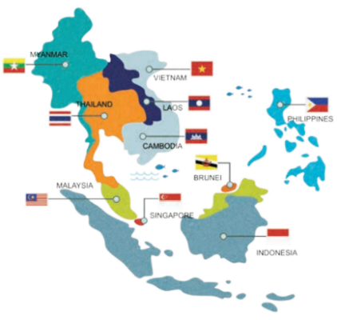  Suggested answers:  - Ha Noi of Viet Nam  - Phnom Penh of Cambodia  - Jakarta of Indonesia  - Manila of Philippines  - Naypyitaw of Myanmar  - Kuala Lumpur of Malaysia  - Singapore of Singapore  - Vientiane of Laos  - Bangkok or Krung Thep of Thailand  10. Banda Seri Begawan of Brunei Darussalam | - Teacher shows the map of ASEAN countries on the screen and asks Ss to name the capital of ASEAN countries.  - Feedback.
Activity 2 – Pre-listening
Aims: To help students brainstorm about Bangkok.
Task 1: Work in groups. Discuss and answer the questions.  - Where is Bangkok?  - What is Bangkok famous for?  Suggested answers:  1. Bangkok is in Thailand.  – It is the capital and the biggest city.  – It has the population of about 8 million.  2. It’s famous for pagodas, temples, open/night/ ﬂoating markets and shopping centres, silk, street food, friendly people, and entertainments. | - Teacher tells students that they will listen to a talk about Bangkok, the capital of Thailand.  - Teacher asks students to work in groups of four to answer the 2 questions and discuss with them to see what they know about Bangkok or Thailand.  - Teacher allows students to talk in Vietnamese (sometimes) if they do not have enough vocabulary in English.  - Teacher asks students to look at the photos and say what they see, and if it’s similar to Viet Nam.
Activity 3-While-listening
Aims: To help students develop listening skill for specific information (T/F).
To help students develop listening skill for specific information (gap-filling).
Task 2: Listen and tick True or False.  * True – False prediction:  * Listen and decide True or False:  Answer key:  1. F (markets and street food)  2. F (cheap)  3. F (on the river)  4. T | - Teacher asks students to go through the statements (1 – 4) to make sure that they understand them and know what information they have to catch for the answers.  - Students underline the key word(s) in each statement and guess whether they are True or False individually.  - Teacher plays the recording.  - Teacher asks students to listen and tick the answers.  - Teacher calls on some students to read aloud their answers and correct the false one(s).  - Teacher checks students answers as a class.
Task 3: Listen again and fill in each gap with one word/ number.  Answer key:  1. 15,000  2. 5  3. life  4. delicious | - Teacher asks students to read the questions carefully and determine what information they need to fill the gaps (numbers, words).  - Teacher plays the recording for students to fill the gaps.  - Teacher gets feedback.
Activity 4 – Pre-writing
Aims: To help students talk about a holiday city and collect information for their later writing.
Task 4: Work in groups. Talk about a city in our country, using the questions below as a guide.  Example:  Teacher: What city is it?  Student: It’s Ha Noi, the capital of Viet Nam.  Teacher: What is it like? Can you tell me more about its weather, people and food?  Student: There are 4 seasons in Ha Noi. It’s warm in spring and hot in summer. It’s not so cold in winter. Autumn is the best time of a year when it’s always cool. The people in Ha Noi are very friendly. They also helpful and hospitable. Ha Noi is famous for many delicious dishes, especially Phở or beef noodles soup.  Teacher: What can you see and do in Ha Noi?  Student: I can see many interesting places such as Old Quarter, One Pillar Pagoda, the Temple of Literature and Imperial Academy, etc. I can go to the night market or the walking street at weekends. | - Teacher models the task by showing the picture of Hanoi, ask a student questions about it.  - Teacher asks students to choose a city they know and discuss as guided by the questions.  - Teacher asks students to take short notes of the answers for later use.
Activity 5 – While-writing
Aims: To teach students how to write a holiday postcard.
Task 5: Write a postcard about 50 words about your holiday in a city. Use the information in Task 4.  - 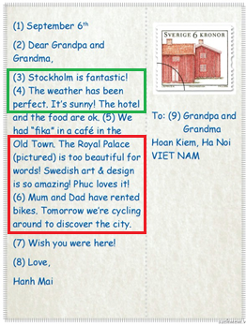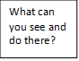  What is it like? (the weather, the people, the food) | - Teacher shows the postcard in Task 2 – Skills 1 to help students identify the main parts of a postcard for students.  - Teacher asks students to use their ideas in Task 4 to write a postcard to their family.  - Teacher asks students to refer to Reading 2 if needed.  - Teacher explains to students that the space for writing on postcards is not big so people often write short sentences which contain the most important information.  - Teacher tells students that contraction is often used in writing postcards to make them short and informal.
Activity 6- Post writing
Aim: To final check students’ writing.
 | - Teacher asks students to show their writing to check their friends’ writing.
Homework
Aim: To allow students finalize their postcards after being checked by friends and the teacher.
- Rewrite the postcard on the notebook.  - Prepare Unit 9 Looking back and project. | T asks Ss do their homework.

Date of preparing: 12/03/2024
Date of teaching: 14/03/2024

Period 75 UNIT 9 - CITIES OF THE WORLD

Lesson 7 - Looking back and project

I. OBJECTIVES:
1. Knowledge: By the end of the lesson, students will be able to review the vocabulary and grammar of Unit 9;
* Vocabulary:
* Grammar:
2. Competences: Listening , speaking and reading
3. Educational aim:
II. TEACHING AIDS:
- Grade 6 textbook
- sachmem.vn
- Google meet: nxb-zgmd-ecp
III. PROCEDURES:
Content | Teacher’s and Ss’activities
Activity 1 – Warm up
Aims:
Activity 2 – Vocabulary
Aims: To help students revise the adjectives describing cities and landmarks. (Task 1)
To help students revise the nouns showing landmarks in a city. (Task 2)
Task 1: Choose the best two options to complete the sentences.  Answer key:  1. A, B  2. A, C  3. A, C  4. A, B  5. B, C  Suggested answers:  1. peaceful, lively, busy, industrial, cosmopolitan, green, historic, modern, etc.  2. rainy, wet, humid, dry, arid, frigid, foggy, windy, stormy, breezy, windless, calm, etc.  3. reliable, passionate, generous, kind, ambitious, etc.  4. tall, high, modern, etc.  5. delicious, salty, bitter, creamy, awful, etc. | - Teacher encourages students to complete the task individually.  - Teacher gives feedback as a class discussion.  - Teacher encourages students to provide more adjective for each questions in the Warm-up part and according to their background knowledge.
Task 2: Write the words in the box under the pictures.  Answer key:  1. towers  2. river bank  3. beach  4. night market  5. palace  6. postcard | - Teacher asks students to read the words in the box first and make sure they remember their meanings.  - Teacher then allows students some time to write the words under the correct pictures.  - Teacher encourages students to complete the task individually.  - Teacher gives feedback as a class discussion.
Activity 3 – Grammar
Aims: To help students revise the possessive pronouns in context. (Task 3)
To help students revise the possessive adjectives and possessive pronouns in context.(Task 4)
Task 3: Complete the sentences with the correct possessive pronouns in the box.  Answer key:  1. yours  2. theirs  3. mine  4. Ours  5. hers | - Teacher has students complete the task individually.  - Student exchange their textbook to discuss the reasons about their choices.  - Students should record their original answers to guide their self-assessment later.  - Teacher gives feedback as a class discussion.
Task 4: Read the sentences and correct the underlined words.  Answer key:  1. its  2. our  3. their  4. its  5. ours | - Students work in pairs.  - Teacher ask students to read the sentences carefully and correct the underlined words.  - Students complete the task and discuss about the answers.  - Teacher gives feedback as a class discussion.
Activity 4 – Homework
Aims: To prepare for the next lesson.
Prepare for the next lesson: Review 3. | - T reminds Ss to do the homework.

