LESSON PLAN
Trường THCS Giáo viên : Nguyen Thi Thu Loan
Tổ: Tiếng Anh
Date of planning: 24-1-2025
Date of teaching:
UNIT 12: ENGLISH-SPEAKING COUNTRIES
PERIOD.....Lesson 1: Getting started – A holiday in Australia.

I. Objectives : By the end of this lesson, Ss will be able to gain:
1. Knowledge
- an overview about the topic “English-speaking countries”
- lexical items related to people and places in English-speaking countries
2. Competences
- Develop communication skills and cultural awareness
- Be collaborative and supportive in pair work and teamwork
- Actively join in class activities
3. Attitude
- Develop self-study skills
- Raise students’ awareness of the need to learn English.
II. TEACHING AIDS:
- Grade 7 textbook, Unit 12, Getting started
- Computer connected to the internet, TV/ pictures
- sachmem.vn
III. PROCEDURES:

1. WARM UP AND LEAD-IN (5mins)
- Aims: To introduce the topic of the unit.
To lead in the topic of the lesson.
To set the context for the introductory conversation.
Contents |  | Teacher’s and students’ activities
Flags matching    The USA The UK    Canada New Zealand   Australia |  | - Teacher divides the class into 2 big groups and asks them to match the flag illustrations with names of the countries.  - Students work in groups to discuss and do the matching.  -Teacher allows students to share their answers before discussing as a class and encourages them to pronounce the names of the countries correctly.  -Teacher asks students to explain their choice, checks the answers as a class, gives feedback then introduces the similarity of these countries “English-speaking countries”.
2. PRESENTATION (10mins)
Aim::- To provide students with vocabulary.
- To help students well-prepared for the listening and reading tasks.
Contents |  | Teacher’s and students’ activities
UNIT 12: ENGLISH-SPEAKING COUNTRIES  Lesson 1: Getting started – A holiday in Australia.  * Vocabulary    island sunset    Landscape penguin |  | - VOCABULARY  -Teacher introduces the vocabulary.  - Teacher introduces the vocabulary by:  - providing the pictures  - eliciting the definition of the words  - Teacher rubs out and checks  - Teacher checks students’ pronunciation and gives feedback.  - Teacher reveals that these four words will appear in the reading text and asks students to open their textbook to discover further.
3. PRACTICE (20 mins)
A. ACTIVITY 1
-Aim : To have students get to know the topic.
- To help students get the main idea of the conversation.
- To draw students’ attention to the key information of the text and see how much they can remember about the text.
- To introduce some key words related to the topic.

Contents |  |  | Teacher’s and students’ activities
1: Listen and read (p. 124). |  |  | - Teacher can play the recording more than once.  - Students listen and read.  - Teacher can invite some pairs of students to read aloud.  - Teacher check students’ pronunciation ad give feedback.
B. ACTIVITY 2
-Aim : To help students get the main idea of the conversation.
2: What are Phong and Mark talking about? (p. 125).  Answer key: A |  |  | - Teacher asks to answer the question without reading the conversation again.  - Students choose the most suitable option A B or C.  -Teacher allows students to share their answers before discussing as a class and encourages them to pronounce the words / phrases correctly.  -Teacher asks students to explain their choice and checks the answers as a class and gives feedback.
C. ACTIVITY 3
-Aim - To draw students’ attention to the key information of the text and see how much they can remember about the text.
- To introduce some key words related to the topic.

3: Read again and tick the information you can find in the conversation. (p. 125)  Answer key:  1. In Australia, Phong used English in real life.  4. Australia is beautiful.  5. Australians love outdoor activities. |  |  | -Teacher asks students to work individually to complete tick the information they can find in the conversation.  - Students work individually to read the sentences and do the task without referring to the text.  -Teacher allows students to share answers before discussing as a class.  -Teacher calls on some students to give the answers and asks them where they find the information.
D. ACTIVITY 4
Aims - To draw students’ attention to the key information of the text and see how much they can remember about the text.
- To introduce some key words related to the topic.

4: Complete the sentences with the words and phrases from the box. (p. 125)  Answer key:  1. landscape  2. penguin watching  3. island  4. sunset  5. Australians |  |  | -Teacher asks students to read the words and phrase in the box and work on their meanings. These words have appeared somewhere in the previous units (except the word Australians).  - Students fill in the blanks with the most suitable words/phrases.  -Teacher allows students to share answers before discussing as a class.  -Teacher can ask students to read aloud the full sentences and correct their pronunciation if needed.
4 . PRODUCTION (7 mins)
E. ACTIVITY 5
- Aims: To introduce the names of five English-speaking countries and their capital cities through a game.
To create a fun atmosphere in the class.
Contents | Teacher’s and students’ activities
5: Matching game: What’s its capital city? (p. 125)  Answer key:  1. Washington D.C.  2. Ottawa  3. London  4. Canberra  5. Wellington | -Teacher writes the countries and the capital cities on the board (like in the book).  -Students discuss in their groups and do the task.  -Teacher can go around to help weaker students.  -Teacher stops the game when time is up. The first group to find all the correct answers wins.
5. HOMEWORK (3 minutes)
- Learn vocabulary by heart.
- Reread the dialogue , redo exercises.p.125 in the textbook
- Prepare unit 12: A closer look 1.

Date of planning:26-6-2025
Date of teaching:
UNIT 12: ENGLISH-SPEAKING COUNTRIES
Period 95 LESSON 2 : A CLOSER LOOK 1

  - I. OBJECTIVES: By the end of this lesson, students will be able to:
1. Knowledge
- Vocabulary: Use words related to people and places in the English-speaking countries.
- Pronunciation: ask questions with the correct rising and falling intonation.
2. Competences
- Develop communication skills and creativity
- Be collaborative and supportive in pair work and teamwork
- Actively join in class activities
3. Attitude:
- Develop self-study skills
- Raise students’ awareness of the need to keep their neighbourhood green.
II. Teaching and learning resources:
- Grade 7 textbook, Unit 12, A closer look 1
- Computer connected to the internet, TV/ Pictures/ Cards, sachmem.vn
III. Procedures:
1. WARM UP (5mins)
-Aim: To recall students’ vocabulary on community activities.
Contents | Teacher’s and students’ activities
Homework checking:  Names of English-speaking countries.  Canada  The USA  New Zealand  Scotland  Ireland  - United Kingdom  - Australia  - Liberia  - Jamaica  - ..... | T checks’Ss homework  -Teacher divides the class into groups of four and asks them to share their homework.  -Students work in groups to:  - discuss and share names of English-speaking countries.  - list all the names of English-speaking countries in a piece of paper.  - Teacher asks the groups to swap their pieces of paper and do cross checking. The group with the most correct names of English-speaking countries will be the winner.  -Teacher confirms the answers and give compliments to the winner.
2.VOCABULARY (8 mins)
- Aim: - To introduce new words.
Contents |  | Teacher’s and students’ activities
VOCABULARY  - native (adj) /ˈneɪ.tɪv/: Bản ngữ, nguyên quán  - amazing (adj) /əˈmeɪ.zɪŋ/: Tuyệt vời  - unique (adj) /juːˈniːk/: Độc nhất  - local (adj) /ˈləʊ.kəl/: Thuộc về địa phương  - ancient (adj) /ˈeɪn.ʃənt/: Cổ, xưa |  | - Teacher introduces the vocabulary.  -Teacher introduces the vocabulary by:  - providing the pictures  - providing the definition of the words.  -Teacher asks students to repeat.  -Teacher rubs out and checks
3. PRACTICE (15 mins)
A. Activity 1
- Aim: To introduce some key words (nouns) related to people and places through pictures.
Contents | Teacher’s and students’ activities
1. Write the words or phrases under the correct pictures. (p. 126)  Answer key:  1. kangaroo  2. island country  3. tattoo  4. Scottish kilt  5. castle  6. coastline | -Teacher has students read aloud the words in the box and and asks them to match the words with the pictures illustrating them within 3 - 4 minutes.  - Students read the words and phrases in the box and match them with the pictures.  - Teacher asks them to share their answers in pairs before checking the answers as a class.  - Teacher invites students to take turns to read out their answers and corrects their pronunciation if needed
B. Activity 2
- Aim: To introduce some key words (adjectives) to describe people and places in context.
2. Use the words in the box to complete the sentences. (p. 126)  Answer key:  1. amazing  2. ancient  3. unique  4. local  5. native | -Teacher asks to read the words in the box first, explains their meanings if needed then allows students 5 minutes to do the task.  -Students do the task individually.  -Teacher allows students to swap their textbooks to peer check first.  -Teacher confirms the answers and gives feedback, if necessary.  Ask Ss to read the words in the box first. Explain their meanings if needed.
C. Activity 3
- Aim: To introduce some more nouns and phrases through explanations.
3. Work in pairs. Discuss and write the word or phrase in the box next to its explanation. (p. 126)  Answer key:  1. tower  2. symbol  3. capital  4. boat ride | - Teacher asks students to work in pairs to read the words and phrase first and see if they know any of them.  -Students have 4 - 5 minutes to discuss and complete the task.  -Teacher asks students to work in pairs to swap their answers and peer check.  -Teacher checks their answers as a class.
4. PRONUNCIATION (10 mins)
A. Activity 4
-Aim : To help students recognise and practise the rising and falling intonation with questions.
Contents | Teacher’s and students’ activities
4. Listen and repeat, paying attention to the intonation of the following questions. (p. 126)  - Can you speak English?  - What is the capital of Scotland?  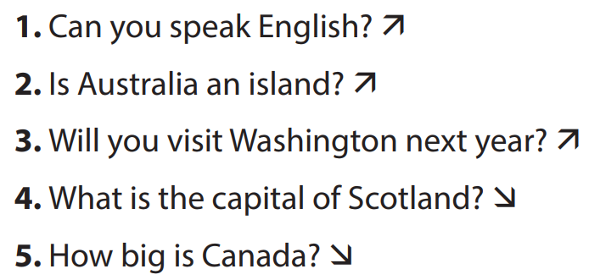 | -Teacher writes two short questions on the board: a yes / no question and a wh-question. Have some Ss say aloud the questions first, then ask other students to pay attention to the intonation at the end of the questions.  - Students look at the questions with the rising and falling already marked, listen and repeat as a class, a group, and finally as individuals.  - Teacher plays the recording for Ss to listen once, then listen and repeat as a class, a group, and finally as individuals. Teacher can play the recording as many times as necessary.  -Teacher elicits the pattern from students: use rising intonation for yes / no questions and falling intonation for wh-questions.
A. Activity 5
-Aim : To provide students with more practice in the intonations of questions.
5. Circle the correct intonation. Then listen and repeat. (p. 126)  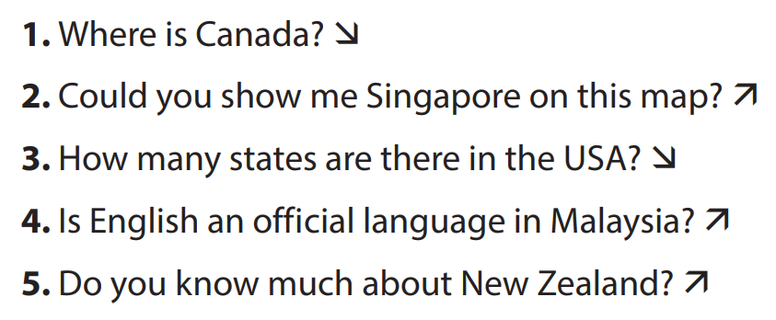 | - Teacher has students circle the correct intonation individually, based on what they have learnt in Task 4.  -Teacher plays the recording for students to listen and repeat each question and check their answers.  -Teacher corrects them if needed and calls on some students to read the questions aloud.  -Teacher plays the recording again and ask students to repeat each question after the recording. Teacher confirms the answers.
5 . PRODUCTION (4mins)
Aim: To test students' quick reaction to the targeted intonation.
Contents | Teacher’s and students’ activities
Game: Up or Down?  1. Where is the USA?  2. Will you visit New York next month?  3. How was your holiday in Australia?  4. Is Phu Quoc an island?  5. What is the capital of Viet Nam?  6. How many sudents are there?  7. do you know much about England? | -Teacher explains the rules:  - Teacher divides the class into 2 teams.  - Students will listen to questions which are made up from the words in the lesson.  - Students will have to stand up if it is a yes / no question and sit down if it is a wh-question.  - The team will receive minus points equivalent to the number of students who pose incorrect actions (stand up or sit down).  - The team with less minus points will be the winner.  - Students play the game.  -Teacher helps students in the game.  - Teacher gives feedback.
6. HOMEWORK (3mins)
- Learn vocabulary by heart
- Choose a favourite English-speaking country. Find the information about its location and attractions.
- Do exercises 1, 2 p 93 in the workbook
- Prepare vocabulary for the next lesson: A closer look 2.

Date of planning:26-1-2025
Date of teaching: Unit 12: ENGLISH-SPEAKING COUNTRIES
Period 96 Lesson 3: A closer look 2
  - I. OBJECTIVES
By the end of this lesson, students will be able to:
1. Knowledge:
a. Vocabulary:
b. Grammar: - Understand the use of articles
- Practice using articles correctly
2. Competences: - Develop communication skills and creativity
- Be collaborative and supportive in pair work and teamwork
- Actively join in class activities
3. Attitude: - Develop self-study skills
- Raise students’ awareness of the need to learn languages
II. Teaching and learning resources:
- Grade 7 textbook, Unit 12, A closer look 2, Computer connected to the Internet, TV,sets of word cards, sachmem.vn
III. Procedures
Contents | Teacher’s and students’ activities
1. WARM UP AND LEAD IN ( 5mins)
Aim: To activate students’ prior knowledge related to the targeted grammar: the past simple.
- I see a clock. The clock is The Big Ben Clock Tower.  - I see two buses. The buses are double-decker ones. |  |  | Picture describing  -Teacher asks students to describe the picture.    -Students look at the picture and describe it.  -Teacher and students discuss some sentences used to describe the picture:  - Teacher corrects students answers if needed and confirms the use of articles “a/an” or “the”
2. PRESENTATION ( 8mins)
Aim: To teach students the use of articles “a/an” or “the”
- Unit 12: ENGLISH-SPEAKING COUNTRIES  Lesson 3: A closer look 2  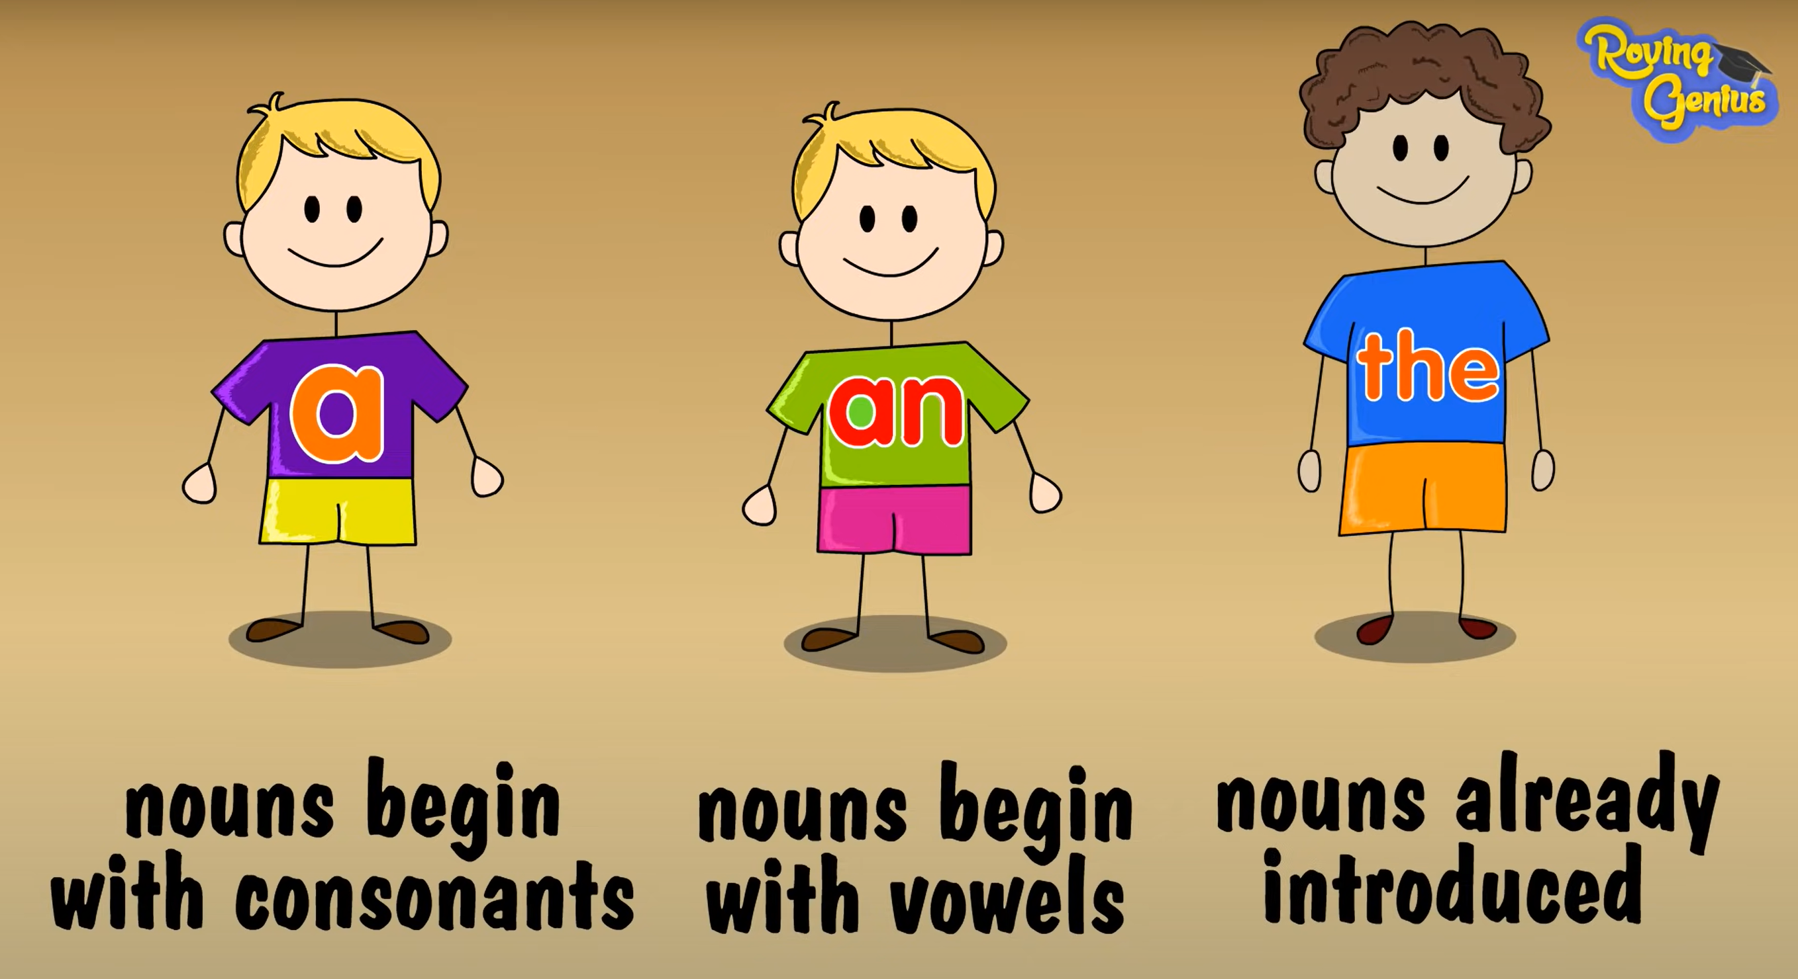 |  | -Teacher lets students watch the following video and asks them to summarise the use of articles “a/an” or “the”:  https://www.youtube.com/watch?v=drTyYqbz6Xk  - Teacher then asks students to study the grammar box and give some more examples.  - Teacher and students discuss the examples.  - Teacher confirms the answers and gives feedback.
3. PRACTICE (22mins)
A. Activity 1
Aim: To help students revise the uses of articles they have learnt in Grade 6.
1. Complete the sentences with “a / an” or “the” (p. 127)  Answer key:  1. the  2. an  3. a  4. a  5. the |  | -Teacher has students work individually.  - Students work individually to complete sentences with the articles.  - Teacher lets students work in pairs and exchange the answers before checking with the whole class (explain each sentence if necessary).  -Teacher confirms the answers and gives feedback.
B. Activity 2
Aim: To help students practise the uses of the as presented in the Remember! box.
2. Put in "the" where necessary. (p. 127)  Answer key:  1. The – x  2. x – the  3. the – the  4. x- the  5. the – the |  | -Teacher has students work individually.  - Students work individually to complete the sentences.  -Teacher lets students work in pairs and exchange the answers before checking with the whole class (explain each sentence if necessary).  -Teacher confirms the answers and gives feedback.
C. Activity 3
Aim: To teach students the use of articles with nationalities.
3. Put in “a / an” or “the”. (p. 127)  Answer key:  1. a  2. an  3. an  4. the  5. a |  | -Teacher allows students some time to read the table first, then do the exercise.  -Students work in pairs to complete the task.  -Teacher then has students compare their sentences. Teacher can go around to help students.  -Teacher confirms the answers and gives feedback. (Note: The English, the Japanese, the French, but Australians, Canadians, Russians.)
D. Activity 4
Aim: To give students further practice in articles.
4. Complete the sentences with “a / an”, or “the” (p. 128)  Answer key:  1. an 2. The 3. the  4. the 5. an 6. the |  | -Teacher has students do this exercise individually.  -Students complete the exercise individually.  - Teacher lets students work in pairs and exchange the answers before checking with the whole class (explain each sentence if necessary).  -Teacher confirms the answers and gives feedback.
4. PRODUCTION (7mins)
Aim: To provide students with more advanced practice in articles.
5. Game – Faster detective.  Answer key:  1. “What do you call a person from England?” – “The Englishman.”  Correct  - Edinburgh is a capital city of Scotland.  the  3. Queenstown is a amazingly beautiful town.  an  4. Are ancient castles an attraction of Scotland? BTV xem lại câu này.  5. Where can you see a red telephone box? SGV sai đáp án |  | -Teacher introduces the rules of the game:  - The class will be divided into 2 teams.  - Each team will have to detect errors in some sentences (if any) then make correction as fast as possible.  - The team with more correct answers will be the winner.  - Students play the games.  -Teacher lets the 2 teams discuss and give comments to their answers.  -Teacher confirms the corrects answers and gives compliments to the winner.
IV. HOMEWORK (3’)
- Learn all the new words and grammar by heart.
- Teacher asks students to make sentences about themselves, using the prepositions of time and place.
- Do exercises 3, 4, 5, 6 P 94 in the workbook.
- Prepare lesson 4 ( Communication).

Date of planning: 26-5-2025
Date of teaching:
  - Unit 12: ENGLISH-SPEAKING COUNTRIES
Period 97 Lesson 4: Communication
  - I. OBJECTIVES
By the end of this lesson, Ss will be able to:
- express amazement
- know interesting facts about English-speaking countries
1. Knowledge
a. Vocabulary: vocabulary on the topic “English-speaking countries”.
b. Grammar: structures to express amazement.
2. Competences: - Develop communication skills and creativity
- Be collaborative and supportive in pair work and teamwork
- Actively join in class activities
3. Attitude : - Develop self-study skills
- Raise students’ awareness of the need to learn languages.
II. Teaching and learning resources:
- Grade 7 textbook, Unit 12, Communication, computer connected to the internet , TV/ Pictures/
- sachmem.vn
III. Procedures
Contents | Teacher’s and students’ activities
1. WARM UP ( 5’)
Aim: To introduce the topic of the lesson.
Guessing the remaining of the picture  - Who are wearing these skirts?  -Do you know the name of this kind of skirt? | -Teacher asks students to guess the remaining of the picture:    -Students answer the questions.  -Teacher and students discuss the answers.  -Teacher confirms the answers, reveals the remaining of the picture and provide more information on the Scottish kilts.  
2. EVERYDAY ENGLISH (15’)
A. Activity 1
-Aim: To introduce two ways to express amazement
Giving compliments  1. Listen and read the conversations, paying attention to the highlighted parts. (p. 128)  2 ways to express amazement:  - Wow ... I didn’t know that!  - Amazing! | - Teacher plays the recording for students to listen and read the conversations and asks students to pay attention to the highlighted parts.  -Students pay attention to the highlighted parts.  -Teacher elicits the expressions of amazement.  -Teacher confirms the answers and gives feedback.
B. Activity 2
-Aim: To introduce to students two ways to express amazement and to provide them some practice.
2. Work in pairs. Make similar dialogues with the following situations, using expressions of amazement. (p. 128)  - New Zealand has the cleanest and safest air on the planet.  - There are no snakes in New Zealand.  - More than half of all the lakes in the world are in Canada. | -Teacher has students work in pairs to make similar dialogues.  - Students work in pairs to make similar dialogues, using the contexts given:  -Teacher asks some pairs to practice the dialogue so that the whole class can give comments.  -Teacher gives feedback as a class.
3. Interesting facts about English-speaking countries (17’)
C. Activity 3
-Aim:To help students learn some facts about English-speaking countries through a quiz.
3.Work in groups. Discuss and write the name of the country next to the fact. (p. 129)  Answer key:  1. Australia  2. The USA  3. Canada  4. The UK  5. New Zealand | -Teacher has students work in groups to read the facts, discuss, and do the matching.  - Students work in groups to complete the task.  -Teacher has the groups cross check and discuss.  -Teacher gives feedback and correction (if needed)
D. Activity 4
-Aim: To provide students with more facts about English-speaking countries and encourage interaction through responding.
4. Work in pairs. Read some facts about English-speaking countries and tick the column true for you. Then role play by one person saying one statement aloud and the other responding to it. (p. 129)  Example:  A: New York is the biggest city but not the capital of the USA.  B: I know this.  A: The state of Alaska in the USA has over 2,600 islands.  B: This is new to me. | - Teacher asks students to read the instructions, then the example to know what they have to do.  - Students work in pairs read the facts and tick the column true for them, then take turns with one saying a fact aloud and the other responding with his / her answer.  - Teacher calls on 2 - 3 pairs to role-play in front of the class.  - Teacher corrects any grammar or pronunciation mistakes if necessary.
4. CONSOLIDATION 5’
E. Activity 5
-Aim: To encourage students to share what they know about English-speaking countries with the class.
5. Work in groups. Share with your group some interesting facts you know about English-speaking countries. The group takes notes and presents its findings to the class. (p. 129) | -Teacher asks students work in groups and allows them time to think about a fact they know and how to say it.  - Students share the facts in the group. The group leader takes notes of the facts. Some Ss may repeat facts which have previously appeared in the unit. This is also a revision activity.  -Teacher calls on group representatives to share the facts with the class.  -Teacher gives feedback on their reports.
5. HOMEWORK (3’)
- Learn all the new words by heart.
- Prepare some photos of your favourite English-speaking country.
- Do exercises 1,2, 3 / P 95 in the workbook.
- Prepare lesson 12 ( Skills1).

Date of planning: 27/ 1 / 2025
Date of teaching:

  - Unit 12: ENGLISH-SPEAKING COUNTRIES
Period 98......Lesson 5: Skills 1
I. OBJECTIVES
By the end of this lesson, students will be able to gain:
1. Knowledge
- Develop reading skill for specific information about New Zealand
- Develop speaking skill: talk about Scotland
2. Competences:
- Develop communication skills and creativity
- Be collaborative and supportive in pair work and teamwork
- Develop presentation skill
- Actively join in class activities
3. Attitude: - Develop self-study skills
- Raise students’ awareness of the need to learn languages.
II. Teaching and learning resources:
- Grade 7 textbook, Unit 12, Skills 1, computer connected to the internet , TV
- sachmem.vn
III. Procedures
Contents |  |  | Teacher’s and students’ activities
1. WARM UP ( 5’)
Aim: - To introduce the topic and to lead in the lesson.
Flags matching  The USA The UK  Canada New Zealand  Australia |  |  |  |  | Guessing: What country is it?  -Teacher asks students to look at the flags and give the names of the countries.  - Students look at the flags raise hands to give the names of the countries.  -Teacher confirms the answers and gives feedback.
2. PRE- READING ( 7’)
A. Activity 1
Aims: To provide students with some lexical items before reading the text.
To lead in the text about New Zealand
- Unit 12: ENGLISH-SPEAKING COUNTRIES  Period ......Lesson 5: Skills 1  Vocabulary  - shining (adj) /ˈʃaɪ.nɪŋ/: lấp lánh, tỏa sáng  - historic (adj) /hɪˈstɒr.ɪk/; có tính chất lịch sử, nổi tiếng trong lịch sử  - rich (adj) /rɪtʃ/; có nhiều  1. Work in pairs. Discuss and choose the correct answer A, B, or C. (p. 130).  Answer key:  1. A  2. B |  | - Teacher introduces the vocabulary.  -Teacher asks students to get the meaning in context and try to make up sentences with of the following words:  -Teacher and students discuss the answers.  -Teacher confirms student’s answers and checks their pronunciation and gives feedback.  -Teacher students to work in pairs to discuss and answer the questions.  -Students work in pairs to complete the task.  -Students discuss the answers.  -Teacher asks some pairs to share their answers. (Don’t confirm the answers. Leave them till the end of the reading.)
3. WHILE-READING( 15 mins)
B. Activity 2
Aim ::To help students develop their reading skill of guessing the meaning of a word by using its context.
2. Read the passage and match the words in bold from the passage (1-4) with their meanings (a-d). (p. 130)  Answer key:  1. c 2. d 3. a 4. b |  |  | - Teacher asks students to work individually to read the passage and find the highlighted words.  - Students read the text in detail, paying attention to the words in bold.  -Teacher asks students to read the sentences where the words appear, and before and after it.  - Teacher calls some students hare their answers then check the answers as a class.
C. Activity 3
Aim : To help students develop their reading skill for specific information (scanning).
3. Read the passage again and choose the correct answer A, B, or C. (p. 130)  Answer key:  1. C  2. B  3. B  4. A  5. C |  |  |  | - Teacher asks some students to do the task individually: read each question, locate where it appears in the text, read that part carefully and circle the correct answer.  - Students work individually to complete the task.  - Teacher allows students to share their answers before discussing as a class and encourages them to give evidence.  - Teacher calls a student to write his/her answer on the board, then check the answers as a class.
4. PRE-SPEAKING
D. Activity 4
Aims:To give students an opportunity to express their own feelings about what they personally like about New Zealand.
4. Work in pairs. Note two things you like about New Zealand. Share them with your partner. (p. 130)  Suggestion for the opening:  There are two things I like about New Zealand. They are ... |  |  |  | - Teacher allows students to work individually first, referring (if necessary) to the text and list the two things they like most about New Zealand.  - Students work in pairs to to share their ideas with their partners, using use the suggested opening provided.  - Students should give some reasons for their choice.  - Teacher listens and passes positive comments.
5. WHILE-SPEAKING ( 6 mins)
E. Activity 5
Aim: To provide an opportunity for students to practise introducing a country.
5. Work in groups. Prepare a short introduction of Scotland and present it to the class. (p. 130)  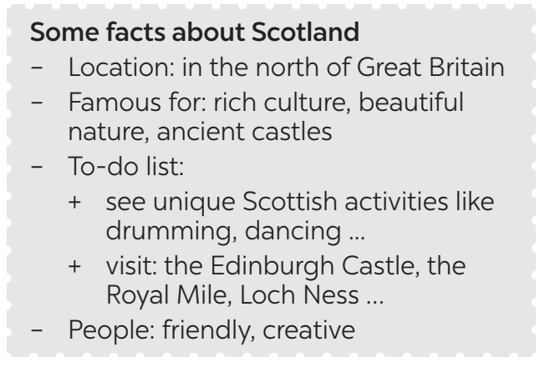 |  |  |  | - Teacher asks students to read the facts about Scotland first. Teacher explains that the introduction consists of four parts (as shown in the box).  - Students work in groups, refer to the reading to see how the ideas are used to discuss, then form complete sentences from the information given.  - Teacher goes around to help students.  - Teacher calls on some groups to share their answers with the class.
6. POST-SPEAKING- READING ( 4 mins)
Aims: - To help students improve next time.
To help some students enhance presentation skill
Teacher asks students to talk about what they have learnt in the lesson. | - Teacher allows students to give comments for their friends and vote for the most interesting and informative presentation.  -Students give comments for their friends and vote for the most interesting and informative presentation.  - Teacher and students discuss the presentations.  - Teacher gives feed-back and comments.
7. HOMEWORK (3’)
- Learn all the new words by heart.
- Prepare short phrases/sentences to describe the photos of your favourite English-speaking country.
- Do exercises 1, 2/ P 96,97 in the workbook.
- Prepare lesson 12 ( Skill 2).

Date of planning: 26/ 1/ 2025
Date of teaching:

  - Unit 12: ENGLISH-SPEAKING COUNTRIES
Period 99 LESSON 6: SKILL 2
  - I. OBJECTIVES: By the end of this lesson, students will be able to:
1. Knowledge
- listen for specific information about a tour of a city;
- write a diary entry about a tour of a city.
2. Competences:
- Develop communication skills and creativity
- Be collaborative and supportive in pair work and teamwork
- Actively join in class activities
3. Attitude: - Develop self-study skills
- Raise students’ awareness of the need to learn languages.
II. Teaching and learning resources:
- Grade 7 textbook, Unit 12, Skills 2, computer connected to the internet
- sachmem.vn
III. Procedures
Contents |  | Teacher’s and students’ activities
1. WARM- UP ( 4’)
Aim:- To lead in the topic of the lesson.
Guessing game: What city is it?  A tour around London.  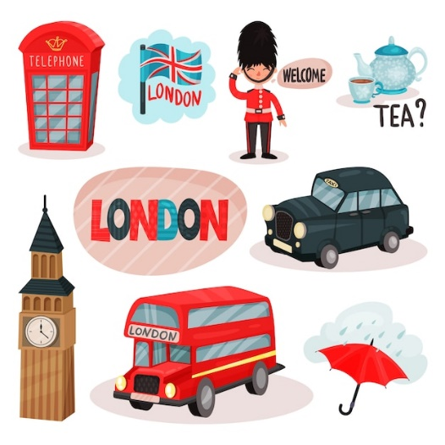  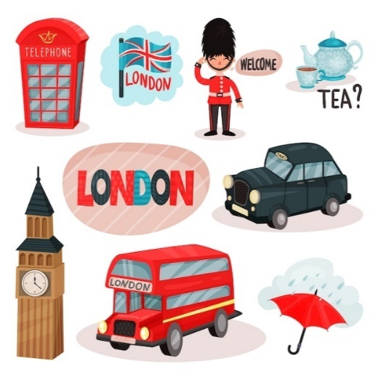 | -Teacher divides the class into 2 teams. Each team will guess the the name of the city based on pictures given gradually by the teacher.  - Students play the guessing game.  - The team with correct answer will be the winner.  - Teacher introduces the topic of the listening task:
2. PRE-LISTENING( 3 mins)
A. Activity 1
Aim: To prepare students for the listening by introducing two key phrases visually
- Unit 12: ENGLISH-SPEAKING COUNTRIES  LESSON 6: SKILL 2  1. Work in groups. Match the phrases to the pictures (p. 131)  Answer key:  1. Changing of the Guard  2. Buckingham Palace | - Teacher asks students work in groups to read the phrases and match them to the pictures.  - Students discuss with partners.  -Teacher elicits as many learnt vocabularies as possible and asks one or two students to re-describe the pictures to the class.  - Teacher gives feedback and introduces the topic of the listening task: A tour around London.
3. WHILE-LISTENING(10 mins)
B. Activity 2
- Aim: To help students develop their skill of listening for specific information, in this case: times.
2. A tour guide is talking about the schedule for a day trip in London. Listen and fill in the times. (p. 131)  Answer key:  1. 11:30 a.m.  2. 1:00 p.m.  3. 3:15 p.m.  4. 5:00 p.m. | -Teacher helps students revise the use of time in the listening and note taking skills by saying 3 - 4 different times for students to write down.  - Teacher has students read the questions quickly. This helps students get some ideas of what they are going to listen to as well as determine the information they need for answering the questions.  - Teacher has students exchange answers in pairs, invites some pairs to read their answers and confirm the correct ones  - Teacher confirms the answers and gives feedback.
C. Activity 3
Aim: To help students further develop their listening skill for specific information.
3. Listen again and complete each sentence with ONE word. (p. 131)  Answer key:  1. Queen  2. garden  3. Clock  4. photos  5. attractions | - Teacher has students read the questions and determine what information they need for answering the questions, reminds them that the questions ask for one-word answers.  - Teacher plays the recording again twice for students to listen and complete the sentences.  - Teacher has students exchange answers in pairs, invites some pairs to say their answers and confirm the correct ones.  - Teacher plays the recording again if needed, stopping at each place where the answers appear.
5. PRE-WRITING (7mins)
D. Activity 4
Aim: To help students summarise the content of the listening in notes.
4. Work in pairs. Fill in the table with information about the London tour. (p. 131)  Suggested answers:  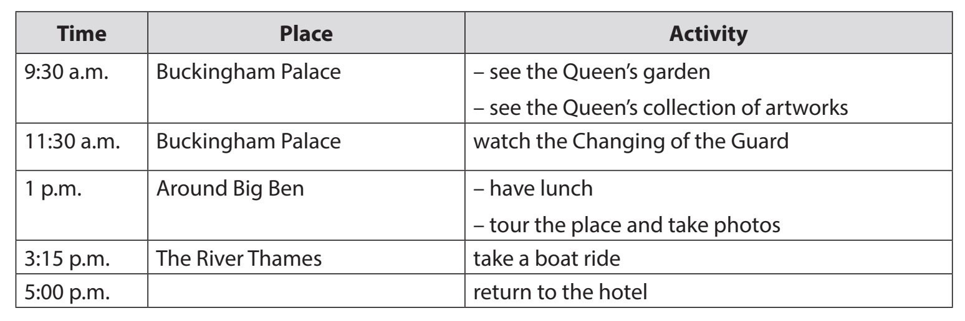 |  | -Teacher asks students to work in pairs, lets them read the table and decide what information they need to complete the table.  -Students do the task within 4-5 minutes.  -Teacher invites some pairs to share their answers with the class  - Teacher gives feedback and provides suggested answers.  
6. WHILE-WRITING (10mins)
E. Activity 5
Aim: To teach students how to write a diary entry about a tour they have taken.

5. Imagine that you took the tour of London. Write a diary entry of about 70 words about your tour, based on the table in 4 or use your imagination. (p. 131)  Suggested answers:  The tour of London began at 9:30 a.m. First, we went to Buckingham Palace. We visited the Queen’s Garden and saw her collection of artworks. At 11:30 a.m. we watched the Changing of the Guard. We then went to Big Ben. We took a lot of photos there. At 3:15 p.m., we took a boat ride on the River Thames. We saw many historic attractions along the river. I enjoyed the tour very much. |  | - Teacher explains to students what a diary entry is: It is a description of what you do during a tour and how you feel about it.  Students refer to the table in 4 for information. They can write about everything or just choose the activities they like most.  Teacher allows students to peer check first.  Teacher goes around to help (if necessary).  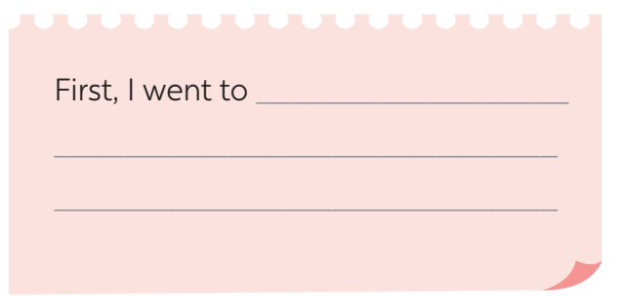
7. Post-Writing And Writing(5 mins)
Aim: To peer check, cross check and final check students’ writing.
Giving peer-reflection & evaluation |  | -Teacher asks students to work in groups of four and swap the entries to their group members.  - Students can give comment to others’ work.  - Students then give comments to each other.  - Teacher then gives feedback as a class discussion.
8. HOMEWORK (3’)
- Rewrite the diary on your notebook.
- Learn all the new words by heart.
- Prepare lesson 7 Unit 12 ( Looking back & project).

Date of planning: 28 / 1 / 2025
Date of teaching: / /

UNIT 12: ENGLISH-SPEAKING COUNTRIES
Period : Lesson 7: LOOKING BACK AND PROJECT
  - I. OBJECTIVES: By the end of this lesson, students will be able to:
1. Knowledge
Review the vocabulary and grammar of Unit 12
Apply what they have learnt (vocabulary and grammar) into practice through a project
2. Competences: - Develop communication skills and creativity
- Develop presentation skill
- Develop critical thinking skill
- Be collaborative and supportive in pair work and team work
- Actively join in class activities
3. Attitude : - Be more creative when doing the project
- Develop self-study skills
II. Teaching and learning resources:
- Grade 7 textbook, Unit 12, Looking back & Project
- Computer connected to the Internet, TV/ Pictures, sachmem.vn
III. Procedures
Contents |  | Teacher’s and students’ activities
1. WARM- UP ( 5’)
Aim:- To revise the vocabulary related to the topic and lead in the next part of the lesson.
Video watching:  How many English-speaking countries are there? What are they?  Answer key:  1. There are 6 English-speaking countries in the video.  2. They are:  - The Philippines  - Australia  - Republic of Ireland  - Canada  - The USA  The UK |  | - Teacher lets students watch a video and ask them the questions:  - How many English-speaking countries are there in the video?  - What are they?  - Students watch the video, note down the names and the number of English-speaking countries.  -Teacher and students discuss the answers.  -Teacher confirms the answers as a class.  Video link: https://ejoy-english.com/go/intl/vi/video/6-english-speaking-countries/60729
2.VOCABULARY ( 15’)
A. Activity 1
-Aim: To help students revise the vocabulary (nouns showing things and places) they have learnt in the unit.
VOCABULARY  1. Look at the pictures and write the correct words or phrases to complete the sentences. (p. 132)  Answer key:  1. island  2. castle  3. boat ride  4. tattoos  5. coastline |  | -Teacher asks students to work in pairs, has students read the sentences and see if they can find the equivalent words illustrated by the pictures.  -Students do the task in pairs.  -Students exchange their answers with their partners.  -Teacher gives feedback as a class discussion.
B. Activity 2
-Aim:
To help students revise more key vocabulary they have learnt in the unit.
2. Choose the best answer A, B, or C to complete each sentence. (p. 132)  Answer key:  1. A  2. B  3. B  4. C  5. A |  | - Teacher asks students to to complete the task individually.  - Students do the task individually complete the sentences.  - Students exchange their textbooks with their partners.  -Teacher gives feedback as a class discussion.
3. GRAMMAR(17’)
C. Activity 3
-Aim:To help students revise the use of articles.
3. Complete the sentences with "a / an" or "the". (p. 132)  Answer key:  1. the – the  2. A – a  3. the – the  4. a – the  5. An – an |  | -Teacher encourages students to complete the task individually.  -Students complete the passage with "a / an" or "the".  - Students exchange their textbooks with their partners.  - Teacher gives feedback as a class discussion.
D. Activity 4
-Aim:To help students recognise mistakes in the use of the articles and correct them.

4. Underline and correct the article mistakes in the sentences below. (p. 132)  Answer key:  1. Ottawa is a capital of Canada. → the  2. He’s the Englishman. He lives in Oxford. → an  3. When people travel, they use an map to find their ways round. → a  4. Can you see a Big Ben from where you are standing? → the  5. Canadians love ice hockey, the winter sport. → a |  | -Teacher asks students to do this exercise in pairs.  - Students read each sentence carefully and discuss to find out which article is incorrect, then correct it.  -Teacher then asks them to check their answers with a partner before discussing the answers as a class.  -Teacher confirms the answers and explains if necessary.
4. PROJECT (5’)
Aim: To guide students how to find information for a poster introducing a place in an English-speaking country

Posters exhibition:  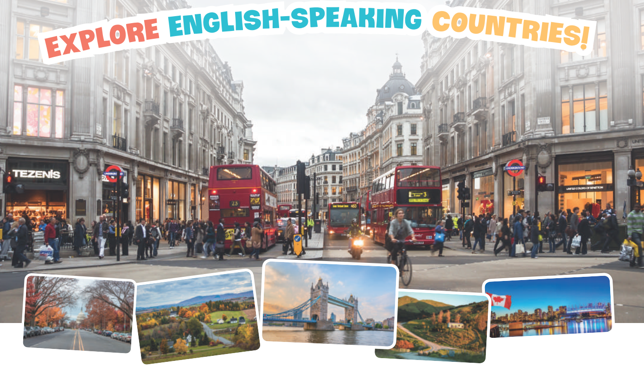 | -Teacher has students work in groups and gives instructions to students as follow:  -Discuss and choose a place in an English-speaking country.  -Find information about it, including:  - its name  - its location  - its attractions  -Students do the project in groups.  -Students vote for the best poster.  -Teacher gives feedback.
5. HOMEWORK (3’)
- Learn all the new words and structures by heart.
- Do exercises 1, 2 P 98 in the workbook.
- Prepare for the Second Term Test.

