LESSON PLAN
Trường THCS Thị Trấn Phú Hòa Giáo viên Nguyễn Thị Thu Loan
Tổ: Tiếng Anh
Date of planning: 1 -3 -2024
Date of Teaching : 2-3-2024 UNIT 9: FESTIVALS AROUND THE WORLD
Period 69 Lesson 1: Getting started – A Tulip Festival
I. Objectives : By the end of the lesson, the students will be able to gain :
- An overview about the topic “Festivals around the world”
- lexical items related to the topic “Festivals”: names of different festivals around the world
1. Knowledge:
a. Grammar :
b. Vocabulary: Vocabulary about names of different festivals around the world
2. Competences:
- Develop communication skills and enhance awareness of preserving the culture
- Be collaborative and supportive in pair work and team work
- Actively join in class activities
3. Attitude: -Help Ss develop self-study skills and know cultures in the world.
II. TEACHING AIDS:
- Grade 7 textbook, Unit 6, Getting started
- Computer connected to the internet,TV/ pictures
- sachmem.vn
III. PROCEDURES:
Contents | Teachers and Students ‘ activities
1. WARM UP (3 minutes)
Aim: To introduce and lead in the topic
CHATTING AND DESCRIBING THE PICTURE  - What can you see in the picture?  - Can you guess the name of the festival?  - Have you ever heard of this festival? If yes, what do you know about it? | -Teacher shows the picture of the Tulip Festival and asks students some related questions:  - Students raise hands to answer the questions.  - Teacher and students discuss the questions.  -Teacher accepts all students’ questions.
2. PRESENTATION
A. ACTIVITY 1 (10 minutes)
Aim : - To provide students with vocabulary
- To help students well-prepared for the listening and reading tasks
VOCABULARY:  - folk dance (n)/ˈfəʊkˌdɑːns/điệu nhảy/ múa dân gian  - costume (n)/ˈkɒstjuːm/ trang phục  - float (n) /fləʊt/ xe diễu hành  - parade (n) /pəˈreɪd/ cuộc diễu hành  -feast (n) /fiːst/ bữa tiệc  - fireworks display (n)/ˈfɑɪəwɜ:rks dɪˈspleɪ/  màn bắn pháo hoa  1. Listen and read. (Ex 1, p. 28) | - Teacher introduces the vocabulary by giving definitions/ examples/ pictures of the words.  - Teacher writes all students’ answers on the board.  - Teacher circles or highlights the following words and discuss the meanings of these words:  Ss : Read Voc  -Teacher checks students’ pronunciation and gives feedback. Teacher reveals that these four words will appear in the reading text and asks students to open their textbook to discover further.  -Teacher can play the audio more than once.  - Students listen and read.  - Teacher can invite some pairs of students to read aloud.  - Tacher checks students’ pronunciation and gives feedback.
3 . PRACTICE
B. ACTIVITY 2 (7 minutes)
Aim : To have students get specific information of the text
2. Read the conversation again. Who did the following activities? Tick the correct column. Tometimes you need to tick both. (Ex 2, p. 93)  - Answer key :  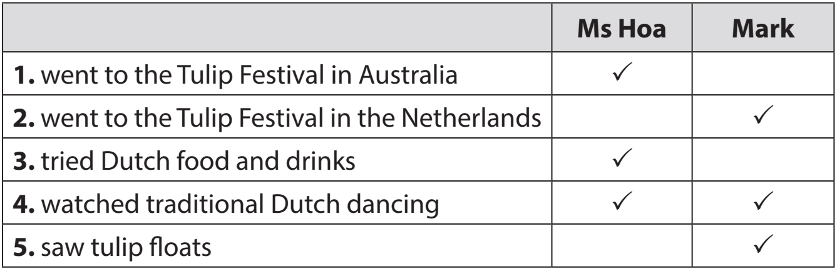 | -Teacher tells students to read the conversation again and work independently to find the answers.  - Students do the task individually.  -Teacher allows students to share their answers before discussing as a class and encourages them to give evidence.  - Teacher calls some students to give the answers and gives feedback.
C. ACTIVITY 3: (7 minutes)
Aim : To introduce some more vocabulary related to the topic festivals.
3. Write a word or phrase from the box under each picture. (Ex 3, p. 93)  Game: Who is faster?  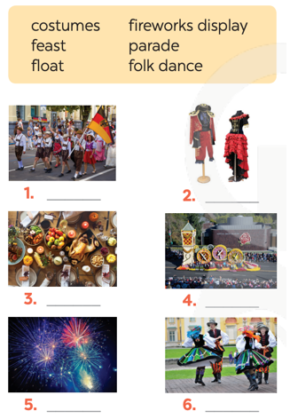  Answer key:  1. parade 2. costumes 3. feast  4. float 5. fireworks display 6. folk dance | - Teacher divides the class into 2 teams. Each team sends a leader to play the game on the board.  - Teacher explains the instructions of the game:  - Teacher gives each team a set of cards with words/phrases from the box.  - The two leaders of the teams come to the board and pin the cards under the correct pictures.  - Who can finish faster with more correct answers will be the winner.  - Students play the games in teams.  -Teacher has students write down the correct answer.  -Teacher confirms the answers and gives feedback. Teacher can ask for translation to check their understanding.
D. ACTIVITY 4 (8 minutes)
Aim: To help Ss practise the words/ phrases in 3
4. Fill in each blank with a word or phrase from 3. You may have to change the form of the word or phrase. (Ex 4, p. 93)  Answer key:  1. folk dances  2. fireworks display  3. feast  4. parades  5. floats; costumes | -Teacher asks students to work individually to complete the task. Remind them to change the form of the words/phrases if needed.  -Students fill in the blanks with the most suitable form of word/ phrase.  -Teacher allows students to share answers before discussing as a class.  -Teacher can ask for translation to check their understanding.
4. PRODUCTION :
F. ACTIVITY 6 (7 minutes)
Aim: To check Ss’ knowledge of some familiar festivals.
Task 5: Quiz. What festival is it? Match each description with a festival (p.93).  Answer key:  1. e 2. a 3. d  4. c 5. b | - Teacher lets Ss work in groups of 4-6.  - Ss work in groups to find the answers.  - Teacher can go around to help weaker students.  - Teacher calls the first group to come up with the answers to share.
5. HOMEWORK : (3 minutes)
Aim: To revise what they have learnt..
- Learn Vocabulary by heart .  - Practing reading the conversation again .  - Write Ex3, 4 page 39 in your notebooks  - Prepare Unit 9 A closer look 1 |  | Teacher guides Ss to prepare homework
*Checking :

Date of planning: 2 -3 -2024
Date of Teaching : 4-3-2024 UNIT 9: FESTIVALS AROUND THE WORLD
- Period 70 : Lesson 2: A closer look 1
I. Objectives : By the end of the lesson, the students will be able to :
- Know types of festivals and festival activities
- Pronounce two-syllable words with correct stress
1. Knowledge:
a. Grammar : Yes / No questions
b. Vocabulary: Vocabulary about names of different festivals around the world
2. Competences:
- Develop communication skills and creativity
- Be collaborative and supportive in pair work and team work
- Actively join in class activities
3. Attitude: Help Ss develop self-study skills and know cultures in the world.
II. TEACHING AIDS:
- Grade 7 textbook, Unit 6, A closer look 1
- Computer connected to the internet, TV/ Pictures/ Cards, sachmem.vn
III. PROCEDURES:
Contents | Teachers and Students ‘ activities
1. WARM UP (5 minutes)
Aim: - To review the previous lesson and activate students’ knowledge.
GAME: HOT SEAT  - Latomatina  - Cheese rolling  - Christmas  - Tet  - 5. Mid- Autumn Festival | - Teacher divides the class into 2 teams. Each team will send a leader to play the game on the board.  - Teacher explains the instructions of the game:  - Each leader stands against the board.  - Teacher shows/ writes the names of the festivals (exercise 5 – page 93).  - Other members from each team describe the festivals and let the leader guess the names of the festivals.  - The team with more correct answers is the winner.  - Students play in teams.  - Students give the correct answers.  - Teacher confirms the answers and gives feedback.
2. PRESENTATION
A. ACTIVITY 1 (7 minutes)
Aim : To introduce the new words.
Vocabulary:  - Cannes Film Festival : /kæn fɪlm festɪvl/ Liên hoan phim Cannes  - Mid-Autumn Festival : /mɪd-ɔːtəm festɪvl/ Tết Trung thu  - Thanksgiving (n) /ˌθæŋksˈɡɪvɪŋ/ Lễ Tạ ơn  - Easter (n) /ˈiːstər/ Lễ Phục sinh  - carve (v) /kɑːv/ chạm, khắc  - perform (v) /pəˈfɔːm/ biểu diễn | -Teacher introduces the vocabulary.  - Teacher introduces the vocabulary by:  - providing the pictures  - providing the definition/ example of the words  -Teacher asks students to repeat.  - Ss reads Voc  -Check Voc : ROR
3. PRACTICE
B. ACTIVITY 2 (7 minutes)
Aim: To present some types of festivals
1. Write under each picture a festival name from the box. (Ex 1, p. 94)  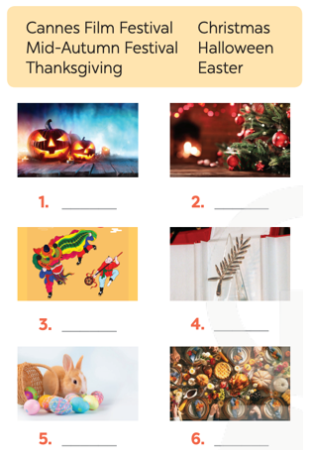  Answer key:  1. Halloween 2. Christmas  3. Mid-Autumn Festival 4. Cannes Film Festival  5. Easter 6. Thanksgiving] | - Teacher has students look at the pictures and asks them if they know the names of the festivals.  -Teacher gets students to do the exercise in individuals.  - Ask them to share their answers in pairs before checking the answers as a class.  - Teacher then encourages students to explain their answers. Correct if necessary.
C. ACTIVITY 3 (7 minutes)
Aim: To present some festival activities
2. Complete the table below with the phrases  * Answer key :  *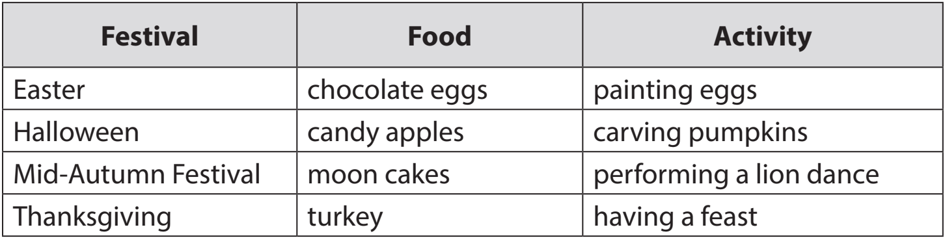 | - Teacher tells Ss that people celebrate festivals with different food and activities.  -Teacher asks them to do the task individually.  -Teacher asks students to share their answers in pairs before checking the answers as a class.  - Teacher then encourages students to explain their answers. Correct if necessary.
4. PRODUCTION
C. ACTIVITY 3 : (5 minutes)
Aim: To give Ss further practice with words related to festivals and festivals activities
3. Fill in each blank with a word or phrase from the box. (Ex 3, p. 94)  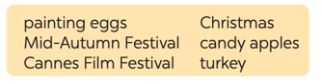  Answer key:  1. Christmas 2. painting eggs  3. candy apples 4. Cannes Film Festival  5. Mid-Autumn Festival 6. turkey | - Teacher asks Ss to work in pairs to complete the sentences with the words/ phrases given.  - Ss work in pairs.  - Teacher allows students to cross check first.  - Teacher invites some pairs to share their answers and gives feedback.
PRONUNCIATION
D. ACTIVITY 4 (6 minutes)
Aim: To help Ss identify how to pronounce two-syllable words with correct stress
4. Listen and repeat. then underline the stressed syllable in each word. (Ex 4, p. 94)  * Answer key ;  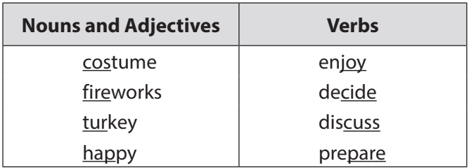 | - Teacher helps Ss to understand what a syllable is. Explain to them that a syllable is a unit of pronunciation having one vowel sound, with or without surrounding consonants, forming the whole part of a word. Give some examples of one-, two- and three-syllable words.  - Have Ss name some more two-syllable words.  -Ss listen and repeat out the words in the table  Teacher allows students to cross check first.  -Teacher lets Ss share their answer and gives feedback. Ask Ss if they recognize any rules related to stress in two-syllable words. Share with them the most common rules.
E. ACTIVITY 5 (5 minutes)
Aim: To help Ss pronounce two-syllable words with correct stress in sentences.
5. Listen and repeat the sentences. underline the stressed syllables in the bold words. (Ex 5, p. 94)  1. We are going to attend an Easter party at Ncik’s house .  2. The dancers will perform traditional dances at the festival .  3. At Christmas , people usuaslly buy presents for theit family .  4. Did you go to Da lat flower festival with your parents ?  5. My Aunt is clever and patient . | -Teacher has Ss read the sentences quickly and plays the recording. Ask them to pay attention to the bold words and underline the stressed syllables.  - Students practice in pairs or in groups.  - Teacher goes around offering help or correcting pronunciation, if necessary.  - Teacher calls some students to say the sentences in front of the class. Check their pronunciation if necessary.
5. HOMEWORK (3 minutes)
Aim: To review the vocabulary in this lesson.
-Learn Vocabulary by heart .  - Redo exercises 2, 3 in notebooks  - Practice Pronounce two-syllable words with correct stress in sentences.  - Do Exercises A1,2 and B 2,3,4 in workbooks  - Prepare Unit 9 A closer look 2 |  | Teacher guides Ss to prepare homework

*Checking :

Date of planning:4 / 3 / 2024

Date of teaching: 6/ 3/ 2024 UNIT 9: FESTIVALS AROUND THE WORLD

Period 71 : Lesson 3 : Acloser look2
I. Objectives : By the end of the lesson, the students will be able to practice Yes/No questions
1. Knowledge:
a. Grammar : Yes/No questions
b. Vocabulary: Review Voc
2. Competences:
- Develop communication skills
- Be collaborative and supportive in pair work and team work
- Actively join in class activities
3. Attitude: Help Ss develop self-study skills.
II. TEACHING AIDS:
- Grade 7 textbook, Unit 6, A closer look 2, Computer connected to the Internet, TV,sets of word cards, sachmem.vn
III. PROCEDURES:
Contents | Teachers and Students ‘ activities
1. WARM UP (5 minutes)
Aim: To activate students’ prior knowledge related to the targeted grammar: Yes/No questions
GAME: SENTENCE PUZZLING  1. you / cakes / moon / Are / eating ?  2. eat / they / moon / cakes / the / at /festival / Did / last year / ?  3. She / Does / often / Moon / join / Festival / in ?  4. he / can / moon / cakes / eat ?  *Answers :  1.Are you eating moon cakes?  2. Did they eat moon cakes at the festival last year?  3. Does she often join in Moon Festival ?  4. Can he eat all these mooncakes? | - Teacher divides the class into 4 groups.  - Teacher delivers different sets of word cards to each group.  - Each group has to arrange the word cards to make meaningful sentences.  - 1 point for each correct answer.  -Students play the game in groups.  -Teacher and students discuss the answers.  -Teacher confirms the answers and gives feedback.
2. PRESENTATION
A. ACTIVITY 1 (5 minutes)
Aim : To have students get to know about the Yes/No questions.
*GRAMMAR :  Yes/No questions  We use the auxiliary verb or modal verb before the subject.  Examples:  - Are you tired?  - Did you get many Christmas presents?  - Can you eat all the cakes? | -Teacher asks students to study the Grammar box.  - Teacher draws students’ attention to the use and how to form a Yes/No question with an auxiliary verb or with a modal verb.  -Teacher then asks some more able students to give some more examples.  -Teacher and students discuss the answers.  -Teacher confirms the answers and gives feedback
3. PRACTICE
B. ACTIVITY 2 (7 minutes)
Aim: To check students’ understanding of the Yes/No questions
1. Fill in each blank with a correct auxiliary verb or modal verb. (Ex 1, p. 95)  Answer key:  1. Do  2. Did  3. Are  4. Can  5. Does | - Teacher has students work individually.  -Students work individually to complete the sentences.  - Teacher lets students work in pairs and exchange the answers before checking with the whole class (explain each sentence if necessary).  - Teacher confirms the answers and gives feedback
C. ACTIVITY 3 : (7 minutes)
Aim: To help Ss practise making Yes/No questions.
2. Change the sentences into yes / no questions. (Ex 2, p. 95)2. However  Answer key:  1. Can your mother make a costume for you?  2. Will she bake a birthday cake for him?  3. Are the dragon dances interesting?  4. Does the Rio Carnival take place every year in Brazil?  5. Did they see a fireworks display on New Year’s Eve? | -Teacher has students work individually.  -Students work individually to complete the sentences.  - Teacher lets students work in pairs and exchange the answers before checking with the whole class (explain each sentence if necessary).  - Teacher confirms the answers and gives feedback.
D. ACTIVITY 4 : (3 minutes)
Aim: To give further practice with Yes/No questions
3. Match the questions in column A with their answers in column B. (Ex 3, p. 95)  Answer key:  1. c  2. a  3. a  4. b  5. d | -Teacher asks students to read the instruction.  -Teacher asks students to do the exercise individually and match the questions in column A with the answers in column B.  - Teacher then has them work in pairs, comparing their sentences. Teacher can go around to help students.  -Teacher confirms the answers and gives feedback.
E. ACTIVITY 5 (6minutes)
Aim: To give further practice with Yes/No questions
4. Mark is talking to trang about the mid-autumn festival. Fill in the blanks with trang’s answers below. (Ex 4, p. 95, 96)  Game: Who is faster?  Answer key:  1. b  2. e  3. a  4. c  5. d | -Teacher divides the class into 2 teams. Each team will send a leader to play the game on the board.  - Teacher explains the instructions of the game:  - Teacher gives each team a set of cards with phrases from the box.  - The two leaders of the teams come to the board and pin the cards under the correct number.  - Who can finish faster with the correct answer will be the winner.  - Students play the games in team mode.  -Teacher has students write down the correct answer.  -Teacher confirms the answers and gives feedback. Teacher can ask for translation to check their understanding.
4. PRODUCTION :
F. ACTIVITY 6 (5 minutes)
Aim: To help Ss practise producing Yes/No questions
5. Game. Festival mystery.  work in groups. One student thinks of a festival he/she likes. Other students ask yes/no questions to find out what the festival is. (Ex 5, p. 96)  Example:  A: Do many countries celebrate the festival?  B: Yes, they do.  A: Do children like the festival?  B: Do they paint eggs?  A: Yes, they do.  C: Is it Easter?  B: Yes, it is. | - Teacher has students work in groups.  -One student thinks of a festival that he/ she likes. Other students ask Yes / No questions to find out what the festival is.  The group leader keeps a record of the group’s performance.  - Teacher moves around to observe and pays attention to Ss’ yes / no questions.  -Teacher asks some groups to perform in front of the class, confirms the answers and gives feedback.
5. CONSOLIDATION :
G. ACTIVITY 7 (4 minutes)
Aim: To consolidate what students have learnt in the lesson
 | Teacher asks students to talk about what they have learnt in the lesson.
6. HOMEWORK : (3minutes)
Aim: Reactivate the knowledge that students have gained..
- Learn Yes / No questions  - Do exercise 4,5 ( workbooks )  - Prepare Unit 9 Communication | Teacher guides Ss to prepare homework
- Checking :

Date of planning: 4 -3 -2024
Date of teaching: 6-3 -2024 UNIT 9: FESTIVALS AROUND THE WORLD
Period : 72 Lesson 4 : COMMUNICATION

I. Objectives : By the end of the lesson, the students will be able to:
- Express disappointment
- Understand the concept of festival symbols and their meanings
- Talk about the concept of festival symbols and their meanings
1. Knowledge:
a. Grammar : structures to express disappointment
b. Vocabulary: revise vocabulary on types of festivals and festival activities
2. Competences:
- Develop communication skills
- Be collaborative and supportive in pair work and team work
- Actively join in class activities
3. Attitude:
-Help Ss respect festival symbols and develop self- study skills .
II. TEACHING AIDS:
- Grade 7 textbook, Unit 6, Communication, computer connected to the internet , TV/ Pictures/
- sachmem.vn
III. PROCEDURES:
Contents | Teachers and Students ‘ activities
1. WARM UP (3 minutes)
Aim: To activate students’ knowledge and interest
GAME: NAME THE FESTIVALS | - Teacher divides the class into 2 teams. Teacher shows pictures of some festivals on the slides.  - Ss give the correct names of the festivals as fast as possible. The one with more correct answers is the winner.  - Students work in team mode.  -Teacher checks and gives feedback.
2. PRESENTATION
A. ACTIVITY 1 (7 minutes)
Aim : To help students get to know the ways to express disappointment

EVERYDAY ENGLISH  1. Listen and read the conversation. Pay attention to the highlighted sentences. (Ex 1, p. 96)  Expressing disappointment  * It was disappointing!  * It was a big disappointment.  Other expressions:  * That’s too bad! * What a disaster!  * That’s so disappointing! | -Teacher lets students listen to the examples in Ex 1 in the book.  - Teacher draws their attention to the form of ways to express  disappointment.  - Teacher and students discuss the form of ways to express disappointment and give some other expressions.  - Teacher confirms the answers and gives feedback.
3. PRACTICE
B. ACTIVITY 2 (5 minutes)
Aim: To help students practise the ways to express disappointment
2. Work in groups. Make a similar conversation for each situation below. (Ex 2, p. 96) | -Teacher has students work in groups to discuss and make similar conversation for each situation.  - Students work in groups to discuss.  - Teacher then asks students to exchange their answers among the class.  - Teacher moves around to observe, provides help and gives feedback.
C. ACTIVITY 3 : (7 minutes)
Aim: - To help Ss understand the concept of festival symbols
- To provide Ss with some Christmas symbols and their meanings.
3. Listen to mark talking about festival symbols. Fill in each blank with one word. (Ex 3, p.96)  Answer key:  1. think  2. meaning  3. life  4. happiness | -Teacher asks Ss what they think of when they talk about Christmas, i.e Christmas symbols. Elicit answers from students.  Have Ss read the sentences given. Ask them to predict what word to use to fill in each blank. Write their answers on the board.  - Students work individually. Then listen to the recording and check the answers.  - Teacher invites some Ss to share their answers.  - Teacher gives feedback and correction (if needed).
E. ACTIVITY 4 (5 minutes)
Aim : To help Ss understand the symbols and meanings of other festival
4. Work in pairs. Match each festival with its symbol and meaning. (EX 4, p. 97)  Answer key:  1. C - b  2. A - c  3. D - a  4. B - d | - Teacher introduces some new words if necessary (prosperity, reunion).  - Ss works in pairs to finish the task.  -Teacher allows the student to cross check first.  -Teacher confirms the answers and gives feedback.
4. PRODUCTION :
F. ACTIVITY 6 (5 minutes)
Aim: To let students practise talking about festival symbols and their meanings
5. Work in groups. Choose a festival and talk about its symbol(s) and meaning. (Ex 5, p. 97)  Example : When we talk about Christmas , we think of the Christmas tree. It is the symbol of a long life . | - Teacher lets students group up and spend 5 minutes on taking notes of a festival.  - Students work in groups.  - All group members choose a festival and talk about its symbols and meanings.  -Teacher moves around to observe and offers help if needed.  -Teacher invites some students to talk about festival symbols and their meanings.  - Students share their group’s answers.  -Teacher allows students to cross check first.
5. HOMEWORK : (3 minutes)
Aim: Reactivate the knowledge that students have gained.
- Practice reading EX1,2 ( p. 96 )  - Do Exercises B1,2 ( work books )  - Prepare Unit 9 skills1 | Teacher guides Ss to prepare homework
- Checking :

Date of planning: 14 -3 - 2024
Date of teaching: 16-3 -2024 UNIT 9: FESTIVALS AROUND THE WORLD

Period 73 Lesson 6: SKILLS 1
I. Objectives : By the end of the lesson, the students will be able to:
- read about an unusual festival
- talk about a festival they enjoy
1. Knowledge:
a. Grammar : shoud / shouldn’t
b. Vocabulary: Vocabulary about traffic rules
2. Competences:
- Develop communication skills and creativity
- Be collaborative and supportive in pair work and team work
- Actively join in class activities
3. Attitude: - Help Ss develop sefl – study skills
II. TEACHING AIDS:
- Grade 7 textbook, Unit 6, Skills 1, computer connected to the internet , TV
- sachmem.vn
III. PROCEDURES:
Contents | Teachers and Students ‘ activities
1. WARM UP (3 minutes)
Aim: To introduce the topic of reading
To enhance students’ skills of cooperating with team mates
GAME: WHO IS FASTER? | -Teacher divides the class into 2 teams.  - Each team has to run in a relay to the board to write the correct types of festivals and their symbols and meaning under the posters.  - The team with more correct answers will be the winner.  -Students play the game in team mode.  Teacher and students discuss the answers.  - Teacher confirms the answers and gives feedback.
READING
2. ACTIVITY 1 : PRE-READING (7 minutes)
Aim : To lead in the reading skills
To provide students with some lexical items before reading the text
1. Work in pairs. Look at the pictures. Which events do you think happen at the twins day festival? (Ex 1, p. 97)  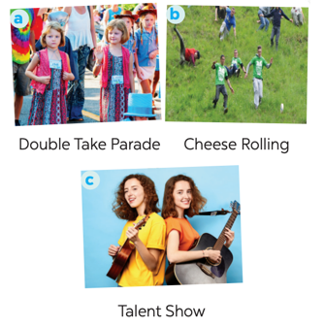  Vocabulary  1. join (v) tham gia  2. feature (v) /ˈfiːtʃər/ trình diễn đặc biệt  3. performance (n) /pəˈfɔːməns/ màn biểu diễn | -Teacher has students work in pairs, look at the pictures in the book. Ask Ss to discuss what/ who they see in the pictures and answer the questions.  -Students work in pairs.  -Teacher and students discuss the questions and answers.  - Teacher accepts all students’ questions and answers  -Teacher introduces the vocabulary.  - Teacher asks students to get the meaning in context and try to make up sentences with of the following words:  - Teacher and students discuss the answers.  -Ss : Read Voc  - Teacher confirms the student's answers and checks their pronunciation and gives feedback.
3. WHILE-READING
B. ACTIVITY 2 (7 minutes)
Aim: To develop the skill of guessing the meanings of new words in context
2. Match each word from the email in 1 with its meaning. (Ex 2, p. 98)  Answer key:  1. b  2. d  3. a  4. c | -Teacher has Ss Read the words in the left column.  + Locate each word in the text.  + Read around the word to get the general meaning.  + Read the definitions in the right column, find the suitable meaning to match each word.  Ask Ss to repeat the steps (they can speak in Vietnamese).  - Students read the text and do the task in individuals.  -Teacher allows students to share their answers before discussing as a class and encourages them to give evidence.
C. ACTIVITY 3 : (7 minutes)
Aim: To develop reading skill for specific information (scanning)
3. Read the email again. Complete each sentence with no more than two words. (Ex 3, p. 98)  Answer key:  1. first weekend  2. (different) countries  3. walked together  4. performance  5. Fun Run  6. exciting | -Teacher can set a longer time limit for students to read the text again and complete the sentences.  Briefly tell them the steps: read the sentences – underline key words – locate the key words in the text – find the words to complete the sentences.  - Teacher asks students to work in individuals and find the answer.  -Teacher allows students to share their answers before discussing as a class and encourages them to give evidence.  - Teacher calls a student to write his/ her answer on the board, then checks sentence by sentence with the class.
4. PRE- SPEAKING :
E. ACTIVITY 4 (6 minutes)
Aim: - To help students identify how to ask and answer about a festival they
4. Match the questions and answer about a festival someone joined. (ex 4, p. 98)  . Answer key:  1. d 2. B 3. e  4. c 5. a | - Teacher tells Ss they are going to ask and answer about a festival they attended and that this activity can serve as a model for them to follow in the writing task.  - Teacher asks students to work individually and then check in pairs.  - Teacher can go around to help weaker students.  -Teacher calls on some pairs to give the answers and check as the whole class.
6 . WHILE-SPEAKING :
F. ACTIVITY 5 (7 minutes)
Aim: To give Ss practice in asking and answering about a festival Ss attended
5. Work in pairs. Ask and answer about a festival you and your friend joined, using the questions in 4 as cues. Tell the class about the festival your partner joined  What festival did you join?  - I joined Mid-Autumn Festival.  - Where and when did you join it?  - I joined the festival in the middle of the eighth lunar month in my hometown.  - Why do people celebrate it?  - It’s a chance for people to gather.  - What did you do there?  - I watched lion dances and ate moon cakes.  - Did you like the festival? Why or why not?  - Yes, I liked the festival much because it was funny and meaningful. | -Teacher has students work in pairs, ask and answer about a festival they attended.  - Students work in pairs to do the task.  - Teacher goes around to help students.  - After finishing, teacher can call some pairs to give presentations in front of the class.
7. POST-READING AND SPEAKING
G . ACTIVITY 6 : (5 minutes)
Aim : - To help students present Ex5 they did
- Teacher allows students to give comments for their friends and vote for the most interesting dialogue.
-Students give comments for their friends and vote for the most interesting dialogue.
- Teacher and students discuss.
- Teacher gives feed-back and comments.
5. HOMEWORK : (3 minutes)
Aim: To revise what they have learnt..
- Learn Vocabulary by heart  - Rewrite Ex5 ( page 98) . ( speaking )  - Do EX C 3 ( workbooks )  - Prepare Unit 9 Skills 2 | Teacher guides Ss to prepare homework

Date of planning: 12 -3 -2024

Date of teaching: 13-3 -2024 UNIT 9: FESTIVALS AROUND THE WORLD
Period 74 Lesson 6: SKILLS 2

I. Objectives : By the end of the lesson, the students will be able to:
- Listen for special information about a festival
- Write an email to describe a festival
1. Knowledge:
a. Grammar : Review
b. Vocabulary: Vocabulary about festivals
2. Competences:
- Develop communication skills
- Be collaborative and supportive in pair work and team work
- Actively join in class activities
3. Attitude: Help Ss develop sefl- study skills
II. TEACHING AIDS:
- Grade 7 textbook, Unit 6, Skills 2, computer connected to the internet
- sachmem.vn
III. PROCEDURES:
Contents | Teachers and Students ‘ activities
1. WARM UP (3 minutes)
Aim: To warm up and get Ss’ interest
* CHATTING : CHECK OLD LESSON  What festival did you join?  - Where and when did you join it?  Why do people celebrate it?  What did you do there? | -Teacher asks some questions about Festival Ss learnt last lesson  - Students answer the questions  - Teacher corrects mistakes
2. PRE-LISTENING:
A. ACTIVITY 1 : (7 minutes)
Aim : To prepare Ss for the listening text
1. lLook at the animal. Discuss the questions with a partner. (Ex 1, p. 99)  1. What is it?  2. What festival is it a part of?  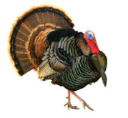 | -Teacher asks students to work in pairs, read the questions and answer.  -Students quickly discuss with a partner.  -Teacher allows Ss to cross check.  -Teacher calls some Ss to give their answer on the board and elicits their answers.
3. WHILE-LISTENING
B. ACTIVITY 2 (7 minutes)
Aim: To help Ss check their answers in Task 1
2. Listen to mark talking about how his family celebrates a festival. Check your answers. (Ex 2, p. 99)  Answer key:  1. A turkey  2. Thanksgiving | -Teacher tells Ss what they are going to listen to and plays the recording.  - Students listen and check their answers.  -Teacher allows students to peer check first.  -Teacher confirms the answers and gives feedback.
C. ACTIVITY 3 : (7 minutes)
Aim: To help students develop listening skills for specific information
3. Listening again and decide whether the following statements are true or false. (Ex 3, p. 99)  Answer key:  1. F 2. F 3. T  4. F 5. T 6. T | -Teacher asks students to read through the statements, have a guess before they listen to the recording the second time and write their guesses on the board.  - Teacher plays the recording again. Ask students to listen and choose the correct answer.  - Teacher lets students peer-check with a partner.  - Teacher calls some students to give the answers to the class and correct the mistakes where necessary, encourages students to correct the false statements.
3. POST- LISTENING / PRE- WRITING
D. ACTIVITY4 : (7 minutes)
Aim: To brainstorm ideas and make an outline for Ss’ writing
4. Think about a festival that your family usually celebrates. Fill in the blanks with your answers. (Ex 4, p. 99)  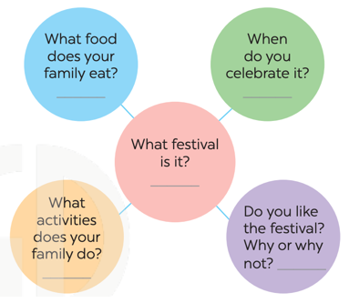 | - Teacher asks students to work individually to complete the mind map.  - Students decide on their festival.  -Teacher goes around and helps if needed.  - Teacher calls some Ss to give their answer (if time allows) and gives feedback.
4. WHILE-WRITING
E. ACTIVITY 5 : (4 minutes)
Aim: To practise how to write a paragraph about a festival
5. Write an email of about 70 words to tell mark about the festival. Use the notes in 4. (Ex 5, p. 99) | - Teacher shows a model of a short paragraph about a festival (T may use the audio script or reading passage on page 97). Then recalls students’ knowledge on the structure of an email.  -T has Ss write their email in individuals based on the information in 4.  - Teacher allows students to cross check first.  - Teacher gives feedback.
6. POST- WRITING
G. ACTIVITY 7 (7 minutes)
Aim: To peer check, cross check and final check students’ writing.
Suggested answers:  Dear Mark,  How are you? I’m going to tell you about Mid Autumn Festival. It takes place in the middle of the eighth lunar month. My family and I often eat moon cakes, autumn fruits and watch lion dances. I like the festival very much because it was funny and meaningful.  I hope one day you can join the festival with us.  Cheers,  Linh | - Teacher asks students to read their “production”.  - Students listen to each other’s work.  - Students then give comments to each other.  -Teacher then gives feedback as a class discussion
5. HOMEWORK : (3 minutes)
Aim: To allow students finalize their passage after being checked by friends and the teacher.
- Write a passage in the notebooks and hand in the teacher the next period  -Prepare Unit 9 Looking back | Teacher guides Ss to prepare homework  .

- Checking :

Date of planning: 13 -3 -2024
Date of teaching: 14-3 -2024 UNIT 9: FESTIVALS AROUND THE WORLD
Period 75 Lesson 7 : LOOKING BACK & Project
I. Objectives : By the end of the lesson, the students will be able to:
Review the vocabulary and grammar of Unit 9
Apply what they have learnt (vocabulary and grammar) into practice through a project
1. Knowledge:
a. Grammar : Yes / No questions
b. Vocabulary: Vocabulary about types of festivals and festive activities
2. Competences:
- Develop communication skills
- Develop presentation skill and critical thinking skill
- Be collaborative and supportive in pair work and team work
- Actively join in class activities
3. Attitude:
- Help Ss Be more creative when doing the project
- Develop self-study skills
II. TEACHING AIDS:
- Grade 7 textbook, Unit 6, Looking back & Project
- Computer connected to the Internet, TV/ Pictures, sachmem.vn
III. PROCEDURES:
Contents | Teachers and Students ‘ activities
1. WARM UP (3 minutes)
Aim: - To review the vocabulary related to the topic and lead in the next part of the lesson
- To enhance students’ skills of cooperating with team mates
Brainstorming  Types of Festivals | -Teacher divides the board, and divides the class into 2 teams.  - Members of each team take turns and write as many types of festivals as possible in 2 minutes.  -Students cross check their answers first.  - Teacher confirms the answers and gives feedback. The group having more correct answers is the winner.
2. PRACTICE :
A. ACTIVITY 1 (7 minutes)
Aim : To help students review vocabulary items they have learnt in the Un
1. Circle the correct words or phrases in brackets. (Ex 1, p. 100)  Answer key:  1. fireworks  2. Cannes Film Festival  3. painting  4. candy apples  5. Thanksgiving | -Teacher encourages students to complete the task individually.  - Students do the task individually.  - Students exchange their textbooks with their partners.  - Teacher gives feedback as a class discussion.
B. ACTIVITY 2 (7 minutes)
Aim: To help students review vocabulary items they have learnt in the Unit
2. Complete each sentence by filling in the blank with a word or phrase in the box. (Ex 2, p. 100)  Answer key:  1. lion dances 2. floats  3. costumes 4. Bunny  5. gathering | - Teacher encourages students to complete the task individually.  - Students do the task individually.  -Students exchange their textbooks with their partners.  -Teacher gives feedback as a class discussion.
C. ACTIVITY 3: (7 minutes)
Aim: To help students review Yes / No questions
GRAMMAR  3. Choose the correct question A or B. (Ex 3, p. 100)  Answer key:  1. A 2. B 3. A  4. B 5. B | -Teacher encourages students to complete the task individually.  - Students do the task individually.  - Students exchange their textbooks with their partners.  - Teacher calls some Ss to read aloud their answers and gives feedback
D. ACTIVITY 4: (6 minutes)
Aim: To help students review Yes/No questions.
4. Answer the following questions about yourself. (Ex 4, p. 100 | - Teacher encourages students to complete the task individually.  - Students do the task individually.  - Students share their answers in groups.  -Teacher calls some Ss to read aloud their answers and gives feedback
3. PRODUCTION : PROJECT
E. ACTIVITY 1 (7 minutes)
Aim: To allow students to apply what they have learnt (vocabulary and grammar) into practice through a project
Posters exhibition:  1. Think of a new festival that you would like to celebrate. Disucss the following points :  Suggested answer :  - Name of the festival: Lipsticks festival  - Time and place of the festival: every August in France  - Festival activities: people loving lipsticks gather and exchange theirs  2. Organise them into an exhibition.  3. Vote for the best poster. | -Teacher has students work in groups as divided in Lesson 1 and gives instructions to students as follow:  1. Review about the festival they have prepared at home.  2. Discuss and finalize in groups.  3. Tell the class about the festival.  - Ss work in groups to do the task.  - Teacher calls some groups to present their signs to the class.  -Teacher listens and confirms.
4. CONSOLIDATION : (5 minutes)
Aim : To consolidate what students have learnt in the lesson.
 | Teacher asks students to talk about what they have learnt in the lesson.
5. HOMEWORK : (3 minutes)
Aim: To revise what they have learnt..
- Learn the grammar notes by heart  - Do Exercises in workbook .  - Prepare Review 3 | Teacher guides Ss to prepare homework
*Checking :

