LESSON PLAN
Trường THCS Giáo viên :Nguyen Thi Thu Loan
Tổ: Tiếng Anh
Date of planning: 22-10-20
Date of teaching:
UNIT 5: FOOD AND DRINK
Period 35 Lesson 1: Getting started – At a Vietnamese restaurant

I. Objectives : By the end of this lesson, Ss will be able to gain:
1. Knowledge
- An overview about the topic Food and Drink
- Vocabulary to talk about food and drink
2. Competences
- Develop communication skills and cultural awareness
- Be collaborative and supportive in pair work and teamwork
- Actively join in class activities
3. Attitude
- Develop healthy eating habits and awareness of balanced diets
- Be proud of the homeland
II. TEACHING AIDS:
- Grade 7 textbook, Unit 5, Getting started
- Computer connected to the internet,TV/ pictures
- sachmem.vn
III. PROCEDURES:

1 –WARM UP (5mins)
- Aims: To activate students’ knowledge on the topic of the unit
To enhance students’ skills of cooperating with teammates
Contents | Teacher’s and students’ activities
Game: Brainstorming  Tell about some Vietnamese food and drink you know  - Suggested answer  Chicken, soup, noodles, egg, bread, water, orange juice, lemonade.. | -Teacher gives instructions  -Groupwork  - check their answers
2-PRESENTATION (10mins)
A. ACTIVITY 1
-Aim - To get students interested in the topic
Contents |  |  |  | Teacher’s and students’ activities
UNIT 5: FOOD AND DRINK  Period ......Lesson 1: Getting started – At a Vietnamese restaurant  * Vocabulary  - roast (v) /rəʊst/: quay, nướng (thịt…)  - 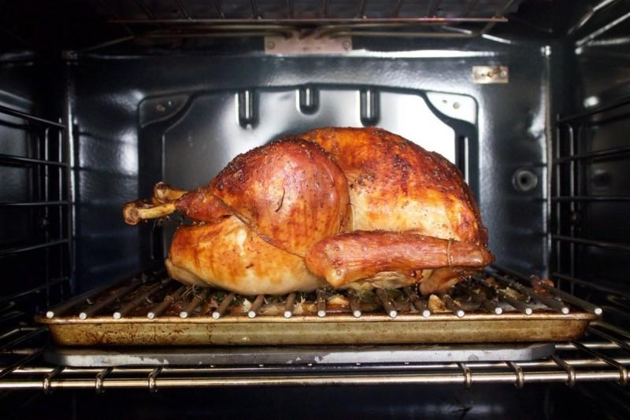  - fry (v) /fraɪ/: rán  - 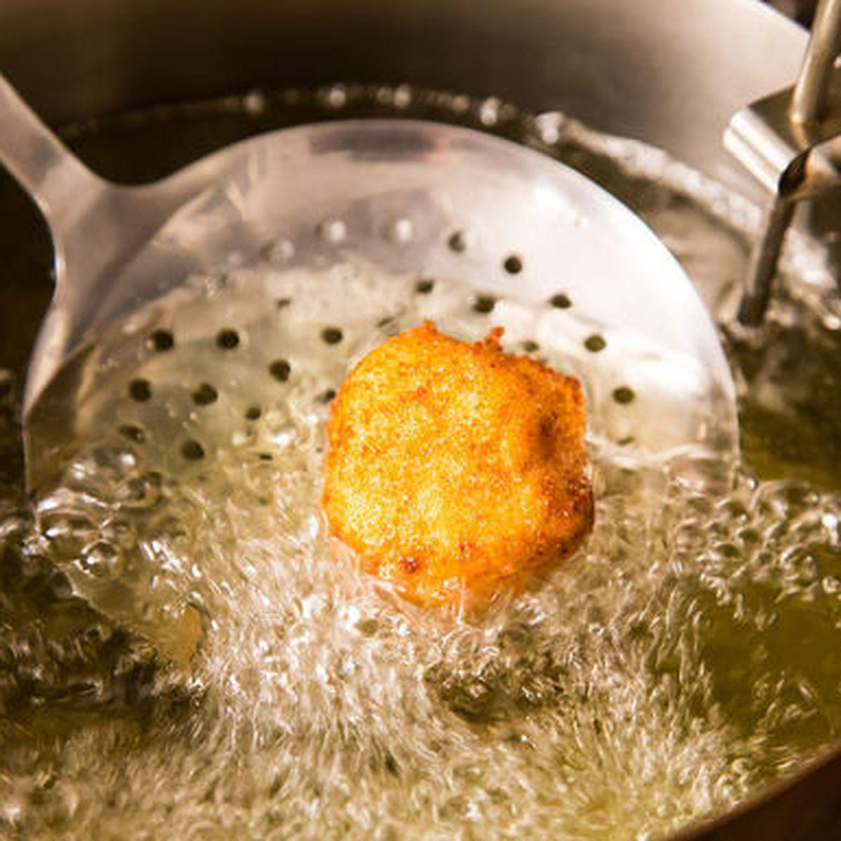  - shrimp (n) /ʃrɪmp/: con tôm  - 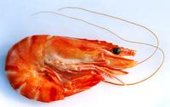  - lemonade (n) /ˌleməˈneɪd/: nước chanh  - 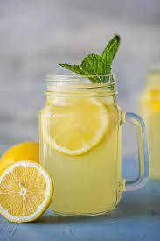  - mineral (adj) /ˈmɪnərəl/: khoáng chất |  |  |  | -T asks Ss to look at the photos and answer the question: What is this?  -Ss say the words.  - Other Ss correct if the previous answers are incorrect.  -Teacher shows and says the words aloud and asks Ss to repeat them.  -Teacher asks Ss to translate the word “khoáng chất” into English  -Ss says the word  - Teacher gives the correct answer "mineral”
B. ACTIVITY 2
-Aim: set the context and help Ss understand the main idea of the text
Answer the questions . (Ex 2, p.51)  + What do your family usually eat for dinner?  + Where does Mark's family eat dinner?  What is Mark's family doing?  A. Ordering food for dinner.  B. Preparing for their dinner.  C. Talking about their favourite food.  Suggested answer :C |  |  |  | - Teacher asks Ss to look at the picture (p.50-51) and answer the questions:    - Ss ask and answer questions in pairs.  - Ss share their answers as a whole class.  - T asks them to read and listen to the conversation and check their answers.
3 –PRACTICE (20 mins)
A. Activity 3
-Aim: To practise reading and listening for specific information
Contents |  |  | Teacher’s and students’ activities
3: Find the words and phrases about food and drink inthe conversation and write them in the correct columns. (Ex 3, p.51)  Key:  Food Drink  rice, pork, fish sauce, roast chicken, fried vegetables, fried tofu, spring rolls, canh (soup), shrimp, fish, juice, lemonade, green tea, mineral water, winter melon juice, |  |  | - Teacher asks Ss to work individually to read and listen to the conversation and find the words and phrases and then share their answers with their partners who sit next to them.  -Ss do exercise 3 individually  - Ss share and discuss with their partners to write all words/ phrases down on the notebooks.  -Teacher corrects their answers as a class.
B. Activity 4
-Aim: To practise scanning, and develop Ss' vocabulary for food and drink
4: Read the conversation again and tick (✓) T OR F . (Ex 4, p.51)  Answer key:  1. T  2. F (Mark wants some fried tofu and spring rolls.)  3. F (Mark's dad thinks they will try some canh)  4. T  5. F (Mineral water for me, green tea for my husband, and juice for my children) |  |  | -Teacher gives clear instructions.  - Ss work individually step by step:  - Read the statements carefully and underline key words  Suggested keywords in the statements:  1. Mark's family is at a Vietnamese restaurant.  2. Mark wants fried tofu and beef for dinner.  3. They don't order canh.  4. Mark's mum wants mineral water.  5. His mum doesn't allow her children to drink juice during dinner.  - Scan the conversation to locate the underlined key words  - Read intensively to tick True or False  -Teacher nominates Ss to read the statements aloud and say which ones are True and False, the others attentively listen to and correct their answers if necessary.  - Teacher checks and gives the correct answers.
4. PRODUCTION (7 mins)
- Objectives: - To help Ss be able to talk about favourite food and drink, develop teamwork skills
and give students authentic practice in using target language
Contents |  | Teacher’s and students’ activities
5: Work in pair. Think about your favorite food and drink. Then ask your partner about his or her favorite food and drink. . (Ex 5, p.51)  What kinds of food are the most popular?  What ingredients are there?  What is the food like? …  - Vocabulary of Food and Drink  - Reading for specific information and details |  | -Teacher gives Ss clear instructions in order to make sure Ss can role-play effectively.  - Teacher divides Ss into 2 main groups and call them Vietnamese tour guides and French visitors who visit Vietnam for the first time.  - Teacher pairs each tour guide with a French visitor and ask them to role play talking about the most favourite food in Viet Nam.  - T observes Ss while they are role playing, note their language errors  - Teacher gives Ss feedback.  -Teacher asks students to talk about what they have learnt in the lesson:
5: HOMEWORK (3 minutes)
- Talk about your favourite food (for a minute), Learn vocabulary by heart.
- Reread the dialogue , redo exercises.p.51
- Do exercises 2p 35, 1,2 p 36 in the workbook
- Prepare unit 5: A closer look 1.

Date of planning:25-11-2023
Date of teaching: 27-11-2023
UNIT 5: FOOD AND DRINK
Period 36 LESSON 2 : A CLOSER LOOK 1

  - I. OBJECTIVES: By the end of this lesson, students will be able to:
1. Knowledge
- Use the lexical items related to the topic Food and Drink
- Know how to use the measurement words and phrases often used with food and drink
- Pronounce the sounds /ɒ/ and /ɔ:/ correctly
2. Competences
- Be collaborative and supportive in pair work and team work
- Access and consolidate information from a variety of sources
- Actively join in class activities
3. Attitude:
- Promote pride in the values ​​of Vietnamese culture
- Develop love for family
II. Teaching and learning resources:
- Grade 7 textbook, Unit 5, A closer look 1
- Computer connected to the internet, TV/ Pictures/ Cards, sachmem.vn
III. Procedures:
1 –WARM UP (5mins)
Objectives: - To set in the context of using the lexical items and measurement words/ phrases related to the topic Food and Drink, activate students’ knowledge and get students interested in the topic
Contents | Teacher’s and students’ activities
1. lemon, grapefruit, grape, lime  2. fridge, cooker, microwave, toaster  3. cow, chicken, sheep, fish  4. bacon, egg, tomato, toast  5. rice, wheat, potato, pasta  6. bread, cake, pie, pizza | - Teacher puts Ss in small groups, explains that they are going to dictate five sets of four words, such as pea, orange, potato, onion. Teacher gives Ss some time to choose an odd one out for each set. More than one answer is possible.  -Ss listen and write the set. Then they choose the odd one out and circle it.  -Each group explains their decisions,  e.g. A pea, because it's the only one that's green. / An orange, because it makes terrible soup.  -T may create his / her own lists or choose from the list below:
2. PRESENTATION (8 mins)
A. VOCABULARY
Aim: -To revise and help Ss understand the measurement words and phrases often used with food and drink
Contents | Teacher’s and students’ activities
UNIT 5: FOOD AND DRINK  LESSON 2 : A CLOSER LOOK 1  * Vocabulary  - teaspoon /ˈtiːspuːn/: thìa cà phê  - litre /ˈliːtə/: lít  - tablespoon /ˈteɪbəlspuːn/: thìa canh  - millimetre /ˈmɪlɪmiːtə(r)/: mi-li-mét  - omelette /ˈɒmlət/: trứng ốp lết  - pancake /ˈpænkeɪk/: bánh kếp  - spring rolls /sprɪŋ rəʊlz/: nem rán  - onion /ˈʌnjən/: hành tây  - pepper /ˈpepə/: hạt tiêu  - butter /ˈbʌtə/: bơ | * Pre teach vocabulary  Teacher leads students into the lesson by telling them that “In today lesson, we are going to learn more words to talk about Food and Drink and two sounds /ɒ/ and /ɔ:/”  - Teacher use different techniques to teach vocab (pictures, realia)  - Follow the seven steps of teaching vacab.  - Repeat in chorus and individually  - Copy all the words  * Checking vocab: < Rub out and remmember>
B. Activity 1
Aim: -To help Ss identify new words of dishes and ingredients
1: Match the phrases with the picture. Then listen, check, and repeat the phrases. (Ex 1, p.52)  - a kilo (kg) of  - a teaspoon (tsp) of  - a litre (l) of  - a tablespoon (tbsp) of  - 200 grams (g) of  - 400 millilitres (ml) of  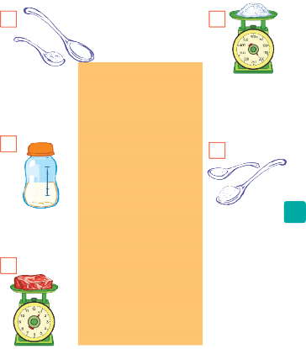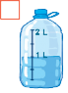  Answer key:  1. b 2. f 3. a 4. c 5. d 6. E | - Teacher gives Ss instruction, lets Ss have time to work individually, in pairs and then supports them if necessary.  -Ss quickly match the phrases with the pictures individually.  -Ss then swap their answers with their partners to check their answers by listening to the recording at the same time.  -Teacher observes, checks, gives correct answers as well as pauses the recording after each phrase and asks them to repeat chorally and individually.  - Teacher corrects Ss’ pronunciation.  - With weaker classes, teacher may ask for translations to check Ss’ understanding.
C. Activity:
Aim: To help Ss identify new words of dishes and ingredients
2: Write the following words and phrases in the correct columns. Add any other dishes and ingredients you know. (Ex 2, p. 52)  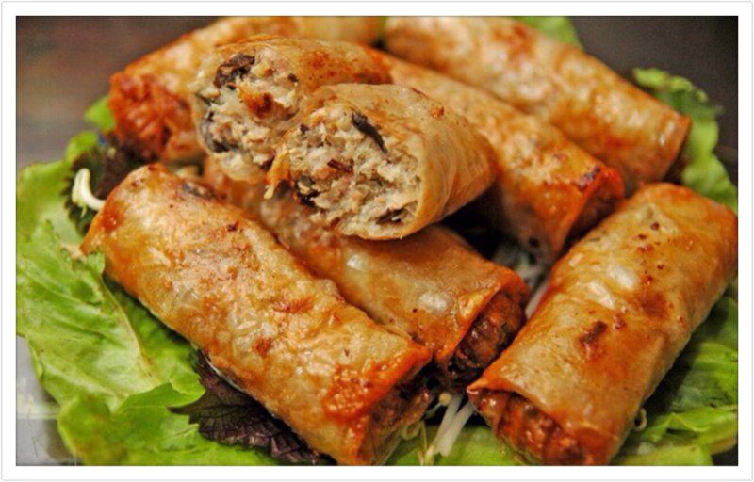 spring rolls omelette butter  onions pancake pepper  Key:  Dishes Ingredients  spring rolls butter  omelette onions  pancake pepper | Activity 1  - Teacher divides the class into 4 groups and gives instructions.  - Individually, Ss carefully and closely watch in order to write down the words for the items appearing on the screen. -Then, Ss discuss the meanings of the words given in groups.  -T gives feedback  Activity 2 – Who is faster?  -Teacher sticks 4 group boards on which there are two columns of Dishes and Ingredients, at four corners in the class, hands out four sets of six word cards to each group and explains the rules of the game.  -Ss receive the signal of the teacher, quickly sort the words and stick them onto the correct columns on their group's board at the corner of the class.  -The fastest group which has the most appropriate words in the columns will be the winner.
3 –PRACTICE (15 mins)
- Aim: To get Ss to practise asking and answering about the ingredients for a dish using measurement words and phrases they have learnt.
Contents | Teacher’s and students’ activities
3: Work in pair. Ask and answer about the ingredients for Linh’s apple pie, using the quantities in the recipe. (Ex 52  Apple-12 Milk-300ml  Salt- 1tsp Water-120ml  Sugar-300gr Flour-500g  Eg. A: How many apples do we need?  B: We need 12.  A: How much saltdo we need?  B: A teaspoon | - T pairs ss to make conversation, ask and answer about the quatity of ingredients for an apple pie.  -Ss work in pairs to practise.  -Teacher nominates some pairs of Ss to model this activity in front of the class. The others vote the best pairs they like best.  -Teacher gives feedback to help students improve their talk later
4 . PRONUNCIATION (10 mins)
A. Activity 4
-Aim: To show, model and help Ss how to pronounce the sounds /ɒ/ and /ɔ:/ and practise pronouncing these sounds correctly in words and in context
Contents | Teacher’s and students’ activities
4: Listen and repeat the words. Pay attention to the sounds /ɒ/ AND /ɔ:/. (Ex 4, p.52)  Key:  /ɒ/ fond, lot, not  /ɔ:/ short, call, water, pork, sauce | -Teacher plays the video modelling the sounds /ɒ/ and /ɔ:/ first and asks Ss to watch closely to see how the sounds are formed, and then gives them instruction to practise pronouncing the sounds.  - Ss listen and put the words in the correct columns.  -Ss share their answers with their partners  -Teacher plays the recording, show them the correct answers and asks Ss to listen and repeat.  -Ss repeat until they can pronounce the sounds correctly.
B. Activity 5
-Aim: to practise pronouncing these sounds correctly in words and in context
5: Listen and repeat, paying attention to the underlined words. Tick (✓) the sentences with the /ɒ/ SOUND. (Ex 5, p.52)  Key:  √: 1, 2, 4 | -Teacher asks Ss to listen twice and asks Ss to tick (√) the sentences with the /ɒ/ sound.  -Ss do as instructed individually  -Ss share their answers with Ss who sit next to them.  -Then Teacher plays the recording again, checks and asks Ss to repeat and provides further practice if needed
5 .PRODUCTION (4mins)
Aim: To help students to recall information they’ve learned during class and reflect on gaps in their knowledge
Contents | Teacher’s and students’ activities
- Some vocab in the lesson  - how to pronounce these two sounds /ɒ/ and /ɔ:/. | - Teacher asks Ss to summarise what they have learnt in the lesson by asking them some questions.  - What food have we learned to make today?  - What ingredients do we need to make it?  - How many/ How much of them do we need?  - What sounds do we learn today?
IV. HOMEWORK (3mins)
-Teacher asks Ss to make sentences about the quantity of ingredients for a dish using the words and phrases they have learnt in unit 5.
- do exercise 3,4,5/p37 in workbook
- Prepare lesson 3 ( A closer look 2)..

Date of planning:27-10-2024
Date of teaching:
UNIT 5: FOOD AND DRINK
Period 37 Lesson 3: A closer look 2
  - I. OBJECTIVES
By the end of this lesson, students will be able to:
1. Knowledge:
a. Vocabulary: countable, quantity, describe, popular, cartoon
b. Grammar: - Know how to use the measurement words and phrases such as some and a lot of / lots of with countable and uncountable nouns
- Understand and use the How many/ How much to ask and answer about quantities
2. Competences: - Develop communication skills
- Be collaborative and supportive in pair work and team work
- Actively join in class activities
3. Attitude: - Promote pride in the values ​​of Vietnamese culture, and develop love for family
II. Teaching and learning resources:
- Grade 7 textbook, Unit 5, A closer look 2, Computer connected to the Internet, TV,sets of word cards, sachmem.vn
III. Procedures
Contents | Teacher’s and students’ activities
1. WARM UP ( 5mins)
Aims:- To activate students’ knowledge about countable and uncountable
- To get students interested in the topic
Mini game: Are these countable and uncountable?  apple, carrot, chicken, salt, meal, sugar, star, cucumber, pepper, meat… | - Teacher put Ss into 2 big teams (named Mango & Orange) and gives instruction.  -When teacher say the words aloud:  - Ss of Mango team stand up and shout out if the word is countable.  - Ss of Orange team stand up and shout out if the word is uncountable.  -Teacher checks and tells Ss the noun is countable or uncountable when they have already reacted.
2. PRESENTATION (7mins)
Aim: to help Ss understand and know how to use some, a lot of / lots of
UNIT 5: FOOD AND DRINK  Period ......Lesson 3: A closer look 2  - Vocabulary  - đếm được: countable /ˈkaʊntəbəl/  - số lượng: quantity /ˈkwɒntəti/  -miêu tả: describe /dɪˈskraɪb/  - nhiều người biết đến: popular /ˈpɒpjələr/  - hoạt hình: cartoon /kɑːˈtuːn/  Grammar  some, a lot of / lots of  - Remember! box. | T presents the new lesson  -Teacher shows meanings of the new words in Vietnamese and asks Ss to translate them into English before starting the lesson.  - Teacher asks Ss to to look at some countable nouns and uncountable nouns.  -T asks them to tell the difference between countable nouns and uncountable nouns  - Teacher briefly explains that some and a lot of / lots of are all used with both countable nouns and uncountable nouns to talk about quantities.
3. PRACTICE (20mins)
A. Activity 1
Aim: - To help Ss practise using some and a lot of / lots of in sentences and in context .
1: Circle the correct words or phrases to complete the following sentences . (Ex 1, p.53)  Key:  1. a lot of 2. lots of 3. some  4. a lot of 5. Some | - Teacher asks Ss to read the sentences carefully and choose the best answers on their own, then then swap with their partners.  -Ss do the exercise as instructed.  -Ss share their answers and discuss the reasons why they have chosen them.  - Teacher nominates some Ss to read their answers in front of the whole class, check and correct their answers.
B. Activity2
Aim: - To give Ss further practice on using some and a lot of / lots of in sentences and in context
2: Look at the pictures and complete each sentence. Write SOME, ANY OR A LOT OF/ LOTS OF in the blanks. (Ex 2, p.53)  Key:  1. a lot of/lots of 2. any  3. some 4. a lot of/lots of | - Teacher divides the class into 4 groups, asks them to look at the photos on the screen, write down the words/ phrases to complete the sentences as quickly as they can on their mini boards/ paper sheets and raise the board above their heads, saying "Bingo!"  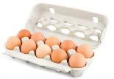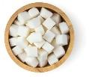  -The groups having more members who write correct answers the most quickly will get a star
C. Activity 3
Aim: - T help Ss revise the use of any.
3: Fill in the blank HOW MANY OR HOW MUCH. Answer the questions, using the pictures.(Ex 3, p.54)  Key  1. How much – Two litres 2. How many – Two books  3. How many – Two books 3. How many – Three bananas  5. How many – Five spring rolls | -Teacher observes them closely and has one student assist in writing the number of stars each group achieves.    -Teacher asks Ss to read the sentences carefully and choose the best answers on their own, then then swap with their partners.  -Ss do the exercise as instructed.  -Ss share their answers and discuss the reasons why they have chosen them.
D. Activity 4
Aim: - To get Ss to use How much/ How many to ask questions about quantities
4: Work in pairs. Ask and answer, using the questions in 3. (Ex 4, p.54)  Eg. A: How much water do you drink every day?  B: Two litres.  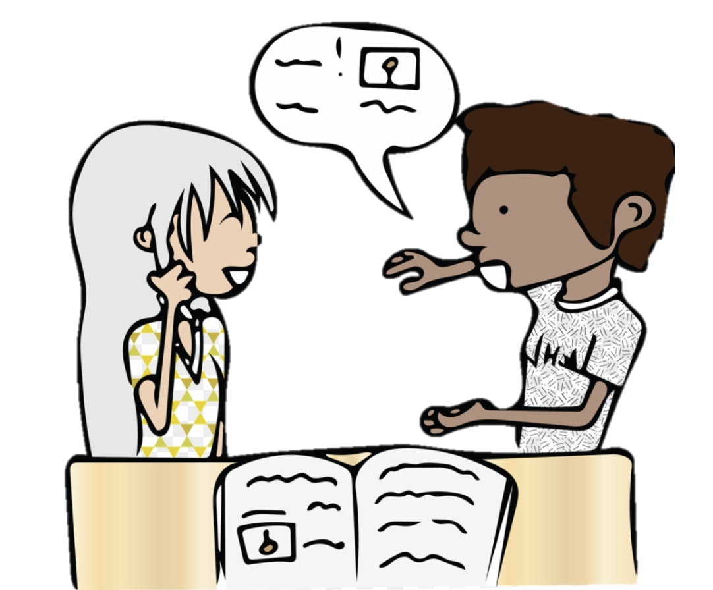 | - Teacher nominates some Ss to read their answers in front of the whole class, check and correct their answers.  - Teacher gives Ss two minutes to think of and write down as many questions using How much and How many as they can.  - Teacher pairs them to take turns asking and answering the questions in Task 3 and the questions they have prepared.  - Ss work in pairs to practise.  -Teacher nominates some pairs of Ss to model this activity in front of the class. The others vote the pairs they like best.  -Teacher gives feedback to help students improve their talk later.
4. PRODUCTION (7mins)
Aim: To get Ss to practise using measurement words and phrases, words of dishes and ingredients, How many and How much in contex
5: Work in pairs. Take turns to ask and answer about the recipes. (Ex 5, p.54)  A: what do we need to make pancakes?  B. We need eggs, sugar, flour, milk and butter.  How manyeggs do we need?  B: Two | - Teacher chooses some strong Ss in the class and assign the role of culinary teachers to them. The others will be culinary learners.  - Teacher asks them to sit in their groups to discuss and list all the questions and answers to make conversations in a culinary class.  -Every S in the group needs motivation to take part in the conversations while teacher goes around and observes them talking.  - Teacher notes all useful measurement expressions and some students' grammatical errors for later comments.
5. CONSOLIDATION (3mins)
Aim: To help students to recall information they’ve learned during class and reflect on gaps in their knowledge
Teacher summarises the main points of the lesson:
- How to use some, a lot of/ lots of
- How to ask and answer about food, drinks and cooking recipes using some, a lot of/ lots of, How many, How much

5. HOMEWORK (3’)
Teacher asks Ss to make questions and sentences about quantities, using some, a lot of / lots of, any, How much and How many.
- Learn all the new words and grammar by heart.
- Do exercises 6,7 P 38 in the workbook.
- Prepare lesson 4 ( Communication).

Date of planning: 28-10-2024
Date of teaching:

UNIT 5: FOOD AND DRINK
Period 38 Lesson 4: Communication
  - I. OBJECTIVES
By the end of this lesson, students will be able to:
1. Knowledge
a. Vocabulary: - use the lexical items related to the topic Food and Drink
b. Grammar: - Use lexical items related to the favourite food and drink in everyday life
- Understand and use ways to ask and answer about prices and favourite food and drink in English
2. Competences: - Develop communication skills
- Be collaborative and supportive in pair work and team work
- Actively join in class activities
3. Attitude : - Promote pride in the values ​​of Vietnamese culture
- Develop love for family
II. Teaching and learning resources:
- Grade 7 textbook, Unit 5, Communication, computer connected to the internet , TV/ Pictures/
- sachmem.vn
III. Procedures
Contents | Teacher’s and students’ activities
1. WARM UP ( 5’)
Aim: - To activate students’ knowledge, and get students interested in the topic
Restaurants  - a steakhouse  - a vegetarian café  - an expensive French eatery  - a motorway service station restaurant  + a seafood restaurant |  | - Teacher asks Ss to work in small groups.  - Teacher gives each group a different type of restaurant and tells them to create a menu and include starters, main courses, side dishes, desserts and drinks. Don't forget the prices.  - Ss quickly write on their own board, raise the board up and say "Bingo"  -Ss look at others' restaurant menu and say which they want to go to in turns.  -Teacher gives them a quick feedback.
2. PRESENTATION ( 7’)
Aim: To help students use key language more appropriately

UNIT 5: FOOD AND DRINK  Period ......Lesson 4: Communication  Vocabulary  - con lươn: eel /iːl/  - ngoại quốc: foreign /ˈfɒr.ən/  - ưa thích: favourite /ˈfeɪvərɪt/  - cuộc phỏng vấn: interview /ˈɪn.tə.vjuː/  - thử làm gì đó: try /traɪ/ |  |  | 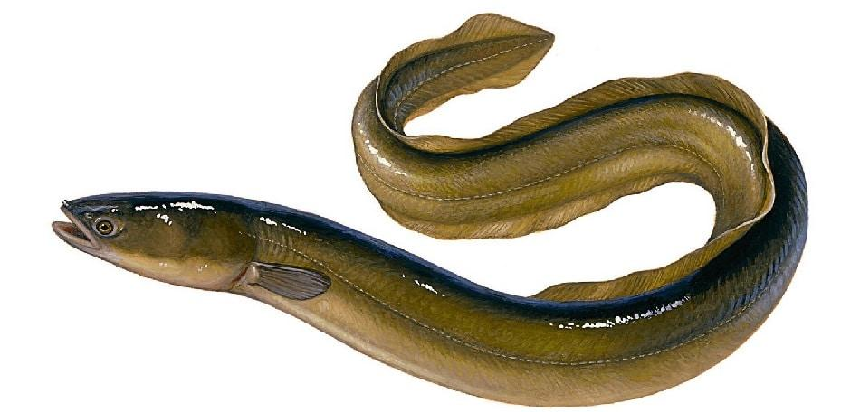  * T asks Ss to look at the photo and answer the * T –T asks Ss to look at the photo and answer the question.  What is this?  -Ss say the word.  -Other Ss correct if the previous answer is incorrect.  -Teacher shows and says the word aloud and asks Ss to repeat it.  -Teacher gives some words in Vietnamese and asks Ss to translate into English  -Ss says the word  -Teacher gives the correct answers  - T asks Ss to read vocab
3. EVERYDAY ENGLISH (12’)
A. Activity 1
-Aim: To introduce ways to ask and answer about prices in English.
1: Listen and read the conversation. Pay attention to the questions and answers. (Ex 1, p. 55)  Audio script – Track 34:  Mark: How much is a bottle of mineral water?  Mai: It’s 5,000 dong.  Mark: And how much are two kilos of apples?  Mai: They’re 50,000 dong. |  |  | -Teacher gives Ss instructions.  -Ss listen carefully, watch closely and repeat as a whole class. They pay attention to the questions whenever Teacher pauses and corrects their mistakes.  -Ss work in pairs to repeat the conversation.  -Teacher shows the conversation on the screen to make sure they ask the correct questions.
B. Activity 2
-Aim To help Ss practise asking and answering about prices.
2: Work in pair. Take turns to ask and answer about the prices of the food and drink on the menu. (Ex 2, p.55)  LY’S RESTAURANT  Breakfasf menu  FOOD  Bowl of beef noodle soup 30.000 dong  Bowl of eel soup 35.000 dong  toast 20.000 dong  DRINK  Glass of milk 9.000 dong  Bottle of mineral water 8.000 dong  Cup of green tea 5.000 dong |  |  | -Teacher shows the menu on the screen, shows the sample of the conversation, pairs Ss and asks them to play the roles of a waiter and a customer to ask and answer about the prices of the food and drink on the menu.  -Ss practise for about 3 minutes.  -Ss work with another partner and change their roles, asking and answering questions about the prices.  -Teacher goes around, observes, corrects their mistakes and notes some of their typical errors if necessary.
4. YOUR FAVOURITE FOOD AND DRINK (12’)
-Aims: To teach Ss the questions they can ask to interview someone about their favourite food and drink;
- To help Ss revise the vocabulary related to the topic.
3. Listen to the conversation and answer the following questions. (Ex 3, p.55)  - What's Nam's favourite food?  - What's his favourite drink?  - What foreign food does he like?  - What food does he want to try?  - What food can he cook?  Key:  1. Spring rolls. 2. Lemonade.  3. Apple pie and pancakes.  4. Hu tieu (in Ho Chi Minh City).  5. Omelettes, rice, and spring rolls | -Teacher gives Ss some time to read the questions in Exercise 3, asks them to pay attention to the key words and predict the answers.  - Ss do the exercise step by step.  - Ss read and underline key words.  - Ss listen twice, find synonyms and paraphrases of the key words and answer the question.  -Teacher asks Ss to swap their notebooks with each other, listen to the recording once again and peer check.  -Teacher gives Ss the correct answers and then asks them to repeat the conversation
5. CONSOLIDATION 6’
Objectives: - To help Ss practise asking and answering about their friends’ favourite food and drink
- To help Ss get information to report on their friends’ favourite food and drink;
- To help Ss practise reporting the results of their interviews
4: Work in group. Interview two of your friends about their favorite food and drink. Write their answers in the table below. (Ex 4, p.55)  Questions  Ss1  What's your favourite food? 30.000 dong  What's your favourite drink? 35.000 dong  3. What food or drink do you want to try? 20.000 dong  4. What foreign food or drink do you like? 4. What foreign food or drink do you like?  5. What can you cook? 5. What can you cook? | -Teach lets Ss randomly pick the cards to choose their teams. Then, teacher gives the instruction.  -Ss work in groups, practise asking and answering the questions to get information about the others in their groups to complete the table.  -Ss share the collected information in the class.  -Teacher listens to them, gives them comments and correct when necessary.
6. HOMEWORK (3’)
- Learn all the new words by heart.
- Do exercises 1,2/ P 39 in the workbook.
- Prepare lesson 5 ( Skills1).

Date of planning:30 / 10 / 2024
Date of teaching:

UNIT 5: FOOD AND DRINK
Period 39 Lesson 5: Skills 1
I. OBJECTIVES
By the end of this lesson, students will be able to gain:
1. Knowledge
- Develop their reading skill for specific information about food and drink
- Talk about the popular food and drink
2. Competences:
- Develop communication skills and creativity
- Be collaborative and supportive in pair work and team work
- Develop presentation skills
- Actively join in class activities
3. Attitude: - Promote pride in the values ​​of Vietnamese culture
- Develop love for family and traditional food and drink
II. Teaching and learning resources:
- Grade 7 textbook, Unit 5, Skills 1, computer connected to the internet , TV
- sachmem.vn
III. Procedures
Contents |  |  | Teacher’s and students’ activities
1. WARM UP ( 5’)
Objectives: - To create an active atmosphere in the class before the lesson
* Chatting  - Which pho would you like to it?  - How does it taste?  - How is it made ?  Which ingredients does it contain ?  . |  |  | T asks Ss to tell some names of pho you know.
2. PRE- READING ( 7’)
Activity 1
Aim: To help Ss understand and activate their knowledge of the topic

UNIT 5: FOOD AND DRINK  Period ......Lesson 5: Skills 1  Vocabulary  - snack /snæk/: đồ ăn vặt  - taste /teɪst/: nếm  - broth /brɒθ/: nước dùng, canh  - stew /stju:/: hầm  - boneless /ˈbəʊnləs/: không xương  1. Work in pair. Discuss the following questions. (Ex 1, p.56)  1. Is pho popular in your neighbourhood?  2. When can we have pho?  3. What are the main ingredients of pho? |  | Pre teach vocabulary  - Teacher uses different techniques to teach vocaburary (action, explanation)  Follow the seven steps of teaching vocaburary.  Concept check: Rub out and Remember technique.  -Teacher pairs Ss, gives them some time to discuss about “Phở”, using suggested questions.  - Ss discuss as guided.  - After discussing, Ss talk about pho in front of the class.  - T listens and may ask some other questions about how to make Phở.
3. WHILE- READING ( 15 mins)
A. Activity 2
Aim: To help students use key language more appropriately.
To help Ss develop their reading skill for specific information (scanning).

2. Read Phong’s blog. Match the underlined words in the text with their meaning. (Ex 2, p.56)  Key:  1. d 2. b 3. c 4. a 5. e |  |  | -Teacher asks Ss to scan the passage to find and work out the meanings of the words (1-5) in the passage and match with their meanings (a-e), using the context.  -Ss quickly locate the words, read with full concentration and complete focus, predict and match them with the provided meanings.  -Ss swap their answers with each other.  -Teacher checks the answers as a class, confirms the correct answers.  Or for weak classes, Teacher may ask for translation to check understanding.
B. Activity 3
Aim: To help Ss develop their reading skill for specific information (scanning)
3. Read Phong’s blog again and circle the correct answer A,B or C . (Ex 3, p. 56)  Key:  1. A 2. A 3. C 4. B 5. A |  |  | -Teacher gives instructions.  -Ss work individually to carefully read choose the correct answer  - Ss share their answers with a partner before showing them in the class and to Teacher. Teacher also asks them to give evidence when giving the answers.  - listens and then gives them correct answers.
4. PRE-SPEAKING ( 5 mins)
Activity 4
Aim: To help Ss generate ideas for the speaking activity
4. Make notes about a popular food and drink in your area. Think about its main ingredients, how often and when you have it. (Ex 4, p. 56)  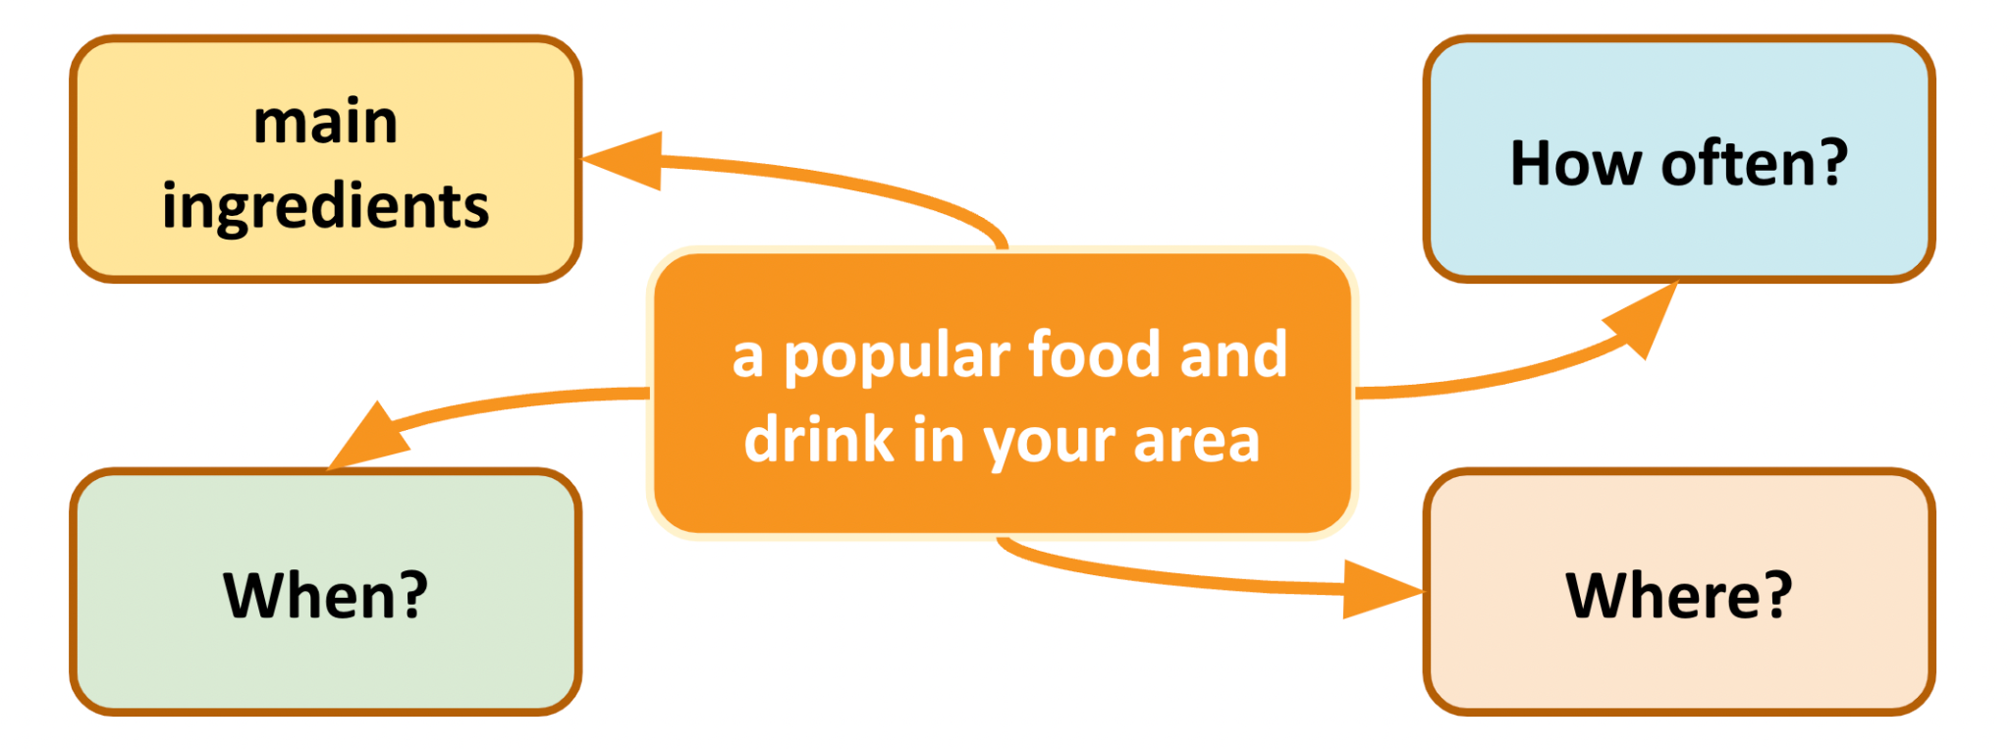 |  |  | -Teacher asks Ss to brainstorm or use a mind map/ web to make notes about a popular food and drink in their area in groups of 4 or 5 Ss  -Ss think about a popular food or drink in their area, its ingredients and how often and when people in their neighbourhood have it and note down quickly these ideas as instructed during the time limit set by the teacher.  - Ss share their ideas with other groups.
Activity 5: WHILE-SPEAKING ( 6 mins)
Aim: To provide an opportunity for Ss to practise talking about a popular food or drink
5: Work in groups of 3 or 4. Take turn to talk about a popular food or drink in your area. (Ex 5, p.56) | - T asks Ss to talk using the notes/ maps/ webs that they have prepared in their own group and then nominates some of them (maybe, strong students) to model this activity in front of the class.  - Ss practise.  -Then, Ss listen to their classmates presenting and give positive comments to the others'.  - Teacher gives feedbacks.
6. POST-SPEAKING- CONSOLIDATION ( 4 mins)
Aim: To help students to recall information they’ve learned during class and reflect on gaps in their knowledge
Teacher asks students to talk about what they have learnt in the lesson. | - Teacher has Ss summarise what they have learnt in the lesson with the two skills. If there is time, have them draw a mind map to summarise the main points of the lesson.  - Teacher has Ss say what they have learnt in the lesson.
7. HOMEWORK (3’)
- Learn all the new words by heart.
- Do exercises 1,2/ P 40,41 in the workbook.
- Prepare lesson 6 ( Skill 2).

Date of planning:2 / 10/ 2024
Date of teaching:
UNIT 5: FOOD AND DRINK
Period 40 LESSON 6: SKILL 2
  - I. OBJECTIVES: By the end of this lesson, students will be able to:
1. Knowledge
- Develop their listening skill for specific information about food and drink
- Write a paragraph about eating habits in their area
2. Competences:
- Develop communication skills and creativity
- Be collaborative and supportive in pair work and team work
- Develop presentation skills
- Actively join in class activities
3. Attitude: - Promote pride in the values ​​of Vietnamese culture
- Develop love for family and traditional food and drink
II. Teaching and learning resources:
- Grade 7 textbook, Unit 5, Skills 2, computer connected to the internet
- sachmem.vn
III. Procedures
Contents |  | Teacher’s and students’ activities
1. WARM UP ( 4’)
A. Aims: - To create an active atmosphere in the class before the lesson;
- To lead in the new lesson.
What did you have yesterday?  Who has the healthiest diet? |  | Our eating habits  -Teacher puts Ss in small groups and asks them to tell each other everything they ate and drank the day before.  -Ss share about what they ate and drank the day before.  - As a group, Ss then decide who has the healthiest diet.
2. PRE- LISTENING ( 3 mins)
Aim: To help Ss understand and activate their knowledge of the topic
UNIT 4 : MUSIC AND ARTS  Period ....: LESSON 6: SKILL 2  1: Work in groups. Discuss the following questions . (Ex 1, p. 57)  1. What time do people in your area often have breakfast, lunch, and dinner?  2. What do they often have for breakfast, lunch, and dinner? |  | -Teacher asks Ss to work in groups of 4 or 5 discussing questions about the eating habits of the people in their area.  - Ss actively discuss and note down all members' answers.  - Ss share their groups' answers as the whole class
3. WHILE- LISTENING (10 mins)
A. Activity 1
Aim: - To help Ss understand what the monologue is about;
2: Listen to Minh talking about the eating habits in his areas. Circle the food and drink you hear. (Ex 2, p.57)  Key:  eel soup, green tea | -Teacher asks Ss to guess which food and drink will appear in the monologue first.  eel soup, cakes , green tea, coffee , toast  -Ss listen to the recording, tick the words or phrases they hear from the monologue.  - Two or three Ss are nominated to write their answers on the board .  - Teacher plays the recording again for Ss to check the answers. If time is limited, T may only play the monologue once. T may pause at the sentences that include the words or phrases Ss need circle.
B. Activity 2
Aim: - To help develop their skill of listening for specific information.
- To help develop their skill of listening for specific information.
3: Listen again and tick(✓) T (True) or F (False).  Key: 1. F 2. T 3. F 4. T 5. T | - Teacher asks Ss how to do it and gives them some strategies to do the exercise. (e.g. reading the sentences, underlining the key words, listening to the text, paying attention to the key words, deciding if each sentence is true or false).  -Ss individually do exercise as instructed  -Ss swap their answers with their partners for checking.  -Teacher nominates Ss to read their answers aloud, checks and gives them the correct ones.
4. POST- LISTENING (3 mins)
Objectives: To help students retell what they have listened.
RETELLING
-Teacher asks students to work in groups and take turns to retell the information about “Street painting” as much as they can.
-Students work in groups to do the task. Teacher moves around and offers help if needed.
-Teacher invites some students to retell it.
-Teacher confirms the correct answers.

5. PRE- WRITING (7mins)
Aim: To help students learn the purpose and format of an informal letter of invitation.

4: Make notes about the eating habits in your area. (Ex 4, p.57)  + What time do they have breakfast, lunch and dinner?  + What food and drink do they have then? |  | -Teacher asks Ss to make notes, brainstorm or cluster ideas to write about the eating habits in their area, using the following questions. (Ss can use the language in the listening exercise.)  - Ss do not have to write full sentences and they can use abbreviations.  - Then Ss share their notes with their partners.  - T may ask some strong students to read out the notes to the whole class.
6. WHILE- WRITING (10mins)
Aim: To help Ss practise writing a paragraph about the eating habits in their area.
5: Write a paragraph of about 70 words about the eating habits in your area. Use the information in 4 to help you.(Ex. 5, p. 47) |  | - Teacher suggests Ss think and write, using the notes they have done in Exercise 4.  - Ss write the first draft individually and listen to their classmates' and Teacher's feedbacks and comments, and then write the final writing.  -Then, they share their writings with the others, using marking criteria to give each other peer-feedbacks.  -T may display some of Ss’s final writings on the wall / notice board and mark them.
7. POST- WRITING (5 mins)
Aim: To peer check, cross check and final check students’ writing.

PEER CHECKING |  | - Teacher asks students to share their writing with their partners. Then, call on some students to show their writing in front of the class.  - Teacher checks ideas, grammar, vocabulary and gives comments.
8. HOMEWORK (3’)
- Rewrite the letter on the notebook.
- Learn all the new words by heart.
- Prepare lesson 7 Unit 5 ( Looking back & project).

Date of planning: 4 / 11 / 2024
Date of teaching:
UNIT 5: FOOD AND DRINK
Period : 41 Lesson 7: LOOKING BACK AND PROJECT
  - I. OBJECTIVES: By the end of this lesson, students will be able to:
1. Knowledge
- Review the vocabulary and grammar of Unit 5. The use of some, any, much, or a lot of/ lots of, questions with How many/ How much.
2. Competences: - - Develop communication skills and creativity
- Develop presentation skill
- Develop critical thinking skill
- Be collaborative and supportive in pair work and team work
- Actively join in class activities
3. Attitude : - Be more creative when doing the project
- Develop self-study skills
II. Teaching and learning resources:
- Grade 7 textbook, Unit 5, Looking back & Project
- Computer connected to the Internet, TV/ Pictures, sachmem.vn
III. Procedures
Contents | Teacher’s and students’ activities
1.WARM UP ( 5’)
Aim: - To create an active atmosphere in the class before the lesson
Game: What can you make?  Ingredients:  Eggs, sugar, milk, flour, butter, eel, water, salt, pepper,onion, tomatoes,  Suggested answers:  1. Eel soup  2. Pancakes  3. Omelette | - Teacher puts Ss in small groups, shows some ingredients on the screen and gives through instructions.  - Ss work in their teams to decide what food they can cook, using the ingredents provided.  - Students then share their ideas with other groups.  -Teacher corrects students’ answers if they make any mistakes and suggests some food they can make using the given ingredients.
2. VOCABULARY ( 15’)
A. Activity 1
-Aim: To help Ss revise the vocabulary items they have learnt in the unit.
1: Add the words and phrases you have learnt in the correct. (Ex 1, p.58)  Dishes Ingredients Units of measurement  pancakes omelette eel soup ... Flour,sugar, milk, water, salt, pepper, .... gram teaspoon kilo litter ... | -Teacher encourages students to find as many words or phrases as possible to add to the columns individually.  -Students do the task individually.  -Ss compare with their partners to find out who has more words and add any words they haven’t had into their tables.  -Teacher gives feedback as a class discussion.
B. Activity 2
-Aim: To help Ss revise the vocabulary items they have learnt in the unit.
2: Read the recipe and write sentences as in the example. (Ex 1, p.58)  Suggested answers:  We need 5 eggs. We need 2 tomatoes.  We need 2 tablespoons of cold water.  We need 40 grams of butter.  We need 5 grams of onion.  We need 1 teaspoon of salt.  We need 1 teaspoon of pepper. | -Teacher has Ss do this activity individually.  - Ss read the recipe and write about 7 sentences.  - Ss then compare their answers with their partners. Some strong ones are nominated to read out their answers in front of the class.  - Teacher gives feedback as a class discussion.
3. GRAMMAR (17’)
A. Activity 3
-Aim: To help Ss revise the use of some, any, much and a lot of / lots of.

3: Complete the sentences. Write SOME, ANY, MUCH, or A LOT OF/ LOTS OF. (Ex 3, p.58)  Key:  1. any 2. some 3. a lot of/ lots of 4. a lot of/ lots of 5. any, some | - Teacher gives instructions.  - Ss do the exercise individually first.  -Then they can swap and check their answers with a partner before discussing the answers as a class. Remind Ss to record their original answers so they can use that information in their Now I can … statement.  -Teacher gives feedback as a class discussion
B. Activity 4
-Aim: To help Ss revise the use of How much and How many.
4: Make questions with AKE HOW MANY/ HOW MUCH for the underline words in the following. (Ex 4, p. 58)  Key:  1. How many bottles of juice are there in the fridge?  2. How much butter do you need for your pancakes?  3. How many bottles of fish sauce do you / we have?  4. How many chairs do you / we need (for the party)?  5. How much sugar did she put in her lemonade? | - Teacher gives instructions.  -Ss do the exercise individually first.  -Then they can swap and check their answers with a partner before discussing the answers as a class. Remind Ss to record their original answers so they can use that information in their Now I can … statement.  -Teacher gives feedback as a class discussion.
4. PROJECT (5’)
Objectives: To allow students to apply what they have learnt (vocabulary and grammar) into practice through a project.
5: Posters exhibition:   | -T shows the poster of eating habits around the world and asks Ss to call the names of them.  -Teacher asks Ss design a poster about eating habits in an area or a foreign country they kno, including :  - what typical food they eat for the meals  - what ingredients they need to cook  - how they cook  - how they serve the meals  - pictures or photos for illustration  - Organise an exhibition.  - Vote for the best poster.  - Students do the project in groups and present in the next period
5. HOMEWORK (3’)
- Learn all the new wordsby heart.
- Do exercises 1 P 41 in the workbook.
- Prepare lesson 1 Unit 6 ( Getting started)

