LESSON PLAN
Trường THCS Thi Tran Phu Hoa Giáo viên Nguyen Thi Thu Loan
Tổ: Tiếng Anh
Date of planning: 1 -10 -2024 UNIT 3: COMMUNITY SERVICE
Date of Teaching : Periop 16 Lesson 1: Getting started – Sounds like great work!

I. Objectives : By the end of the lesson, the students will be able to
-gain an overview about the topic “Community service” and lexical items related to community activities
1. Knowledge:
a.Grammar : past simple tense
b. Vocabulary: Vocabulary about community activities
2. Competences:
- Develop communication skills and enhance awareness of preserving the culture
- Be collaborative and supportive in pair work and team work
- Actively join in class activities
3. Attitude:
Help Ss develop self-study skills and raise students’ awareness of the need to keep their neighbourhood green
II. TEACHING AIDS:
- Text book, teaching plan, a laptop connected TV, sachmem.vn .
III. PROCEDURES:
Contents | Teachers and Students ‘ activities
1. WARM UP (3 minutes)
Aim: To introduce the topic of the unit.
Game : Kim’s game  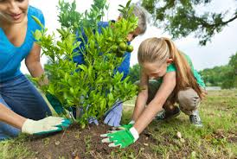  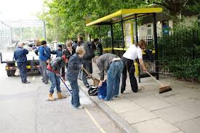 | T : Ask Ss to play Kim’s game and ss tell some activities in the pictures.  T asks :Do you like these activities?  Are they useful works?  What do you call these activities?  Ss ; “Community activities ”  - Teacher draws students’ attention to the picture in the textbook and asks them some questions about it:  - What are they doing?  Ss : they are doing “community activities”.
2.PRESENTATION : 7 minutes
A. ACTIVITY 1 (7 minutes)
Aim : - To provide students with vocabulary.
- To help students well-prepared for the listening and reading tasks.
VOCABULARY:  1. community activity (n.phr.) /kəˈmjuːnɪti ækˈtɪvɪti/ hoạt động cộng đồng  2. donate (v) /dəʊˈneɪt/ quyên góp, ủng hộ  3. nursing home (n.phr.) /ˈnɜːsɪŋ həʊm/ viện dưỡng lão  4. homeless (adj) /ˈhəʊmləs/ vô gia cư | -Teacher introduces the vocabulary.  -Teacher introduces the vocabulary by:  - providing the pictures  - eliciting the definition of the words  Ss : Read Voc  -Check Voc : What and where
3 . PRACTICE
B. ACTIVITY 2 (7 minutes)
Aim: To have students get to know the topic.
1: LISTEN AND READ. (Ex 1, p. 28) | - Teacher can play the recording more than once.  - Students listen and read.  - Teacher can invite some pairs of students to read aloud.  - Teacher check students’ pronunciation ad give feedback.
C ACTIVITY 3
Aim : To help students read for specific information about Minh and Tom’s community activities
2: READ THE CONVERSATION AGAIN AND TICK THE APPROPRIATE BOX. (Ex. 2, p. 29)  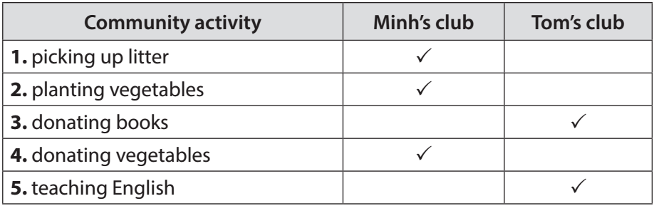 | -Teacher tells students to read the conversation again and work in pairs to find the answers.  -Students can underline the words and phrases about community activities then work together for one or two minutes to check the words / phrases they have underlined.  - Teacher allows students to share their answers before discussing as a class and encourages them to pronounce the words / phrases correctly.  -Teacher checks the answers as a class and gives feedback.
D. ACTIVITY 4 : (3 minutes)
Aim: - To help students use phrases related to community activities.
3: COMPLETE THE PHRASES UNDER THE PICTURES WITH THE VERBS BELOW. (Ex 3, p. 29)  Answer key:  1. pick up  2. help  3. recycle  4. donate  5. clean | - Teacher asks students to work individually to complete the phrases under the pictures with the given verbs.  - Students work individually to complete the task.  -SS :share answers before discussing as a class.  - Teacher asks students to say the phrases aloud and makes sure they pronounce the words and phrases correctly. Teacher can ask for translation to check their understanding.
E. ACTIVITY 5 (7 minutes)
Aim: To help students use the vocabulary related to community activities in the right contexts...
4: COMPLETE THE SENTENCES WITH THE CORRECT WORDS OR PHRASES BELOW. (Ex 4, p. 29)  Answer key:  1. homeless children  2. litter  3. old people  4. taught  5. planted | - Teacher asks students to work independently to complete each sentence with a word or phrase from the box.  - Students fill in the blanks with the most suitable words / phrases.  -Teacher allows students to share answers before discussing as a class.  - Teacher can ask students to read aloud the full sentences and correct their pronunciation if needed.
4. PRODUCTION :
F. ACTIVITY 6 (7 minutes)
Aim: - To help students review and reuse the learnt vocabulary.
- To create a fun atmosphere in the class..
5: VOCABULARY PING-PONG GAME. (Ex 5, p. 29)  Example:  Team A: Litter  Team B: We often pick up litter in the park. Trees.  Team A: We plan trees in our school every year. Book. | - Teacher instructs students to play the Vocabulary Ping-Pong game:  - Ask Ss to think of the topic Community Service.  - One student from team A shouts out a word or phrase related to the topic. Then one student from team B makes a sentence with that word or phrase. Then switch roles.  - The team that cannot give a phrase or make a correct sentence loses and the other team gets a point.
5. HOMEWORK :
Aim: To revise what they have learnt..
-Learn Vocabulary by heart .  - Practing reading the conversation again .  - Prepare Unit 3 A closer look 1 |  | Teacher guides Ss to prepare homework  .
*Checking :

Date of planning: 1 -9 -2024 UNIT 3: COMMUNITY SERVICE
Date of Teaching : Period 17 Lesson 2: A closer look 1

I. Objectives : By the end of the lesson, the students will be able to
- Use words related to community activities.
- pronounce the sounds: /t/, /d/, /ɪd/ in isolation and in context
1. Knowledge:
a.Grammar : past simple tense
b. Vocabulary: Vocabulary about community activities
2. Competences:
- Develop communication skills and and creativity
- Be collaborative and supportive in pair work and team work
- Actively join in class activities
3. Attitude:
Help Ss develop self-study skills and raise students’ awareness of the need to keep their neighbourhood green
II. TEACHING AIDS:
- Text book, teaching plan, a laptop connected TV, sachmem.vn .
III. PROCEDURES:
Contents | Teachers and Students ‘ activities
1. WARM UP (3 minutes)
Aim: To recall students’ vocabulary on community activities
Game : MATCHING GAME:  recycle Help plant  trees vegetables small children old people  books bottles cans homeless children | - Teacher has students play in two groups and explains the game rules.  -Ss Each group will have a list of verbs and nouns. Students match the verbs they have with the correct nouns.  -Teacher and students discuss the answers. The group with the most correct answers wins.  -Teacher confirms the answers and gives feedback.
2.PRESENTATION : 7 minutes
A. ACTIVITY 1 (7 minutes)
Aim : - To provide students with vocabulary.
VOCABULARY:  1. exchange (v) /ɪksˈʧeɪnʤ/ trao đổi  2. pick up (phr. v.) /pɪk ʌp/ nhặt lên  3. tutor (v) /ˈtjuːtə/ dạy kèm | -Teacher introduces the vocabulary.  -Teacher introduces the vocabulary by:  - providing the pictures  - providing the definition of the words.  -Teacher asks students to repeat.  - Ss reads Voc  -Check Voc : What and where
3 . PRACTICE
B. ACTIVITY 2 (7 minutes)
Aim: To introduce some verbs and verb phrases that are often used to describe community activities
1: MATCH A VERB IN A WITH A WORD OR PHRASE IN B. (Ex 1, p. 30)  Answer key:  1. e  2. a  3. d  4. c  5. b | -Teacher has read aloud the verbs in A and words / phrases in B.  - Students work in pairs to match the verbs in A with words / phrases in B.  - Teacher asks them to share their answers in pairs before checking the answers as a class.  - Teacher invites students to take turns to read out their answers and corrects their pronunciation if needed.
C ACTIVITY 3
Aim : To help students read for specific information about Minh and Tom’s community activities
To allow students to use the learnt words / phrases in contexts.  2: COMPLETE EACH OF THE SENTENCES WITH A SUITABLE WORD OR PHRASE FROM THE BOX. (Ex 2, p. 30) | - Teacher asks students to work individually to complete each of the sentences with a suitable word / phrase from the box. All of these words / phrases have been learnt in.  -Students do the task individually.  -Teacher allows students to swap their textbooks to peer check first.  -Teacher confirms the answers and gives feedback, if necessary.
4. PRODUCTION :
D. ACTIVITY 4 : (3 minutes)
Aim: To have students practise producing full sentences using the learnt words / phrases.
3: USE THE PHRASES FROM THE BOX TO WRITE FULL SENTENCES UNDER THE CORRECT PICTURE. (Ex 3, p. 30)  Answer key:  1. She’s reading books to the elderly.  2. They’re giving gifts to old people.  3. They’re exchanging used paper for notebooks.  4. They’re donating clothes to poor children.  5. She’s planting trees in the park | - Teacher asks students to work individually to write full sentences, using the given phrases.  - Students read aloud the six phrases and match with the appropriate pictures.  - Teacher asks students to work in pairs to swap their answers and peer check.  -Teacher checks their answers as a class.
PRONUNCIATION
E. ACTIVITY 5 (7 minutes)
Aim: - To help students identify how to pronounce the sounds /t/, /d/ and /ɪd/.
- To help students practise pronouncing the sounds in words.
4: LISTEN AND REPEAT. PAY ATTENTION TO THE SOUNDS /t/, /d/ AND /ɪd/. (Ex 4, p. 30) | - Teacher has students listen to the recording once first.  - Students listen to the recordings and read out the words.  - Teacher plays the recording for them to listen and repeat each word as a class, then as individuals.  - Teacher check students’ pronunciation if needed.
F. ACTIVITY 6 (7 minutes)
Aim: To help students practise pronouncing the sounds /t/, /d/ and /ɪd/ in sentences
5: LISTEN TO THE SENTENCES AND PAY ATTENTION TO THE UNDERLINED PARTS. TICK THE APPROPRIATE SOUNDS. PRACTISE THE SENTENCES (Ex 5, p. 31).  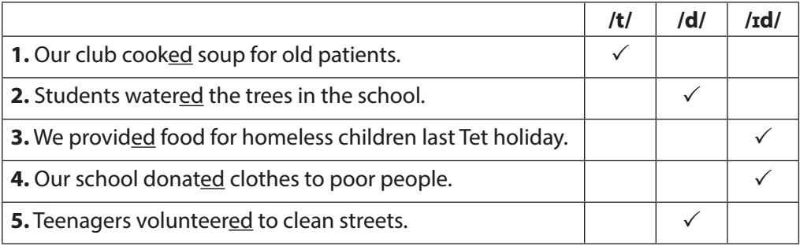 | - Teacher has some students read the sentences first and asks them to pay attention to the underlined parts.  - Teacher plays the recording for Ss to listen then have them tick the appropriate sounds.  -Teacher invites some Ss to share their answers. Confirm the correct ones.  -Teacher plays the recording again and ask students to repeat each sentence after the recording. Teacher confirms the answers
5. HOMEWORK :
Aim: To review the vocabulary in this lesson.
-Learn Vocabulary by heart .  - Redo exercises 2, 3 in notebooks  - Prepare Unit3 A closer look 2 |  | Teacher guides Ss to prepare homework

*Checking :
Date of planning: 2 -9 -2024 UNIT 3: COMMUNITY SERVICE

Date of teaching: Period 18 : Lesson 3 : Acloser look2

I. Objectives : By the end of the lesson, the students will be able to:
- Understand the use of the past simple tense
- Practice using the past simple to talk about past activities
1. Knowledge:
a.Grammar : The simple past tense
b. Vocabulary: Vocabulary about community activities
2. Competences:
- Develop communication skills
- Be collaborative and supportive in pair work and team work
- Actively join in class activities
3. Attitude:
Help Ss develop self-study skills and raise students’ awareness of the need to keep their neighbourhood green
II. TEACHING AIDS:
- Text book, teaching plan, a laptop connected TV.
III. PROCEDURES:
Contents |  | Teachers and Students ‘ activities
1. WARM UP (3 minutes)
Aim: To activate students’ prior knowledge related to the targeted grammar: the past simple.
CHATTING  What did you do last weekend?  What did you watch yesterday?  Who did you meet two days ago? |  | -Teacher asks students some questions:]  -Students answer the questions, using the past simple.  - Teacher and students discuss the answers.  -Teacher corrects students answers if needed and confirms the use of the past simple (to talk about completed actions in the past).
2.PRESENTATION : 7 minutes
A. ACTIVITY 1 (7 minutes)
Aim : To review students’ knowledge of the past simple tense.
. Grammar focus  Positive S + V-ed / V 2  Negative S + did not / didn’t +V  Questions and short answers Did + S + V ? - Yes, S + did. - No, S + didn’t.  The past simple  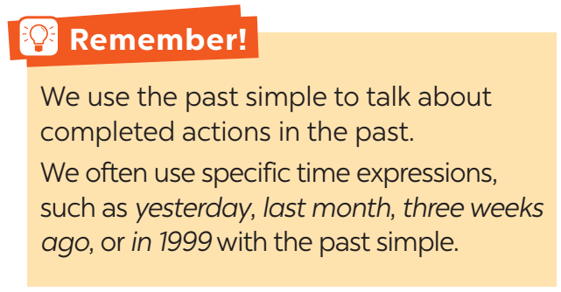 |  | -Teacher asks students to study the Grammar box.  - Teacher draws students’ attention to the meaning and use of the past simple.  -Teacher then asks some more able  - students to give some more examples.  - Teacher and students discuss the answers.  -Teacher confirms the answers and gives feedback.
3 . PRACTICE
B. ACTIVITY 2 (7 minutes)
Aim: To review students’ knowledge of the past simple tense.
1: CIRCLE THE CORRECT ANSWER A, B, OR C TO COMPLETE EACH SENTENCE. (Ex 1, p. 31)  Answer key:  1. B  2. C  3. B  4. A  5. C | - Teacher has students work individually.  -Students work individually to to complete the sentences with the past simple form of the given verbs.  - Students work in pairs and exchange the answers before checking with the whole class (explain each sentence if necessary).  - Teacher confirms the answers and gives feedback.
C.ACTIVITY3 :
Aim: To raise students’ awareness of the past simple tense and past forms of some verbs.
2: COMPLETE THE SENTENCES WITH THE PAST SIMPLE FORM OF THE GIVEN VERBS. (Ex 2, p. 31)  Answer key:  1. took  2. Did … join  3. helped  4. sent  5. volunteered | - Teacher has students work individually.  - Students work individually to complete the sentences.  -Teacher lets students work in pairs and exchange the answers before checking with the whole class (explain each sentence if necessary).  -Teacher confirms the answers and gives feedback.
D. ACTIVITY 4 : (3 minutes)
Aim: To help students distinguish between the present simple, present continuous and past simple in specific contexts.
3: COMPLETE THE SENTENCES WITH THE CORRECT FORMS OF THE VERBS FROM THE BOX. (Ex 3, p. 31)  Answer key:  1. cook  2. Did … plant  3. are picking up  4. recycled  5. read | - Teacher asks the whole class to read aloud the verbs in the box then has students work individually to complete the sentences with the correct forms of the verbs from the box.  -Students work individually to complete the task.  - Students work in pairs, comparing their sentences. Teacher can go around to help students.  - Teacher confirms the answers and gives feedback.
FURTHER PRACTICE
E. ACTIVITY 5 (7 minutes)
Aim: To help students write full sentences using the correct forms of the verbs.
4: WRITE COMPLETE SENTENCES FROM THE PROMPTS. (Ex 4, p. 32)  Answer key:  1. Last year, our club donated books to children in rural areas.  2. Children sent thank-you cards to us a week ago.  3. I taught two children in grade 2 last summer.  4. Last spring, we helped the elderly in a nursing home.  5. We helped people in flooded areas last year. | -Teacher has students work independently.  -Teacher asks students to do the exercise individually.  - Students work in pairs and exchange the answers before checking with the whole class (explain each sentence if necessary).  -Teacher confirms the answers and gives feedback.
4. PRODUCTION :
F. ACTIVITY 6 (7 minutes)
Aim: - To help students be aware of some community activities that students in other countries do.
5: THE RED CROSS IN 2016 AND 2020 (Ex 5, p. 32)  Work in groups. Tom is from the Red Cross. Look at the fact sheet and ask Tom about his projects in 2016 and 2020.  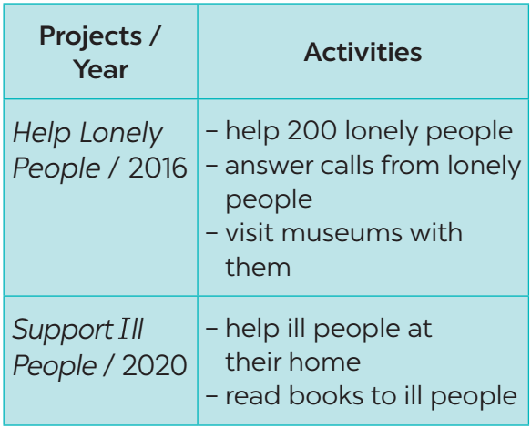  . Example:  Tom: I’m from the Red Cross. I worked on the Help Lonely People project in 2016.  Lan: What did you do?  Tom: We helped 200 lonely people… |  | -Teacher introduces the Red Cross projects and activities in 2016 and 2020 and has students work in pairs for 5 minutes to practise asking and answering questions based on the fact sheet.  - Students use the past simple when they ask and answer questions about the past activities.  -Teacher invites some pairs to make short conversations as an example.  - Teacher corrects any grammar and pronunciation mistakes if necessary.
5. HOMEWORK :
Aim: Reactivate the knowledge that students have gained
-Learn The simple past tense .  -Redo exercise 2,3,4 .  - Prepare Unit3 Communication |  | Teacher guides Ss to prepare homework
- Checking :

Date of planning: 5 -10 -2024 UNIT 3: COMMUNITY SERVICE
Date of teaching: Period 19: Lesson 4 : COMMUNICATION

I. Objectives : By the end of the lesson, the students will be able to:
- know how to give compliments
- discuss and present the benefits of community activities
1. Knowledge:
a.Grammar : structures to give compliments.
b. Vocabulary: vocabulary on community activities.
2. Competences:
- Develop communication skills
- Be collaborative and supportive in pair work and team work
- Actively join in class activities
3. Attitude: -Help Ss develop self-study skills and raise students’ awareness of the need to keep their neighbourhood green
II. TEACHING AIDS:
- Text book, teaching plan, a laptop connected TV, sachmem.vn
III. PROCEDURES:
Contents | Teachers and Students ‘ activities
1. WARM UP (3 minutes)
Aim: To review students’ knowledge of the past simple tense.
ALPHABET GAME  Example:  A: He asked me my name.  B: I bought a hat.  C: I came here last month. | - Teacher divides the class into 4 groups. Students take turns to use the past simple in a sentence. The first letter of the verbs must follow the sequence of the alphabet.  - Students work in groups to play the game. If a student from a group can’t think of one verb, he/she is out of the game. The next student from other groups continues with the next letter.  -Teacher goes around to help weaker students.  -Teacher gives compliments to the group which has the most correct answers.
2.PRESENTATION : 7 minutes
A. ACTIVITY 1 (7 minutes)
Aim : To introduce two ways to give compliments.
1: LISTEN AND READ THE DIALOGUE BETWEEN LAN AND MARK. PAY ATTENTION TO THE HIGHLIGHTED PARTS. (Ex 1, p. 32)  2 ways to give compliments:  - Sounds like great work!  Wonderful! | -Teacher asks students to look at the conversation in GETTING STARTED and check if they find any phrases or clauses that Minh and Tom use to compliment the other for doing something good deeds.  - When students have found the clause “Sounds like great work!”,  - Teacher plays the recording for Ss to listen and read the dialogue between Lan and Mark.  -Students pay attention to the highlighted parts.  -Teacher emphasizes the use of the compliments.  -Teacher confirms the answers and gives feedback.
3 . PRACTICE
B. ACTIVITY 2 (7 minutes)
Aim: To help students practise giving compliments.
2: WORK IN PAIRS. MAKE SIMILAR CONVERSATIONS. (Ex 2, p. 32) | - Teacher has students work in pairs to make similar dialogues.  - Students work in pairs to make similar dialogues, using the contexts given and the sample compliments.  - Teacher asks some pairs to practice the dialogue so that the whole class can give comments.  - Teacher gives feedback as a class.
C.ACTIVITY3 :
Aim: - To help students learn more about some benefits of community activities.
- To help students practise reading for specific ideas.
3: READ THE POSTER ABOUT THE VOLUNTEER ACTIVITIES FOR TEENAGERS AT LENDING HAND. WRITE THE PROJECT NUMBER (1-3) NEXT TO ITS BENEFITS (A-E). (Ex 3, p. 33)  Answer key:  1. B, E  2. C, D  3. A | - Teacher has students work in pairs to read the poster and asks them questions like:  - How many projects does Lending Hand offer?  - What activities can you do / join in Projects 1, 2 and 3?  - Students work in pairs to write the number of the projects (1 - 3) next to the benefits (A - E).  - Teacher asks some pairs to to read out their answers.  -Teacher gives feedback and correction (if needed).
FURTHER PRACTICE
E. ACTIVITY 1 (7 minutes)
Aim: - To help students practise asking and answering questions about which activities they want to join and why.
4: ASK AND ANSWER WHICH ACTIVITIES IN TASK 3 YOU WANT TO JOIN. GIVE REASONS. (Ex 4, p. 33)  Example:  Minh: Which activity do you want to join?  Lan: I want to join some clean-up activities.  Minh: Why do you want to join these activities?  Lan: Because they make the neighbourhood cleaner. |  | - Teacher asks students to work in pairs to ask and answer questions about which activities they want to join and why.  - Students work in pairs to do the task. They can use the example in the Student’s book. They should clarify any other benefits they can think of.  - Teacher invites some pairs to role-play, asking and answering questions in front of the class.  -Teacher corrects any grammar or pronunciation mistakes if necessary.
4. PRODUCTION :
F. ACTIVITY 6 (7 minutes)
Aim: - To help students practise asking and answering questions about which activities they choose to joinand the benefits of those activities.
- To help students practise giving reasons.
5: WORK IN GROUPS. DISCUSS WHICH ACTIVITY EACH MEMBER OF YOUR GROUP CHOOSES AND THE BENEFIT(S) OF THE ACTIVITY. PRESENT YOUR GROUP’S ANSWER TO THE CLASS. (Ex 5, p. 33)  Example:  Mai wants to donate food to street children because this helps feed them. Lan wants to join clean-up activities because these activities make our neighbourhood cleaner… |  |  | -Teacher lets students work in groups discuss which activity each member of their group chooses and the benefits of each activity.  -Students can give more than one benefit to any activity or any benefits they can think of in addition to those they find in the Student’s book.  -Teacher invites group representatives to report their group’s answers.  - Teacher gives feedback on their reports.
5. HOMEWORK :
Aim: To review what students have learnt in this lesson.
- Practice asking and answering EX4  -Do Exercises B1,2,3,4( work books )  - Prepare Unit3 skills1 | Teacher guides Ss to prepare homework
- Checking :
Date of planning: 1 -9 - 2024 UNIT 3: COMMUNITY SERVICE

Date of teaching: Period 19 : Lesson 6: SKILLS 1

I. Objectives : By the end of the lesson, the students will be able to:
-Read for specific information about community activities at a school
- Talking about the reasons why students join different community activities
1. Knowledge:
a.Grammar : simple sentence
b. Vocabulary: Vocabulary on community activities
2. Competences:
- Develop presentation skill
- Be collaborative and supportive in pair work and team work
- Actively join in class activities
3. Attitude:
- Help Ss develop self-study skills
- Raise students’ awareness of the need to keep their neighbourhood green.
II. TEACHING AIDS:
- Text book, teaching plan, a laptop connected TV,sachmem.vn
III. PROCEDURES:
Contents |  | Teachers and Students ‘ activities
1. WARM UP (3 minutes)
Aim: - To remind students of some community activities.
- To enhance students’ skills of cooperating with team mates.
GAME: WHO IS FASTER?    1. collecting rubbish 2. donating clothes  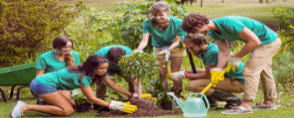  3. planting trees 4. tutoring homeless children    5. helping old people 6. cleaning the street | - Teacher divides the class into 2 teams.  - Each team will have to run in a relay to the board to match the correct description with each picture.  - The team with more correct answers will be the winner.  - Students play the game in team mode.  -Teacher and students discuss the answers.  -Teacher confirms the answers and gives feedback.
READING
2. ACTIVITY 1 : PRE-READING
Aim :To provide students with some lexical items before reading the text.
Vocabulary  -monthly (adj/adv) hàng tháng  -be proud of (adj) : tự hào về … | - Teacher has the class read out loud the three activities.  - Students work in pairs to circle the activities they would like to do at their school.  - Students can name some more activities they would like to do at their school if the class is more fluent.  -Teacher accepts all students’ answers.  -Teacher introduces the vocabulary.  - Teacher asks students to get the meaning in context and try to make up sentences with of the following words:
3 . WHILE-READING
B. ACTIVITY 2 (7 minutes)
Aim: - To improve students’ knowledge of vocabulary related to community activities.
- To improve students’ skill of reading for details..
2: READ THE PASSAGE AND MATCH THE HIGHLIGHTED WORDS WITH THEIR MEANINGS. (Ex 2, p. 34)  Answer key:  1. donate  2. exchange  3. monthly  4. proud  5. tutor | -Teacher asks students to work individually to read the passage and find the highlighted words.  -Students read the text and do the task.  - Teacher allows students to share their answers before discussing as a class and encourages them to give evidence.  - Teacher calls some students to give the answer, explain which sentence give them the information.
C.ACTIVITY3 :
Aim: To develop reading skill for specific information.
3: READ THE PASSAGE AGAIN AND TICK T (TRUE) OR F (FALSE). (Ex 3, p. 34)  Answer key:  1. T  2. F  3. T  4. F  5. T | -Teacher asks some students to read out loud the sentences in the table.  - Students work individually for some minutes and tick T (True) or F (False).  -Teacher allows students to share their answers before discussing as a class and encourages them to give evidence.  -Teacher calls a student to write his/her answer on the board, then check sentence by sentence with class.
4. PRE- SPEAKING :
E. ACTIVITY 4 (7 minutes)
Aim: - To enable students to review and reuse the name of some community activities;
4: READ ABOUT THESE STUDENTS. WRITE THE NAMES OF THE PROJECTS YOU THINK THEY SHOULD JOIN IN THE PROJECTS COLUMN. (Ex 4, p. 34)  Answer key:  1. C  2. A  3. B  4. D  5. E | - Teacher asks students work in pairs to read the sentences in the table. Ask some Ss to stand up to answer the  questions: What did you learn about Nick / Ann / Minh / Mark / Tom?  -Students work in pairs to to discuss and decide which student should join which project in the reading.  - Students should give some reasons for their choice.  - Teacher confirms the answers and gives feedback if necessary.
6 . WHILE-SPEAKING :
F. ACTIVITY 5 (7 minutes)
Aim: To give Ss an opportunity to practise explaining reasons.
5: WORK IN GROUPS. DISCUSS WHICH PROJECT IN TASK 4 YOU WOULD LIKE TO JOIN, AND WHY. REPORT YOUR GROUP’S ANSWERS TO THE CLASS. (Ex 5, p. 34)  Example:  Lan will join the Tutoring project because she is good at maths and English. She also loves children. |  | - Teacher has students work in groups to discuss which project each of them would like to join.  - Students work in groups to discuss which project that each of them would like to join and give reasons.  -Teacher goes around to help students.  - After finishing, teacher can call some groups to give presentations in front of the class.
7. POST-READING AND SPEAKING
G . ACTIVITY 6 :
Aim : To help students improve next time.
- To help some students enhance presentation skill.
-Teacher allows students to give comments for their friends and vote for the most interesting and informative presentation.
-Students give comments for their friends and vote for the most interesting and informative presentation.
- Teacher and students discuss the presentations.
-Teacher gives feedback and comments.
5. HOMEWORK :
Aim: To revise what they have learnt..
-Learn Vocabulary by heart  -Redo exercise 5 . ( speaking )  - Do EX D1,2 ( workbooks )  - Prepare Unit 3 Skills 2 |  | Teacher guides Ss to prepare homework

- Checking :

Date of planning: 7 -10 -2024 UNIT 3: COMMUNITY SERVICE
Date of teaching: Period 21 : Lesson 6: SKILLS 2

I. Objectives : By the end of the lesson, the students will be able to:
- listen for specific information about some community activities and their benefits;.
- write an email about community activities one did last summer.
1. Knowledge:
a.Grammar : The simple past tense
b. Vocabulary: Vocabulary about community activites
2. Competences:
- Develop communication skills
- Be collaborative and supportive in pair work and team work
- Actively join in class activities
3. Attitude: Help Ss aise students’ awareness of the need to keep their neighbourhood green..
II. TEACHING AIDS:
- Text book, teaching plan, a laptop connected TV,sachmem.vn
III. PROCEDURES:
Contents | Teachers and Students ‘ activities
1. WARM UP (3 minutes)
Aim: To lead in the topic of the lesson: school community activities in summer.
CHATTING & HOMEWORK CHECKING | -Teacher reminds student of the homework of the previous lesson: Plan some school activities for next summer holiday.  - Students raise hands to talk about their plans.  -Teacher asks the whole class to discuss and give feedback on their friends’ plans.  -Teacher chooses some useful and feasible and leads in the topic of the lesson: school activities in summer.
2. PRE-LISTENING: 7 minutes
A. ACTIVITY 1 : (7 minutes)
Aim : PRE-LISTENING: - To help Ss brainstorm key words/ phrases for listening;.
1: WHAT COMMUNITY ACTIVITIES ARE THE CHILDREN DOING IN THE PICTURES? (Ex 1, p. 35)  Suggested answer:  a. reading books to the elderly  b. picking up litter  c. planting trees | - Teacher asks students to work in pairs to describe the pictures or discuss what the teenagers are doing in the pictures.  -Students discuss with a partner.  -Teacher elicits as many learnt vocabularies as possible and asks one or two students to re-describe the pictures to the class.  -Teacher gives feedback and tell students that they are going to listen to a talk between Tom and Kate about the community activities they did last summer.
3. WHILE-LISTENING
B. ACTIVITY 2 (7 minutes)
Aim: To draw students’ attention to listening skills: predicting, identifying keywords, and listening for specific details.
2: LISTEN TO TOM AND LINDA TALKING ABOUT THEIR COMMUNITY ACTIVITIES LAST SUMMER. CIRCLE THE CORRECT ANSWERS. (Ex 2, p. 35)  Keywords in the questions:  - Question 1: Linda, friends, taught  - Question 2: Linda, friends, elderly  - Question 3: Tom, friends, picked up  - Question 4: Tom, friends  Answer key:  1. C 2. B 3. C 4. A | - Teacher asks students to work individually to read through Questions 1 to 4 and underline the key words.  - Teacher plays the recording once  - Students listen and circle the answers.  - Teacher allows student to peer check first, then plays the recording a second time  - Students check their answers again.  -Teacher confirms the answers and gives feedback.
C.ACTIVITY3 :
Aim: To improve students’ listening comprehension and note taking skills..
3: LISTEN AGAIN AND FILL IN EACH BLANK WITH NO MORE THAN TWO WORDS. (Ex 3, p. 35)  Answer key:  1. fun  2. good time  3. skills | - Teacher tells students to think about the part of speech of the words / phrases they will need to use for each blank (e.g. adjective, verb or noun).  - Teacher reminds students of the possible plural and singular forms of nouns  - Teacher plays the recording again.  Students listen and fill in the blanks.  - Teacher lets students peer-check with a partner.  -Teacher calls some students to give the answers to the class and correct the mistakes where necessary
4. PRE- WRITING :
D. ACTIVITY 4 : (3 minutes)
Aim: To provide students with a sample of an email.
- To prepare students for the writing activity.
4: READ TOM’S EMAIL TO NAM ABOUT HIS SCHOOL ACTIVITIES LAST SUMMER. (Ex 4, p. 35)  + Who is writing to whom?  + What is the subject of the third paragraph of the email? | -Teacher asks students to work individually to read the email.  -Teacher asks students questions that elicit the format of an email:  - Teacher asks students to underline the main activities that Tom and his friends did and ask them to underline the words / phrases that show their feelings, and words / phrases that show the benefits of their activities.  -Students work individually as directed.  -Teacher asks students to work in pairs to discuss and peer check the results.  -Teacher gives feedback and confirms the structure of an email as a class.
5. WHILE-WRITING:
E. ACTIVITY 5 (7 minutes)
Aim: To improve students’ writing skills.
5: YOU ARE NAM. NOW WRITE AN EMAIL OF ABOUT 70 WORDS TO TOM ABOUT YOUR SCHOOL ACTIVITIES LAST SUMMER. START YOUR EMAIL AS SHOWN BELOW. (Ex 5, p. 35)  Suggest answer :  To: tom@webmail.com  Subject: School activities last summer  Dear Tom,  Things are good. We also did some interesting activities last summer. Last Sunday, I and my brother donated books and clothes for a charity organization. Here, I met the orphan’s children. I played with them. Then I gave candies to them. They were all very happy and so did I.  Please write back to me.  See you soon,  Nam | -Teacher asks students to work in pairs to list:  - the activities they did and how they feel about doing them;  - the benefits that they got from their community activities last summer.  -Students work in pairs to write on an A1 / A2 size piece of paper.  -Teacher allows students to cross check first.  -Teacher goes around to help (if necessary).
6 . POST-LISTENING AND WRITING
F. ACTIVITY 6 (7 minutes)
Aim: To peer check, cross check and final check students’ writing.
TASK 6: CLASS GALLERY  . | -Teacher asks students to stick their emails onto the board.  - Students can go and see others’ work.  - Students give comments to each other.  -Teacher gives feedback as a class discussion
5. HOMEWORK :
Aim: To allow students finalize their passage after being checked by friends and the teacher.
- Write a passage in the notebooks and hand in the teacher the next period  -Prepare Unit 3 Looking back | Teacher guides Ss to prepare homework  .

- Checking :
Date of planning: 12 -10 -2024 UNIT 3: COMMUNITY SERVCIE

Date of teaching: Period 22 : Lesson 7 : LOOKING BACK

I. Objectives : By the end of the lesson, the students will be able to:
- Review the vocabulary and grammar of Unit 3
- Apply what they have learnt (vocabulary and grammar) into practice through a project.
1. Knowledge:
a.Grammar : The past simple tense
b. Vocabulary: Vocabulary about community activities
2. Competences:
- Develop communication skills
Develop presentation skill and critical thinking skill
- Be collaborative and supportive in pair work and team work
- Actively join in class activities
3. Attitude: Help Ss Be more creative when doing the project
II. TEACHING AIDS:
- Text book, teaching plan, a laptop connected TV.
III. PROCEDURES:
Contents | Teachers and Students ‘ activities
1. WARM UP (3 minutes)
Aim: - To help students revise the vocabulary items they have learnt in the unit.
- To enhance students’ skills of cooperating with team mates.
GAME: WHO IS FASTER ?    1. homeless children 2. the elderly    3. litter 4. bottles  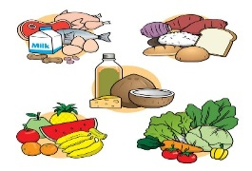  5. books 6. food | - Teacher shows the pictures and asks students to give descriptions to them. Teacher can divide the class into 2 teams and runs the game Who’s faster.  - Members of each team take turns to raise hands to give description for each picture.  -Students discuss their friends’ anwers  -Teacher confirms the answers and gives feedback. The group having more correct answers is the winner.
2.PRACTICE : 7 minutes
A. ACTIVITY 1 (7 minutes)
Aim : - To help students revise the vocabulary learnt.
- To help students match the correct verbs with the appropriate nouns / noun phrases to make phrases about community activities
VOCABULARY  1: COMPLETE THE TABLE WITH THE WORDS AND PHRASES FROM THE BOX. (Ex 1, p. 36)  Answer key:  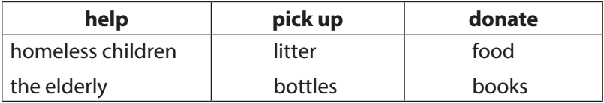 | - Teacher encourages students to complete the task individually.  -Students do the task individually.  - Students exchange their textbooks with their partners.  - Teacher gives feedback as a class discussion.
B. ACTIVITY 2 (7 minutes)
Aim: - To help students use the correct phrases about community activities in the correct contexts.
2: COMPLETE EACH SENTENCE WITH ONE PHRASE FROM TASK 1. REMEMBER TO USE THE CORRECT FORMS OF THE VERBS. (Ex 2, p. 36)  Answer key:  1. donated food  2. picked up bottles  3. helped the elderly  4. donated books  5. helped homeless children | -Teacher asks students to complete the task individually.  - Students do the task individually to put the correct phrases in the blanks.  -Students exchange their textbooks with their partners.  - Teacher gives feedback as a class discussion.
C.ACTIVITY3 :
Aim: - To help students revise the past simple form of some verbs.
.
GRAMMAR  3: USE THE CORRECT FORM OF THE VERBS FROM THE BOX TO COMPLETE THE PASSAGE. (Ex 3, p. 36)  Answer key:  1. had 2. collected  3. sold 4. donated  5. went | -Teacher encourages students to complete the task individually.  -Students complete the passage using the correct forms of the verbs in the box.  -Students exchange their textbooks with their partners.  -Teacher gives feedback as a class discussion.
3. FURTHER PRACTICE
D. ACTIVITY 4 : (3 minutes)
Aim: To help students improve their writing about community activities.
4: WRITE FULL SENTENCES ABOUT THE ACTIVITIES THE STUDENTS DID TO HELP THEIR COMMUNITY LAST YEAR. (Ex 4, p. 36)  Answer key:  1. Mi sang and danced for the elderly at a nursing home.  2. Mark and his friends collected books and set up a community library.  3. Lan and Mai grew and donated vegetables to a primary school.  4. Minh and his friends gave food to young patients in a hospital.  5. Tom made and sent postcards to the elderly at Christmas. | -Teacher asks students to do individually first.  -Students complete the task individually.  -Teacher then asks them to check their answers with a partner before discussing the answers as a class.  -Teacher confirms the answers and corrects students’ pronunciation if necessary.
4. PRODUCTION : PROJECT
E. ACTIVITY 1 (7 minutes)
Aim: - To help students identify problems that their neighbourhood is facing and brainstorm possible solutions to deal with those problems.
5: OUR GREEN NEIGHBOURHOOD  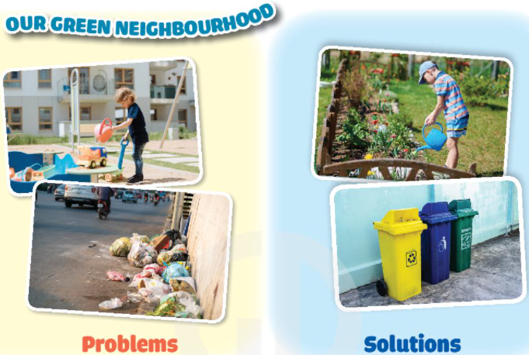 | -Teacher has students work in groups and gives instructions to students as follow:  - discuss some environmental problems their neighbourhood is facing and how you are going to solve the problems.  - look at the pictures as clues to brainstorm ideas.  - Students discuss in groups then present the environmental problem to the class.  -Students vote for the best performance.  -Teacher gives feedback.
4. CONSOLIDATION :
Aim : To consolidate what students have learnt in the lesson.
 | Teacher asks students to talk about what they have learnt in the lesson.
5. HOMEWORK :
Aim: To revise what they have learnt..
-Learn the past simple tense  -Do Exercises in workbook .  - Prepare Review 1 | Teacher guides Ss to prepare homework
*Checking :

