LESSON PLAN
Trường THCS Thi Tran Phu Hoa Giáo viên : Nguyen Thi Thu Loan
Tổ: Tiếng Anh

Date of teaching:6/9/2024
Period 1

LESSON PLAN

INTRODUCTION

I/ OBJECTIVES:

- Introduce to students the content of English 6.

- Make students get acquainted with studying the foreign language.

- Students will be able to understand some commands and requests used in class.

II/ LANGUAGE CONTENTS:

- Grammar: imperatives

- Vocabulary: class expressions

III/ TECHNIQUES : Explaining, repetition

IV/ TEACHING AIDS:

V/ PROCEDURES:
CONTENTS | NOTES
_{1/ WARM-UP: Greetings}  _{2/ PRESENTATION :}  T : - Introduce the content of English7.  - Make students get ready for learning English.  - Supply some commands and requests which are frequently used in class.  A. Some commands and requests usually used in class :  - Stand up, please. - Take out your book / notebook  - Sit down. – Put away your book / notebook  - Listen to me. - Repeat after me.  - Look at the board. - Put your pens down.  - Look at your book (s) .- Work in pairs / groups.  _{- Go to the board.}  B. Asking for permission in class :  _{- May I go out ?}  _{- May I come in ?}  - Parden ? / Can you explain it again ?  _{* What does it mean ?}  It means........................  _{C. Some abbriveations.}  - n : noun - adv. : adverb  - v : verb - pron. : pronoun  -a / adj : adjective - prep. : preposition  _{3 / PRACTICE :}  _{T : make requests or commands.}  _{S: do as ordered}  _{4/ HOMEWORK :}  _{- Learn the class expressions.}  - Prepare for unit 1: My hobbies. | T : guide students how to greet the teacher at the beginning of the class.  - Chatting: What aspects of learning English do you find the most difficult?  - Listening…  explaining  It consists of 12 units  Unit 1: My hobbies – 7 lessons  Unit 2: Health living  Unit 3: community service  Review 1  Unit 4: Music and arts  Unit 5: Vietnamese food and drink  Unit 6: A visit to school  Review 2  Unit 7 Traffic  Unit 8 Films  Unit9 Festivals around the world  Rewiew 3  Unit 10: Energy Sourses  UNIT 11:Travelling in the future  Unit 12: English_ speakingcuontries  Review 4  …………  T: - give commands and requests  - model reading  - explain  - get students repeat ( whole class)  Ss - practice reading  - coppy  T divide the class into groups and pairs  practice speaking  - controlled practice ( T-S)  - free practice (S-S)  How can you learn English well?  - English is not too difficult but it requires your working hard.  - Focusing on vocabulary you come across. Write sentences with the new words to understand more.  - Review the lesson everyday.  - Practise English everyday

Complements:…………………………………………………………………………………………………………………………………………………………………………………………………………………………………………………………………………………………………………………………………………………………………………………………………………………………………………………………………

Date of planning : 5/9/2024 Unit 1: HOBBIE
Date of teaching :7/9/2024
Lesson 1: GETTING STARTED
Period 2: Getting started- My favourite hobby

I. Objectives : By the end of the lesson, students will be able :

-to listen to get specific information about a hobby.

- to read for general and specific information about an unusual hobby.

- to use lexical items related to hobbies.
1. Knowledge:
a. Vocabulary: hobbies’ lexical items
b. Grammar:
- The simple present tense
2. Competences:
- Develop communication skills and creativity
- Be collaborative and supportive in pair work and teamwork
- Actively join in class activities
3. Attitude: To teach Ss to love talking about their hobbies. Ss have the good attitude to working in groups, individual work, pairwork, cooperative learning and working.
II. TEACHING AIDS:
- Text book, teaching plan, a laptop connected TV.
III. PROCEDURES:
Contents | Teacher’s &Student’s activities
1. WARM UP (3 minutes)
Aim: To create an active atmosphere in the class before the lesson
To lead into the unit
What do you like doing for pleasure in your free time?  - Swimming - collecting stamps  - playing badminton - collecting dolls  - What are all these activities called?  HOBBIES | T : Ask  Ss Answer
2. PRESENTATION (15 minutes)
A. ACTIVITY 1
Aim: To introducecthe topic of unit , the vocabulary , the sound , the gramar points to be learnt
T Can you guess who they are?  - Where are they?  - What can you see in the piture?  What may the hobby be?  -Listen to the tape  1. Listen and read.  * New words :  1. unusual (adj) /ʌnˈjuːʒuəl/ khác thường  2. creativity (n) /ˌkriːeɪˈtɪvəti/ sự sáng tạo  3. dollhouse (n) /ˈdɒlhaʊs/ nhà búp bê  4. cardboard (n) /ˈkɑːdbɔːd/ bìa các tông  5. glue (n) /ɡluː/ keo dán, hồ  6. making models /ˈmeɪkɪŋ ˈmɒdlz/ làm mô hình | T asks – Ss answer( individually)  T introduces Elena, nick and his sister.  T plays the recording  Ss listen and read  Ss pick up new words  T explains Voc in Vietnamese and give examples  Ss copy /  -choral reading  -individual reading
3. PRACTICE (12 minutes)
B. ACTIVITY 2:
Aim: Help Ss understand the conversation and do exercise
2. Read the conversation again and tick T (True) or F (Fasle).  - Are the sentences true( T ) or False ( F ) ?  1- Trang needs help the doolhouses.. __F__  She made herself.  2- Trang use glue and cardboard to build her dollouse. __T__  3- To build a doolhouse, you need to use your creativity.. __T__  4-Ann goes to a hourse riding club every Sunday.. _T__  5- Ann’lesson starts at 8p.m __F__  Ann’lesson starts at 8a.m. | Ss read the sentences carefully and decide if they are true or false. Then share their answers with a partner before discussing as a class.  T have Ss correct the false sentences.
C. ACTIVITY 3:
Aim: To introduce some vocabulary iterms related to hobbies
3. Write the words and phrases from the box in each gap.Then Listen and check  1. making models 2. Riding horse  3. collecting coins 4. Gardening  5. building dollhouse  6. collecting teddy bears | T leading SSs to do EX3  Ss Ss work in pairs and complete the table.  - Write their answers on the board  - Explain their answers.  T gives feedback.
D. ACTIVITY 4:
Aim: To help Ss categorise hobbies
4. Work in pairs . Write the hobbies from EX3 in the suitable columns  Doing things Making things Collecting things  Riding horse Gardening . ……. Making models Buiding dollhouse ……. Collecitng coins ….. | Ss work in pairs and complete the table.  - Write their answers on the board  - Explain their answers.  T gives feedback.
4. PRODUCTION (10 minutes)
E. ACTIVITY 5:
Aim: Ss can review the vocabularies by playing game
5 . Find some one Who ….  Using the questions : Do you like …….? | T sets the times 3-5 minutes  Ss ask their friends to complete the table.  The student with the most names wins.
5: HOMEWORK (5 minutes)
Aim: Help Students revise the lesson
- Learn vocabulary by heart.  - Reread EX1, redo exercises.p.9  - Prepare unit 1: A closer look 1. | T guides students to do their homework
- Checking :

Date of planning : 9/9/2024 Unit 1: HOBBIES
Date of teaching : 11/9/2024 Period 3 : Lesson 2 : Acloser look1
I. Objectives : By the end of this lesson, students will be able
- to pronounce correct the sounds / ə / and / ɜː / in isolation and in context.
- use lexical items related to hobbies.

1. Knowledge:
a.Grammar : verbs of liking + V-ing.
b. Vocabulary: hobby lexical items
2. Competences:
- - Linguistic competence, cooperative learning and communicative competence.
3. Attitude:
To teach Ss the love of English . The awareness about importance of learning English. Ss have the good attitude to working in groups, individual work, pairwork, cooperative learning and working.
II. TEACHING AIDS:
- Text book, teaching plan, a laptop connected TV.
III. PROCEDURES:
Contents | Teacher’s &Student’s activities
1. WARM UP (3 minutes)
Aim: To create an active atmosphere in the class before the lesson
- To lead into the unit
Write and read some words / phrases indicating the hobbies you learn. | T divides class into two groups.  Ss go to the board and write the words  T gives feedback.  Ss read new words in chorus.  T introduces the new lesson
2. PRESENTATION (7 minutes)
A. ACTIVITY 1
Aim: To present some action verbs that go with nouns to describe hobbies
Vocabulary  1- go : swimming , jogging ( camping / horse- riding  2- do : judo , yoga . ( karate , gymnastics …. )  3-. collecting : dolls , coins ( bottles / phothos /…..) | T have Ss read the action verbs in column A and match them with the suitable words / phrases in column B.  Remind them that a verb can go with more than one word/ phrase.  Ss work in pairs- give their answer.  T check and confirm the correct answer.
3. PRACTICE (7 minutes)
B. ACTIVITY 2:
Aim: Help Ss practice the verbs of liking or disliking and action verbs
Complete the sentences, using the -ing form of the verbs from the box  1- collecting 2- going 3-playing  4- making 5-doing | Ss read the sentences carefully and decide if they are true or false. Then share their answers with a partner before discussing as a class.  T have Ss correct the false sentences.
C. ACTIVITY 3: (8 minutes) FURTHER PRACTICE
Aim: To give futher practice with verbs of liking / disliking
3. Look at the pictures and say the sentences. Use suitable verbs of liking or disliking and the -ing form  1. He hates / doesn’t like doing judo  2. They enjoy playing football  3. They like gardening  4. They like collecting stamps  5. She hates riding a horse | T Ask Ss to work in pairs to make sentences by looking the pictures  Ss : doing Ex and share their answers  T gives feedback.
D. ACTIVITY 4: (7 minutes) PRONUNCIATION
Aim: Ss can pronounce correctly the sounds / ə / and / ɜ :/ isolation and in context
4 Listen and repeat. Pay attention to the sound /ə/ and /3:/  ə/ /3:/  Amazing Yoga Collect Column Learn Surf Work Thirteen | Ss work in pairs and complete the table.  - Write their answers on the board  - Explain their answers.  T gives feedback.
E. ACTIVITY 5: (8 minutes)
Aim: help Ss to pronunce the sound /ə/ and /3:/
Listen to the sentences and pay attention to the underlined parts. Tick (√) the appropriate sounds. Practice the sentences  /ə/ /3:/  1. My hobby is collecting dolls √  2. I go jogging every Thursday √  3. My cousin likes getting up early √  4. My best friend has thirty pens √  5. Nam enjoys playing the violin √ | T sets the times 3-5 minutes  Ss ask their friends to complete the table.  The student with the most names wins.  Ss do this exercise individually first, then compare their answer with a partner.  T checks their answers.  Ss say the words that has  / ə/ or / ɜː in each sentence.  Ss read the sentences loudly.
5: HOMEWORK (5 minutes)
Aim: Help Students revise the lesson
- Learn the new words by heart.  - Practice pronouncing two sounds / ə / and / ɜː /.  - Redo the exercise B1,2,3 ( page 10 – textbook )  - Prepare CLOSER LOOK 2 | T guides students to do their homework
- Checking :

Date of planning: 10/9/2024
Date of teaching: 13/9/2024

Unit 1: HOBBIES
Period 4 : Lesson 2 : Acloser look2
I. Objectives : By the end of the lesson, the students will be able to:
- use the Present simple tense correctly.
1. Knowledge:
a.Grammar : Present simple tense
b. Vocabulary: hobby lexical items
2. Competences:
- - Linguistic competence, cooperative learning and communicative competence.
3. Attitude:
To teach Ss the love of English . The awareness about importance of learning English. Ss have the good attitude to working in groups, individual work, pairwork, cooperative learning and working.
II. TEACHING AIDS:
- Text book, teaching plan, a laptop connected TV.
III. PROCEDURES:
Contents | Teacher’s &Student’s activities
1. WARM UP (3 minutes)
Aim: To create an active atmosphere in the class before the lesson
- To lead into the unit
-What do you often do for pleasure in free time?  - Who do you often share your hobby with?  -What time do you get up? | T : Ask some questions  Ss : answer about them.  T leads in the situation  - What tense is used here ? The present simple tense
2. PRESENTATION :
A. ACTIVITY 1 (7 minutes)
Aim: To help Ss to identify and remember the uses of the present simple tense
. Grammar:  1.The present simple :  + S+ V.(s, es)  - S + don’t / doesn’t + V (m)  ? Do /Does + S + V (m) ?  Match the sentences (1-5) to the correct uses (a-c) :  1-b 2-a 3-c  4-a 5-b | T : Ask Ss to remind the simple present ( the form , the usage ,…)  T : Ask Ss to do EX  Ss : Do EX individually  - share answer with partner  T ; correct
3B. ACTIVITY 2: (7 minutes)
Aim: Help Ss practice the correct form of the present simple tense
2. Complete the sentences. Use the present simple form of the verbs  1- make 2- does…do 3. have  4. doesn’t like 5. Does….start…?  3. Fill in each blank with the correct form of the verb in brackets  1- enjoys 2- spends 3-don’t like  4- go 5- begins 6-don’t enjoy | T asks Ss to present the form and the usage of these two tenses.  Ss do this exercise individually and then compare the answers with a partner  Ss write the correct answer on  the board.  T give feedback – correction.  . Ss do this exercise individually and then compare the answers with a partner.  Ss write the correct answer on the board.  T give feedback – correction
C. ACTIVITY 3: (8 minutes) FURTHER PRACTICE
Aim: To give futher practice with the present simple tense
4.Write complete sentences, using the given words and phrases. You may have to change the words or add some  1. The sun sets in the west every evening  2. Do Trang and Minh play basketball everyday after school?  3. The flight from Ho Chi Minh city doesn’t arrive at 10.30  4. Our science teacher starts our lessons at 1 p.m on Fridays  5. Do you make models at weekend? | Ss write the sentences using the words as clues.  Some Ss go to the board and write their sentences.  T check and comment on Ss’ sentences.
D. ACTIVITY 4: (7 minutes) PRODUCTION
Aim: To help Ss make sentences with thr present simple tense
5. Sentences race  Work in group.  Go  I go to school every morning .  Rise  The Sun rises in the East . | T : Remind the present simple tense  - Divide Ss into groups assign a group leader  - Write e verb on the board  Ss : make senteces with the verbs ,,using the present simple tense  T : comment and announce the winners
5: HOMEWORK (5 minutes)
Aim: Help Students revise the lesson
- Learn grammar notes by heart.  - Rewrite the exercises in your notebook.  *Prepare section 4 COMMUNICATION | T guides students to do their homework
- Checking :

Date of planning: 10/9/2024
Date of teaching: 13/9/2024
Unit 1: HOBBIES
Period 5 : Lesson 4 : COMMUNICATION
I. Objectives : By the end of this lesson, Ss will be able to describe and give opinions about hobbies.
1. Knowledge:
a.Grammar : Present simple tense
b. Vocabulary: hobby lexical items
2. Competences:
- Develop creativity and communication skills
- Be collaborative and supportive in pair work and team work
- Actively join in class activities
3. Attitude:
- Help Ss Be ready to describe and give opinions about hobbies.- Be interested more about new hobbies.
II. TEACHING AIDS:
- Text book, teaching plan, a laptop connected TV.
III. PROCEDURES:
Contents | Teacher’s &Student’s activities
1. WARM UP (3 minutes)
Aim: To create an active atmosphere in the class before the lesson
- To lead into the unit
GAME: Arrange the following verbs of linking in descending order of preference .  Like , detest , dislike , adore , love , hate  Keys :  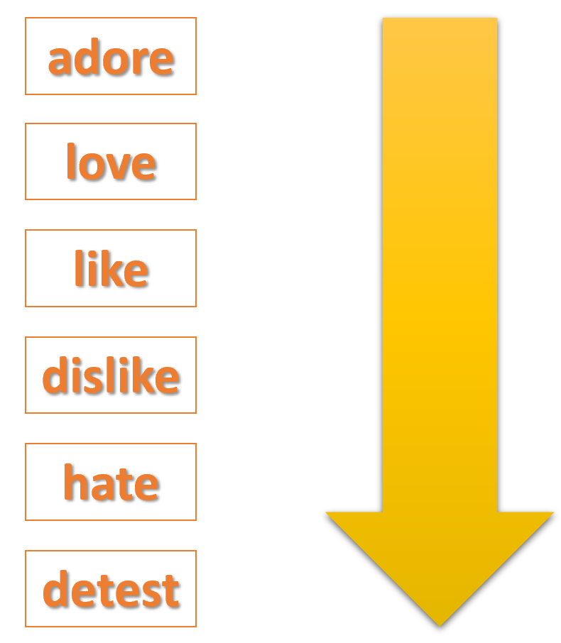 | T: Lead Ss to play a game  Ss : working in group then give the answers  T Ask Ss to make sentences about theses verbs  - What tense is used here ? The present simple tense
2. PRESENTATION :
A. ACTIVITY 1 (7 minutes)
Aim: To help Ss practise talking about likes and dislikes.
EX1+2 Listen and read the dialogue below. Pay attention to the questions and answers. Work in pairs. Ask and answer the questions about what you like and don’t like doing. | T: Play the recording for Ss to listen and read the dialogue between Mi and Ann at the same time.  Ss : Listen to the tape  T- Ask Ss to pay attention to the questions and answers.  Have Ss practise the dialogue in pairs.  - T call on some Ss to give examples.  Ss : discuss the answers.  T : confirm the answers and gives feedback
B. ACTIVITY 2: (7 minutes)
Aim: To provide practice with answering about Ss’ hobbies.
Answer the questions. Fill in column a with your answers (Ex 3, p. 13)  How much free time do you have a day ?  What do you not like doing ?  What do you like doing every day / in the summer ….. ? 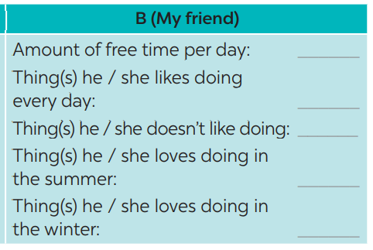 | T asks Ss to work individually and fill in column A  Ss work individually to do the task.  T invites some Ss to share their answers before checking with the whole class.  T gives feedback and comments.  T gives feedback – correction
C. ACTIVITY 3: (8 minutes) FURTHER PRACTICE
Aim: To let students further practise asking and answering about hobbies
NOW INTERVIEW YOUR FRIEND, USING THE QUESTIONS IN 3. WRITE HIS / HER ANSWERS IN COLUMN B. (Ex 4, p. 13) | T asks Ss to take turns being the person who asks the questions. This S has to note down his/ her partner’s answers to report to the class later.  Ss work in pairs to do the task.  T calls on some Ss to report the answers to the class.  T and other Ss give comments.
D. ACTIVITY 4: (7 minutes) PRODUCTION
Aim: To consolidate what Ss have learnt in the lesson.
Compare your answers with your friends. Then present them to the class. (Ex 5, p. 13)  Example:  I have one hour of free time a day, but my friend Lan has only about 30 minutes.  I like listening to music every day, and Lan likes it too. I don’t like exercising,  but Lan does. | T asks Ss to read the example to understand how to report the answers.  Ss work in pairs again to compare the answers and prepare a short presentation.
5: HOMEWORK (5 minutes)
Aim: Help Students revise the lesson
- Practice speaking  - Write about five sentences about your hobbies using like or dislike  - Preare skills 1 | T guides students to do their homework
- Checking :
Date of planning: 16/9/2024
Date of teaching: 18/9/2024

Unit 1: HOBBIES
Period 6 : Lesson 5 : Skill 1
I. Objectives - Develop reading skill for general and specific information about Gardening.
- Talk about their hobbies and the benefits of them.
1. Knowledge:
a.Grammar : Present simple tense
b. Vocabulary: hobby lexical items
2. Competences:
- Linguistic competence, cooperative learning and communicative competence.
3. Attitude:
-Help Ss understand more about their preference of different types of hobbies
- Ss have the good attitude to working in groups, individual work, pairwork, cooperative learning and working.
II. TEACHING AIDS:
- Text book, teaching plan, a laptop connected TV.
III. PROCEDURES:
Contents |  |  | Teacher’s &Student’s activities
1. WARM UP (3 minutes)
Aim: To create an active atmosphere in the class before the lesson.
- To lead into the new lesson.
 | T introduces the objectives of the lesson and asks Ss to list out as many hobbies as possible within 1 minute.  Ss work in groups to brainstorm hobbies.  Which teams can list out more correct  T introduces the objectives of the lesson and asks Ss to list out as many hobbies as possible within 1 minute.
2. PRE-READING
A. ACTIVITY 1 (7 minutes)
Aim: To lead in the reading skills.
1: Work in pair. Look at the picture and discuss the questions below.  2  Vocabulary :  outdoor (adj) /ˈaʊtdɔː(r)/ ngoài trời  patient (adj) /ˈpeɪʃnt/ kiên nhẫn  responsibility (n) /rɪˌspɒnsəˈbɪləti/ trách nhiệm  maturity (adj) /məˈtʃʊərəti / sự trưởng thành  valuable (adj) /ˈvæljuəbl/ giá trị |  | T has Ss look at the picture in the book or show the picture in the book on a slide.  - Ask Ss who they see in the picture and what they are doing.  T has Ss work in pairs to discuss the two questions.  T invites some Ss to share their answers.  - Tell Ss that they are going to read a text about gardening.  T : Explain Voc  Explaination  Translation  Ss Read Voc  - play with Voc
3. WHILE – READING (7 minutes)
ACTIVITY 2
Aim To help students read to find some words in context, and their meaning.
To develop reading skill for specific information.
2: Read the text about gardening. Match each word in column A with its definition in column B. (Ex 2, p. 14)  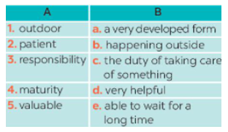  Answer key:  1. b 2. e 3. c 4. a 5. d |  | T tells Ss what they are going to do.  - T asks Ss how to do the exercise. Elicit answers from Ss.  + Read around the word to get the general meaning.  + Read the definitions in column B, find the suitable meaning to match each word.  Ss do the exercise individually and then check answers in pairs.  T invites some Ss to share their answers.  confirm the correct answers.
C. ACTIVITY 3: (8 minutes)
Aim: To develop reading skill for specific information.
3: Read the text again. Complete each sentence with no more than three words. (Ex 3, p. 14)  Answer key:  1. doing things 2. insects and bugs 3. patient  4. join in 5. an hour |  | T asks Ss to do the exercise individually and then check their answers in pairs.  Ss share their answers. Have them explain their answers.  T Confirm the correct answers.
4. PRE-SPEAKING
. ACTIVITY 4: (7 minutes)
Aim: To help Ss form the ideas for their speaking
4: Work in pairs. Match each hobby with its benefit. One hobby may have more than one benefit. (Ex 4, p. 14)  Answer key:  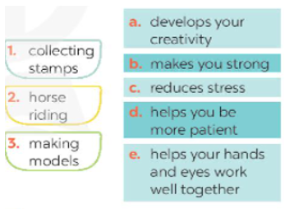  1. c, d 2. b, c 3. a, c, d, e |  | T introduces some structures to talk about the benefits of hobbies:  – Give some examples.  ** Ss work in pairs to match the hobby with its benefit(s). Check as the whole class.  – T asks Ss to name other benefits of these hobbies.  Invite some Ss to share their answers.  T Confirm the answers.
5: WHILE-SPEAKING (5 minutes)
ACTIVITY :5
Aim: To help Ss use what they have learnt so far to talk about hobbies.
5: Work in group. Ask one another the following questions. Then present your partners’ answers to the class. (Ex 5, p. 14)  1. What is your favourite hobby?  2. What are its benefits? |  | T Have Ss work in groups to ask and answer the two questions.  – Model the answers to the two questions if needed.  Ss work in groups to ask and answer the two questions.  T Invite some Ss to share their partner’s answers to the questions.  – Invite other Ss to comment on the answers.  T Comment on Ss’ answers.
6. POST-READING AND SPEAKING (5 minutes)
Aim: - Check Ss’ understanding about the reading passage.
- To help some Ss enhance presentation skill.
T allows Ss to give comments for their friends and vote for the most interesting and informative presentation.
Ss do as required.
T calls Ss to share answer.T gives feedback and comments.
7. HOMEWORK : (5 minutes)
Aim: To review the lesson that they have learnt and prepare for the next lesson Skills 2.
- Learn Vocbulary by heart  - Practice speaking about your hobby before your friends.  * Prepare section 6: SKILL 2 |  | T : Lead Ss to prepare homework

- Checking :

Date of planning: 17/9/2024
Date of teaching: 18/9/20234

Unit 1: HOBBIES
Period 7 : Lesson 6 : SKILLS 2
I. Objectives - Use the lexical items related to the topic Hobbies
- Listen for specific information about Trang’s hobby
- Write a passage about her hobbies
1. Knowledge:
a.Grammar : Present simple tense
b. Vocabulary: hobby lexical items
2. Competences:
- - Linguistic competence, cooperative learning and communicative competence.
3. Attitude:
- Help Ss Learn more about their own hobby
- Be encouraged to take up a new hobby if they haven’t had one
II. TEACHING AIDS:
- Text book, teaching plan, a laptop connected TV.
III. PROCEDURES:
Contents | Teacher’s &Student’s activities
1. WARM UP (3 minutes)
Aim: To create an active atmosphere in the class before the lesson.
- To lead into the new lesson.
What will you mention when you talk about someone’s hobby?  Suggested answers:  + Name of the hobby  + The time he / she started the hobby  + His / Her feeling about the hobby  + His / Her future plan about the hobby | CHATTING  -T asks Ss to answer the question:  - Ss work individually to answer the questions.  - T calls Ss to give answers.  -T sets the scene: You are going to listen to an interview about Trang’s hobby and complete the word web.
2. PRE-LISTENING
A. ACTIVITY 1 (7 minutes)
Aim: To provide students with some lexical items before listening the text.
Vocabulary :  Decorate (v) : /ˈdekəreɪt/ : trang trí    benefit (n) /ˈbenɪfɪt/ lợi ích  1:Look at the picture. What hobby is it? Do you think it is a good hobby? Why or why not? (Ex 1, p. 15)  + Do you know anything about building dollhouses?  + Do you think it is a good hobby? Why/ Why not?  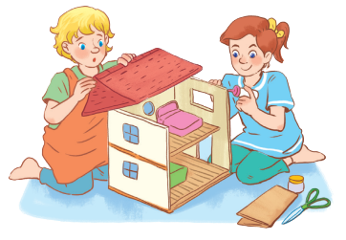 | T : Explain Voc  Explaination  Translation  Ss Read Voc  play with Voc  * T asks Ss to work in pairs to answer the questions.  Ss work in pairs to answer.  Ss share their answers. T monitors and accepts all answers if they make sense.  T explains the way to listen to Trang’s hobby and asks them to guess and complete the mind map.  Ss share their answers
3. WHILE-LISTENING (7 minutes)
ACTIVITY 2
Aim To help Ss develop the skill of listening for specific information.
2: Listen and complete the mind map. (Ex 2, p. 15)  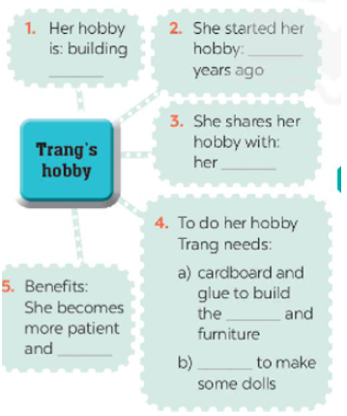  Answers:  1. dollhouses 2. three / 3 3. cousin  4. a) house b) cloth 5. creative | -T asks Ss to work individually to listen and complete the word web.  -Ss work individually to listen and complete the word web.  -Ss work in pairs to compare their answers with each other and with the word / phrase on the board.  -T plays the recording a second time for pairs to check their answers.  -T asks Ss to write the answers on the board.  -T Checks and corrects.
4. POST-LISTENING
C. ACTIVITY 3: (8 minutes)
Aim: To check Ss’ understanding of the listening part.
Summarize the information of the listening part | T asks Ss to work in groups of four.  Ss work in groups of four.  T asks Ss to summarize the information in the listening part and talk about it.  T helps if necessary.  Ss give answers.  T gives comments and feedback.
4. PRE-WRITING
ACTIVITY 4: (7 minutes)
Aim: To help Ss take notes and make outline for the next writing passage.
3: What is your hobby? Fill in the blanks below. (Ex 3, p. 15)  1. Colecting stamps  2. 3 years ago  3. My brother  4.a lot of stamps  5. It makes me more patient and reduce stress. | T tells Ss that they are going to write about his / her hobby.  T asks Ss to use the word web as a way to organize their ideas.  T models with a S (Ex: Lan)  Ss work individually to do Task 3.  T checks the answer.  T give more comments and feedback.
5: WHILE-WRITING (5 minutes)
ACTIVITY :5
Aim: To let Ss write about their hobby..
4: Write a paragraph about your hobby. (Ex 4, p.15)  My hobby is collecting stamps. I started it three years ago. I shared it with my friends and family.  With this hobby, I need a lot of stamps. | T asks Ss to write their paragraphs individually based on the information in their word webs.  Ss listen to the teacher then do the task.  T asks one S to write his / her paragraph on the board.  T asks Ss to check the writing.  T gives comments to the students.
7. HOMEWORK : (5 minutes)
Aim: To wrap up and consolidate what Ss have learnt in the lesson.
- Write about one of your family members’ hobby in about 60 words.  - Prepare : Looking back | T : Lead Ss to prepare homework

- Checking :

Date of planning:18/9/2024
Date of teaching: 20/9/2024

Unit 1: HOBBIES
Period 8 : Lesson 7 : Looking back
I. Objectives : By the end of the lesson, the students will be able to:
- Review the vocabulary and grammar of Unit 1
- Apply what they have learnt (vocabulary and grammar) into practice through a project
1. Knowledge:
a.Grammar : Present simple tense / verbs of liking
b. Vocabulary: hobby lexical items
2. Competences:
- - Linguistic competence, cooperative learning and communicative competence.
3. Attitude:
- Help Ss be more creative when doing the project and develop self-study skills
II. TEACHING AIDS:
- Text book, teaching plan, a laptop connected TV, - sachmem.vn
III. PROCEDURES:
Contents | Teacher’s &Student’s activities
1. WARM UP (3 minutes)
Aim: - To revise the vocabulary related to the topic and lead in the next part of the lesson.
- - To enhance Ss’ skills of cooperating with team mates.
GAME: GUESSING GAME  E.g:1. I have a lot of bottles, dolls or stamps. What is my hobby? | -T divides the class into two big groups.  - Ss take turns to think of a hobby for your partner to guess.  - Their partner can ask up to 10 yes / no questions and he / she can only answer with a 'yes’ or 'no’.  - Time allowance: 3 minutes  T asks ss to listen carefully and say aloud the name of the hobby. Who has the quicker and correct answer will get one point. The group with more points is the winner.  Ss work in groups to do the task.  Ss give answer.  T monitors and gives feedback.
2. PRACTICE
A. ACTIVITY 1 (7 minutes)
Aim: To help Ss revise the vocabulary items they have learnt in the unit
1: Complete the sentences with appropriate hobbies. (Ex 1, p. 16)  Answer key:  1. collecting coins 2. doing judo  3. making models 4. gardening  5. playing football | T Have Ss do this activity individually then compare their answers with their partners.  Ss do this activity individually.  T Ask for Ss’ answers or ask one student to write his / her answer on the board.  - Confirm the correct answers.
B. ACTIVITY 2: (7 minutes)
Aim: To help Ss revise vocabulary relating to hobbies.
2: Write true sentences about you and your family members. (Ex 2, p. 16)  I like ……………….  My dad enjoys ………………  My mum doesn’t like ………………..  My grandmother loves ……………….  My grandfather hates ………………….. | T has Ss write true sentences about them and their family members.  Ss write true sentences about them and their family members.  T asks them to share their answers with a classmate.  T invites some Ss to write their sentences on the board. T and other Ss comment  Ss write the correct answer on the board.  T give feedback – correction
C. ACTIVITY 3: (8 minutes) GRAMMAR
Aim: To help Ss revise the present simple.
3: Use the present simple form of each verb to complete the passage. (Ex 3, p. 16)  Answer key:  1. loves 2. has 3. enjoys 4. don’t like 5. is 6. is 7. go 8. Begins | T Ask Ss about the uses of the present simple that they have learnt in the unit.  T Have Ss do this exercise individually.  Ss compare their answers with a partner. Call on some Ss to give the answers.  T Confirm the correct answers and write them on the board.
D. ACTIVITY 4: (7 minutes)
Aim: To help Ss revise the present simple in questions and negative sentences.
4: Change the following sentences into questions and negative ones. (Ex 4, p. 16)  Answer key:  1. Does this river run through your home town?  This river doesn’t / does not run through my home town.  2. Does your drawing class start at 8 a.m. every Sunday?  My drawing class doesn’t / does not start at 8 a.m. every Sunday.  3. Do they enjoy collecting stamps?  They don’t / do not enjoy collecting stamps.  4. Do you do judo every Tuesday?  I don’t / do not do judo every Tuesday.  5. Does your brother love making model cars?  My brother doesn’t / does not love making model cars. | T HaS Ss do this exercise individually then compare their sentences with a partner.  Ss do this exercise individually.  T InviteS some Ss to read their answers aloud.  - Give feedback.
E. ACTIVITY 5: CONSOLIDATION (7 minutes)
Aim: Help Students revise the lesson
 | T: remind the simple present tense and Vocabulary in uint 1
F. ACTIVITY 6 : PROJECT
Aim : To allow Ss to apply what they have learnt (vocabulary and grammar) into practice through a project.
HOBBY POSTER | T Ask Ss to read the instructions again . Make sure they understand what to do  - Ask Ss to work in group to do the project Ss may do the project at home and hand them in the Next period  Ss vote for the best poster.  T comment and give marks
5: HOMEWORK (5 minutes)
Aim: Help Students revise the lesson
- Revise the Voc related to the topic “ hobbies “  - Revise the present simple tense  *Prepare Unit 2 : getting started | T guides students to do their homework

- Checking :

