**Review E 5 Ki 2 Read and circle the correct answer.**

1. Are you going to do your homework? - Yes,............A. I am           B. I was         C. he is          D. he was

2. What's the matter............. you? -I have a cold.A. to              B. with              C. from        D. in

3. How many seasons are............ in England?A. these           B. those              C. they         D. there

4. It's often............... in the rainy season.A. cold              B. warm               C. rainy        D. sunny

**Task 6. Look and read. Put a tick(v) or a cross (x) .**

|  |  |  |
| --- | --- | --- |
| He is skating. |  | V |
| Don’t play with the matches |  | X |
| 1. He has fever. |  |  |
| 2.I’m reading the Story of Mai An Tiem |  |  |
| 3.I’d like to be an architect because I’d like to design buildings. | kien truc su |  |
| 4.Phong and Nam often go capping in their free time | cau ca |  |
| 5 .She’d like a teacher. |  |  |

**Task 7: Read and answer the questions.**

**Last Sunday, Lan didn't go to school, but she went to her friend's birthday party. She got up early in the morning, went to the shop, and bought some gifts and flowers. Then, she went to her friend's house. At the party, she ate a lot of cakes and drank soft drink. She danced beautifully, sang many songs, and told a lot of interesting stories. All her friends were there too. They played many games such as hide and seek, skipping rope and cards. They were very happy and enjoyed themselves a lot. Finally, the party came to an end. They said goodbye to each other and went home late in the the evening.**

**1. Did Lan go to school yesterday?**

**.....................................................................................**

**2. Where did she go to?**

**....................................................................................**

**3. What did she do at the party?**

**.....................................................................................**

**4. When did they go home?**

**.....................................................................................**

**Task 8 . Look and complete. There is one example.**

|  |  |
| --- | --- |
| Ex: 0. I have a ........................ |  |
| 1. Where is the ……………………….? |  |
| 2.I ’d like to be a …………………..…..? |  |
| 3.They usually go…………………….. in the forest. |  |
| 4.The strory of …………………………is a famous of Vietnamese. |  |

**Task 9 : Put the words in order.**

1.today / These / going / the / students / are / cinema / to.

______________________________________________________________________

2.stay / home / you / yesterday / at / Did /?

______________________________________________________________________

3.go / your / does / Where / weekend / brother / on / ?

______________________________________________________________________

4.like / the / in / What / weather / summer / is ?

_____________________________________________________________________

1. Does he have math on Friday? - Yes, he _______________.A. is B. does C. doesn’t

2. My class finishes at half _______________ ten.A. to B. pass C. past

3. _______________ do you go to school? - by bike.A. What B. How C. Who

4. I take a bus to school every day, but I am _______________ to school now.A. walking B. walk C. walks

5. _______________ a truck in front of the store.A. There are B. There is C. Those are

**Read the following text and write True or False.**

I am Tra My. I am at school with my friends. We are all hungry now because it’s lunch time. I’d like some rice with beef and a bottle of water. Mary doesn’t like beef. She would like some rice with chicken and a carton of milk. She drinks three cartons of milk every day. Manh would like a bowl of noodles and a can of coke. He drinks two cans of coke every day. We like eating in the school canteen because the food is delicious and clean.

1. Her name is Tra My.

2. She is at her house.

3. Tra My has a can of milk.

4. Mary has rice with chicken.

5. Manh doesn't have noodle.

6. They like their school canteen.

**Reorder these words to have correct sentences**

1. had/ yesterday/ They/ fun/ a lot of/ ./__________________________________________

2. Do/ plane/ Ho Chi Minh City/ you/ to/ go/ by/ ?__________________________________________

3. is/ late/ always/ for class/ Lisa/ ?/_____________________________

1. him/ the/ what’s/ with/ matter___________________________________________  
2. have/ a/ I/ fever/ bad___________________________________________

3. should/ see/ you/ dentist/ the___________________________________________

4. shouldn’t/ carry/ you/ things/ heavy___________________________________________

5. a/ I/ bad/ have/ cough_____________________________________

1. Why would you like to be a writer? - _______.

A. Because I would like to look after the patients. B. Because I would like to teach the children.

C. Because I would like to write stories for children. D. Because I would like to fly a plane.

2. Linda has a pain in her throat. She has a/an ___A. toothache B. sore throat C. earache D. backache

3. Don’t ride your _____ so fast! A. car B. matches C. bike D. stairs

1. What would you like _______?A. to eat B. eat C. eating D. eats

2. They _________ swimming last Saturday.A. go B. going C. went D. goes

3. He should go to the ________ because he has a toothache.A. dentist B. architect   C. teacher D. pilot

4. What’s the matter _______ you? - I have a cold.A. to B. with C. from D. in

5. How many seasons are ________ in England? A. these B. those C. they D. there

**I. Odd one out.**

1.A. tooth B. eye C. head D. matter

2.A. bought B. flew C. danced D. sang

3.A. beautiful B. souvenir C. interesting D. colorful

4.A. weather B. summer C. autumn D. winter

5.A. pharmacy B. museum   C. cinema D. opposite

1.A. windy B. cloudy C. sky D. rainy

2.A. fever B. matter C. toothache D. cough

3.A. mouth B. arm C. health D. eye

4.A. summer B. spring C. season D. winter

5.A. village B. bus stop C. railway station D. airport

**Read and match.**

1. Where did Hoa go last Sunday? A. It’s more beautiful than I expected.

2. How can I get to the nearest bus station? B. It’s quite hot.

3. What would you like to drink?  C. She went to her best friend’s house.

4. What is the weather like today? D. A cup of tea, please.

5. What do you think of Hoi An Ancient town? E. Go ahead for about five minutes. It’s next to the bookshop.

2. ________ is it from Hanoi to Hue? ~ About 900 kilometers.

A. How old B. How C. How far D. How many

3. There are four ________ in my country: spring, summer, autumn and winter.

A. season B. seasons C. people D. students

4. What ________  you ________  next weekend?

A. do / do B. are / do C. did / do D. are / going to do

5. James would like to be a _______ in the future because he wants to fly a plane.

A. architect B. pilot C. astronaut D. worker

6. Yesterday John ________  go to school because he ________ a toothache.

A. didn’t / had B. doesn’t / has C. didn’t / has D. doesn’t / had

7. How do you get to your hometown? – I ______ a coach. A. make   B. do   C. go D. take

**Find ONE mistake in each sentence and correct it.**

1. What’s the matter by you?

2. Last Saturday, I am at Hoa’s birthday party.

3. He likes watching TV. He watch it every day.

4. Mai is writeing a story at the moment.

5. How much bowls of rice do you eat every day?

**Rearrange the given words to make correct sentences.**

1. music/ did/ to/ listen/ you/ last night________________________________________________?

2. rainy/ wet/ season,/ In/ is/ everything/________________________________________________.

3. wants/ a/ Phong/ footballer/ to/ be .________________________________________________.

4. in/ the weather/ What/ spring/ like/ is/ your country/ in________________________________________________?

5. just/ here/ is/ The cinema/ from/ five-minute walk________________________________________________.

1. A: What's the matter? B: __________________a. I have a cold. b. I feel great today.

2. A: What's wrong with your teeth? B:__________________a. I have a stomach ache. b. I have a toothache.

3. A: You should have a rest. B: __________a. Thanks for your advice. b. I'm very well. Thank you.

4. A: How are you feeling today? B: __________________a. No problem b. I’m very well. Thank you.

**Listen and number. Nghe Unit 15**

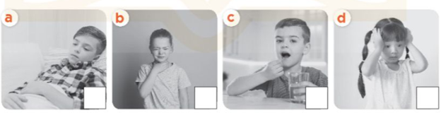

**Read and complete.**

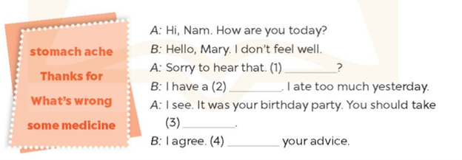

Read and circle.

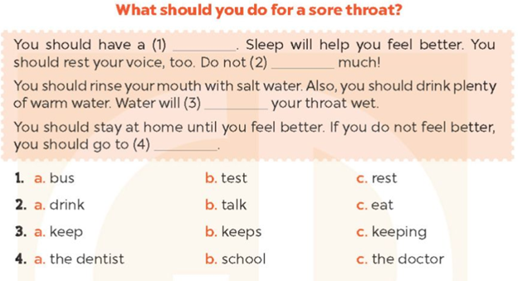

Make sentences.

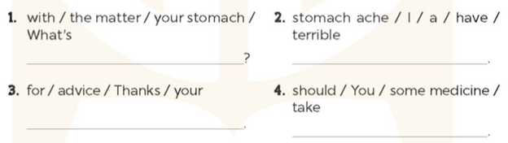

**Nghe Self- check3 1. Listen and number.**

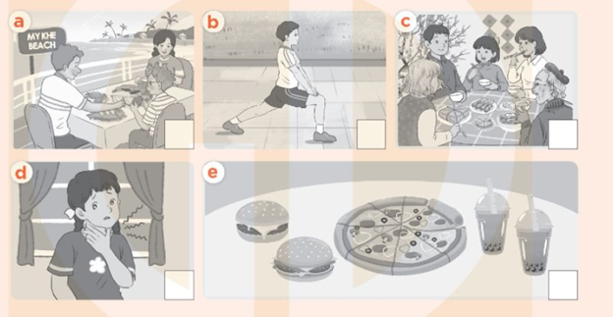

Make sentences.

1. should / take / You / some medicine

2. your sister / twice a week / Does / play sports

3. buy/Will/a branch of peach blossoms / you / for Tet

4. they do / at / Mid-Autumn Festival/ What will?

5. collected / with /1/ seashells / my brother

a. 2b. 1c. 5d. 4e. 3