1. Dora would like to be a gardener in the future..

2. Dora doesn’t like trees, but she likes flowers.

3. Dora father gives her many seeds.

4. Dora’s house has got a large garden.

5. Dora waters the flowers twice a day..

**I. Odd one out.**

1.A. tooth B. eye C. head D. matter

2.A. bought B. flew C. danced D. sang

3.A. beautiful B. souvenir C. interesting D. colorful

4.A. weather B. summer C. autumn D. winter

5.A. pharmacy B. museum   C. cinema D. opposite

1.A. windy B. cloudy C. sky D. rainy

2.A. fever B. matter C. toothache D. cough

3.A. mouth B. arm C. health D. eye

4.A. summer B. spring C. season D. winter

5.A. village B. bus stop C. railway station D. airport

II. Choose the correct answer.

1. What would you like _______?

A. to eat B. eat C. eating D. eats

2. They _________ swimming last Saturday.A. go B. going C. went D. goes

3. He should go to the ________ because he has a toothache.

A. dentist B. architect   C. teacher D. pilot

4. What’s the matter _______ you? - I have a cold.A. to B. with C. from D. in

5. How many seasons are ________ in England?A. these B. those C. they D. there

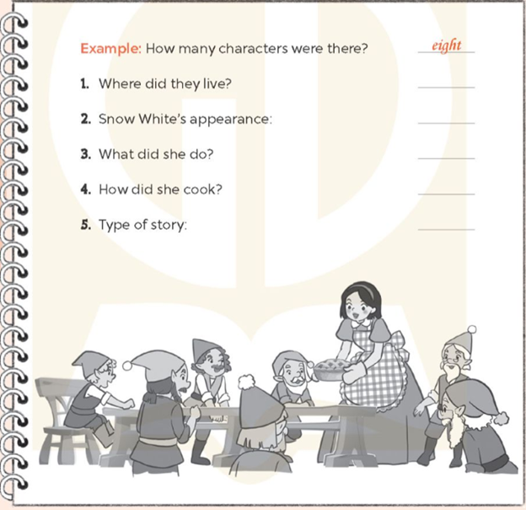

This summer, Nga and her family are going to visit Da Nang. They are going to get there by plane. They are going to stay in a hotel in the city. First, they are going to see Dragon Bridge. It looks beautiful at night. They are going to swim in the sea and eat some seafood at My Khe Beach. After that, they are going to take a cable car to Ba Na Hills. They are going to visit Golden Bridge and French Village, and take lots of photos there. Finally, they are going to go to Hoi An by coach. It is about thirty kilometres from Da Nang City. They are going to visit Hoi An Ancient Town, look at the lanterns and buy some gifts at the night market. Hoi An is a really attractive place for all visitors.

1. How is Nga's family going to get to Da Nang?a. By train. b. By plane. c. By coach.

2. What are they going to see first?a .Dragon Bridge. b. Golden Bridge. c. My Khe Beach.

3. Which place are they going to visit at Ba Na Hills?a. Golden Bridge. b. French Village. c. a and b.

4. How far is it from Da Nang City to Hoi An? a. About 3 km. b. About 13 km. c. About 30 km.

5. What is Hoi An like for visitors?a. Exciting. b. Attractive. c. Peaceful.

**Circle and write.**

1. What do the children think (of / with) _______ Ba Na Hills?

2. They think Ban Gioc Waterfall is (beautiful / beauty) __________.

3. How (long / far) _________ is it from Hue to Nha Trang?

4. It's about 149 (kilometres / metres) ____________ from Can Tho to Ca Mau.

**Lan and her parents** are going to visit London this summer. First, they are going to visit Buckingham Palace. It is a beautiful place where the King lives. After that, they are going to visit Big Ben. Big Ben is a very large bell inside a tower. There is a clock on the tower. Many people believe that the tower is called Big Ben, but that is not true. Then, they are going to see the London Eye. It is a big, tall wheel that moves around. It looks wonderful at night. Finally, they are going to visit Tower Bridge. It is over the River Thames, one of the famous historic places in London.

1. When is Lan's family going to visit London?a. This weekend. b. This summer. c. This winter.

2. What place are they going to visit first? a. Big Ben b. The London Eye

3. What is Big Ben?a. A clock b. A bell c. A tower

4. How does the London Eye look at night?a. Beautiful b. Wonderful c. Famous

5. What is over the River Thames?a. The London Eye. b. Big Ben. c. Tower Bridge.

**Read and complete.**

**1. _________ do you think of Sydney Opera House?a. How b. Where c. What**

**2. I __________ London is big and exciting. a. think b. tell c. speak**

**3. It's about 500 metres from my house ______ the bank. a. at b. on c. to**

**4. How far _______ from your school to the park? a. are they' b. is it c. are you**

**Listen and tick True or False.**

**Mai likes Mid-Autumn Festival.**

**1. The festival is in October this year..**

**2. The party will be in the school playground..**

**3. Mai will sing songs at the party.**

**4. Mai and her friends will have mooncakes and apples at the party..**

**5. Bill wants to come to the party.**

**Listen and choose**

1. How's the weather in Ha Noi in spring? a.. It's sunny and warm. b. It's sunny and humid.

2. How's the weather in Ho Chi Minh City in the dry season?a. It's sunny and dry. b.. It's sunny and hot.

3. What does she usually wear in Ha Noi in spring?

a. Jeans and a blouse. b.. A skirt and a blouse.

4. What does he usually wear in New York in summer?

a.. Shorts and a T-shirt. b. Trousers and a shirt.

**2. Choose the correct answer.**

**(Chọn câu trả lời đúng.)**

**1. Where do you want to visit? a. I want to visit the park. b. I want to take a taxi.**

**2. How can I get to the opera house?a. You can get there in the morning. b. You can get there by bus.**

**3. Do you want to visit the square?b. Yes, it is. a. No, thank you.**

**4. Let's go to the aquarium!a. That sounds good b. Yes, it is. c. Yes, you can.**

**Circle and write.**

**1.(How's / How) ____________ the weather in your town now?**

**2. It's (hot/cold) ____________  and windy in Sydney in winter.**

**3. (What's / What) ____________ do you usually wear in summer?**

**4. I often (put/ wear) ____________ a long skirt and a jacket in winter.**

**Listen and number 1**2143

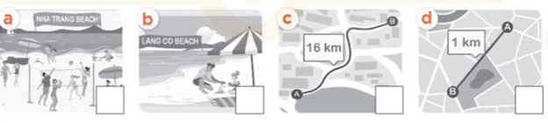

**Listen and number.2**45213

