UNIT 11: SCIENCE AND TECHNOLOGY
Lesson 1: Getting started – Great news for students
I. OBJECTIVES
By the end of this lesson, Ss will be able to:
1. Knowledge
- Gain an overview about the topic Science technology
- Gain vocabulary to talk about Science and technology
2. Competences
- Develop communication skills and creativity
- Be collaborative and supportive in pair work and teamwork
- Actively join in class activities
3. Personal qualities
- Ss are more aware of development of Science and technology
II. MATERIALS
- Grade 8 textbook, Unit 11, Getting started
- Computer connected to the Internet
- Projector / TV/ pictures and cards
- hoclieu.vn
III. PROCEDURES : (STAGES)
Activity 1: Warm-up (5’)
a. Aims:
- To create an active atmosphere in the class before the lesson;
- To review the previous unit;
- To lead into the new unit.
b. Content:
* Chitchatting:
- Look at the pictures and answer the Qs
c. Expected outcomes:
Having a chance to speak English and focus on the topic of the lesson.
d. Organization
Teacher’s and Ss’activities | Content
* Warm up:  - Teacher has Ss to look at the pairs of pictures and talk about it by answering the question.  What do you think of these pictures?  - Ss work in pairs to do the task.  - Teacher calls on some Ss to give their ideas about it.  - Teacher listens, comments, then leads Ss to the new lesson.  Teacher says: “In the lesson today we are going to learn a new unit about Science technology . Let’s start to see and find out more information related to our new topic”. | * Chitchatting:  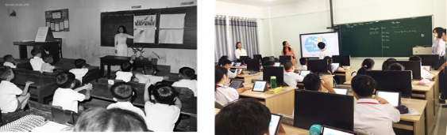    What do you think of these pictures?  Talk about the development of science and technology.
Activity 2: Presentation (7’)
Pre-teach Vocab
a. Aims:
- To set the context for the introductory dialogue;
- To introduce the topic of the unit.
b. Content:
- Learn some new words. Read the conversation and find out new words.
c. Expected outcomes:
- Know more new words
- Understanding the conversation; topic of the lesson,…
d. Organisation
Teacher’s and Ss’activities | Content
Pre teach vocabulary  - Teacher introduces the vocabulary.  - Teacher explains the meaning of the new vocabulary by pictures/ explanation/ examples.  - Teacher reveals that these seven words will appear in the reading text and asks students to open their textbooks to discover further. | * Vocabulary  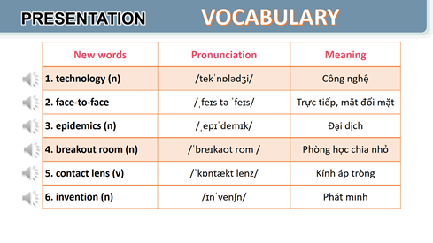
Activity 3: Practice: (23’)
Task 1,2,3,4
a. Aims:
- To help Ss read for specific information about the conversation.
- To help Ss learn words and phrases related to different modern technologies;
- To help Ss have more information about inventions.
b. Content:
- Listen and read the conversation, Labelling the pictures, Sentence completing activity.
- To learn some more words about different modern technologies and inventions.
c. Expected outcomes:
- Know more new words about different modern technologies and inventions, understand the conversation; topic of the lesson.
d. Organisation
Teacher’s and Ss’activities | Content
Task 1  Set the context:  - Teacher has Ss to look at the pictures in the book and answer the questions.  - T encourages ss to answer the questions, but doesn’t confirm their answers.  - Teacher plays the recording for ss to listen and read along. Then invite some pairs of Ss to read the conversation aloud.  - T refers to the questions previously asked and confirms the correct answer. | Task 1. Listen and read.  Questions:  - Who are the girl and the boy?  - Where do you think they are?  - What might they be talking about?  - What can you see in the bubble?  * Suggested answer:  They are Minh and Ann. They are at school.  They are discussing their online class / robot teacher.
Task 2  - Ask Ss to work in pairs to read the conversation.  - Ask them to underline the key words and phrases in the statements. Then have pairs work for one or two minutes to check if the statements are true or false.  - Have Ss read out the statements and say if the statements are true or false.  - Make sure they pronounce the words correctly.  - Check the answers as a class. | Task 2. Read the conversation again and tick (v) T (True) or F (False)  * Answer key:  1. F 2. T 3. F 4. T 5. T
Task 3  - Ask Ss to say the phrases aloud. Make sure they pronounce the phrases correctly.  - Ask Ss to work in pairs to label the pictures with the appropriate words or phrases.  - Check the answers as a class. | Task 3. Label each picture with a phrase from the box.  * Answer key:  1. computer screen 2. 3D contact lenses  3. online class 4. robot teacher  5. breakout rooms  6. Internet connection
Task 4  - Ask Ss to work independently to complete each sentence with a phrase from the box in 3.  - Allow Ss to refer to the pictures and phrases in Activity 3 or the conversation if needed.  - Check the answers as a class.  - Ask several Ss to read aloud the full sentences. Correct Ss’ pronunciation if needed. | Task 4. Complete the sentences, using the phrases in 3.  * Answer key:  1. computer screen  2. breakout rooms  3. robot teacher  4. online class  5. 3D contact lenses
Activity 4: Production:(5’)
Task 5
a. Aims:
- To introduce some inventions
- To create a fun atmosphere in the class.
b. Content:
- Find out the things that were invented in the given years
c. Expected outcomes:
- Ss can find out the things that were invented in the given years
d. Organisation
Teacher’s and Ss’activities | Content
Task 5:  - Ask Ss to work in pairs to read the information and to make guesses.  - Encourage Ss to guess as many things as possible.  - Ask some Ss to report things they have thought of / work out. | Task 5:  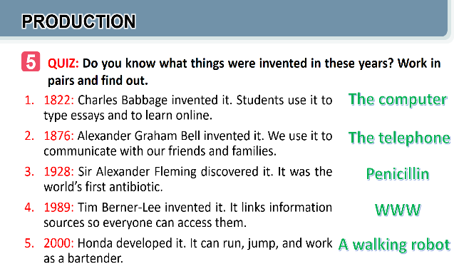
Activity 5: Consolidation (3’)
a. Aims: To consolidate what students have learnt in the lesson.
b. Content: Talk about what they have learnt in the lesson
c. Expected outcomes: Say aloud some words they remember from the lesson.
d. Organisation:
Teacher’s and Ss’activities | Content
- Teacher asks students to talk about what they have learnt in the lesson.  - Ss work indepently | - Some new words  - Read and understand content of the conversation
* Homework (2’)
a. Aims: To revise the lesson and prepare for the next lesson.
b. Content: Review the lesson and prepare for the next lesson and do exersie in the workbbook
c. Expected outcomes: Students’ textbook and workbook
d. Organisation:
Teacher’s and Ss’ activities | Content
- Teacher asks students to talk about what they have learnt in the lesson.  - Ss work indepently | - Some new words  - Read and understand content of the conversation

Date of planning : …/… / 2024
Date of teaching : …/… / 2024
Week: UNIT 11: SCIENCE AND TECHNOLOGY

Period : Lesson 2: A closer look 1

I. OBJECTIVES:
By the end of this lesson, Ss will be able to:
1. Knowledge
- Identify some nouns related to the topic of science and technology and some new technologies.
- Identify some new verb phrases that used to talk about inventions, discoveries, creations and development
- Identify sentence stress.
2. Competences
- Developcompetencies of communication, cooperation, and self-management.
- Be collaborative and supportive in pair work and teamwork
- Actively join in class activities
3. Personal qualities
- Raise ss’ knowledge of science and technology
- Love science and technology and use them propery in life
II. MATERIALS
- Grade 8 textbook, Unit 11, A closer look 1.
- Computer connected to the Internet
- Projector /TV
- Hoclieu.vn
III. PROCEDURES
Activity 1: Warm-up (5’)
a. Aims:
- To create an active atmosphere in the class before the lesson;
- Provide more knowledge to the lesson
b. Content:
- Ss play a game: Matching
c. Expected outcomes:
- Having a chance to speak English and focus on the topic of the lesson.
d. Organisation
Teacher’s and Ss’activities |  | Content
* Warm up  - Have Ss play in two teams.  - Ss match the pictures with phrases describing them.  - T gives feedback.  - The team with the most correct answers wins  T leads in the new lesson. |  | * Warm up: Matching  Match the pictures with phrases describing them.  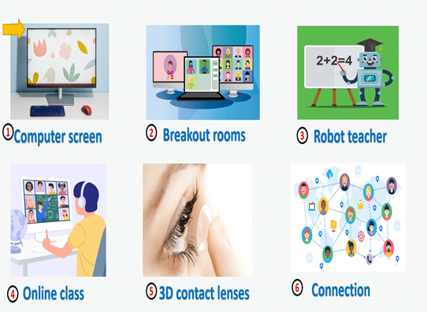
Activity 2: Presentation (7’)
Pre teach vocabulary(Task 1)
a. Aims:
- To introduce visually some nouns related to the topic of science and technology
b. Content:
- Learn some nouns related to new technologies.
c. Expected outcomes:
- Know more new nouns related to new technologies.
d. Organisation
Teacher’s and Ss’activities |  | Content
Task 1  -T runs through the words  - T has Ss read aloud the words / phrases in the box.  - T ask Ss to work in pairs to look at the pictures and describe the pictures.  - Ss work in pairs, write the correct words / phrases under the pictures.  T explains the meaning of the new words / phrases .  - T corrects their pronunciation if needed.  - Check the answers as a class. |  | I. VOCABULARY  Task 1: Write the words and phrases under each picture.  * Keys:  1. digital communication(n):giao tiếp kỹ thuật số  2. face recognition(n): công nghệ nhận biết gương mặt  3. eye-tracking(n): theo dõi (cử động) mắt  4. experiment(n): thí nghiệm  5. fingerprint scanner(n): thiết bị quét vân tay.  6. video conferencing(n)
Activity 3: Practice (13’)
Task 2,3
a. Aims:
- To allow Ss to use the learnt words / phrases in different contexts.
b. Contents:
Task 2: Choose the option that best completes each phrase
Task 3: Complete the sentences with the words and phrases from the box
c. Expected outcomes:
- Know how to use learned words/phrases in context.
d. Organisation
Teacher’s and Ss’activities |  | Content
Task 2  - Ask Ss to read aloud the given verbs and nouns.  - Explain the verbs and if possible, give some examples. Also explain the verbs in Vietnamese.  - Ask Ss to work in pairs to choose the correct options to complete the phrases.  - Check the answers as a class.  + Have some Ss read aloud the phrases.  + Correct Ss’ pronunciation if necessary.  Also ask Ss to add more words / phrases to the verbs to make up other phrases. This way, T can broaden Ss’ vocabulary if they are ready |  | Task 2: Choose the option that best completes each phrase.  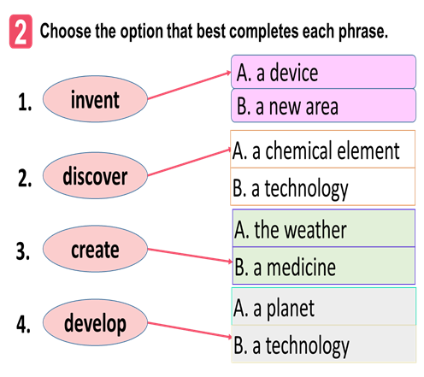
Task 3  -T guide Ss to decide the word formation in each blank  - T asks Ss to work individually to choose the correct answer for each sentence.  - Ss work individually  - Ss swap their answers with partners. Then check the answers as a class.  - T asks some Ss to read out their answers. Then have some Ss read the sentences aloud as a class. |  | Task 3: Complete the sentences with the words and phrases from the box.  * Answer key:  1. discovered  2. invented  3. created  4. experiments  5. fingerprint scanner
Activity 4: PRONUNCIATION (15’)
Task 4,5
a. Aims:
- To help Ss be aware of which words in a sentence should be stressed, and which are not;
- To help Ss say sentences with the correct stress.
- To help Ss practise saying sentences with the correct stress.
b. Contents:
Task 4: Listen and repeat the sentences. Pay attention to the bold syllables
Task 5: Listen and repeat the sentences. How many stressed words are there in each sentence
c. Expected outcomes:
- Say sentences with the correct stress.
d. Organisation
Teacher’s and Ss’activities |  | Content
Task 4  -T has Ss listen to the recording once first. Ask them to pay attention to the stressed syllables.  -T plays the recording again for them to listen and repeat the sentences, then as individuals. Play the recording as many times as possible.  - Ss read out the sentences. T corrects their pronunciation and stress if needed.  -T introduces the rules in the Remember!  Box:stress sentences, which words in a sentence should be stressed, and which are not. |  | Task 4. Listen and repeat the sentences. Pay attention to the bold syllables.  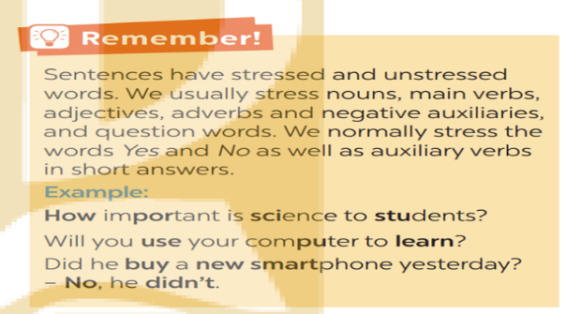
Task 5  - T plays the recording for Ss to listen and repeat each sentence after the recording. Correct Ss’ pronunciation if necessary.  - Ss listen and repeat each sentence  - T asks Ss to count the number of stressed words in each sentence. Check if Ss have counted enough stressed words in each of the sentences.  - Ss listen and count  - T calls on some Ss to read the sentences. aloud |  | Task 5: Listen and repeat the sentences. How many stressed words are there in each sentence  He is an inventor.  We won’t have a robot teacher next year.  She likes learning online.  Was she checking attendance when you came? - No, she wasn’t.  What did he invent?  Key: 1. 1 2. 6 3. 3 4. 6 5. 2
Activity 5: Consolidation (3’)
a. Aims: To consolidate what students have learnt in the lesson.
b. Content: Talk about what they have learnt in the lesson
c. Expected outcomes: Say aloud some words they remember from the lesson.
d. Organisation:
Teacher’s and Ss’activities | Content
- Ask one or two Ss to tell the class what they have learnt.  - Ask Ss to make some sentences with words and phrases they remember from the lesson. | - Vocabulary related to the topic  - Sentence stress
* HOMEWORK (2’)
a. Aims: To revise the lesson and prepare for the next lesson.
b. Content: Review the lesson and prepare for the next lesson and do exersie in the workbbook
c. Expected outcomes: Students’ textbook and workbook
d. Organisation:
Teacher’s and Ss’activities | Content
- T reminds Ss to do homework and prepare the new lesson. | - Learn by heart all the new words.  - Do exercises in workbook.  - Prepare lesson 3 ( A closer look 2).
*- Evaluation: …………………………………………………………………………………………………………………………………………………………………………………………………………………………

Date of planning : …/… / 2024
Date of teaching : …/… / 2024

Week: UNIT 11: SCIENCE AND TECHNOLOGY

Period : Lesson 3: A closer look 2
I. OBJECTIVES:
By the end of this lesson, Ss will be able to:
1. Knowledge.
- Identify what direct speech and reported speech are.
- Realize some differences between a direct speech and a reported speech (statements).
- Be aware of changes in tenses, pronouns, time, and place expressions.
2. Competences.
- Develop competencies of communication, cooperation, and self-management.
- Be collaborative and supportive in pair work and teamwork.
- Develop self-study skills.
- Actively join in class activities.
3. Personal qualities.
- Have a positive attitude to using reported speech in daily life.
II. MATERIALS.
- Grade 8 textbook, Unit 11, A closer look 2.
- Computer connected to the Internet.
- Projector / TV/ pictures and cards; phần mềm tương tác hoclieu.vn
III. PROCEDURES.
Activity 1: Warm-up (5’)
Task 1
a. Aims:
- To create an active atmosphere in the class before the lesson.
b. Content: Matching
* Match direct speech and reported speech
c. Expected outcomes:
- Having a chance to speak English and focus on the topic of the lesson.
d. Organisation.
Teacher’s and Ss’activities |  | Content
Task 1  - Have Ss work in pairs to look at direct speech and reported speech boxes to match.  - Check the answers as a class.  - Ask some Ss to underline the differences in the pairs of sentences they have just matched.  - Emphasize will in direct speech is turned into would in the reported speech.  - T leads in the new lesson |  | Task 1. Look at part of the conversation in GETTING STARTED again. Then match Minh’s uncle’s direct speech with his reported speech.  * Key:  1. B  2. A
Activity 2: Presentation (5’)
GRAMMAR: Reported speech (Statements)
a. Aims:
- To realize some differences between direct speech and reported speech (Statements)
- To be aware of the changes in verb tenses, pronouns, time and place expressions.
b. Content:
- Match direct speech with its reported speech.
- Know the changes in verb tenses, pronouns, time and place expressions.
c. Expected outcomes:
- Know what direct speech and reported speech are.
- Understand the changes in verb tenses, pronouns, time and place expressions.
d. Organisation
Teacher’s and Ss’activities | Content
- Have Ss work individually to read the Remember! box.  - Write examples of direct speech and reported speech on the board.  - Ask some Ss to point out the differences between pairs of sentences (direct and reported speech sentences)  - Remark on the differences in (1) verb form, (2) time expressions, (3) time and place expression, and (4) pronouns. | GRAMMAR:  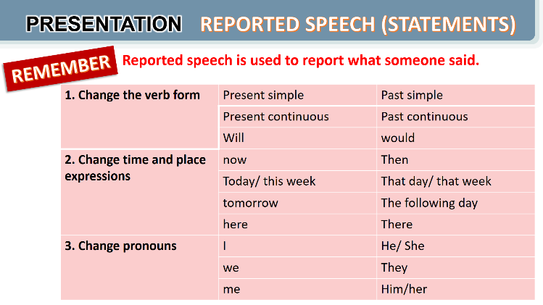  * Form: S + said /told (that) + S + V(lùi thì)
Activity 3: Practice (20’)
Task 2,3,4
a. Aims:
- to be aware of how to change verb forms when they report information.
- to apply rules of changes in time and place expressions when they report information
- to practise changing direct sentences into reported sentences.
b. Content:
Task 2. Complete the second sentences using the correct verb form.
Task 3. Complete the second sentences with the words and phrases from the box.
Task 4. Complete the second sentence in each pair so that it means the same as the first one.
c. Expected outcomes:
- Remember the rules of changes in verb tenses, time and place expressions, and pronouns when reporting information.
d. Organisation
Teacher’s and Ss’activities | Content
Task 2  - Remind Ss that they should put the verb one tense back when they report something.  - Have Ss work in pairs to finish the sentences with the correct verb forms.  - Ask some Ss to write their answers on the board.  - Check Ss’ answers. Correct any mistakes and re-explain the rule if necessary.  - Have Ss read out loud sentences again and correct pronunciation if necessary. | Task 2. Complete the second sentences using the correct verb form.  * Key:  1. was  2. would take  3. was talking  4. were going  5. didn’t have
Task 3  - Have Ss work individually to underline the expressions denoting time and place in the direct sentences.  - Ss choose the correct word / phrase from the box to fill each of the reported sentence.  - T reminds Ss of the expressions they have just underlined in each of the direct speech sentences.  - Ask some Ss to read out the direct and reported speech sentences. Correct pronunciation if n ecessary.  Check the answers as a class. | Task 3. Complete the second sentences with the words and phrases from the box  * Key:  1. the next day  2. then  3. that day  4. that year  5. there
Task 4  - Have Ss work individually for five minutes to complete the reported sentences. Then ask them to work in pairs to swap their answers.  - Ss write their reported sentences on the board.  - T checks the answers as a class.  - Have the class read out the sentences. Correct pronunciation when necessary. | Task 4. Complete the second sentence in each pair so that it means the same as the first one.  Key:  1. The scientist said that we would live much longer in the future.  2. Our teacher said that our school was going to have a new laboratory there.  3. My dad said that they were developing technology to monitor students better.  4. Tom said that there were no classes the next day because their teacher was ill.  5. The teacher said that they wanted some students to join the science club the next semester.
Activity 4: Production
Task 5
a. Aims:
- To enable Ss to practise reporting speech;
- To create an atmosphere of playing and learning.
b. Content:
- Task 5. Report the answers of one of your group members to the class
c. Expected outcomes:
- Reporting direct sentences correctly.
d. Organisation.
Teacher’s and Ss’activities | Content
Task 5.  - Have Ss work in groups to discuss their online learning platforms.  - Tell them that they can make notes about what their friends like and dislike about the platform their classes /teachers use.  - Ask them to use ideas from the posts and the table in Activity 3.  - Invite group representatives to report one of their group member’s answers. Give feedback on Ss’ reports. | Task 5. Report the answers of one of your group members to the class  *You can conclude:  The name of the platform you use for your online classes or one you know about.  Its benefits  Its problems  Example:  Lan said that her extra class used Microsoft Teams. She said that she and her classmates found it difficult to use. However, it is convenient to have online classes on Microsoft Teams when the weather is bad.
Activity 5: Consolidation (3’)
a. Aims: To consolidate what students have learnt in the lesson.
b. Content: Talk about what they have learnt in the lesson
c. Expected outcomes: Say aloud some words they remember from the lesson.
d. Organisation:
Teacher’s and Ss’activities | Content
- Ask Ss to summarise what they have learnt in the lesson.  - Have them retell the form and uses of the past continuous | - Know what direct speech and reported speech are.  - Know how to change verb tenses, pronouns, time and place expressions
* Homework (2’)
a. Aims: To revise the lesson and prepare for the next lesson.
b. Content: Review the lesson and prepare for the next lesson and do exersie in the workbbook
c. Expected outcomes: Students’ textbook and workbook
d. Organisation:
Teacher’s and Ss’activities | Content
- T reminds Ss to do homework and prepare the new lesson. | - Remember the form and use of the reported speech  - Do exercises in the workbook.  - Prepare for Lesson 4 - Communication
*- Evaluation: ……………………………………………………………………………………………………………………………………………………………………………………………………………………….

Date of planning : …/… / 2024
Date of teaching : …/… / 2024

Week: UNIT 11: SCIENCE AND TECHNOLOGY

Period : Lesson 4 : Communication
I. OBJECTIVES:
By the end of this lesson, Ss will be able to:
1. Knowledge
- identify how to give and respond to good news.
- know about the benefits and problems of online learning.
2. Skills:
- Give and respond to good news.
- Read and talk about the benefits and problems of online learning.
3. Competences
- Develop competencies of communication, cooperation, and self-management.
- Be collaborative and supportive in pair work and group work.
4. Personal qualities
- Raise ss’ awareness of the benefits and problems of online learning.
- Have good attitude to giving and responding to good news.
II. MATERIALS
- Grade 8 textbook, Unit 11, Communication.
- Computer connected to the Internet
- Projector / TV/ pictures and cards
- Phần mềm tương tác hoclieu.vn
III. PROCEDURES
Activity 1: Warm-up (5’)
a. Aims:
- To create an active atmosphere in the class before the lesson;
b. Content:
- Have students watch a clip to create a friendly and relaxed atmosphere to inspire Ss to warm up to the new class.
c. Expected outcomes:
- Having a chance to speak English and focus on the topic of the lesson.
d. Organisation
Teacher’s and Ss’activities | Content
Clip watching:  - T lets ss watch a clip and ask ss what the clip is about.  - Ss answer the Q exactly.  - T leads in the new lesson  - Ask Ss to look at COMMUNICATION on page 86. | * Warm-up: Clip watching:  - Question: What is the clip about?  *Expected answers:  - Giving and responding the news
Activity 2: Presentation ( 5’)
* EVERYDAY ENGLISH
a. Aims:
- To introduce how to give and respond to good news
- To help Ss practise giving and responding to good news
b. Content:
- Use everyday expressions to develop language skills (Giving and responding good news)
c. Expected outcomes:
- Leaning how to give and respond to good news
d. Organisation
Teacher’s and Ss’activities | Content
Task 1  – Play the recording for Ss to listen and read the conversation between Nick and Mi. Ask Ss to pay attention to the highlighted parts. Emphasise the ways to give good news and respond to good news:  - Tell Ss that Great! and Congratulations! are different ways to respond to good news in different contexts. Tell them that if good news is general and good for everyone, we can say Great!; if the news is good for the speaker only, the responder may say Congratulations!  - Have Ss practise the conversation. | * Everyday English: Giving and responding to good news  Task 1: Listen and read the conversation, paying attention to the highlighted parts.  Nick: Great news for us. We’ll have school clouds so we won’t have to carry lots of books to school.  Mi: Great!  Nick: And my dad promised to give me a new Ipad to read books from the school clouds.  Mi: Congratulations!  - To give and respond to good news, you can use:  - Great news for us.  - Great!  - Congratulations!
Activity 3: Practice (20’)
Task 2,3,4
a. Aims:
– To help Ss learn the language to describe the benefits and problems of online learning;
– To help Ss practise reading for specific information.
- To help Ss practise giving and responding to good news
b. Content:
- Give news and respond to the news in the following situations
- Read the posts from some students about online learning and complete the table.
- Talk about a platform you use for your online classes or one you know about.
c. Expected outcomes:
- Knowing the benefits and problems of online learning.
- Practising reading for specific information and practising speaking about a platform ss use for online classes or one ss know about.
d. Organisation
Teacher’s and Ss’ activities | Content
Task 2  - Ask Ss to work in pairs to make similar conversation. - - Tell them to use the contexts given and the sample expressions.  - Give feedback on their conversation. | Task 2: Work in pairs. Give news and respond to the news in the following situations  1. You tell your classmate about the new vending machine at your school.  2. You tell your classmate about a new laptop that your dad gave you on your birthday.
Task 3  - Ask some Ss to read the posts aloud.  - Have Ss work in pairs to read the posts to get information from the post and to fill in the table below.  - Ask some pairs to read out their answers. Make corrections if necessary.  - Check the answers as a class.  - If time allows, ask some students to retell information from the posts or to role play the four friends to tell class about the platform their teacher uses for their classes. | Task 3. Work in pairs. Read the posts from some students about online learning and complete the table.  Key:  Benefits Problems  1. It’s convenient. 1. Some students don’t have computers or  2. Students don’t have to get up early. smart phones.  2. The Internet connection is poor.  3. It helps students become more 3. It makes some students feel more  independent. stressed when learning online.  4. It helps students avoid traffic jams. 4. Students can’t meet their classmates.  5. Some students get tired eyes and can’t  concentrate well.
Task 4.  - Have Ss work in groups to talk about the benefits and problems of their online learning platform.  - Ask them to think of the platform they use and use the table in Activity 3 to make notes. Tell them to use adjectives or phrases as in Activity 3.  - Invite some Ss to tell about their online learning platforms. Correct any grammar or pronunciation mistakes if necessary. | Task 4. Work in groups. Talk about a platform you use for your online classes or one you know about. What are the benefits and problems of using it?  - Flatform: Zoom meeting  Benefits Problems  - user-friendly - multi-functional : screen sharing, room breaking...) -high security - possible for large-sized class - limit time - chargeable
Activity 4:Production
Task 5
a. Aims:
- To provide Ss with an opportunity to talk about the platform his / her friends use for online learning, the benefits and problems of that online learning platform;
– To help Ss practise reported speech
b. Content:
- Talk about the platform his / her friends use for online learning, the benefits and problems of that online learning platform.
c. Expected outcomes:
- Apply what they have learnt so far in this unit (ideas, vocabulary, grammar) to talk about their the platform his / her friends use for online learning, the benefits and problems of that online learning platform
d. Organization
Teacher’s and Ss’ activities | Content
Task 5.  - Have Ss work in groups to discuss their online learning platforms.  - Tell them that they can make notes about what their friends like and dislike about the platform their classes /teachers use.  - Ask them to use ideas from the posts and the table in Activity 3.  - Invite group representatives to report one of their group member’s answers. Give feedback on Ss’ reports. | Task 5. Report the answers of one of your group members to the class  * You can conclude:  The name of the platform you use for your online classes or one you know about.  Its benefits  Its problems  Example:  Lan said that her extra class used Microsoft Teams. She said that she and her classmates found it difficult to use. However, it is convenient to have online classes on Microsoft Teams when the weather is bad.
Activity 5: Consolidation (3’)
a. Aims: To consolidate what students have learnt in the lesson.
b. Content: Talk about what they have learnt in the lesson
c. Expected outcomes: Say aloud some words they remember from the lesson.
d. Organisation:
Teacher’s and Ss’activities |  | Content
- Ask Ss what they have learnt in the lesson. |  | - Giving and responding to good news.  - Some benefits and problems of online learning.
* HOMEWORK (2’)
a. Aims: To revise the lesson and prepare for the next lesson.
b. Content: Review the lesson and prepare for the next lesson and do exersie in the workbbook
c. Expected outcomes: Students’ textbook and workbook
d. Organisation:
Teacher’s and Ss’activities | Content
- T reminds Ss to do homework and prepare the new lesson. | - Learn by heart all the words that they have just learnt.  - Do exercises in the workbook.  - Prepare for Lesson 5 – Skills 1
*- Evaluation: ………………………………………………………………………………………………………………………………………………………………………………………………………………………..

Date of planning : …/… / 2024
Date of teaching : …/… / 2024

Week: UNIT 11: SCIENCE AND TECHNOLOGY

Period : Lesson 5 : Skills 1
I. OBJECTIVES:
By the end of this lesson, Ss will be able to:
1. Knowledge
- improve the skill of reading advertisements for details.
- remember the lexical items related to some new technologies that are applied at schools
- recognize how to make a conversation to ask and answer information about an invention or a technology
2. Skills:
- develop their reading skill for specific and general information through ticking exercise and multiple choice questions.
- practise asking and answering questions for information about an invention or a technology
3. Competences
- develop communication skills and creativity
- be collaborative and supportive in pair work and teamwork
- develop presentation skill
- actively join in class activities
4. Personal qualities
- raise ss’ awareness of some new technologies that are applied at schools
- have a good attitude to applying and using new technology or inventions at schools
II. MATERIALS
- Grade 8 textbook, Unit 11, Skills 1
- Computer connected to the Internet
- Projector / TV/ pictures and cards
- Phần mềm tương tác hoclieu.vn
III. PROCEDURES
Activity 1: Warm-up (5’)
a. Aims:
- To create an active atmosphere in the class before the lesson;
- To elicit from Ss some reasons why they go shopping
b. Content:
- Game: Brainstorming
c. Expected outcomes:
- Having a chance to speak English and focus on the topic of the lesson.
d. Organisation
Teacher’s and Ss’activities | Content
Brainstorming:  - Ask ss to name the technological applications your school uses  - Ask Ss to look at SKILLS 1 on page 120-121.  - T leads in the new lesson | * Warm up:  Game: Brainstorming  - Suggested answers:  Zoom, Zalo,Azota, canva, google meet,…
Activity 2: Presentation (8’)
a. Aims:
- To set the context for the reading;
- To help Ss practice describing pictures.
- To introduce some new words related to some new technologies;
b. Content:
- Learn some new words.
- Read the list of the technological applications
c. Expected outcomes:
- Know more new words and some technological applications
d. Organisation
Teacher’s and Ss’activities | Content
Task 1  - Have the class work in pairs to describe the pictures and say what technology the pictures are about.  - Ask Ss to discuss if these technologies can be used at schools.  - T gives feedback. | Task 1: Work in pairs. Name the technological applications in the pictures. Can they be used in schools?    * Key:  1. eye tracking  2. fingerprint scanner  3. face recognition
Vocabulary pre-teaching  - Teacher asks ss to look through the text and pay attention to the underlined words.  - Teacher gets ss to guess the meaning of the new vocabulary through context  - Teacher confirms the answers then gets ss to read orally and take notes of all the four words in their notebooks. | * Vocabulary:  1. biometrics (n) /ˌbaɪəʊˈmetrɪks/ Khoa học sinh trắc  2. truancy (n) /ˈtruːənsi/ Trốn học, nghỉ học không phép  3. Nanolearning (n) /’nænəʊlɜːnɪŋ/Dạy học với bài dạy kích thước nhỏ  4. effortless(adj) /ˈefətləs/ Không cần nhiều nỗ lực  5. platform(v) /ˈplætfɔːm/ Nền tảng  6. cheating (n) /tʃiːtɪŋ/ Gian lận
Activity 3: PRACTICE (12’)
* Reading (Task 2+3)
a. Aims:
- to improve Ss’ skill of reading advertisements for details
- to improve Ss’ skill of reading for general information and details.
b. Content:
- Read the reading passage about new technologies that are applied at schools and tick B (Biometrics) or N (Nanolearning) and choose the best answer to the questions.
c. Expected outcomes:
- Understanding the text about the benefits of the two new technological applications.
d. Organisation
Teacher’s and Ss’activities | Content
Task 2  - Ask Ss to work individually to read the texts and to decide if the statements from text are about biometrics or nanolearning. Ask them to write B (Biometrics) or N (Nanolearning).  - Ask Ss to underline the key words in each of the statements then search for the information in the two texts.  - Have Ss to work in pairs to swap answers or to check answers together.  - Ask some Ss to read out loud the statements and say B or N. Ask them to show the parts in the reading where they find the answers.  - Check the answers as a class. | Task 2. Read the passage and tick (v) B (Biometrics) or N (Nanolearning)  * Answer key:  1. N  2. B  3. B  4. N  5. N
Task 3  - Have Ss work individually for five minutes and choose the correct answers. Remind them to underline the key words in the questions and the evidence for the answers.  - Ask Ss to take turns to give the answers. Ask them to show the parts in the reading texts where they find the answers.  - Check the answers as a class.  - T can also ask one or two Ss to say which technology they prefer and why or ask them to orally summarise each of the texts. | Task 3. Read the passage and choose the correct answer A, B, or C.  Suggested answers:  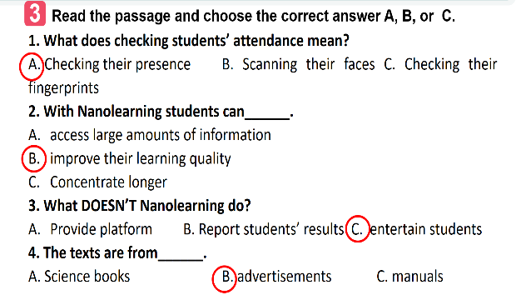
Activity 3: SPEAKING (15’)
Task 4+ 5
a. Aims:
- To have Ss practise asking and answering questions for information about an invention or a technology;
- To give Ss an opportunity to practise explaining how the technology can help us;
- To improve Ss’ confidence in speaking in front of the class.
b. Content:
- Practise asking and answering questions for information about an invention or a technology;
- Practise explaining how the technology can help us.
c. Expected outcomes:
- Speak about information about an invention or a technology and its benefits.
d. Organisation
Teacher’s and Ss’activities | Content
Task 4  - Have Ss work in pairs to match the questions in A with the answers in B.  - Have them practise asking and answering questions about biometrics in the example.  - Assist Ss to make full questions when necessary.  - Ask them to ask and answer questions about an invention or a technology they like or know.  - Ask some pairs to role-play it.  - Ask the class to offer feedback on their questions, answers, and pronunciation.  - Prepare cue cards about different inventions / technologies and ask Ss to practise asking and answering questions about those inventions / technologies.  - This activity helps prepare Ss for 5. | Task 4. Work in pairs. Discuss and match the questions in A with the answers in B, and then make a conversation about an invention.  * Key:  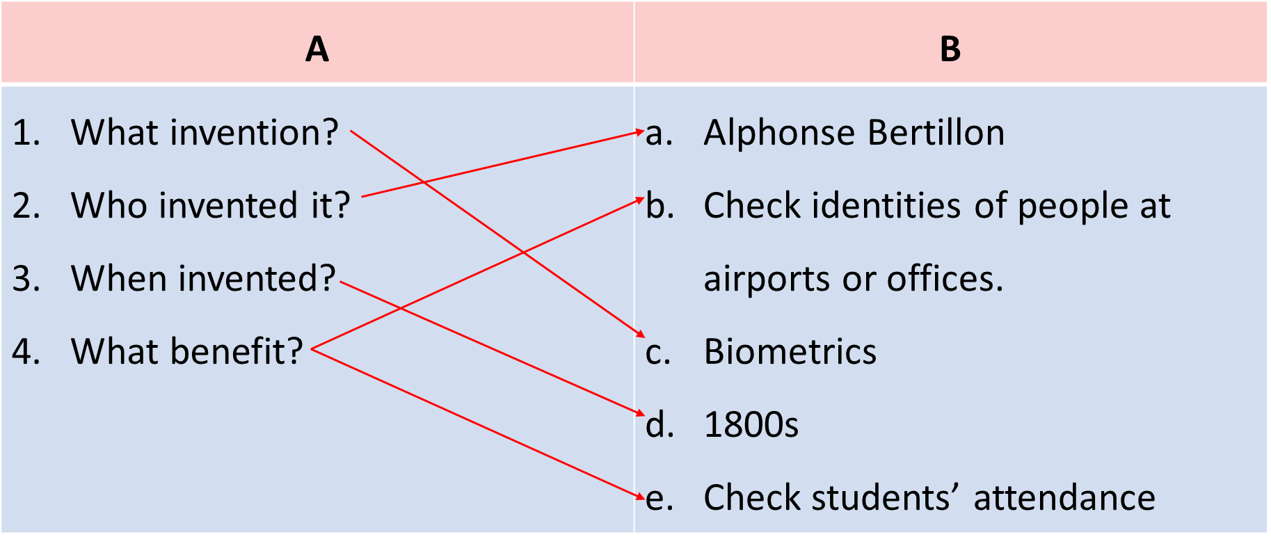  A: What technology do you like?  B: I like biometrics.  A: Who invented it?  B: Alphonse Bertillon  A: When did he invent it?  B: In 1880s  A: How can we use it?  B: It can help us check students’ attendance. We can also use it to check identities of people at airports or offices.
Task 5  - Have Ss work in groups to ask and answer questions about a invention or a technology;  - Ask them to explain what they can use the technology or invention for.  - Invite one representative of each group to report their group’s answers to the class.  - Give feedback on their reports in terms of language, reported verb forms, and pronunciation. | Task 5. Work in groups. Ask and answer questions about a technology or an invention. Use the example in 4 as a cue. Then report your answers to the class.  *Example:  Mi likes biometrics. Alphonse Bertillon invented it in 1800s. It is a very important technology. We use it to …
Activity 5: Consolidation(3’)
a. Aims: To consolidate what students have learnt in the lesson.
b. Content: Talk about what they have learnt in the lesson
c. Expected outcomes: Say aloud some words they remember from the lesson.
d. Organisation:
Teacher’s and Ss’activities | Content
- Teacher asks Ss to summarise the main points of the lesson. | - Some new technologies that are applied at schools  - Information about some inventions or technologies
* Homework (2’)
a. Aims: To revise the lesson and prepare for the next lesson.
b. Content: Review the lesson and prepare for the next lesson and do exersie in the workbbook
c. Expected outcomes: Students’ textbook and workbook
d. Organisation:
Teacher’s and Ss’activities | Content
- T reminds Ss to do homework and prepare the new lesson. | - Learn by heart all the words that they have just learnt.  - Do exercises in the workbook.  - Prepare for Lesson 6 – Skills 2.

*- Evaluation: ………………………………………………………………………………………………………………………………………………………………………………………………………………………….

Date of planning : …/… / 2024
Date of teaching : …/… / 2024

Week : UNIT 11: SCIENCE AND TECHNOLOGY

Period : Lesson 6: Skills 2
I. OBJECTIVES:
By the end of this lesson, Ss will be able to:
1. Knowledge
- recognize listening skills for specific information about what a robot teacher can do and can’t do.
- remember the lexical items related to
- recognize how to write a paragraph expressing opinions about whether a robot teacher will replace human teachers at school.
2. Skills:
- improve the skill of listening for details.
- improve listening comprehension and note-taking skills.
- improve the writing skill of writing a paragraph expressing opinions.
3. Competences
- develop communication skills and creativity
- be collaborative and supportive in pair work and group work
- actively join in class activities
4. Personal qualities
- raise ss’ awareness of what a robot teacher can do and can’t do.
- have the right attitude toward whether a robot teacher will replace human teachers at school.
II. MATERIALS
- Grade 8 textbook, Unit 11, Skills 2
- Computer connected to the Internet
- Projector / TV/ pictures and cards
- Phần mềm tương tác hoclieu.vn
III. PROCEDURES
Activity 1: Warm up
a. Aims:
- To create an active atmosphere in the class before the lesson;
- To help ss focus on the listening writing topic
b. Content:
- Have Naming the pictures activity to elicit from students some types of robots in which there is a teacher robot
c. Expected outcomes:
- Having a chance to speak English and focus on the topic of the lesson.
d. Organisation
Teacher’s and Ss’activities | Content
Naming the pictures  - Ask ss to look at the five pictures on the screen and name 5 types of robots.  - Ss write the name of types of robots on the board .  - T gives feedback.  - The team with the most correct answers wins  Lead in the lesson: There are many types of robots nowadays. Today we are going to learn about teacher robots and what a teacher robot can do and what it can’t do . | Warm up  Game: Naming the pictures  *Suggested answers:  1. doctor robot  2. space robot  3. worker robot  4. home robot  5. teacher robot
Activity 2: Presentation (7’)
a. Aims:
- To help Ss focus on the topic and prepare for the listening text.
- To help Ss brainstorm keywords/phrases for listening.
- To set the context for the listening;
b. Content:
- Learn some new words.
c. Expected outcomes:
- Know more new words
d. Organisation
Teacher’s and Ss’activities | Content
Vocabulary pre-teaching  - Teacher introduces the vocabulary.  - Teacher explains the meaning of the new vocabulary by pictures or explanation  - Teacher reveals that these two words will appear in the listening text and asks students to open their textbooks to discover further.  Task 1  -Ask Ss to work in pairs to tick the things that a robot teacher can do. Ask Ss to add more things a robot teacher can do.  -Tell Ss that they are going to listen to a conversation about a robot teacher and fill in each of the blanks with ONE word.  - Also ask Ss to list things robots in general can do (for example: doing boring housework, hard work in factories, delivering letters at workplaces, etc.) | * Vocabulary:  1. emotional (adj): thuộc tình cảm  2. interact with (v): tương tác  Task 1. Tick (v) the things that you think a robot teacher can do  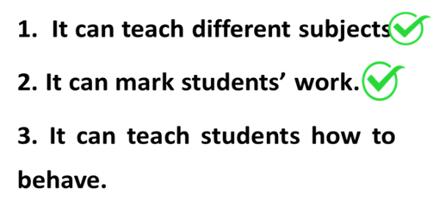
Activity 3: Listening
Task 2,3
a. Aims:
- To improve Ss’ skill of listening for specific information.
- To improve Ss’ listening comprehension and note-taking skills.
b. Content:
- Listen to a conversation and fill in each blank.
- Listen to the conversation and tick T or F
c. Expected outcomes:
- Understanding the conversation about what a robot teacher can do and can’t do.
d. Organisation
Teacher’s and Ss’activities | Content
Task 2  - Ask Ss to work individually to read the table and guess the possible words to fill in each of the blanks.  Remind them to think of the part of speech of that word (noun, verb, adjective, adverb or number). and forms of nouns (singular, plural).  - Play the recording once for Ss to fill in the blanks.  - Ss work individually to write only ONE word for each blank.  - Check Ss’ answers and play the recording again for them to better understand the conversation between Tom and Lan. Stop or rewind the recording where necessary. | Task 2. Listen to the conversation and fill in each blank with ONE word.  * Answer key:  1. languages  2. maths  3. interact  4. behave  5. problems
Task 3  Ask Ss to work in pairs to read the statements and underline the key words in the statements.  Play the recording once. Give them two minutes to decide if the sentences are T (True) or F (False).  Play the recording again and check their answers as a class. | Task 3. Listen again and tick (v) T (True) or F(False).  * Suggested answers:  1. T 2. T 3. F 4. F 5. F
Activity 3: WRITING
a. Aims:
- To provide Ss with vocabulary and ideas about whether a robot teacher will replace human teachers at schools
- To improve ss’ skill of writing a paragraph expressing opinions about whether robots will replace teachers at schools.
b. Content:
- Discuss if ss agree or disagree that robots will soon replace teachers at school and give the reasons.
- Write a paragraph to express opinions about whether robots will replace teachers at schools.
c. Expected outcomes:
- Give at least 3 reasons why you agree or disagree on whether robots will replace teachers at schools.
- Have a paragraph to express opinions about whether robots will replace teachers at schools.
d. Organization
Teacher’s and Ss’activities | Content
Task 4  - Ask Ss to work in pairs to brainstorm ideas and fill in the blanks.  - Ss get ideas from the listening and add any more ideas they have.  - Ask some Ss to read out loud ideas for each column.  Correct their pronunciation where necessary.  - T gives feedback | Task 4. Work in pairs. Discuss if you agree or disagree that robots will soon replace teachers at schools. Write the reasons in the table.  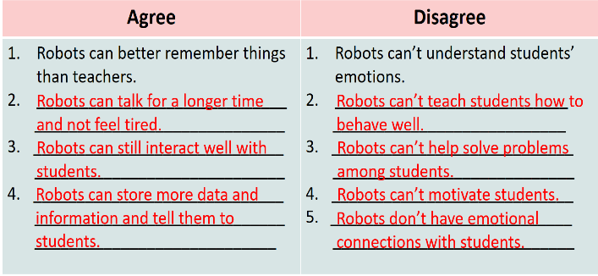
Task 5  - T records the ideas Ss have brainstormed in Activity 4 on the board.  - Ss work individually to write for 15 minutes. Tell them to use the information in Activity 4 and any other ideas they may think of. Remind Ss to choose only three ideas for their paragraph.  - Ss write a paragraph in their notebooks  -T asks one student to read out his / her paragraph. | Task 5. Now write a paragraph (80-100 words) to express your opinion. Use the notes in 4  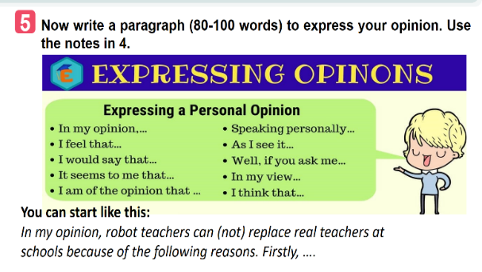
Activity 4: Production (5’)
a. Aim: To peer check, cross check and final check students’ writing.
b. Content: Cross check students’ writing.
c. Expected outcomes:
Students’ writing and cross check.
d. Organization
Teacher’s and Ss’activities | Content
- Teacher asks Ss to share their writing with their partners.  - Ss work in groups to write on an A1 / A0 size piece of paper, then T organises a gallery walk. Ss walk round and offer feedback on peers’ writing in terms of ideas, grammar and connectors..  - Teacher checks ideas, grammar, vocabulary and gives comments. | * Class gallery  
Activity 5:Consolidation (3’)
a. Aims: To consolidate what students have learnt in the lesson.
b. Content: Talk about what they have learnt in the lesson
c. Expected outcomes: Ss summarise the main points of the lesson.
d. Organisation:
Teacher’s and Ss’activities | Content
- Teacher asks Ss to summarise the main points of the lesson. | -What a robot teacher can do and what it can’t do.  - The reasons robot teachers can or can’t replace teachers at school.  - How to write a paragraph expressing opinions.
* Homework (2’)
a. Aims: To revise the lesson and prepare for the next lesson.
b. Content: Review the lesson and prepare for the next lesson and do exersie in the workbbook
c. Expected outcomes: Students’ preparation and workbooks
d. Organisation:
Teacher’s and Ss’activities |  | Content
- T reminds Ss to do homework and prepare the new lesson. |  | - Learn by heart all the  - Do exercises in the workbook.  - Prepare for Lesson 7 – Looking back.
*- Evaluation: …………………………………………………………………………..

Date of planning : …/… / 2024
Date of teaching : …/… / 2024

Week : UNIT 11: SCIENCE AND TECHNOLOGY

Period : Lesson 7: Looking back and project
I. OBJECTIVES
By the end of this lesson, Ss will be able to:
1. Knowledge
- Memorize the vocabulary about new technologies and words and phrases that are used to talk about inventions, discoveries, inventions, and creations.
- Review reported speech (statements)
- Brainstorm ideas about problems they have at home or at school
- Be creative to deal with problems by imagining an invention.
2. Skills:
- Use the vocabulary about new technologies and words and phrases that are used to talk about inventions, discoveries, inventions, and creations to do exercises.
- Apply the knowledge of reported speech (statements) to do exercises.
- Apply what they have learnt (vocabulary and grammar) into practice through a project.
3. Competences
- Develop communication skills and creativity
- Develop presentation skill
- Develop critical thinking skills
- Be collaborative and supportive in pair work and teamwork
- Actively join in class activities
4. Personal qualities
- consolidate ss’ awareness of science and technology.
- have a positive attitude toward problems that they have at home or at school and think creatively to find solutions to those problems.
II. MATERIALS
- Grade 8 textbook, Unit 11, Looking back and project
- Computer connected to the Internet
- Projector / TV/ pictures and cards
- Phần mềm tương tác hoclieu.vn
III. PROCEDURES
Activity 1: Warm -up (5’)
a. Aims:
- To create an active atmosphere in the class before the lesson;
b. Content:
- Have ss play the game “Kim’s game”
c. Expected outcomes:
- Having a chance to speak English and focus on the topic of the lesson.
d. Organisation
Teacher’s and Ss’activities |  | Content
Warm up  - T asks students to work in groups of three or four students  - Get ss to watch a video clip and try to remember all the inventions mentioned in the clip without taking notes.  - After finishing watching the clip, ss write down as inventions as possible.  - T gets ss to swap the posters and give correction after T shows the answers.  -The group with the most correct answers will win.  - T leads in the lesson. |  | * Warm up: Game: Kim’s game  * Answers:  10. The paper  9. The compass  8. The refrigeration  7. The printing press  6. Plumbing  5. Medicine  4. Engines  3. The wheel  2. Communication  1. Electricity
Activity 2: PRACTICE- Vocabulary (10 mins)
a. Aims:
- To help Ss review the vocabulary learnt.
b. Content:
- review some new words related to the topic
c. Expected outcomes:
- Remember the vocabulary learnt.
d. Organisation
Teacher’s and Ss’activities | Content
I.VOCABULARY  Task 1  - Have Ss work individually to circle the option that can combine with the given verbs.  - Have Ss read out their phrases.  - Check answers as a class.  - Correct Ss’ pronunciation if necessary.  Task 2  Have Ss work individually to fill in each blank with the correct form of the words /phrases from the box. Check answers as a class.  Ask some Ss to read aloud the sentences. Correct Ss’ pronunciation if necessary. | I. VOCABULARY  Task 1. Circle the option that goes with each verb.  Have Ss work individually to circle the option that  * Suggested answers:  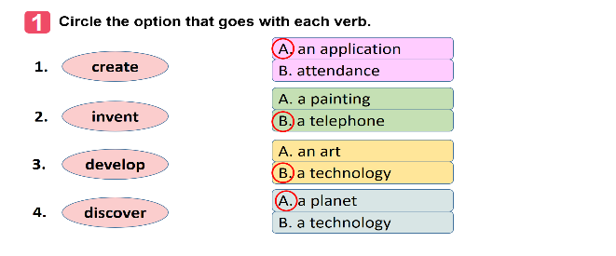  Task 2. Fill in each gap with a word or phrase from the box. You may have to change the form of the word or phrase.  1. robot teacher  2. application  3. face recognition  4. eye-tracking  5. check attendance
Activity 3: PRACTICE- Grammar ( 15mins)
a. Aims:
- To help Ss review reported statements
- To help Ss use the reported statements correctly
b. Content:
- review reported statements
c. Expected outcomes:
- Remember the changes in tenses, pronouns, time and place expressions to report information.
d. Organisation
Teacher’s and Ss’activities |  |  | Content
II. GRAMMAR  Task 3.  - Have Ss work individually to circle a mistake in each of the sentences. Remind them that only the underlined words will have mistakes.  - Ss work in pairs to swap and check their answers.  Check answers as a class.  - Ask one student to read out his/her sentences.  - Correct his / her pronunciation if necessary.  Task 4  - Ask Ss to work individually to complete the sentences as requested in the book.  - Ss go to the board and write their full sentences.  - T askS the class to work in pairs. Tell them to swap their writings and check their partner’s answers.  - T Checks the sentences written on the board.  - Have all Ss correct their partner’s answers.  + Ask some Ss to read out their sentences. Correct Ss’ language and pronunciation if necessary. |  |  | II. GRAMMAR  Task 3. Which of the underlined parts in each question is incorrect? Find and correct it.  * Suggested answers:  1. B (discovers -> discovered)  2. B (is -> was)  3. B (will make ->) would make  4. C (a day ago ->a day before)  5. C ( next year -> the next/following year)  Task 4. Rewrite the following sentences, using the words in BOLD.  * Suggested answers:  1. Tom said they couldn’t connect to the Internet to work online there.  2. Mr. Thompson said (that) science was becoming a more important subject in schools then.  3. The headmaster said (that) the school would use a machine to check students’ attendance the following year.  4. The monitor said to the class (that) they were having a science competition that week.  5. The students said (that) they didn’t like robot teachers at all.
Activity 4: PROJECT (10’)
a. Aims:
– To help Ss to brainstorm ideas about problems they have at home or at school;
– To raise Ss’ awareness of their ability to be creative to deal with the problems;
– To improve Ss’ teamwork and public speaking skills.
b. Content:
- Think about a problem you have at home or at school.
- Imagine an invention (a tool, a machine, an application…) that helps you deal with your problem.
- Prepare a poster presentation with pictures or a paper model of the invention and present it to your class
c. Expected outcomes:
- Present a poster with pictures or a paper model of the invention.
d. Organisation
- Have Ss work in groups of 3-4 students  - Ask Ss to read the instructions and suggestions carefully.  - Encourage Ss to think about a problem they have at home or at school and imagine an invention (a tool, a machine, an application…) that helps them deal with your problem.  - Ss work in groups to discuss a problem they have at home or at school. Ask them to think of an invention that can help them deal with their problem.  - Ask Ss to answer the suggested questions  * Ss can draw pictures, create models or take photos to illustrate their invention. Ask groups of Ss to pin / tape / glue the pictures / photos / models and write how it can help them on a large piece of paper and present it to the class.  * If time is limited, T can assign the project in earlier lessons such as in GETTING STARTED lesson. Make sure you guide Ss in detail and check their progress after each lesson. In the last lesson (LOOKING BACK), ask Ss to present their poster. |  |  | Task 1. Think about a problem you have at home or at school. Imagine an invention (a tool, a machine, an application…) that helps you deal with your problem.  Task 2. Discuss and answer the following questions  - What is the name of the invention?  - What is it look like?  - How can it help you solve the problem?  Task 3. Prepare a poster presentation with pictures or a paper model of the invention and present it to your class  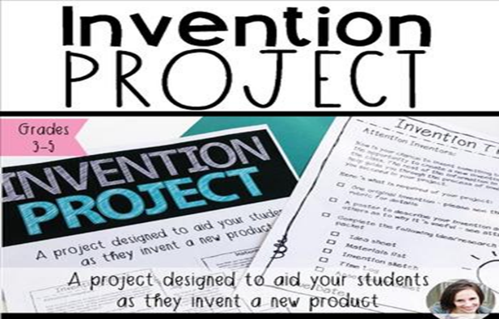
Activity 5: Consolidation (3’)
a. Aims: To consolidate what students have learnt in the lesson.
b. Content: Talk about what they have learnt in the lesson
c. Expected outcomes: Say aloud some words they remember from the lesson.
d. Organisation:
Teacher’s and Ss’activities |  |  | Content
- Teacher asks Ss to summarise the main points of the lesson.. |  |  | - - Reviewing vocabulary in Unit 11  - - Reviewing reported speech (Statements)  - Making a project: An invention that helps you deal with your problem.
* Homework (2’)
a. Aims: To revise the lesson and prepare for the next lesson.
b. Content: Review the lesson and prepare for the next lesson and do exersie in the workbbook
c. Expected outcomes: Students’ preparation and workbooks
d. Organisation:
Teacher’s and Ss’activities |  |  | Content
Teacher asks students to revise old lesson and to do exercise in workbook.  - Teacher asks students to complete the project and prepare the new lesson. |  |  | - Complete the project  - Prepare for the next lesson: Unit 12 (Getting started)
*- Evaluation: ………………………………………………………………………………………………………………………………………………………………………………………………………………………..

