Preparing date: 15/12/2024
Teaching date: 16/12/2024
UNIT 5: AROUND TOWN
Period 43: Lesson 1. PRONUNCIATION + SPEAKING (p.40)
I. OBJECTIVES: By the end of the lesson, Ss will be able to: can buy things they want with colors and size they choose.
1. Knowledge:
a. Vocabulary: review the words related to clothes shopping.
b. Grammar: Present simple
Pronunciation: Do you have………. ? /dʓэ hӕv/
2. Competences:
- notice how the sound changes of the underlined words.
- do shopping clothes (asking and answering about colors/size/price) .
- discuss the items of clothes they bought and how much they spent.
3. Educational aims:
- have good experience in shopping clothes.
II. TEACHING AIDS:
1. Materials: Textbooks, lesson plan, materials from the internet.
2. Equipments: personal computer accessed to the Internet, projector, loudspeaker
III. PROCEDURES:
Time/Steps | Contents | T and Ss’s activities
Warm up (5’)  Presentation  Pronunciation  (10’)  Practice (20’)  Consolidation  7’ | Song: “Old McDonald”  Pronunciation: sound changes  a. “Do you have………. ?» often sounds like /dʓэ hӕv/  b. Listen. Notice the sound changes of the underlined words.  Do you have these panst in blue?  Do you have this jacket in green?  c. Listen and cross out the one with the wrong sound changes.  Do you have these socks in red?  Do you have this shirtt in pink?  a. Practice the conservation.  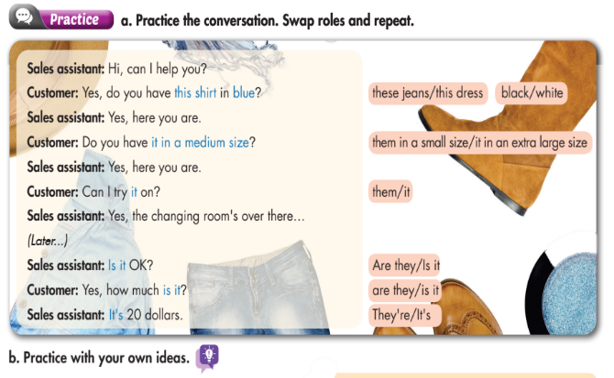  Example:  - This shirt – these jeans  - Blue – black  - It in a medium size – them in extra large size  - Is it – are they  - It is – they are  In group, discuss of the items you bought and how much you spent. | - Play audio (The song “Old MacDonald”) to brainstorm the lesson.  - Teacher and students sing along and greet together.  - T leads to the new lesson.  - T shows example sentences to class, have students speak loudly.  - T lets students listen and recognize the differences. (b/p. 40)  - A pair of students play role & read aloud the conversation.  - T asks students to underline some words that can be replaced.  - A pair of students replaces the underlined words with words given as model.  - T gets some groups to present in front of the class basing on their discussion.  - T gives feedback and evaluation
IV. HOMEWORK: (3’)
- Practice the conservation again.
- Write a conversation in which includes two items that you want to buy.
- Do exercise in WB, p.2

