Date of preparing: 5 /12 /2024
Date of teaching: 7 /12 /2024

Period 39 UNIT 4: FESTIVALS and FREE TIME
Lesson 3 - Part 2 (Page 37) – Reading+ Speaking and WWriting

I. OBJECTIVES
By the end of the lesson, Ss will be able to read an article about a famous festival in Vietnam. Talk about the Mid-Autumn Festival and write messages about a festival.
1.Knowledge:
a.Vocabulary:peach flower (n); apricot flower (n); lantern (n); lion dance (n); special (a)
b.Grammar :
2. Competences: improve the reading, speaking and writing skills.
3.Educational aims:
- have positive attitude in English language learning so that they actively participate in all classroom activities.- respect traditional Vietnam culture.
II. TEACHING AIDS
1.Materials:lesson plan, PPT slides, student’s book, workbook, notebook
2.Equipment: personal computer (if any), projector/TV, speakers, DCR & DHA on Eduhome, handouts…
III. PROCEDURES
Time/steps | Contents | T and Ss’s activities
1.Warm up:  (5’)  2. Reading (15’)  Pre-reading:  While- reading:  Post-reading:  3.Speaking: (15’)  Pre- speaking:  While- speaking:  Post-speaking:  4.Consolidation (8’) | Aim: Ss can grasp the theme about festival in VN  Kim’s game: The festivals in VN  Aim: Ss improve their reading skill (scanning, skimming). Reading an article and recognizing the correct and incorrect information.  New words:  - peach flower(n); (visual)  - apricot flower (n); (visual)  - lantern (n); (visual)  - lion dance (n); (video)  - special (a); (explanation)  a. Read the article and underline all the festival activities  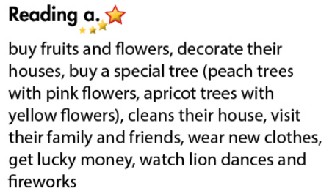  b. Read and write “Yes” or “No”  Keywords:  1. during 2. Every, same  3. during 4. during  No or Yes  1. People buy fruits and flowers before Tết.  2. People in the north and the south have different types of trees.  3. People clean their houses before Tết.  4.You can watch lion dances during Tet.  Aim: Ss can talk about a festival. Talking about what people do before and during the Mid – Autumn Festival.  Festival Fun  a. You’re telling a friend from overseas about the Mid-Autumn Festival. Take turns to talk about what people do before and during the Mid-Autumn Festival  * Model:  What do people do before the festival?  Hmm, Let me see… They…  b. Talk about other festivals you know  a. Read Nhiên and Sarah’s messages. Guess what the emojis (pictures) mean and match the emojis to their meanings.  *Answer keys  a. karaoke b. happy c. party  d. Vietnam e. money f. fireworks  b. Write similar messages about the Mid-Autumn Festival  *Telling the Mid-Autumn.  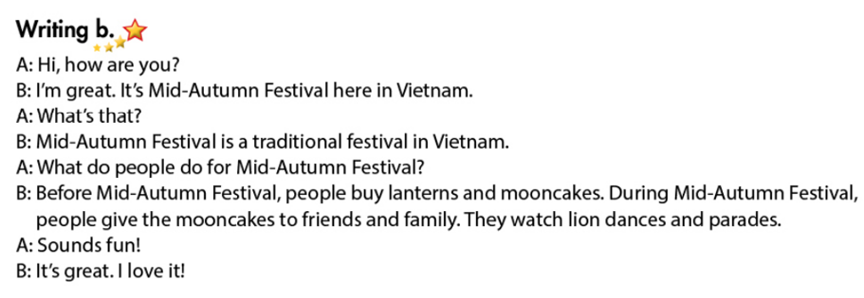  * Festival activities:  Tết: buy fruits and flowers, decorate houses, clean houses, wear new clothes, get lucky money, watch lion dances, …  Mid – Autumn Festival: buy lanterns and mooncakes, give presents to friends and family, watch lion and dragon dancing, watch lantern parades, …  * Asking about festival activities:  What do people do before / during the festival?  What do people do for + holiday? | T guides the game  Ss play in 2 teams  T comments – gives socres  T leads in – Ss read the article individually- T teaches Vovabulary- Checks Vob by R&R  - Ss read the text ind - underline all the festival activities  - T checks answers as a whole class.  -Ss read the sentences and write “Yes” or “No”  - T calls Ss to give answers  - T checks answers as a whole class.  T has Ss to watch a video about Mid- Autumn.  Ss watch video and talk about the things in the festival  - Ss practice the conversation in pairs. Ss take turns to talk about what people do before and during the Mid-Autumn Festival  -T reminds Ss to use the words / sounds to get time to think (hesitate)- Some pairs act out the conversation in front of the class  - T gives feedback and evaluation

IV. HOMEWORK (2’)
- Learn new words by heart
- Do exercises in Workbook: Reading and Writing (page 25).
- Finish the writing part.
- Find more information about some traditional holidays in Vietnam.
- Prepare: Unit 4 - Review (page 92 – SB).

