Date of preparing: 28/ 11/ 2024
Date of teaching: 30/ 11/ 2024

Period 36 UNIT 4: FESTIVALS and FREE TIME
Lesson 2 - Part 2 (Page 34) - Grammar
I. OBJECTIVES
By the end of the lesson, Ss will be able to use the Present Simple for future use.
1.Knowledge:
a.Vocabulary:
b.Grammar :Present Simple for future use
2.Competences:
- improve speaking skill, writing skill.- improve the use of English.
3.Educational aims:
- have positive attitude in English language learning so that they actively participate in all classroom activities.
- be on time when attending events.
II. TEACHING AIDS:
1.Materials:lesson plan, PPT slides, student’s book, workbook, notebook
2.Equipment:personal computer (if any), projector/TV, speakers, DCR & DHA on Eduhome, handouts…
III. PROCEDURES:
Time/steps | Contents | T and Ss’s activities
1.Warm up: (5’)  2. Presentation:  Grammar  (13’)  3.Practice (15’)  3.Consolidation:  (10’) | Aim:Ss can read comprehension and choose the best anwer  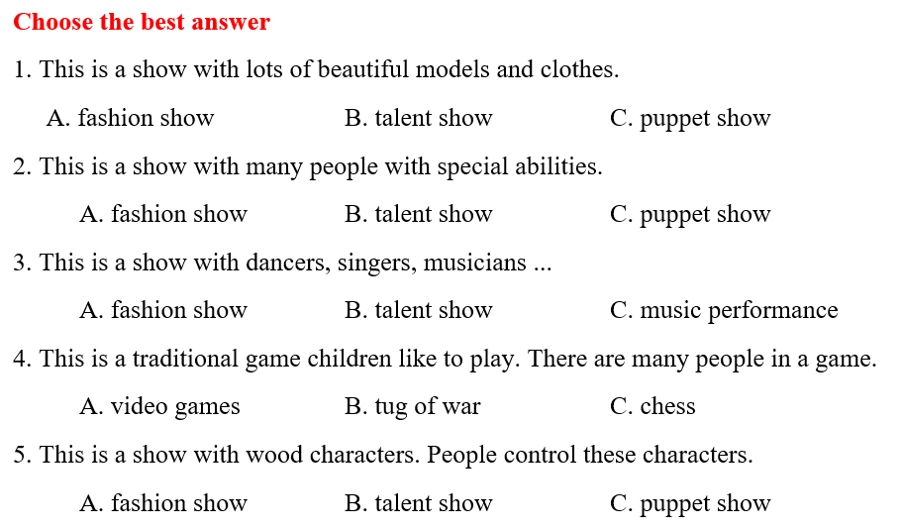  *The Present Simple for future use  Aim: Ss know how to use the Present Simple for future actions.  a. Listen and repeat  *Grammar box:  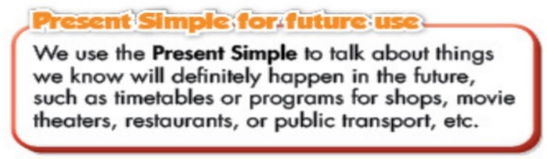  Ex:What time does the talent show start?  It starts at 4  Ok. What time does it end? It ends at 6.  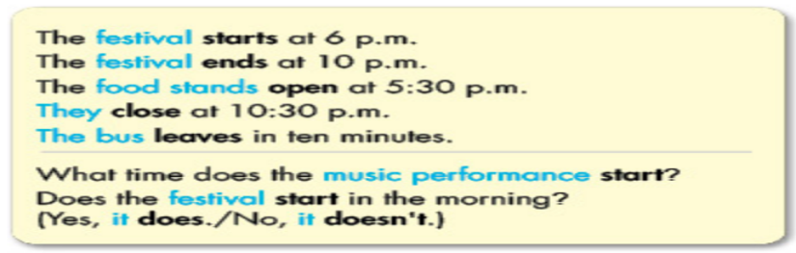  Aim: Ss can get used to using the Present Simple for future activities.  b. Fill in the blanks, using the Present Simple  *Answer keys  2. open 3. leaves 4. close  5. ends 6. leave  c. Answer the questions  *Answer keys  1. It starts at 11 a.m.  2. It ends at 10 p.m.  3. They open at 12.30 p.m.  4. It leaves in 10 minutes  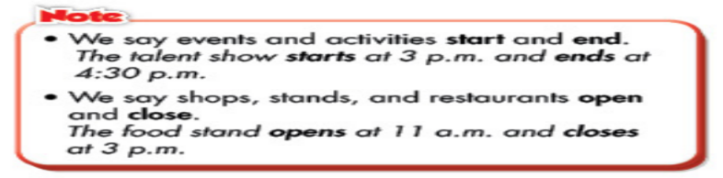  d. Practice the conversation with your partner  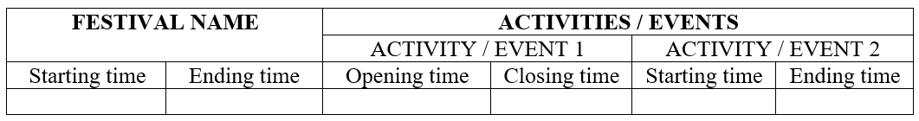  Sample table  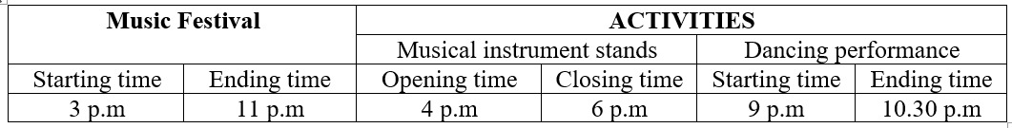 | -T gives the task and guide Ss do ind  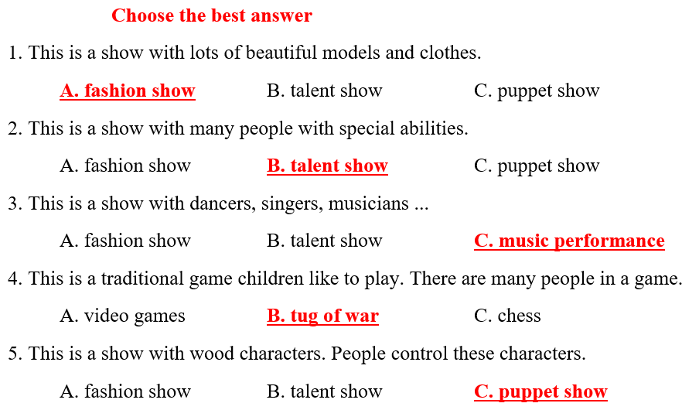  - Ss look at the picture  -T plays the audio ( Track 47)  - Ss to listen and read the speech bubbles- Ss listen and repeat  - T asks Ss to make comments on the black bold verb form in the examples  - Ss retell the form and usage of the Present Simple tense  - T leads to the grammar table and explain the usage of the Present Simple for future activities  - T has Ss to use the Present Simple to fill in the blanks  - Ss work in pairs- check each other’s work  - Ss share their answers with the class by writing down on the board  - T checks Ss’ answers, correct if necessary  - T demonstrates the activity, using the example  Ss work in pairs- write answers  - Ss look at the Note box, - T explains Notes  - Ss practice the conversation in pairs- some Ss present in front of the class  - T give feedback and evaluation  - T gives an extra activity- gives Ss handouts with information of a festival  Ss fill in the table-practice asking and answering about the festival and festival activities (group)  - T calls Ss to demonstrate the activity in front of the class  -T gives feedback and marks
IV.HOMEWORK (2’)
- Make 2 sentences, using the Present Simple for future activities.
- Do exercises in WB: Lesson 2 - Grammar and Writing (page 23).
- Prepare: Lesson 2 – Pronunciation and Speaking (page 35 – SB).

