Date of preparing: 21/ 11/ 2024
Date of teaching: 23/ 11/ 2024

Period 33 UNIT 4: FESTIVALS and FREE TIME
Lesson 1 - Part 2 (Page 31) - Grammar

I. OBJECTIVES
By the end of the lesson, Ss will be able to use adverbs of frequency to talk about how often we do things and how often things happen.
1.Knowledge:
a.Vocabulary:
b.Grammar :How often + Auxiliary verb + Subject + Verb?
2. Competences:
- improve speaking skills, listening skill, writing skills.
- improve the use of English.
3. Educational aims
- have positive attitude in English language learning so that they actively participate in all classroom activities.
- spend a suitable amount of time on studying and relaxing
II. TEACHING AIDS
1.Materials: Lesson plan, PPT slides, student’s book, workbook, notebook,
2. Equipment:personal computer (if any), projector/TV, speakers, DCR & DHA on Eduhome, handouts…
III. PROCEDURES
Time/steps | Contents | T and Ss’s activities
1.Warm up:(5’)  2.Grammar: (15’)  3.Practice  Writing and Speaking (18’)  Consolidation (5’) | Aim: Ss can review ordinary verbs and adverbs of frequency  *Free Time Song:  Aim: Ss know how to use the adverbs of frequency.  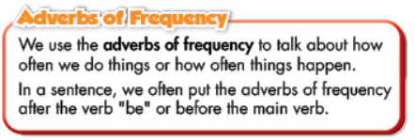  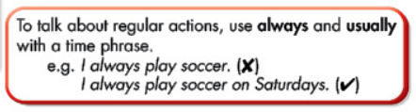  Model:  How often do you play soccer?  I always..  How often does he/ she ….?  He/ She rarely…….  b. Fill in the blanks with the adverbs of frequency  *Answer keys  2. usually 3. never 4. always  5. often 6. rarely  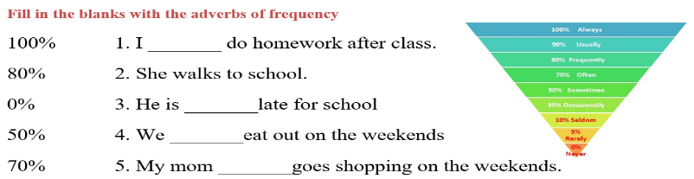  Aim: Ss can write sentences, using adverbs of frequency  c. Look at the photo and write answers  *Answer keys  1. Jack rarely goes shopping (on the weekends) (The time phrase may vary)  2. Bobby always does his homework (after school).  3. Sarah sometimes plays soccer.  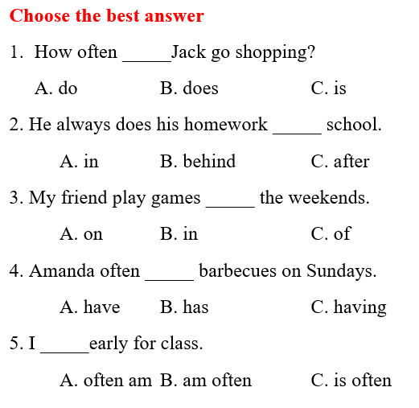  4. Amanda often has barbecues.  *Answer keys  1. B 2. C 3. A 4. B 5. B  d. Ask your partner how often they do these activities  Aim: Ss can know how to use the Adverbs of frwquency.  * The adverbs of frequency  Position: after “be” or before the main verb  To talk about regular actions “always” and “usually” are used with a time phrase | Ss listen to the song and write the activites in the song  ( 2teams) – T comments- give scores – leads in new lesson.  - Ss look at the picture  - T plays audio (Track 43) and have Ss listen and read the speech bubbles  - T plays audio again - Ss listen and repeat.  T explains the usage:  *Usage: talk about how often we do things or how often things happen  Ss work in pairs. Ask and aswer.  - T demonstrates the activity, using the example  - fill in the blanks with the adverbs of frequency  - Ss work in pairs to check each other’s work  - some Ss share their answers with the whole class  -T gives feedback, corrects Ss’ answers if necessary  T demonstrates the activity, using the table  - Ss write the answers in pairs  - Ss check each other’s work  - Some Ss share their answers with the whole class (Write on the board)  - T checks, correct Ss’ answers  - Ss close all books and notebooks  - T gives Ss extra exercise: Choose the best answer ind – T calls –checks – corrects  - Ss do the task in pairs, then swap the roles  - T calls Ss to present the activity in front of the class  - T gives feedback and correct Ss’ pronunciation if necessary

IV. HOMEWORK (2’)
- Make 3 sentences, using adverbs of frequency.
- Do exercise in Workbook: Lesson 1 - Grammar (page 23).
- Prepare: Lesson 1 – Pronunciation and Speaking (page 32 – SB).

