Date of planning: 29 /9 / 2024
Date of teaching: 30/ 9/ 2024
Period 10: UNIT 2: SCHOOL
Lesson 1: New words+ Listening ( p. 14)
I.Objectives: By the end of this lesson, students will be able to: talk about subjects they like and dislike at school
1. Knowledge:
a.Vocabulary: gain vocabulary items about school subjects, including history, P.E (Physical Education), I.T (Information Technology), music, geography, literature, physics, biology, favorite (adj.)
b.Grammar: Ask and answer about favorite subjects with the questions – What’s your favorite subject? – What subject do you like best? – I like …… / My favorite subject is …
2.Competences: - Raise motivations and interests in learning English as a foreign language , Develop communicative and team-working skills through learning activities
3.Educational aims:
- Illustrate problem-solving and critical-thinking skills through learning activities
- Establish responsive and independent characteristics to be a life-long learner
II.Teaching aids: textbooks, plan, video clips, a laptop connected with TV
III.Procedures:
Steps and time | Contents | T & Ss’ activities
Warm-up  5’  Presentation  7’  Practice  10’  Pre- listening  5’  While- listening  10’  Post- listening  5’ | - Game : CROSSWORD  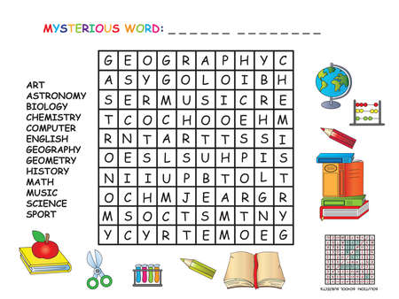  A.New words.  - history, P.E ( Physical Education)(n)  - I.T ( Information Technology) (n)  - Music(n)  - Geography (n)  - Literature)(n)  - Physics (n)  - Biology (n)  - favorite (a)  Match the words to the pictures:  Answer:  - History – C  - P.E – H  - I.T - G  - Music – B  - Geography - D  - Literature - E  - Physics – F  - Biology - A  Ask and answer three more subjects you know:  Ex: - Do you like math? Yes, I do  - Do you like English? Yes, I do  - Do you like literature? Yes, I do  B. Listening:  a. Listen and answer Who like more school subjects ?  Answer: Sarah likes more school subjects.  b. Listen and fill in the blanks:  1. Art  2. P.E  3. Geography  4. P.E | -T divides class into 6 groups, each group has to finish the crossword as quickly as possible.  -Teacher gives feedback, then links to the theme: subjects  -Use context to introduce the new words:  - “How many subjects do you have at school?”  - T lists new words :  -Have students read all the words together (chorally). Correct student’s pronunciation if necessary.  -Teacher lets pictures of subjects appear one by one, students look and name these things.  -Ss work in pairs  - Ss ask and answer about more subjects you know  - T calls 5 pairs  - T remarks and feedback  -T introduces the context of listening, has students listen and complete the faces in the blanks.  -T has students listen three times, then discuss in groups  -T checks and gives feedbacks  - T has students note three more subjects and discuss if they like them  - Have some students share their ideas with the class.  -T demonstrates the activity  -T plays audio, has students listen and fill in the blanks  -T checks answer as a whole class
IV. Homework: (3’)
- Learn newwords about subjects at school by heart
- Do the exercises a,b,c / 8 in the workbook
- Prepare the next period : Grammar

