School: ……………………………………….. | Date:……………………………………..
Class: ……………………………..................... | Period: ………………………………….

UNIT 3: LIVING ENVIRONMENT
Review: Listening, Reading and Vocabulary (Pages 92 & 93)

1. Objectives
By the end of this lesson, students will be able to…
1.1. Language knowledge/ skills
- review the target language learned in the unit
- practice test-taking skills
1.2. Competences
- improve Ss’ communication, collaboration, analytical, and critical thinking skills.
1.3. Attributes
- improve knowledge about technology in modern houses.
2. Teaching aids and materials
- Teacher’s aids: Student’s book and Teacher’s book, class CDs, DCR– Phần mềm tương tác trực quan, DHA – Ứng dụng trò chơi tương tác, projector / interactive whiteboard /TV (if any), PowerPoint slides.
- Students’ aids: Student’s book, Workbook, Notebook.
3. Assessment Evidence
Performance Tasks | Performance Products | Assessment Tools
- Listen and fill in the blanks.  - Read the email and choose the best word (A, B, C, or D) for each space.  - Circle the correct answers.  - Listen and write a letter (A– H) next to each person.  - Read and choose the correct answer (A, B, or C). | - Ss’ answers.  - Ss’ answers.  - Ss’ answers.  - Ss’ answers.  - Ss’ answers. | - Observation and feedback.  - Observation and feedback.  - Observation and feedback.  - Observation and feedback.  - Observation and feedback.
4. Procedures
A. Warm-up: 5 minutes
a. Objectives: to review the vocabulary about living environment.
b. Content: unscramble the words.
c. Expected outcomes: Ss can rearrange the letters to make meaningful words.
d. Organization
Teacher’s activities | Students’ activities
COMPETITION TIME:  Create groups/teams of 3 students.  You will be given some words with letters in incorrect order.  You will work in groups to unscramble the words.  You will use the numbered letters to find out the secret word.  The team(s) with the most correct answers win (s).  Time limit: 5 minutes  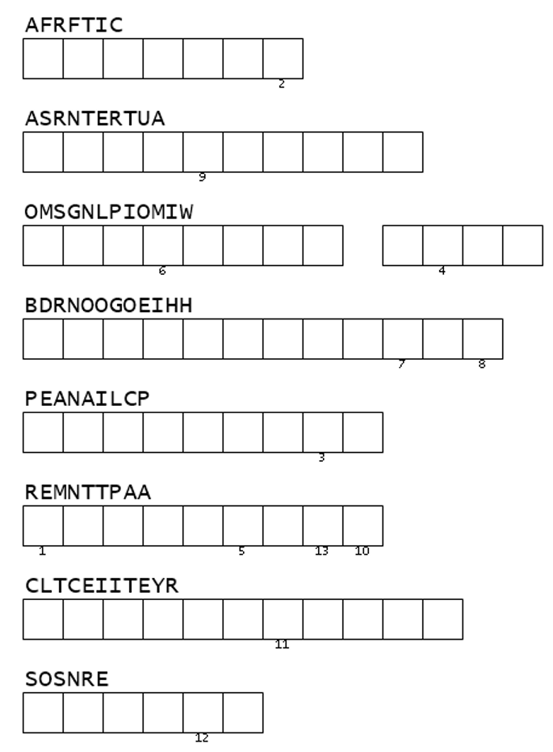  - Ask Ss to work in groups to unscramble the words and find the secret word (using the DCR/ PPTs slides).  - Check the answers and decide the winner. | - Work in groups to unscramble the words and find the secret word.  Answer Keys  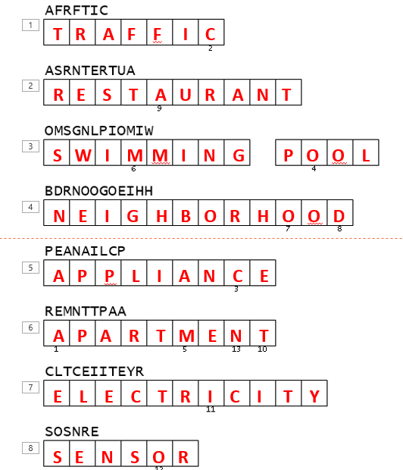  The secret word: ACCOMMODATION

B. New Lesson (35’)
1. Listening (15’)
a. Objectives: To help Ss improve their listening skill.
b. Content: listening task in SB and WB (p.52).
c. Expected outcomes: Ss can listen and fill in the gaps and match.
d. Organization
Teacher’s activities | Students’ activities
You will hear a man talking about a smart apartment building. Listen and fill in the blanks. You will hear the information twice.  - Explain and model the activity.  - Ask Ss to guess the type of the missing words and underline key words (using the DCR/ PPTs slides).  - Ask Ss to listen and fill in the blanks  - Ask Ss to check the answers with a partner.  - Check Ss’ answers (using the DCR). | - Guess the type of the missing words and underline key words.  - Listen and fill in the blanks.  - Check the answers with a partner.  Answer Keys:  1. elevator system  2. outdoor spaces  3. monitors your health  4. a voice assistant  5. (a) spa
Further practice. (Workbook p.52)  You will hear Peter and Betty talking about their neighborhoods and houses. What does each person wish was different? For each question, write a letter (A– H) next to each person. You will hear the conversation twice.  - Explain and model the activity.  - Ask Ss to listen and write a letter (A– H) next to each person.  - Ask Ss to check the answers with a partner.  - Check Ss’ answers (using the DCR). | - Listen and write a letter (A– H) next to each person.  - Check the answers with a partner.  Answer keys:  1. F 2. A 3. E 4. C 5. B

2. Reading (Reading – 15’)
a. Objectives: To help Ss read for details.
b. Content: reading task in SB & WB.
c. Expected outcomes: Ss can read for specific information.
d. Organization:
Teacher’s activities | Students’ activities
Read the email. Choose the best word (A, B, C, or D) for each space.  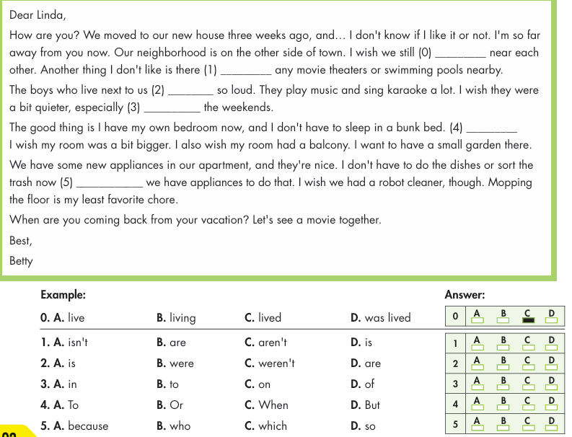  - Ask Ss to read the email and choose the best word.  - Ask Ss to compare the answer with a partner and show the evidence to justify the answer.  - Check Ss’ answers. | - Read the email and choose the best word.  - Compare the answer with a partner and show the evidence to justify the answer.  Answer Key: 0. C  1. C 2. D 3. C 4. D 5. A
Further practice. (WB p.52)  Read the passages about three smart apartments. Choose the correct answer (A, B, or C).  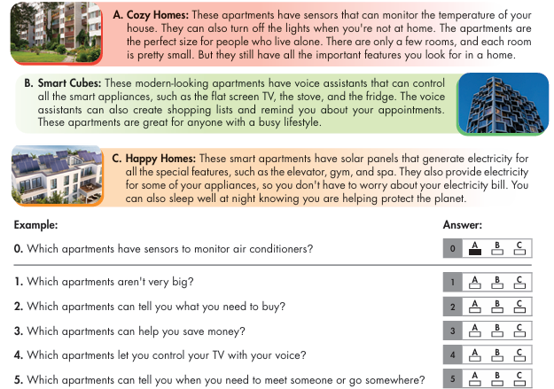  - Ask Ss to read the passages and choose the correct answer.  - Ask Ss to compare the answer with a partner and show the evidence to justify the answer.  - Check Ss’ answers. | - Read the passages and choose the correct answer.  - Compare the answer with a partner and show the evidence to justify the answer.  Answer Key:  1. A 2. B 3. C 4. B 5. B

3. Vocabulary (5’)
a. Objectives: To help Ss review the new words they have learnt in unit 3.
b. Content: vocabulary task.
c. Expected outcomes: Ss can remember the meanings of the words and do the task correctly.
d. Organization
Teacher’s activities | Students’ activities
Circle the correct answers.  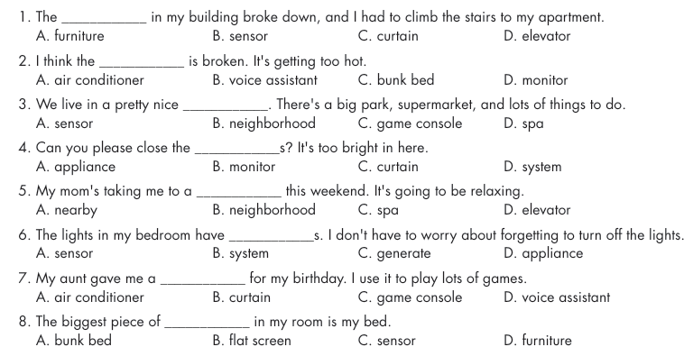  - Ask Ss to read and circle the correct answer.  - Ask Ss to compare the answer with a partner and show the evidence to justify the answer.  - Check Ss’ answers. | - Read and circle the correct answer.  - Compare the answer with a partner and show the evidence to justify the answer.  Answer Key:  1. D 2. A 3. B 4. C  5. C 6. A 7. C 8. D

C. Consolidation and homework assignments (5’)
- Review the new words to talk about houses of the future.
- Make sentences using the new words in SB.
- Prepare for the next lesson (Review Unit 3, pages 93 & 94 - SB).
- Play the consolidation games on www.eduhome.com.vn
5. Reflection

a. What I liked most about this lesson today:
…………………………………………………………………………………………
b. What I learned from this lesson today:
…………………………………………………………………………………………
c. What I should improve for this lesson next time:
…………………………………………………………………………………………

