School: ……………………………………….. | Date:……………………………………..
Class: ……………………………..................... | Period: ………………………………….

UNIT 3: LIVING ENVIRONMENT
Lesson 3.2: Writing & Speaking (Page 33)

1. Objectives
By the end of this lesson, students will be able to…
1.1. Language knowledge/ skills
- practice parallel structures (Writing skills)
- talk about the dream house.
- write a paragraph about the dream house you talked about above.
- improve writing and speaking skills.
1.2. Competences
- improve Ss’ communication, collaboration, analytical, and critical thinking skills.
1.3. Attributes
- Nurture the ability to design a dream house.
2. Teaching aids and materials
- Teacher’s aids: Student’s book and Teacher’s book, class CDs, DCR– Phần mềm tương tác trực quan, DHA – Ứng dụng trò chơi tương tác, projector / interactive whiteboard /TV (if any), PowerPoint slides.
- Students’ aids: Student’s book, Workbook, Notebook.
3. Assessment Evidence
Performance Tasks | Performance Products | Assessment Tools
- Read about using parallel structures, underline the parts that have parallel structures, and then write what part of speech after each parallel structure.  - Rewrite the underlined parts using parallel structures  - Discuss what's important when choosing a house.  - Discuss your dream house, then complete the table.  - Now, write a paragraph about  your dream house. | - Ss’ performance.  - Ss’ answers.  - Ss’ presentation.  - Ss’ performance.  - Ss’ answers. | - Observation.  - Observation and feedback.  - Observation and feedback.  - Observation and feedback.  - Observation and feedback.
4. Procedures
A. Warm-up: 5 minutes
a. Objectives: to introduce the writing skill.
b. Content: unscramble sentences.
c. Expected outcomes: Ss can make sentences by rearranging the given words.
d. Organization
Teacher’s activities | Students’ activities
COMPETITION TIME:  - Create groups/teams of 5 students.  - You will be given some sentences but in the wrong order, you have to unscramble the sentences.  - The team(s) with the most correct answers win (s).  - Time limit: 5 minutes  1. My / house / will / a / dream / pool / and / home / have / theater.  2. to / be / my / dream / I / cozy. / and / want / house / small  3. to / play / watch / It’ll / space / and / listen / to / games, / TV, / music. / have  4. will /fun. / having / growing / be / a / garden / I / think / and / vegetables  5. one / two / for / my / myself. / family / I’ll / and / one / for / TVs: / have | - Listen to the instructions.  - Work in groups and unscramble the sentences.  - Ss’ answers  Answer Keys  1.My dream house will have a pool and a home theater.  2. I want my dream house to be small and cozy.  3. It'll have space to play games, watch TV, and listen to music.  4. I think having a garden and growing vegetables will be fun.  5. I'll have two TVs: one for my family and one for myself.

B. New Lesson (35’)
1. Writing skill (10’)
a. Objectives: To help Ss practice parallel structures.
b. Content: Tasks a, and b.
c. Expected outcomes: Ss can improve their write correct sentences with parallel structures.
Teacher’s activities | Students’ activities
Task a: Read about using parallel structures,  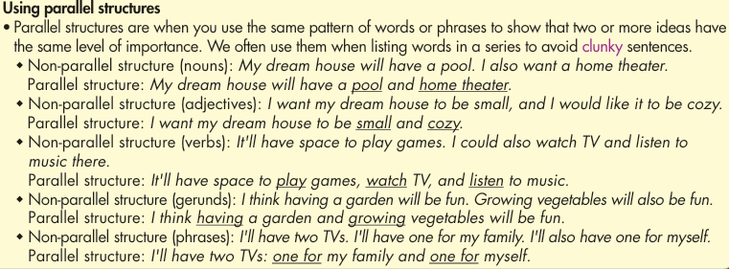  Read Alex's blog again. Underline the parts that have parallel structures, then write what part of speech she used after each parallel structure.  - Ask Ss to read Alex's blog again and underline the parts that have parallel structures, then write what part of speech she used after each parallel structure.  - Ask Ss to compare with their partners.  - Elicit Ss’s answers and check. | - Listen and take notes.  -Read Alex's blog again and underline the parts that have parallel structures, then write what part of speech she used after each parallel structure.  -Compare with their partners.  Answer keys.  My house will be a set of three wooden tree houses: one for my living room and kitchen, one for my bedroom, and one for my bathroom. (phrases)  I want all the houses to look really nice and cozy (adjectives) with yellow curtains and lots of string lights.  The house with the living room will have an outdoor area with a view of the forest and a lake. (nouns)  I'll spend lots of time there reading, working, and watching sunsets. (verbs) My bedroom will have huge windows and a window on the roof (nouns) so that I can see stars and the moon(nouns) from my bed. My bathroom will have an outdoor bathtub and shower. (nouns) There will also be a garden where I can grow vegetables, fruit, and flowers. (nouns) I'll also decorate my house with lots of photos, paintings, and small souvenirs. (nouns)
Task b: Rewrite the underlined parts below using parallel structures.  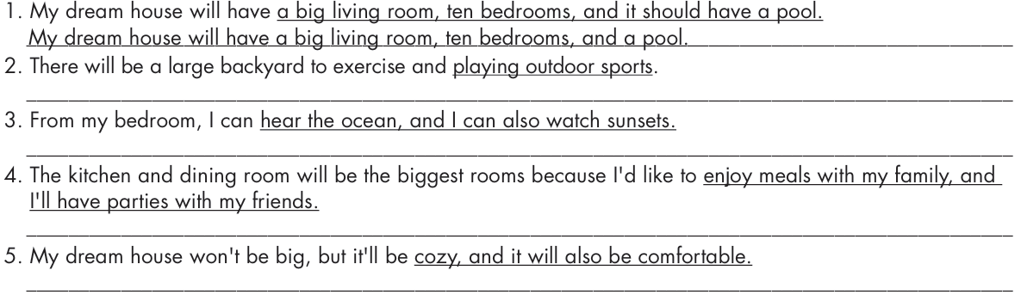  - Ask Ss to rewrite the underlined parts below using parallel structures.  - Ask Ss to compare with their partners.  - Elicit Ss’s answers and check. | - Rewrite the underlined parts below using parallel structures.  - Compare with their partners.  Answer keys.  1. My dream house will have a big living room, ten bedrooms, and a pool.  2. There will be a large backyard to exercise and play outdoor sports.  3. From my bedroom, I can hear the ocean and watch sunsets.  4. The kitchen and dining room will be the biggest rooms because I'd like to enjoy meals with my family and have parties with my friends.  5. My dream house won't be big, but it'll be cozy and comfortable.

2. Speaking (10’)
a. Objectives: To help Ss practice talking about their dream house.
b. Content: Tasks a and b.
c. Expected outcomes: Ss can say what their dream house will look like, what rooms or things it will have, and how they will decorate it.
d. Organization:
Teacher’s activities | Students’ activities
Task a: In pairs: Discuss what's important when choosing a house.  - Ask Ss to discuss what's important when choosing a house.  - Ask Ss to share their ideas with the class.  - Give feedback. | - Discuss what's important when choosing a house.  - Share their ideas with the class.  Suggested answers  Location/Kind of house: city / country, apartment / tree house / …  Appearance: color / size / …  Rooms/Things: living room / bedrooms / kitchen / yard / garden / …  What rooms/things/have? Sofa / air conditioner / bathtub / …  Decorations: paintings / photos / plants / flowers / …
Task b: Now, use the question prompts below to discuss your dream house, then complete the table. List two or three ways to say what it will look like, what rooms or things it will have, and how you will decorate it.  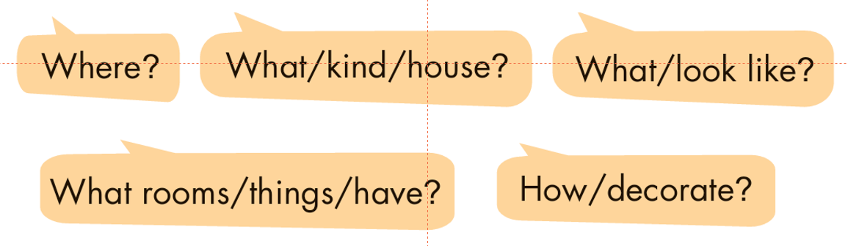  - Ask Ss to use the question prompts to discuss their dream house and complete the table (pair work).  - Check Ss’ answers and give feedback (using the DCR/ PPT slides). | - Discuss their dream house and complete the table.  Sample answer:  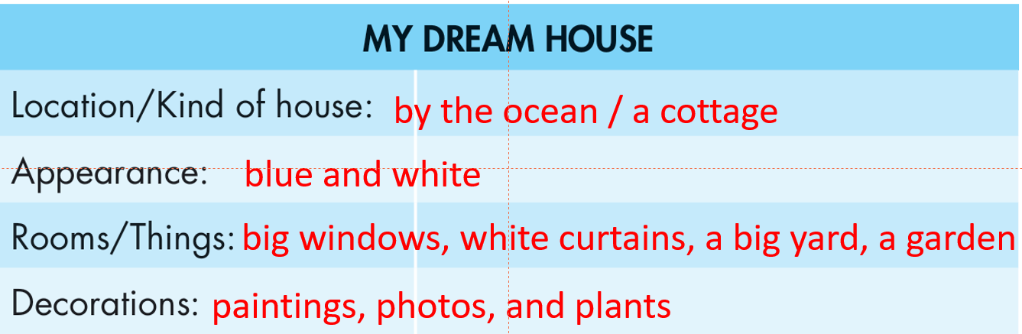

3. Writing (15’)
a. Objectives: To help Ss write a paragraph about their dream house.
b. Content: writing task.
c. Expected outcomes: Ss can write a paragraph about the dream house they talked about above.
d. Organization
Teacher’s activities | Students’ activities
Now, write a paragraph about your dream house. Use the Writing Skill box, the reading model, and your speaking notes to help you.  Write 100 to 120 words.  - Ask Ss to write a paragraph about the dream house they talked about.  - Set the time and go around to help if necessary.  - Ask Ss to exchange their writing with their partner and give suggestions if needed.  - Ask the fastest finsher to show their writing and give feedback. | - Write a paragraph about the dream house they talked about  - Exchange their writing with their partner and give suggestions if needed  Suggested answers:  My dream house will be by the ocean. I want to live there because I love swimming in the ocean and walking along the beach. It'll be a cozy cottage. It'll be blue and white. It'll have big windows and white curtains. There will be a big yard where I can sit to watch sunsets and read my books. It'll also have a garden with lots of plants, trees, and flowers. I'll grow lots of flowers and fruit trees in my garden. My dream house will look very cozy and modern inside. I'll decorate it with lots of paintings, photos, and plants.

C. Consolidation and homework assignments (5’)
- Tell your partner about the dream house you have written.
- Review rapallel structures.
- Prepare for the next lesson (Review Unit 3, pages 92 & 93 (Listening, Reading & Vocab)).
- Play the consolidation games on www.eduhome.com.vn

5. Reflection

a. What I liked most about this lesson today:
…………………………………………………………………………………………
b. What I learned from this lesson today:
…………………………………………………………………………………………
c. What I should improve for this lesson next time:
…………………………………………………………………………………………

