School: ……………………………………….. | Date:……………………………………..
Class: ……………………………..................... | Period: ………………………………….

UNIT 3: LIVING ENVIRONMENT
Lesson 3: Reading (Pages 32)

1. Objectives
By the end of this lesson, students will be able to…
1.1. Language knowledge/ skills
- to practice reading for main ideas and specific information.
- present their ideas about a dream house.
- improve reading skills.
1.2. Competences
- improve Ss’ communication, collaboration, analytical, and critical thinking skills.
1.3. Attributes
- improve creativity to design a dream house.
2. Teaching aids and materials
- Teacher’s aids: Student’s book and Teacher’s book, class CDs, DCR– Phần mềm tương tác trực quan, DHA – Ứng dụng trò chơi tương tác, projector / interactive whiteboard /TV (if any), PowerPoint slides.
- Students’ aids: Student’s book, Workbook, Notebook.
3. Assessment Evidence
Performance Tasks | Performance Products | Assessment Tools
- Talk about the pictures.  - Read a blog and choose the main idea.  - Read and choose the correct answers.  - Listen and read.  - Say whether you would like to live in Alex's dream house (pair work). | - Ss’ answers/ presentation.  - Ss’ answers.  - Ss’ answers.  - Ss’ performance.  - Ss’ answers/presentation. | - Observation and feedback.  - Observation and feedback.  - Observation and feedback.  - Observation and feedback.  - Observation and feedback.
4. Procedures
A. Warm-up: 5 minutes
a. Objectives: to introduce the topic.
b. Content: Let’s talk.
c. Expected outcomes: Ss can talk about the house they want to live in based on the title and the picture.
d. Organization
Teacher’s activities | Students’ activities
In pairs: Look at the pictures.  Which house would you like to live in? Why?  What do you want in your house?  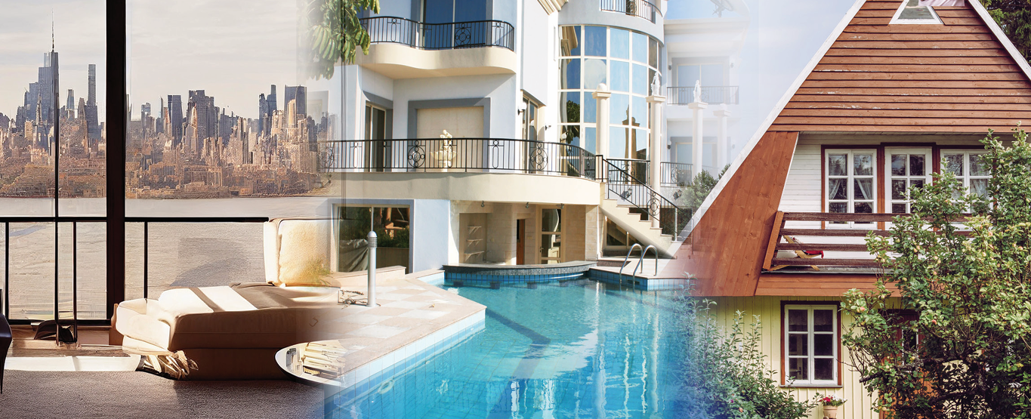  - Ask Ss to work in pairs, look at the title and the picture, and answer the questions (using the DCR/ PPTs slides).  - Call some pairs to give their answers.  - Give feedback. | - Work in pairs, look at the title and the picture and answer the questions.  - Share/exchange the answers with the class.  Answer Keys  I would like to live in a palace in the countryside because I want to enjoy the fresh air and the peaceful life there. I want to have a swimming pool and a garden full of flowers and fruit trees.  Ss’ answers

B. New Lesson (35’)
1. Pre-Reading (Guessing)
a. Objectives: To help Ss guess the main idea of the blog.
b. Content: guessing activity.
c. Expected outcomes: Ss can guess the meaning of the reading passage based on the picture.
d. Organization
Teacher’s activities | Students’ activities
- Ask Ss to look at the picture and guess the main idea of the blog (using the DCR/ PPTs slides).  1. Things Alex wants in her dream house  2. The way Alex built her dream house  - Ask Ss to compare the answers with a partner.  - Elicit Ss’ answers around the class. | - Look at the picture and guess the main idea of the blog.  - Check the answers with a partner.

2. While Reading (Reading – 25’)
a. Objectives: To help Ss read for gist and details.
b. Content: Tasks a, b, c and further practice.
c. Expected outcomes: Ss can read for main idea and specific information about a dream house.
d. Organization:
Teacher’s activities | Students’ activities
Task a: Read Alex's blog below. What is it mainly about?  1. Things Alex wants in her dream house  2. The way Alex built her dream house  - Ask Ss to read the blog and choose the correct answer.  - Ask Ss to compare the answer with a partner and show the evidence to justify the answer.  - Check Ss’ answers. | - Read the blog, underline the evidence, and circle the correct answer.  - Compare the answer with a partner and show the evidence to justify the answer.  Answer Key: number 1  Evidence: They will have modern equipment to make life comfortable. There will be rope bridges connecting the houses together. I want all the houses to look really nice and cozy with yellow curtains and lots of string lights… The house with the living room will have an outdoor area with a view of the forest and a lake… My bedroom will have huge windows and a window on the roof so that I can see stars and the moon from my bed. My bathroom will have an outdoor bathtub and shower. There will also be a garden where I can grow vegetables, fruit, and flowers. I'll also decorate my house with lots of photos, paintings, and small souvenirs.
Task b: Now, read and choose the correct answers.  1. How does Alex describe the city center?  A. ugly B. noisy C. busy D. modern  2. The word They refers to ____.  A. bedrooms B. rope bridges  C. houses D. equipment  3. Which of the following is in the bedroom?  A. TV B. balcony C. big windows D. shower  4. What decorations won't she have?  A. paintings B. yellow curtains  C. pillows D. photos  5. Which of the following can you infer from the passage?  A. Alex wants to have an exciting life.  B. Alex loves nature.  C. Alex doesn't like living alone.  D. Alex loves city life.  - Ask Ss to read the questions and underline key words.  - Ask Ss to read the blog and choose the correct answer.  - Set the time and monitor the class.  - Ask Ss to check the answers with a partner.  - Check Ss’ answers (using the DCR). | - Read the questions and underline key words.  - Read the blog and choose the correct answer.  - Compare the answer with a partner.  Answer Keys  1. B noisy 2. C houses  3. C big windows 4. C pillows  5. B Alex loves nature
Task c: Listen and read.  - Play the CD and ask Ss to listen and read along.  - Pick three Ss to read the three types of accommodation aloud and correct their pronunciation if necessary. | - Listen and read along.
Further practice  - Ask the Ss to read the statements and underline the key words.  1. Alex wants to live in the countryside because it’s not always noisy like in the city.  2. Her house will have three rooms on the trees.  3. There won’t be electricity in her house.  4. She will watch the stars and the moon from her bedroom.  5. She will grow only flowers in the garden.  - Ask Ss to read the blog and write True/False.  - Set the time and monitor the class.  - Ask Ss to check the answers with a partner.  - Check Ss’ answers (using the DCR) | - Read the statements and underline the key words.  - Read the blog and write True/False.  - Check the answers with a partner  Answer Keys  1. True 2. False 3. False  4. True 5. False

3. Post-reading (5’)
a. Objectives: To help Ss share their opinion about Alex’s dream house.
b. Content: Alex’s blog.
c. Expected outcomes: Ss can say whether they would like to live in Alex’s dream house and share the reasons.
d. Organization
Teacher’s activities | Students’ activities
Pair work: Would you like to live in Alex's dream house? Why (not)?  - Ask Ss to ask and answer the questions in pairs.  - Monitor the class and help them if necessary.  - Elicit answers from some students. | - Work in pairs to share their ideas.  - Share their ideas with the class.  Sample answers:  I wouldn’t like to live in Alex’s dream house because it’s inconvenient when the rooms are separate.  I would like to live in Alex’s dream house because I want to live close to nature like her.

C. Consolidation and homework assignments (5’)
- Write four sentences about things you like/don’t like about Alex’s dream house.
- Prepare for the next lesson (Grammar - pages 25 & 26 - SB).
- Play the consolidation games on www.eduhome.com.vn
5. Reflection

a. What I liked most about this lesson today:
…………………………………………………………………………………………
b. What I learned from this lesson today:
…………………………………………………………………………………………
c. What I should improve for this lesson next time:
…………………………………………………………………………………………

