School: ……………………………………….. | Date:……………………………………..
Class: ……………………………..................... | Period: ………………………………….

UNIT 3: LIVING ENVIRONMENT
Lesson 2.2: Grammar (Pages 29 & 30)

1. Objectives
By the end of this lesson, students will be able to…
1.1. Language knowledge/ skills
- practice and use wish with the past simple correctly.
- Make wishes for living environment.
- Improve speaking skills.
1.2. Competences
- improve Ss’ communication, collaboration, analytical, and critical thinking skills.
1.3. Attributes
  - Foster a sense of a better living environment.
2. Teaching aids and materials
- Teacher’s aids: Student’s book and Teacher’s book, class CDs, DCR– Phần mềm tương tác trực quan, DHA – Ứng dụng trò chơi tương tác, projector / interactive whiteboard /TV (if any), PowerPoint slides.
- Students’ aids: Student’s book, Workbook, Notebook.
3. Assessment Evidence
Performance Tasks | Performance Products | Assessment Tools
- Unscramble sentences.  - Read about wish with the Past Simple, then fill in the blanks.  - Listen and check. Listen again and repeat.  - Fill in the blanks with the correct form of the verbs.  - Use the table to write sentences.  - In pairs: Discuss which sentences in Tasks c. and d. you also wish were true. | - Ss’ answers/performance.  - Ss’ answers.  - Ss’ performance.  - Ss’ answers.  - Ss’ answers.  - Ss’ answers/presentation. | - Observation and feedback.  - Observation and feedback.  - Observation and feedback.  - Observation and feedback.  - Observation and feedback.  - Observation and feedback.

4. Procedures
A. Warm-up: 5 minutes
a. Objectives: to introduce the grammar points of wish with the simple past.
b. Content: unscrambling sentences.
c. Expected outcomes: Ss can make complete sentences with the words given.
d. Organization
Teacher’s activities | Students’ activities
Competition time:  - Ask Ss to form groups of 5.  - Give Ss instructions.  - Give Ss some time to unscramble the sentences.  1. Wish / my / I / closer / I / lived / to / friends.  2. My / her / sister / bedroom / a / bigger./ wishes / was / bit  3. we / a / and / a / swimming pool / house. My / family / wish / had / bath / in / our  4. The / wish / in / there / more / residents / entertainment / the / was / neighborhood.  5. principal / to / install / an / the / air conditioner / The / agreed / students / every / wish / in / classroom.  - Check Ss’ answers. | -Form groups of 5.  -Follow the instructions.  -unscramble the sentences in a team/group.  Answer Keys  1. I wish I lived closer to my friends.  2. My sister wishes her bedroom was a bit bigger.  3. My family wish we had a bath and a swimming pool in our house.  4. The residents wish there was more entertainment in the neighborhood.  5. The students wish the principal agreed to install an air conditioner in every classroom.

B. New Lesson (35’)
1. Presentation (15’)
a. Objectives: To help Ss understand how to use wish with the simple past.
b. Content: Tasks a and b.
c. Expected outcomes: Ss can use wish with the simple past in different contexts.
d. Organization
Teacher’s activities | Students’ activities
Task a: Read about wish with the Past Simple, then fill in the blanks.  - Ask Ss to work individually and complete the task (using the DCR/ PPTs slides).  - Ask Ss to compare the answers with a partner.  - Check Ss’ answers around the class.  - Explain the use of wish with the simple past (using the DCR/ PPTs slides)  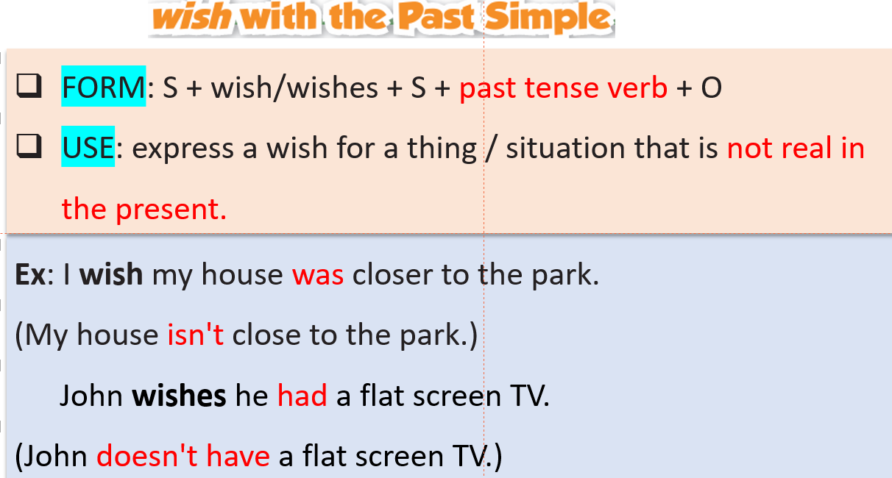  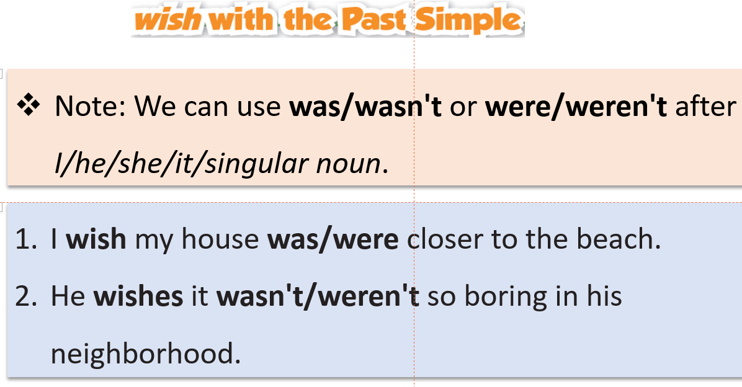 | - Fill in the blanks.  - Compare the answers with a partner.  - Listen to the teacher’s instructions and take notes.  - Listen to the teacher’s instructions and take notes.
Task b: Listen and check. Listen again and repeat.  - Check Ss’ answers around the class.  - Ask students to listen again and repeat. | - Listen and check.  Answer Keys:  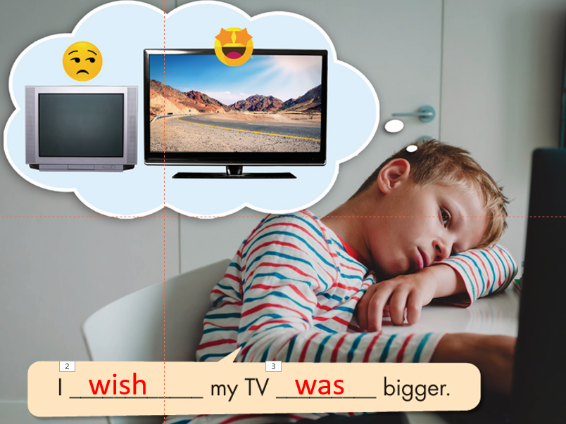  - Listen and repeat.

2. Practice (15’)
a. Objectives: To help Ss practice the use of wish with the simple past.
b. Content: Tasks c and d.
c. Expected outcomes: Ss can use wish with the simple past by making sentences.
d. Organization:
Teacher’s activities | Students’ activities
Task c: Fill in the blanks with the correct form of the verbs.  1. I wish I ________ (have) a bigger bed.  2. He wishes it ________ (be) more exciting in his neighborhood.  3. They wish their friends ________ (live) by their house.  4. I wish my TV ________ (not be) so small.  5. She wishes she ________ (know) her neighbors better.  6. I wish my yard ________ (be) bigger.  7. They wish they ________ (see) their grandparents more.  8. He wishes it ________ (not be) so noisy on his street.  - Ask Ss to complete the task individually.  - Ask Ss to check the answers with a partner.  - Pick some Ss to read the sentence(s) out loud.  - Check and correct Ss’ answers. | - Complete the task.  - Compare the answers with a partner.  - Read the sentences out loud.  Answer Keys:  1. had 2. was/were  3. lived 4. wasn't/weren't  5. knew 6. was/were  7. saw 8. wasn't/weren't
Task d: Use the table to write sentences about what each person wishes to change about their living environment.  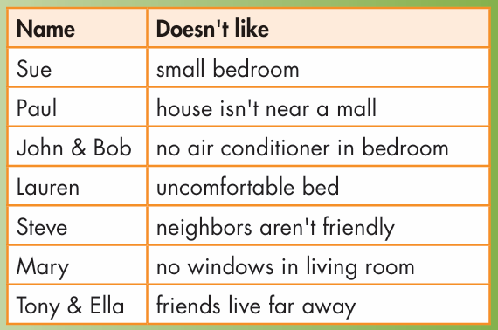  - Ask Ss to write sentences about what each person wishes to change about their living environment using the prompts in the table.  - Set the time and monitor the class.  - Ask Ss to compare the answers with a partner.  - Check Ss’ answers (using the DCR). | -Write full sentences using the prompts.  -Check the answers with a partner.  Answer Key  1. Sue wishes her bedroom was bigger.  2. Paul wishes his house was/were closer to the mall.  3. John and Bob wish their bedroom had an air conditioner.  4. Lauren wishes her bed was/were (more) comfortable.  5. Steve wishes his neighbors were friendlier. / Steve wishes his neighbors weren't (so) unfriendly.  6. Mary wishes her living room had windows.  7. Tony and Ella wish their friends lived closer. / Tony and Ella wish their friends didn't live (so) far away.

3. Production (5’)
a. Objectives: To help Ss produce sentences using wish with the simple past.
b. Content: Task e
c. Expected outcomes: Ss can compare their wishes with others.
d. Organization
Teacher’s activities | Students’ activities
Task e: In pairs: Look at the sentences in Tasks c. and d. Discuss which sentences you also wish were true  - Ask Ss to discuss which sentences in Tasks c. and d. you also wish were true.  - Monitor the class and help them if necessary.  - Ask some Ss to share their ideas. | - Discuss which sentences in Tasks c. and d. you also wish were true  - Share the ideas with the class.  Suggested answers:  I wish I had a bigger bed.  I also wish my bed was more comfortable.  I also wish my yard wasn't so small.  I wish my bedroom was bigger, too.  I wish there was a skatepark near my house, too. I love skateboarding.  I also wish I had an air conditioner in my room.

C. Consolidation and homework assignments (5’)
- Speaking: Ask and answer the question below with your partner, using wish with simple past What do you wish for your living environment?
- Review wish with simple past.
- Prepare for the next lesson (Pronunciation & Speaking - pages 30 & 31 - SB).
- Play the consolidation games on www.eduhome.com.vn
5. Reflection

a. What I liked most about this lesson today:
…………………………………………………………………………………………
b. What I learned from this lesson today:
…………………………………………………………………………………………
c. What I should improve for this lesson next time:
…………………………………………………………………………………………

