School: ……………………………………….. | Date:……………………………………..
Class: ……………………………..................... | Period: ………………………………….

UNIT 3: LIVING ENVIRONMENT
Lesson 2: Vocabulary and Listening (Pages 28 & 29)

1. Objectives
By the end of this lesson, students will be able to…
1.1. Language knowledge/ skills
- learn and use vocab. related to living environment.
- practice listening for gist and specific information
- practice functional English – Asking the same questions.
- present their ideas about technology and appliances they want to have in their house.
- improve listening skills.
1.2. Competences
- improve Ss’ communication, collaboration, analytical, and critical thinking skills.
1.3. Attributes
- improve knowledge about technology in future houses.
2. Teaching aids and materials
- Teacher’s aids: Student’s book and Teacher’s book, class CDs, DCR– Phần mềm tương tác trực quan, DHA – Ứng dụng trò chơi tương tác, projector / interactive whiteboard /TV (if any), PowerPoint slides.
- Students’ aids: Student’s book, Workbook, Notebook.
3. Assessment Evidence
Performance Tasks | Performance Products | Assessment Tools
- Read the definitions, then fill in the blanks with the new words.  - Talk about things students already have in their home and what they want their room to have.  - Listen and answer the question “Does Lisa like her home?”.  - Listen and circle True or False.  - Listen and repeat.  - Listen and circle the phrase  that you hear.  - Discuss how similar or different your home is to Lisa's | - Ss’ answers.  - Ss’ answers/ presentation.  - Ss’ answers.  - Ss’ answers.  - Ss’ answers.  - Ss’ answers.  - Ss’ answers/presentation. | - Observation and feedback.  - Observation and feedback.  - Observation and feedback.  - Observation and feedback.  - Observation and feedback.  - Observation and feedback.  - Observation and feedback.
4. Procedures
A. Warm-up: 5 minutes
a. Objectives: to introduce the topic.
b. Content: Let’s talk.
c. Expected outcomes: Ss can talk about their living environment based on the title and the picture.
d. Organization
Teacher’s activities | Students’ activities
Work in pairs. Look at the pictures:  What can you see?  Do you think they are important things to have in or near your home? Why?  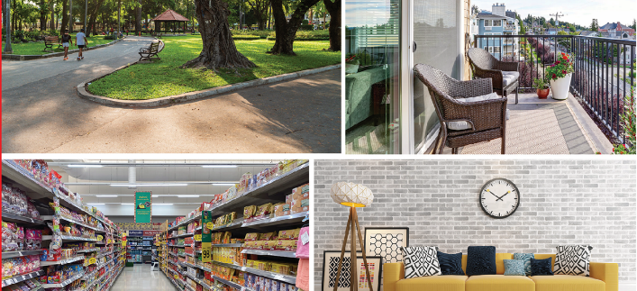  - Ask Ss to work in pairs, look at the title and the picture, and answer the questions (using the DCR/ PPTs slides).  - Call some pairs to give their answers.  - Give feedback. | - Work in pairs, look at the title and the picture and answer the questions.  - Share/exchange the answers with the class.  Suggested answer:  1. A park, a balcony, a convenience store and a living room.  2. Yes. Because they help me have a comfortable life.  Ss’ answers

B. New Lesson (35’)
1. Pre-Listening (Vocabulary - 15’)
a. Objectives: To help Ss improve new words about the topic: living environment.
b. Content: tasks a and b.
c. Expected outcomes: Ss can learn some new words to talk about their house.
d. Organization
Teacher’s activities | Students’ activities
Task a: Read the definitions, then fill in the blanks with the new words. Listen and repeat.  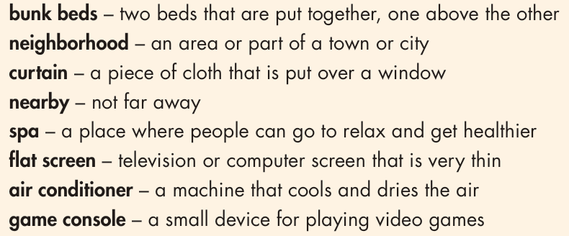  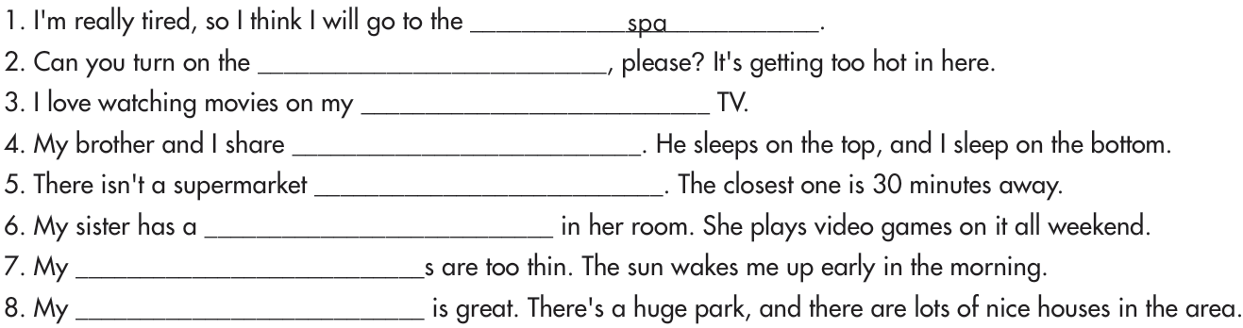  - Ask Ss to work by themselves and fill in the blanks with the new words (using the DCR/ PPTs slides).  - Ask Ss to compare the answers with a partner.  - Check Ss’ answers around the class.  - Ask Ss to listen and repeat. | - Fill in the blanks with the new words.  - Check the answers with a partner.  - Listen and repeat.  Answer Keys:  1. spa 2. air conditioner  3. flat screen 4. bunk beds  5. nearby 6. game console  7. curtain 8. neighborhood
Task b: In pairs: Use the new words to talk about things you already have in your home and what you want your room to have.  - Explain and model the activity.  - Ask Ss to work in pairs, and talk about things they already have in their home and what they want their room to have.  - Check Ss’ answers around the class.  - Pick some Ss to talk about their partner. | - Listen to the instructions.  - Work in pairs, sharing the ideas.  - Share the ideas with the whole class.  Suggested answers:  I have bunk beds in my room. I want a game console.  I have thin curtains in my living room. I would love it if I had a flat-screen TV in my room.  I have an air conditioner in most rooms in my apartment. I want bunk beds in my room.

2. While Listening (Listening – 15’)
a. Objectives: To help Ss listen for gist and details.
b. Content: Tasks a, b, c and d.
c. Expected outcomes: Ss can listen for the main idea and specific information.
d. Organization:
Teacher’s activities | Students’ activities
Task a: Listen to Lisa talking to her friend about her home. How does Lisa feel about her home?  - Ask Ss to listen and answer the question by circling the number.  - Ask Ss to compare the answer with a partner and show the evidence to justify the answer.  - Check Ss’ answers. | - Listen and circle the correct number.  - Compare the answer with a partner and show the evidence to justify the answer.  Answer Key: number 4 (she likes it)  Evidence:  Jacob: What's your house like?  Lisa: It's great. It's really big, and it has a lovely living room and kitchen. I wish we had a bath, but I still really like it without one.
Task b: Now, listen and circle True or False.  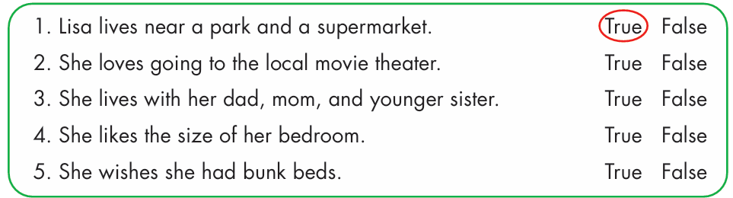  - Ask Ss to read the sentences and underline key words.  - Ask Ss to listen and circle True or False.  - Ask Ss to check the answers with a partner.  - Check Ss’ answers (using the DCR). | - Read the sentences and underline key words.  - Listen and circle True or False  - Compare the answer with a partner.  Answer Keys  - True  Jacob: Hey, Lisa. Where do you live?  Lisa: I live on King's Street.  Jacob: What's your neighborhood like?  Lisa: It's nice. There's a big park and a good supermarket.  - True  Jacob: That's good.  Lisa: Yeah, but I wish there was more entertainment. I love going to the movie theater, but it's so far from my house. I wish I lived closer to it.  - False  Jacob: I understand. Who do you live with?  Lisa: I live with my mom, dad, and older brother.  - False  Jacob: Yeah, maybe. What about your bedroom?  Lisa: It's OK. I wish it was a bit bigger. I don't really have room for all my clothes and books  - True  Jacob: That's annoying.  Lisa: Yeah. I also wish I had bunk beds. If I did, my friends could sleep over.
Task c: Read the Conversation Skill box, then listen and repeat.  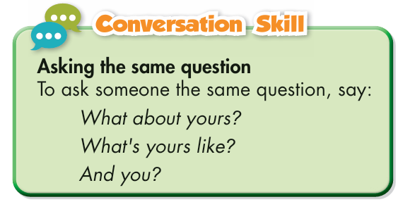  - Present different ways to ask the same question.  - Play the CD and ask Ss to listen and repeat.  - Pick three Ss to read the three ways ask the same question aloud and correct their pronunciation if necessary. | - Listen and take notes.  - Listen and repeat.
Task d: Now, listen to the conversation again and circle the phrase that you hear.  What about yours?  What's yours like?  And you?  - Give instructions.  - Play the CD and ask Ss to listen and circle the phrase that they hear.  - Ask Ss to check the answers with a partner.  - Check Ss’ answers (using the DCR). | - Listen and circle the phrase that they hear.  - Check the answers with a partner.  Answer key: And you?

3. Post-listening (5’)
a. Objectives: To help Ss compare their house with Lisa’s.
b. Content: task e.
c. Expected outcomes: Ss can say the similarities and differences between their house and Lisa’s.
d. Organization
Teacher’s activities | Students’ activities
In pairs: Discuss how similar or different your home is to Lisa's.  - Ask Ss to discuss how similar or different your home is to Lisa's in pairs.  - Monitor the class and help them if necessary.  - Elicit answers from some students. | - Work in pairs to share their ideas.  - Share their ideas with the class.

C. Consolidation and homework assignments (5’)
- Vocabulary:
1. Spa 2. air conditioner 3. flat screen 4. bunk beds
5. Nearby 6. game console 7. Curtain 8. neighborhood
- Review the new words to talk about houses.
- Make sentences using the new words in SB.
- Prepare for the next lesson (Grammar - pages 29 & 30 - SB).
- Play the consolidation games on www.eduhome.com.vn
5. Reflection

a. What I liked most about this lesson today:
…………………………………………………………………………………………
b. What I learned from this lesson today:
…………………………………………………………………………………………
c. What I should improve for this lesson next time:
…………………………………………………………………………………………

