School: ……………………………………….. | Date:……………………………………..
Class: ……………………………..................... | Period: ………………………………….

UNIT 3: LIVING ENVIRONMENT
Lesson 1.3: Pronunciation & Speaking (Pages 26 & 27)

1. Objectives
By the end of this lesson, students will be able to…
1.1. Language knowledge/ skills
- practice ‘…that can...’ and ‘…that care…’ (Sound changes and Rhythm)
- talk about a cool and smart house.
- improve speaking skills.
1.2. Competences
- improve Ss’ communication, collaboration, analytical, and critical thinking skills.
1.3. Attributes
- improve knowledge about technology in future houses.
2. Teaching aids and materials
- Teacher’s aids: Student’s book and Teacher’s book, class CDs, DCR– Phần mềm tương tác trực quan, DHA – Ứng dụng trò chơi tương tác, projector / interactive whiteboard /TV (if any), PowerPoint slides.
- Students’ aids: Student’s book, Workbook, Notebook.
3. Assessment Evidence
Performance Tasks | Performance Products | Assessment Tools
- Listen to the sentences and focus on the underlined letters.  - Listen and cross out the sentence that doesn’t follow the note.  - Read the sentences with the sound change.  - Take turns talking about the smart homes. (Pair work)  - Take turns saying which groups of people would love the apartment and house previously mentioned.  - Discuss and design a house with at least four smart features. (Pair work)  - Join another pair and tell them about your house. | - Ss’ performance.  - Ss’ answers.  - Ss’ performance.  - Ss’ performance.  - Ss’ answers/presentation.  - Ss’ answers/presentation.  - Ss’ answers/presentation. | - Observation.  - Observation and feedback.  - Observation and feedback.  - Observation and feedback.  - Observation and feedback.  - Observation and feedback.  - Observation and feedback.
4. Procedures
A. Warm-up: 5 minutes
a. Objectives: to introduce the transcription of sentences.
b. Content: Pronunciation game: sentence transcription.
c. Expected outcomes: Ss can write sentences based on their transcription.
d. Organization
Teacher’s activities | Students’ activities
COMPETITION TIME:  - Create groups/teams of 5 students.  - You will be given the transcription of 10 sentences.  - You have to write the 10 sentences.  - The team(s) with the most correct answers win(s).  - Time limit: 5 minutes  - /haʊ əʊld ə jʊ/?  - /ʃiː ɪz maɪ ˈsɪstə/  - /duː jʊ spiːk ˈɪŋglɪʃ/?  - /maɪ dæd ˈwɔːtəd ðə plɑːnts/  - /kæn jʊ draɪv ə kɑː/?  - /ðə ˈbeɪbɪ wəz stɪl ˈsliːpɪŋ/  - /maɪ ˈfeɪvərɪt ˈkʌlə ɪz bluː/  - /aɪ ˈɔːlwəz get ʌp ˈɜːlɪ/  - /maɪ mʌm ˈnevə ˈdɑːnsɪz/  - /ʃiː həz ɔːlˈredɪ əˈraɪvd/ | - Listen to the instructions.  - Work in groups and write the sentences.  - Ss’ answers  Answer Keys  - How old are you?  - She is my sister.  - Do you speak English?  - My dad watered the plants.  - Can you drive a car?  - The baby was still sleeping.  - My favorite color is blue.  - I always get up early.  - My mom never dances.  - She has already arrived.

B. New Lesson (35’)
1. Pronunciation (15’)
a. Objectives: To help Ss practice ‘...that can...’ and ‘…that care…’ (Sound changes and Rhythm).
b. Content: Tasks a, b, c and d.
c. Expected outcomes: Ss can improve their pronunciation by changing sounds in sentences.
d. Organization
Teacher’s activities | Students’ activities
Task a: Notes:  - '...that can...' often sounds like /ðækən/.  - '...that care...' often sounds like /ðæker/.  - Ask Ss to take notes. | - Listen and take some notes.
Task b: Listen to the sentences and focus on the underlined letters.  People that_care about the environment should live here.  Our house has walls that_can move. | -Listen to the sentences and focus on the underlined words.
Task c: Listen and cross out the sentence that doesn't follow the note in Task a.  I have smart appliances that clean themselves.  These apartments have safety systems that can call emergency services. | -Listen and choose the correct answer.  Answer:  These apartments have safety systems that can call emergency services.
Task d: Read the sentences with the sound  change noted in Task a. to a partner.  - Ask some students to read the sentences out loud.  - Give some feedback or correction. | - Practice saying the sentences with a partner.  - Read the sentences out loud.

2. Practice (10’)
a. Objectives: To help Ss practice changing sounds to discuss some smart houses.
b. Content: Tasks a and b.
c. Expected outcomes: Ss can discuss smart houses with changing sounds.
d. Organization:
Teacher’s activities | Students’ activities
Task a: In pairs: Take turns talking about the smart homes below.  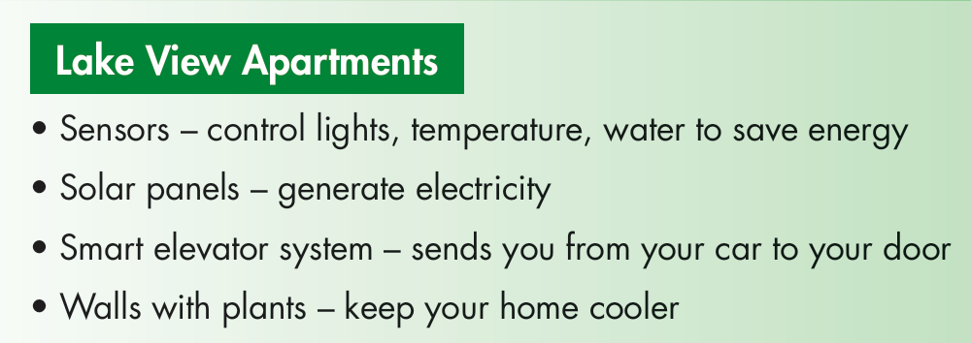  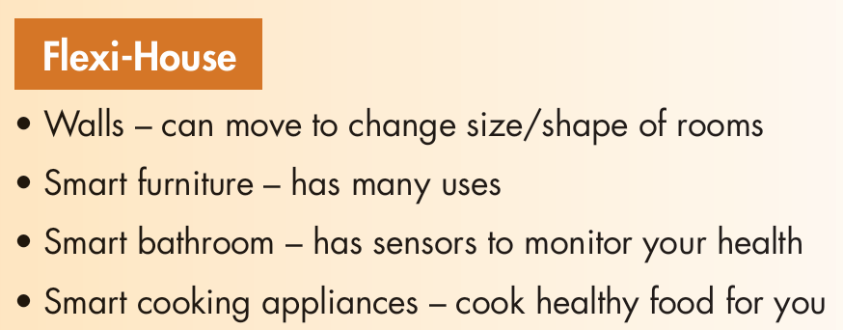  - Ask Ss to practice in pairs.  - Ask Ss to share their ideas with the class.  - Check SS’s answers and give feedback. | - Practice in pairs  - Share the ideas with the class.  Sample answer:  A: What do the Lake View Apartments have?  B: They have sensors that control lights,  temperature, and water to save energy.
Task b: Take turns saying which groups of people would love the apartment and house in Task a  - Ask Ss to work in pairs and share their ideas.  - Check Ss’ answers and give feedback (using the DCR/ PPT slides). | - Share the ideas with a partner.  Sample answer:  A: People who want to save money would  love Lake View Apartments.  B: People that care about the environment  would also love the apartments.

3. Speaking (10’)
a. Objectives: To help Ss further practice changing sounds to discuss how to design some smart houses.
b. Content: Tasks a and b.
c. Expected outcomes: Ss can design some smart houses with changing sounds.
d. Organization
Teacher’s activities | Students’ activities
Task a: You're designing a smart house for one of the types of people below. In pairs: Choose one, then discuss and design a house with at least four smart features for them.  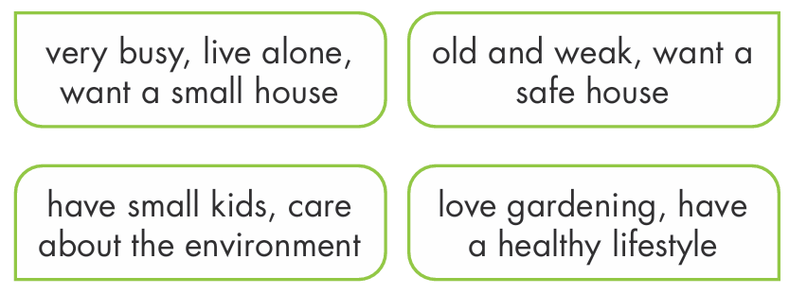  - Ask Ss to work in pairs and discuss and design a house with at least four smart features for different types of people.  - Monitor the class and help them if necessary.  - Elicit answers from some students. | - Work in pairs to share their ideas.  - Share their ideas with the class.  Sample answer:  A: People that are very busy want a house  with lots of smart appliances.  B: Yeah. They want smart appliances which they can control remotely, so they can control them from everywhere.
Task b: Join another pair and tell them about your house.  - Ask Ss to work in pairs and talk about the house they have designed.  - Monitor the class and help them if necessary.  - Elicit answers from some students. | -Discuss in pairs.  -Share their ideas with the class.  Sample answer:  We designed a house for people that are very busy, live alone, and want a small house. It has smart appliances that they can control remotely, so they can control them from everywhere. It also has refrigerators that can order food and drinks for them. In addition, it has walls that can move to change the size/shape of rooms and kitchen robots that can make a whole meal and clean themselves

C. Consolidation and homework assignments (5’)
Practice saying these sentences by changing sounds.
People that_care about the environment should live here.
Our house has walls that_can move.
- Practice saying sentences in the Pronunciation (SB) by changing sounds.
- Prepare for the next lesson (Vocabulary & Listening - pages 28 & 29 - SB).
- Play the consolidation games on www.eduhome.com.vn

5. Reflection
a. What I liked most about this lesson today:
…………………………………………………………………………………………
b. What I learned from this lesson today:
…………………………………………………………………………………………
c. What I should improve for this lesson next time:
…………………………………………………………………………………………

