School: ……………………………………….. | Date:……………………………………..
Class: ……………………………..................... | Period: ………………………………….

UNIT 3: LIVING ENVIRONMENT
Lesson 2: Grammar (Pages 25 & 26)

1. Objectives
By the end of this lesson, students will be able to…
1.1. Language knowledge/ skills
- to learn and use the Defining relative clauses with relative pronouns who, whom, which, that, whose.
- identify the difference between subject relative clause and object relative clause.
- produce sentences using Defining relative clauses with relative pronouns who, whom, which, that, whose.
- improve Grammar and Speaking.
1.2. Competences
- improve Ss’ communication, collaboration, analytical, and critical thinking skills.
1.3. Attributes
- improve knowledge about technology in future houses...
2. Teaching aids and materials
- Teacher’s aids: Student’s book and Teacher’s book, class CDs, DCR– Phần mềm tương tác trực quan, DHA – Ứng dụng trò chơi tương tác, projector / interactive whiteboard /TV (if any), PowerPoint slides.
- Students’ aids: Student’s book, Workbook, Notebook.
3. Assessment Evidence
Performance Tasks | Performance Products | Assessment Tools
- Read about defining relative clauses with relative pronouns, then fill in the blank.  - Listen, check, and repeat.  - Circle the correct words.  - Combine the sentences.  - Share the ideas with the class. | - Ss’ answers.  - Ss’ answers.  - Ss’ answers.  - Ss’ answers.  - Ss’ answers/presentation. | - Observation.  - Observation/feedback.  - Observation/feedback.  - Observation/feedback.  - Observation/feedback.

4. Procedures
A. Warm-up: 5 minutes
a. Objectives: To introduce the grammar point: defining relative clauses with relative pronouns.
b. Content: complete the sentences.
c. Expected outcomes: Ss can complete the sentences with the correct given relative clauses.
d. Organization
Teacher’s activities | Students’ activities
Competition time:  - Ask Ss to form groups of 3.  - Give Ss instructions and one example.  - Give Ss some sentences and relative clauses to complete.  a. that want to reduce their impact on the environment  b. which can entertain your kids  c. who love nature  d. which generate electricity for the whole building  e. that connects to a larger garden  1.People ……………will like this place.  2. Each house has an outdoor space ………  3. The houses also have voice assistants …….  4. These apartments have solar panels……  5. The trash cans will be great for people …  - Check Ss’ answers. | - Form groups of 3.  - Follow the instructions.  - Complete the sentences in a team/group.  Answer Keys  1. c. People who love nature will like this place.  2. e. Each house has an outdoor space that connects to a larger garden.  3. b. The houses also have voice assistants which can entertain your kids.  4. d. These apartments have solar panels which generate electricity for the whole building.  5. a. The trash cans will be great for people that want to reduce their impact on the environment.

B. New Lesson (35’)
1. Presentation (15’)
a. Objectives: To help Ss understand how to use defining relative clauses with relative pronouns who, whom, which, that, whose and identify the difference between subject relative clause and object relative clause.
b. Content: Tasks a and b.
c. Expected outcomes: Ss can make sentences using relative clauses with relative pronouns who, whom, which, that, whose.
d. Organization
Teacher’s activities | Students’ activities
Task a: Read about defining relative clauses with relative pronouns, then fill in the blank.  - Ask Ss to work individually and complete the task (using the DCR/ PPTs slides).  - Ask Ss to compare the answers with a partner.  - Check Ss’ answers around the class.  - Explain the use of defining relative clauses with relative pronouns (using the DCR/ PPTs slides)  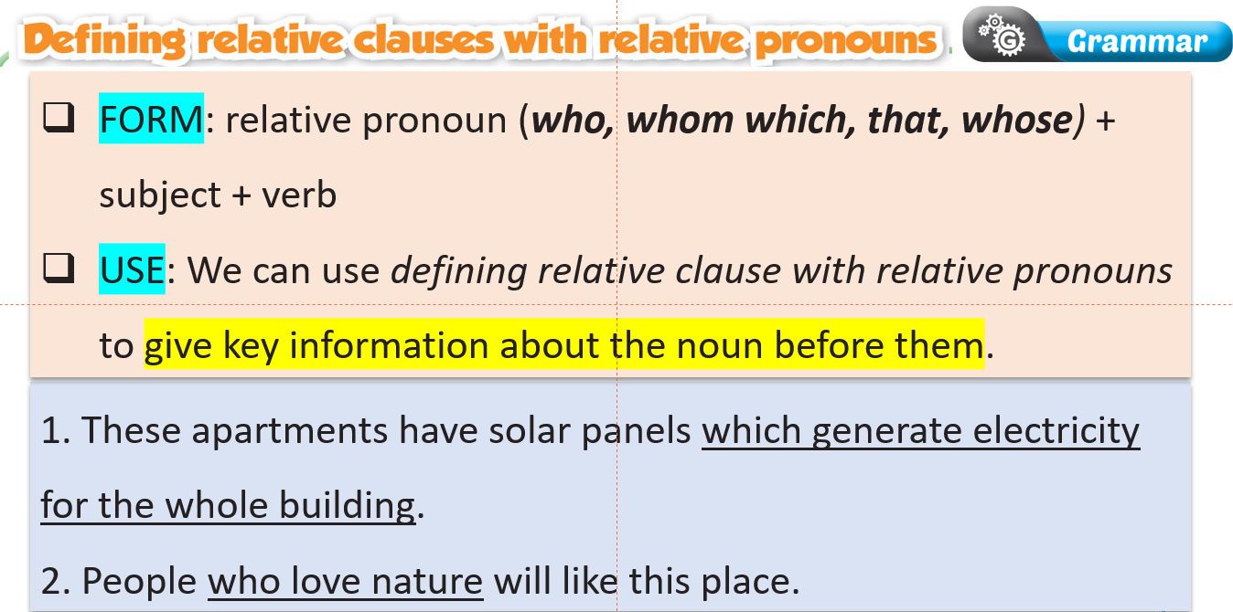  - Explain the use of different relative pronouns (using the DCR/ PPTs slides)  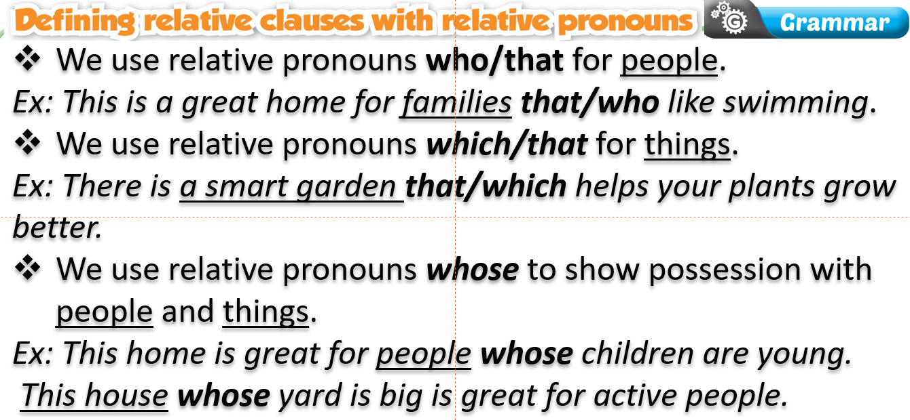  -Explain the difference between subject relative clause and object relative clause.  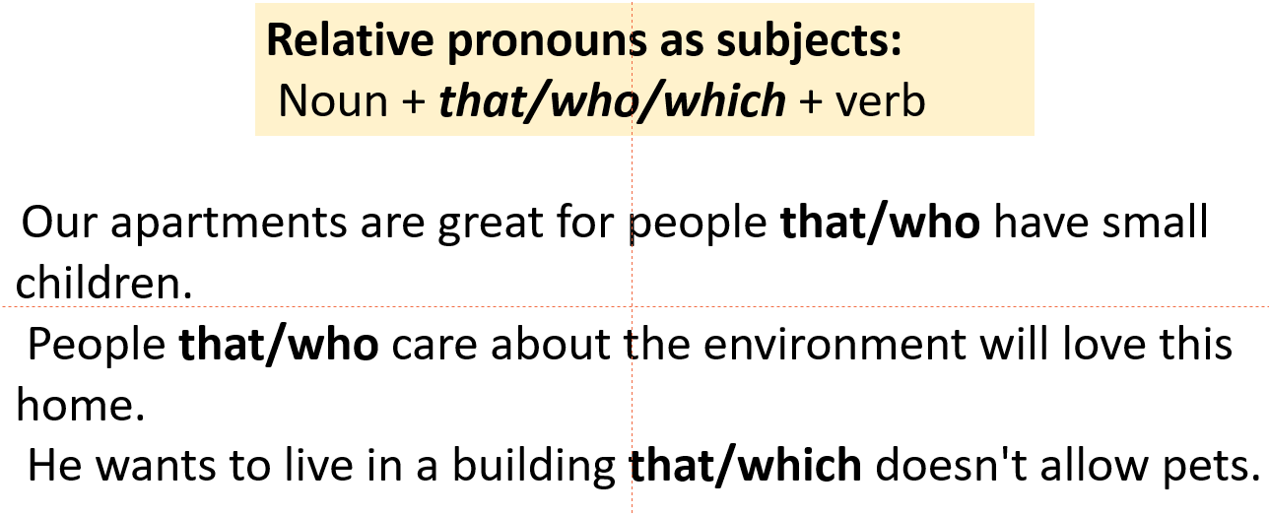  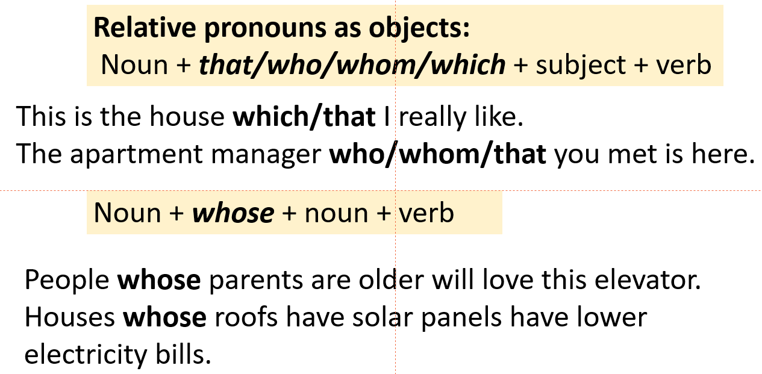  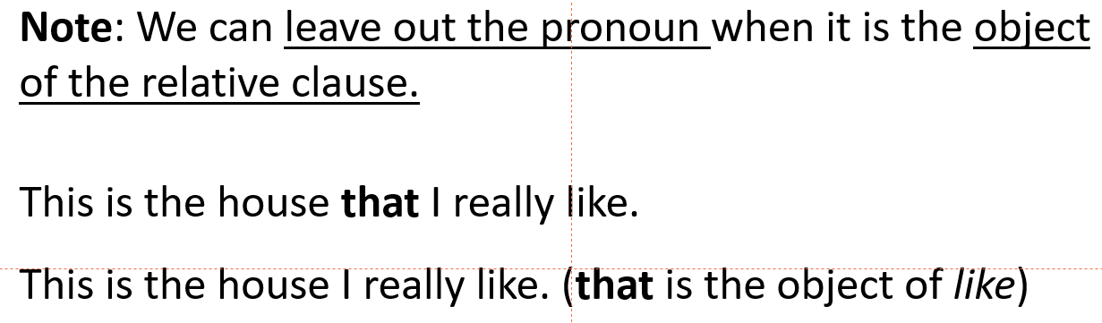 | - Fill in the blanks.  - Compare the answers with a partner.  - Listen to the teacher’s instructions and take notes.  - Listen to the teacher’s instructions and take notes.  - Listen to the teacher’s instructions and take notes.
Task b: Listen and check. Listen again and repeat.  - Check Ss’ answers around the class. | - Listen and check.  Answer Keys:  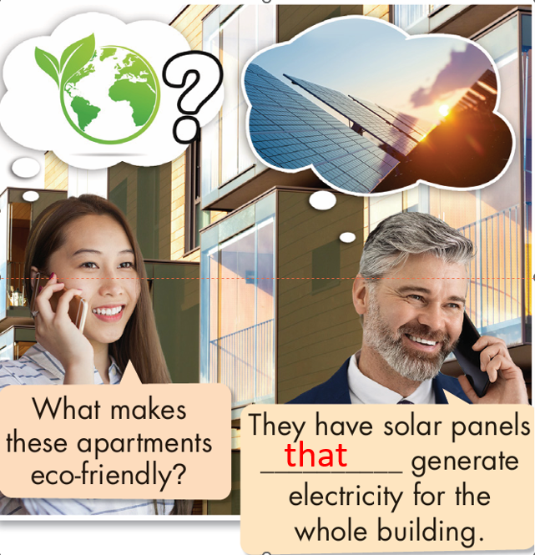  - Listen and repeat.

2. Practice (15’)
a. Objectives: To help Ss practice the use of defining relative clauses with different relative pronouns.
b. Content: Tasks c and d.
c. Expected outcomes: Ss can practice the use of “separable and inseparable phrasal verbs” and when to use them.
d. Organization:
Teacher’s activities | Students’ activities
Task c: Circle who, whose, or which.  - Ask Ss to complete the task individually.  - Ask Ss to check the answers with a partner.  - Pick some Ss to read the sentence(s) out loud.  - Check and correct Ss’ answers. | - Complete the task.  - Compare the answers with a partner.  - Read the sentences out loud.  Answer Keys:  1. which 2. whose 3. Who 4. which  5. who 6. Which 7. Whose 8. who
Task d: Combine the sentences using relative clauses.  1. We have a sofa. The sofa is also a bed.  2. Old people would love a house with a smart safety system. Old people live alone.  3. We have a smart elevator. The elevator sends you from your car to your front door.  4. People will love these smart apartments. People care about the environment.  5. Parents will love the smart safety system. Their kids are very active.  6. The apartment has a smart garden. The smart garden helps plants grow by watering them and giving them plant food.  - Ask Ss to combine the sentences using relative clauses.  - Ask Ss to compare the answers with a partner.  - Set the time and monitor the class.  - Check Ss’ answers (using the DCR). | -Combine the sentences using relative clauses.  -Check the answers with a partner.  Answer Key  1. We have a sofa that/which is also a bed.  2. Old people that/who live alone would love a house with a smart safety system.  3. We have a smart elevator that/which sends you from your car to your front door.  4. People that/who care about the environment will love these smart apartments.  5. Parents whose kids are very active will love the smart safety system.  6. The apartment has a smart garden that/which helps plants grow by watering them and giving them plant food.

3. Production (5’)
a. Objectives: To help Ss produce sentences using defining relative clauses with different relative pronouns.
b. Content: smart appliances and furniture in the future.
c. Expected outcomes: Ss can talk about smart appliances and furniture they think they will have in the future and who the products would be for, using defining relative clauses with different relative pronouns.
d. Organization

Teacher’s activities | Students’ activities
In pairs: Take turns saying what smart appliances and furniture you think we will have in the future and who the products would be for using the table below.  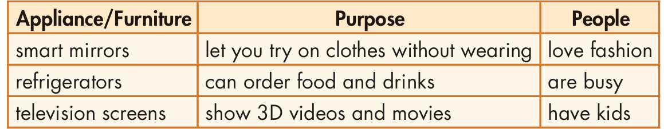  - Ask Ss to say what smart appliances and furniture they think they will have in the future and who the products would be for using the prompts in the table.  - Monitor the class and help them if necessary.  - Ask some Ss to share their ideas. | - say what smart appliances and furniture they think they will have in the future and who the products would be for using the prompts in the table.  - Work in pairs to share the ideas/ sentences.  - Share the ideas with the class.  Suggested answers:  1. A: I think we'll have smart mirrors that let you try on clothes without wearing them.  B: I think they'd be for people who love fashion.  2. A: I think we'll have refrigerators that can order food and drinks.  B: I think they'd be for people who are busy.  3. A: I think we'll have television screens that show 3D videos and movies.  B: I think they'd be for people who have kids.

C. Consolidation and homework assignments (5’)
- Writing: Write 5 sentences, using defining relative clauses with relative pronouns who, whom, which, that, whose.
- Review defining relative clauses with relative pronouns who, whom, which, that, whose.
- Make sentences using defining relative clauses with relative pronouns in SB.
- Prepare for the next lesson (Pronunciation & Speaking - pages 26 & 27 - SB).
- Play the consolidation games on www.eduhome.com.vn

5. Reflection
a. What I liked most about this lesson today:
…………………………………………………………………………………………
b. What I learned from this lesson today:
…………………………………………………………………………………………
c. What I should improve for this lesson next time:
…………………………………………………………………………………………

