School: ……………………………………….. | Date:……………………………………..
Class: ……………………………..................... | Period: ………………………………….

UNIT 2: Life in the past
Lesson: Review 2 (Pages 88 & 89)

1. Objectives
By the end of this lesson, students will be able to…
1.1. Language knowledge/ skills
- Review the target language learned in the unit
- Practice test-taking skills (Grammar, Pronunciation, In the Real World, Conversation, Speaking & Writing)
1.2. Competences
- improve Ss’ communication, collaboration, analytical, and critical thinking skills.
1.3. Attributes
- cultivate a heightened curiosity for diverse learning methodologies.

2. Teaching aids and materials
- Teacher’s aids: Student’s book and Teacher’s book, class CDs, DCR– Phần mềm tương tác trực quan, DHA – Ứng dụng trò chơi tương tác, projector / interactive whiteboard /TV (if any), PowerPoint slides.
- Students’ aids: Student’s book, Workbook, Notebook.
3. Assessment Evidence
Performance Tasks | Performance Products | Assessment Tools
- Fill in the blanks. | - Ss’ answers. | - Observation/feedback.
- Listen and fill in the blanks. | - Ss’ answers. | - Observation/feedback.
- Read the passage and choose the best answer. | - Ss’ answers. | - Observation/feedback.
- Circle the correct words. | - Ss’ answers. | - Observation/feedback.
- Share the ideas with the class. | - Ss’ answers. | - Observation/feedback

4. Procedures
A. Warm-up: 5 minutes
a. Objectives: To review the vocabulary related to family members
b. Content: Share the ideas with the class.
c. Expected outcomes: Ss can talk about family members
d. Organization
Teacher’s activities | Students’ activities
Warm-up activities: Competition time:
- Ask Ss to form groups of 5. | - Form groups of 5.
- Give Ss instructions | - Follow the instructions.
- Ask students to match the words with the correct pictures. | - Match the words with the correct pictures.
- Check the answers. | - Correct the answers.
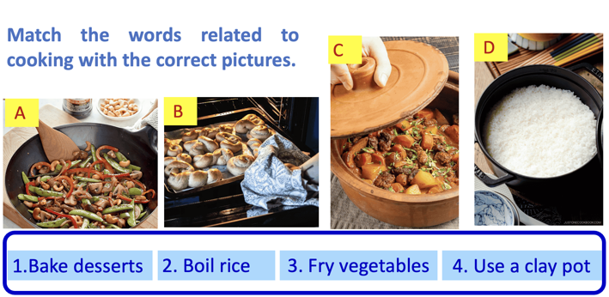 | Suggested answers  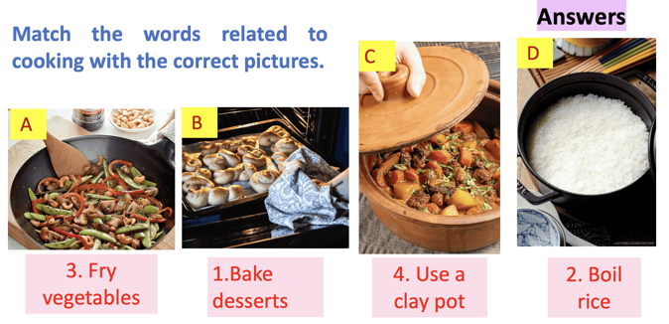

B. New Lesson (35’)
1. Grammar (5’)
a. Objectives: Review the target language learned in the unit
b. Content: Grammar
c. Expected outcomes: Ss can practice test-taking skills.
d. Organization:
Teacher’s activities | Students’ activities
Rearrange the groups of words in the correct order to make complete sentences.
-Demonstrate the activity using the example. | - Listen to the instructions.
- Ask students to unscramble the sentences. | - Complete the task.
- Have pairs check each other's work. | - Compare the answers with a partner.
- Pick some Ss to read the sentence(s) out loud. | - Read the sentences out loud.
- Check and correct Ss’ answers. | - Correct the answers
Answers
1. We used to make delicious food in the evenings.
2. My sister used to work at a market stall.
3. My grandparents would go fishing, and we'd play
board games.
4. I used to live in a cottage with my extended family.
5. Back then, most families ate dinner together every day.
6. Women used to be housewives, and husbands would
be breadwinners.
7. In the past, people would often get married at a
young age.
8. We used to meet our friends at the park after school.

2. Pronunciation (5’)
a. Objectives: Review the target language learned in the unit
b. Content: Pronunciation
c. Expected outcomes: Ss can practice test-taking skills.
d. Organization:
Teacher’s activities | Students’ activities
Task a. Circle the word that differs from the other three in the position of primary stress in each of the following questions.
- Ask Ss to notice the pronunciation feature. | - Notice the pronunciation feature
- Ask Ss to circle the correct answer | - Circle the correct answer
- Ask Ss to compare the answers with a partner. | - Compare the answers with a partner and show the evidence to justify the answer.
- Check the answers as a whole class. | - Correct the answers
Answer Key
- D
- C
Task b. Circle the word that has the underlined part pronounced differently from the others.
- Ask Ss to notice the pronunciation feature. | - Notice the pronunciation feature.
- Ask Ss to circle the correct answer. | - Circle the correct answer.
- Ask Ss to compare the answers with a partner. | - Compare the answers with a partner and show the evidence to justify the answer.
- Check the answers as a whole class. | - Correct the answers.
Answer Key
1. C
2. C

Evidence:
Task a:
1.A. relative | B. family | C. breadwinner | D. extended
/ˈrelətɪv/ | /ˈfæməli/ | /ˈbredwɪnər/ | /ɪkˈstendɪd/
2.A. nephew | B. cottage | C. divorce | D. single
/ˈnefjuː/ | /ˈkɑːtɪdʒ/ | /dɪˈvɔːrs/ | /ˈsɪŋɡl/
Task b:
1. A. divorce | B. relative | C. housewife | D. single
/dɪˈvɔːrs/ | /ˈrelətɪv/ | /ˈhaʊswaɪf/ | /ˈsɪŋɡl/
2. A. bake | B. clay pot | C. relative | D. generation
/beɪk/ | /kleɪ pɑːt/ | /ˈrelətɪv/ | /ˌdʒenəˈreɪʃn/

3. In the Real World (5’)
a. Objectives: Review the target language learned in the unit
b. Content: In the Real World
c. Expected outcomes: Ss can practice test-taking skills.
d. Organization:
Teacher’s activities | Students’ activities
Look at the advertisements. Choose the best answers.
- Ask Ss to read the questions. | - Read the questions.
- Ask Ss to underline the key words | - Underline the key words
- Ask students to read and circle the correct answer. | - Read and circle the correct answer.
- Ask Ss to compare the answers with a partner. | - Compare the answers with a partner and show the evidence to justify the answer.
- Check the answers as a whole class. | - Correct the answers
Answer Key
1. B
(Evidence: Bake fish, not bake desserts)
2.A. $1.75
(Evidence: To the beach- $0.75
To the mall- $1)

4. Conversation (5’)
a. Objectives: Review the target language learned in the unit
b. Content: Conversation
c. Expected outcomes: Ss can practice test-taking skills.
d. Organization:
Teacher’s activities | Students’ activities
Choose the correct answer (A, B, C, or D).
- Ask Ss to read the questions. | - Read the questions.
- Ask Ss to underline the key words | - Underline the key words
- Ask students to read and circle the correct answer. | - Read and circle the correct answer.
- Ask Ss to compare the answers with a partner. | - Compare the answers with a partner and show the evidence to justify the answer.
- Check the answers as a whole class. | - Correct the answers
Answer Key
1. C
2. C
3. B
4. A

5. Speaking (5’)
a. Objectives: Review the target language learned in the unit
b. Content: Speaking
c. Expected outcomes: Ss can practice test-taking skills.
d. Organization:
Teacher’s activities | Students’ activities
In pairs: Discuss how family traditions and customs have changed over time in your country. Give examples from your own family when possible.
- Ask Ss to work in pairs. | - Work in pairs.
- Ask Ss to discuss how family traditions and customs have changed over time in your country and give examples | - Practice speaking
-Have some students demonstrate the activity in front of the class. | - Watch the demonstration.
-Monitor the class and help them if necessary. | - Work in pairs to share the ideas.
- Ask some Ss to share their ideas. | - Share the ideas with the class.
Suggested Answers
Student A: How have family traditions and customs changed over time in your country
Student B: Family traditions and customs in Vietnam have evolved significantly over time. For example, while traditional family meals used to be large and formal, nowadays, families often prefer more casual and relaxed gatherings.

6. Writing (10’)
a. Objectives: Review the target language learned in the unit
b. Content: Writing
c. Expected outcomes: Ss can practice test-taking skills.
d. Organization:
Teacher’s activities | Students’ activities
Write about what your family used to do when you were little. Write 100 to 120 words.
- Ask Ss to brainstorm the ideas in pairs. | - Brainstorm the ideas in pairs.
- Ask Ss to make an outline and make notes. | - Make an outline and make notes.
- Give feedback. | - Listen to feedback.
- Ask Ss to use their notes to write about what your family used to do when you were little | - Practice writing.
- Ask Ss to count the number of words | - Count the number of words
- Ask Ss to check the paragraph | - Check the paragraph
-Choose some students’ paragraphs and correct them in front of the class | - Listen to feedback.
Suggested answer:
When I was little, my family and I used to go to a beach near my grandma's house. We would drive there really early in the morning. I used to swim in the sea with my brother and sister. My parents would sit on the beach and read their books. In the evenings, we used to go into town and eat at a restaurant by the river. It was such a nice place. I would always eat some fish. My brother would usually eat chicken curry. Sometimes, my grandma would cook for us. She would bake vegetables and meat in a clay pot, and we would eat it with rice. I loved those trips.
114 words

C. Consolidation and homework assignments (5’)
- Speaking: Ask and answer the question below with your partner, using “used to”:
What sports did you use to play with friends when you were a child?
Suggested answers: When I was a child, I used to play soccer with my friends.
- Review the target language learned in the unit.
- Practice test-taking skills.
- Prepare for the next lesson (Revision for the midterm test).
- Play the consolidation games on www.eduhome.com.vn

5. Reflection
a. What I liked most about this lesson today:
…………………………………………………………………………………………
b. What I learned from this lesson today:
…………………………………………………………………………………………
c. What I should improve for this lesson next time:
…………………………………………………………………………………………

