School: ……………………………………….. | Date:……………………………………..
Class: ……………………………..................... | Period: ………………………………….

UNIT 2: Life in the past
Lesson: Review 1 (Pages 87 & 88)

1. Objectives
By the end of this lesson, students will be able to…
1.1. Language knowledge/ skills
- Review the target language learned in the unit
- Practice test-taking skills (Listening, Reading & Vocabulary)
1.2. Competences
- improve Ss’ communication, collaboration, analytical, and critical thinking skills.
1.3. Attributes
- cultivate a heightened curiosity for diverse learning methodologies.

2. Teaching aids and materials
- Teacher’s aids: Student’s book and Teacher’s book, class CDs, DCR– Phần mềm tương tác trực quan, DHA – Ứng dụng trò chơi tương tác, projector / interactive whiteboard /TV (if any), PowerPoint slides.
- Students’ aids: Student’s book, Workbook, Notebook.
3. Assessment Evidence
Performance Tasks | Performance Products | Assessment Tools
- Fill in the blanks. | - Ss’ answers. | - Observation/feedback.
- Listen and fill in the blanks. | - Ss’ answers. | - Observation/feedback.
- Read the passage and choose the best answer. | - Ss’ answers. | - Observation/feedback.
- Circle the correct words. | - Ss’ answers. | - Observation/feedback.
- Share the ideas with the class. | - Ss’ answers. | - Observation/feedback

4. Procedures
A. Warm-up: 5 minutes
a. Objectives: To review the vocabulary related to family members
b. Content: Share the ideas with the class.
c. Expected outcomes: Ss can talk about family members
d. Organization

Teacher’s activities | Students’ activities
Warm-up activities: Work in pairs and answer these questions.
- Divide Ss into groups. | - Work in groups.
- Give Ss instructions and one example. | - Follow the instructions.
- Ask students to fill in the blanks with words related to family members | - Fill in the blanks.
- Check Ss’ answers and give feedback. | - Check the answers.
QUESTIONS:  - Fill in the blanks with these words:  niece – uncle – mother- cousin- grandmother  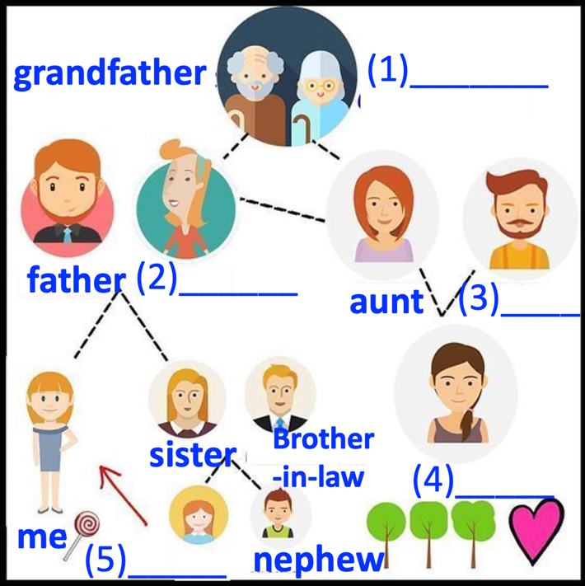 | Suggested answers  1. grandmother  2. mother  3. uncle  4. cousin  5. niece

B. New Lesson (35’)
1. Listening skill (15’)
a. Objectives: Review the target language learned in the unit
b. Content: Listening
c. Expected outcomes: Ss can practice test-taking skills.
d. Organization:
Teacher’s activities | Students’ activities
SB p. 87. You will hear a girl, Lucy, and her mom talking about family customs in the past. Listen and fill in the blanks. You will hear the conversation twice.
CD2 track 38
- Ask Ss to read the questions. | - Read the questions.
- Ask Ss to guess the type of missing word(s) and underline the key words | - Guess the type of missing word(s) and underline the key words
- Play audio. Ask students to listen and circle the correct answer. | - Listen and circle the correct answer.
- Ask Ss to compare the answers with a partner. | - Compare the answers with a partner and show the evidence to justify the answer.
- Check the answers as a whole class. | - Correct the answers
SCRIPT  CD 2-Track 38  Narrator: You will hear a girl, Lucy, and her mom talking about family customs in the past. Listen and fill in the blanks. You will hear the conversation twice.  Lucy: Hey, Mom. I read online that women were only housewives in the past. Is that true?  Mrs. Clark: Well, it depends on when we're talking about. Your grandma's generation, yes, she  was a housewife.  Lucy: But you aren't?  Mrs. Clark: No. We can't live with only your dad working. I worked at a factory when we first  got married. Now, I work at the bank.  Lucy: OK. What about living with extended family?  Mrs. Clark: Yes. I used to live with my grandparents and my ten aunts and uncles. Back when I was young, many generations would live together.  Lucy: You had ten aunts and uncles?  Mrs. Clark: Family sizes were a lot bigger.  Lucy: I also read that people would rarely get divorced. Is that true?  Mrs. Clark: Yes. Back then, it was rare. For many women, it was because they couldn't work. Men had to go to work so that women could raise the children.  Lucy: Life was difficult back then, huh?  Mrs. Clark: Yes. And people didn't get divorced after an argument. People used to work harder to get through difficult times together.  Lucy: I see. That sounds a lot better to me.  Narrator: Now, listen again. | Answer Key  0. a housewife  1. a factory  2. aunts and uncles  3. divorced  4. work  5. get through difficult times
Answer Key | Evidence
1. You will hear a girl talking to her grandpa. Where did her grandpa use to live?  A. by the river  B. near the market  C. near a field of flowers | 1. Narrator: You will hear a girl talking to her grandpa. Where did her grandpa use to live?  Jane: Grandpa, what's this picture?  Mr. Smith: That's our first house. We used to live in a cottage by the river.  Jane: It's pretty.  Mr. Smith: Yeah. We had many beautiful memories there. I would catch fish in the river, and your grandma would sell them at her stall.
2. You will hear a boy talking to his grandma. Who used to have a tuk-tuk?  A. his grandpa  B. his aunt  C. his grandma | 2. Narrator: You will hear a boy talking to his grandma. Who used to have a tuk-tuk?  Phong: Where's this, Grandma?  Mrs. Lý: It's your Aunt Lan's house. We used to visit her every month.  Phong: Oh, yes! When I was little.  Mrs. Lý: You'd usually ask for a ride on her tuk-tuk.  Phong: That's right!
3. You will hear a man talking to his daughter. What did he use to do?  A. bake with his mom  B. go fishing  C. play with his fish | 3. Narrator: You will hear a man talking to his daughter. What did he use to do?  Nancy: Is this you in the photo, Dad?  Mr. Jones: Yes. When I was a little boy, my dad used to take me fishing, then my grandma would bake the fish in a clay pot.
4. You will hear a girl talking to her mom. Where did she use to go?  A. a market  B. a swimming pool  C. a restaurant | 4. Narrator: You will hear a girl talking to her mom. Where did she use to go?  Linh: What's this photo, Mom?  Mrs. Trần: That's the old market. My parents used to take me there in the evenings.  Linh: What did you use to do there?  Mrs. Trần: We used to get snacks. Sometimes we'd sit by the river and eat.
5. You will hear a girl talking to her grandpa. Who did they talk about?  A. his nephew  B. his daughter  C. his son | 5. Narrator: You will hear a girl talking to her grandpa. Who did they talk about?  Mr. Davis: I didn't know we still have these photos.  Sarah: Who's this?  Mr. Davis: That's my nephew. He was the firstborn child in that generation. He used to get all the love until my niece was born.

2. Reading skill (15’)
a. Objectives: Review the target language learned in the unit
b. Content: Reading
c. Expected outcomes: Ss can practice test-taking skills.
d. Organization:
Teacher’s activities | Students’ activities
SB p. 87. Look and read. Choose the correct answer (A, B, C, or D).
- Ask Ss to read the questions and underline the key words | - Read the questions and underline the key words.
- Ask Ss to read the passage again and choose the correct answer. | - Read the passage, underline the evidence, and circle the correct answer.
- Ask Ss to compare the answers with a partner. | - Compare the answers with a partner and show the evidence to justify the answer.
- Check the answers | - Correct the answers
Answer Key
1. D
2. B
3. C
4. D
5. B
Answer Key | Evidence
1. She used to wait __________ for her parents.  A. at school  B. at the market  C. at her house  D. at her grandparents' house | My name's An, and I live in Cần Thơ. I was born in Sóc Trăng, but my family used to live in a cottage in Cà Mau. We used to live near my grandparents, and I'd walk to their house after school with my sister and wait for my parents to come home.
2. She used to __________ with her cousins.  A. sketch clouds  B. play games and go fishing  C. cook  D. make pottery | I always had a good time while I was there. I have many cousins, and we used to play lots of games at my grandparents' house. Sometimes, we'd go fishing, too.
3. Her __________ taught her how to make clay pots.  A. grandmother  B. cousins  C. grandfather  D. sister | My grandpa used to make pottery. He'd let us play with the clay and try to teach us how to make clay pots.
4. She used to __________ with her sister in the rice fields.  A. do pottery  B. look at the river  C. climb a tree  D. sketch the country | Sometimes, we'd climb one of the trees around my grandparents' house and sit there looking at the rice fields, the river, and the clouds. Or we'd walk out to the fields and sketch the country.
5. Which is NOT true about the writer?  A. She loves those memories.  B. Her grandparents still live there.  C. She misses visiting her grandparents.  D. She misses their old cottage. | Those afternoons at my grandparents' home are some of my favorite memories. My grandparents don't live there anymore, and sometimes I miss their old house in the country.

3. Vocabulary (5’)
a. Objectives: Review the target language learned in the unit
b. Content: Vocabulary
c. Expected outcomes: Ss can practice test-taking skills.
d. Organization:
Teacher’s activities | Students’ activities
SB, p.88: Circle the correct answers.
- Ask Ss to read the sentences | - Read the sentences.
- Ask Ss to choose the correct answers | - Circle the correct answers.
- Ask Ss to compare the answers with a partner. | - Compare the answers with a partner and show the evidence to justify the answer.
- Check the answers | - Correct the answers
Answer Key
1. C
2. D
3. D
4. A
5. B
6. C
7. C
8. B

C. Consolidation and homework assignments (5’)
- Speaking: Ask and answer the question below with your partner, using “would” for repeated past actions: What foods or snacks would you always eat when you were a child?
Suggested answers: When I was a child, I would always eat chocolate.
- Review the target language learned in the unit.
- Practice test-taking skills.
- Prepare for the next lesson (Review 2 - Pages 88 & 89 - SB).
- Play the consolidation games on www.eduhome.com.vn

5. Reflection
a. What I liked most about this lesson today:
…………………………………………………………………………………………
b. What I learned from this lesson today:
…………………………………………………………………………………………
c. What I should improve for this lesson next time:
…………………………………………………………………………………………

