School: ……………………………………….. | Date:……………………………………..
Class: ……………………………..................... | Period: ………………………………….

UNIT 2: Life in the past
Lesson 3.1: Reading (Page 22)

1. Objectives
By the end of this lesson, students will be able to…
1.1. Language knowledge/ skills
- learn vocabulary related to the life of a family member.
- practice reading for main ideas and specific information/details.
1.2. Competences
- improve Ss’ communication, collaboration, analytical, and critical thinking skills.
1.3. Attributes
- cultivate a heightened curiosity for diverse learning methodologies.

2. Teaching aids and materials
- Teacher’s aids: Student’s book and Teacher’s book, class CDs, DCR– Phần mềm tương tác trực quan, DHA – Ứng dụng trò chơi tương tác, projector / interactive whiteboard /TV (if any), PowerPoint slides.
- Students’ aids: Student’s book, Workbook, Notebook.
3. Assessment Evidence
Performance Tasks | Performance Products | Assessment Tools
- Read and choose the correct answers. | - Ss’ answers. | - Observation/feedback.
- Talk about your grandparents' childhoods | - Ss’ answers. | - Observation/feedback.

4. Procedures
A. Warm-up: 5 minutes
a. Objectives: to introduce the topic.
b. Content: Let’s talk.
c. Expected outcomes: Ss can talk about lessons from grandparents
d. Organization

Teacher’s activities | Students’ activities
Let’s talk: Look at the title of the unit and the picture. Answer these questions:
1. What are the people doing?
2. Do you have any similar childhood memories with your family?
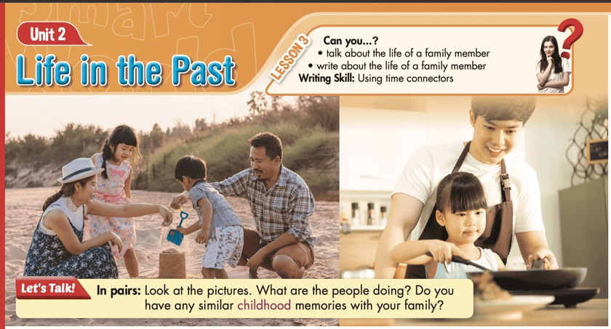
- Ask Ss to work in pairs, look at the title and the picture, and answer the questions (using the DCR/ PPTs slides). | - Work in pairs, look at the title and the picture and answer the questions
- Call some pairs to give their answers. | - Read the answers out loud.
- Give feedback. | - Share/exchange the answers with the class.
Suggested answers
1. What are the people doing?
In picture 1, children are building sandcastles with their parents.
In picture 2, a girl is cooking with her father.
2. Do you have any similar childhood memories with your family?
My childhood memories with my family include going to the beach, visiting amusement parks, and having picnics in the park.

B. New Lesson (35’)
1. Pre-reading (Vocabulary - 10’)
a. Objectives: To help Ss improve their collocations/ new words related to life in the past.
b. Content: new words from the text
c. Expected outcomes: Ss can learn some new collocations/ new words related to life in the past.
d. Organization
Teacher’s activities | Students’ activities
Task: In pairs: Use the new words to talk about childhood memories you know.
- Ask Ss to look at the new words on the slides. | - Look at the new words on the slides.
- Explain and model the activity. | - Listen to the instructions.
- Ask Ss to work in pairs, sharing their ideas about childhood memories | - Work in pairs, sharing the ideas.
- Check Ss’ answers around the class. | - Listen to feedback.
-Pick some Ss to share their ideas. | - Share the ideas with the whole class.
New words:  - afterward (adv)  - childhood (n)  - eventually (adv)  - fall in love (idm)  - meanwhile (adv)  - overcome (v)  - thankful (adj) | Suggested answers:  - We had tea. Afterwards, we sat in the garden to share stories about our childhood adventures.  - During my childhood, I would often go swimming with my friends.  - My parents eventually let me go to the party when I was in high school.  - Falling in love with nature was a significant part of my childhood experience.  - Meanwhile, I would often explore the woods behind our house with my friends during my childhood.  - Despite facing challenges, we were able to overcome them together during our childhood years.  - I am thankful for the love and support my family provided during my childhood.

2. While - reading (Reading- 20)
a. Objectives: To help Ss practice reading for details.
b. Content: Tasks a, b, and c.
c. Expected outcomes: Ss can read for specific information and know about family life in the past.
d. Organization:
Teacher’s activities | Students’ activities
Task a: Read the passage about Lan's grandmother. What lesson does Lan get from her grandmother's stories?
1. We should work hard to overcome difficulties.
2. We should keep our hope in difficult times.
- Ask Ss to read the questions and underline the key words | - Read the questions and underline the key words.
- Ask Ss to read the text and choose the correct answer. | - Read the text, underline the evidence, and circle the correct answer.
- Ask Ss to compare the answer with a partner and show the evidence to justify the answer. | - Compare the answer with a partner and show the evidence to justify the answer.
-Check the answers. | -Correct the answers.
Answer Key: 1. We should work hard to overcome difficulties.
Evidence:
I sometimes think about the stories my grandmother told me and feel thankful for her and my grandfather. Whenever I have a difficult problem, I think about those stories and tell myself to continue to work hard.

Task b: Now, read and choose the correct answers.
- Ask Ss to read the questions and underline the key words | - Read the questions and underline the key words.
-Ask students to read and choose the correct answers. | - Read and choose the correct answers.
- Ask Ss to check the answers with a partner. | - Compare the answer with a partner and show the evidence to justify the answer.
- Check Ss’ answers | -Correct the answers.
Answer Keys
1. C
2. A
3. A
4. D
5. C

ANSWERS | EVIDENCE
1. What does the word them in paragraph 1 refer to?  A. Lan's stories  B. Lan's school days  C. Lan's grandmother's stories  D. Lan's family members | When I was a kid, I used to stay with my grandmother after school. She'd often tell me stories about her life in the past, and I found them very interesting.
2. What was Lan's grandmother's childhood like?  A. It was difficult.  B. There were many adventures.  C. It was fun.  D. There were many parties. | Her childhood was different from mine. She grew up in a large, extended family. Her family was poor, and she only finished elementary school. When she was thirteen, she started working. Her uncle cooked for wedding parties, and she'd go with him to those parties to help him.
3. What was her grandmother's first job?  A. helping at wedding parties  B. selling groceries  C. making pottery  D. cooking at a restaurant | When she was thirteen, she started working. Her uncle cooked for wedding parties, and she'd go with him to those parties to help him.
4. Where did Lan's grandmother meet her grandfather?  A. at a party  B. at school  C. at the market  D. at work | Afterwards, she worked at a pottery place. She was good at making pottery and proud of the things she made. My grandfather also started working there. They fell in love and got married two years later.
5. Which of the following is NOT true about Lan's grandmother?  A. She didn't go to high school.  B. She liked making pottery.  C. She went to work after having her first child.  D. She started working from a young age. | My grandparents worked hard to build a family together. After they had their first child, my grandfather continued to work at the pottery place. Meanwhile, my grandmother sold groceries at home. They eventually saved enough money to buy a house of their own and raised three children.

Teacher’s activities | Students’ activities
Task c: Listen and read.
CD1- Track 25
- Play the CD and ask Ss to listen and read along. | - Listen and read along.
- Pick two students to read the reading passage and correct their pronunciation if necessary. | - Practice reading the passage.

3. Post-reading (5’)
a. Objectives: To help Ss practice talking about grandparents' childhoods.
b. Content: Tasks d
c. Expected outcomes: Ss can talk about grandparents' childhoods.
d. Organization

Teacher’s activities | Students’ activities
Task d: In pairs: What do you know about your grandparents' childhoods? How is your life different or similar?
- Divide the class into pairs. | - Work in pairs.
- Ask Ss to discuss the questions. | - Discuss the questions.
- Check Ss’ answers and give feedback. | - Listen to feedback.
Suggested answer:
1. A: What do you know about your grandparents' childhoods?
B: I know that my grandparents had a simpler childhood compared to mine. They would often play outdoors and help their parents with chores.
2. A: How is your life different or similar?
B: My life is different from my grandparents' life. I often play video games in my room.
C. Consolidation and homework assignments (5’)
- Speaking: Ask and answer the question below with your partner about childhood memories.
Where did you use to go for family vacations when you were a child?
Suggested answers:
We used to go to the beach for family vacations when I was a child.
- Vocabulary:
1. afterwards 2. childhood 3. eventually
4. fall in love 5. Meanwhile 6. overcome 7. thankful

HOMEWORK:
- Learn vocabulary related to the life of a family member.
- Make sentences using vocabularies in SB.
- Prepare for the next lesson (Speaking & Writing - Page 23 - SB)
- Play the consolidation games on www.eduhome.com.vn
5. Reflection
a. What I liked most about this lesson today:
…………………………………………………………………………………………
b. What I learned from this lesson today:
…………………………………………………………………………………………
c. What I should improve for this lesson next time:
…………………………………………………………………………………………

