School: ……………………………………….. | Date:……………………………………..
Class: ……………………………..................... | Period: ………………………………….

UNIT 2: Life in the past
Lesson 2.3: Pronunciation & Speaking (Pages 20 & 21)
1. Objectives
By the end of this lesson, students will be able to…
1.1. Language knowledge/ skills
- practice intonation for exclamations.
- practice talking about a memorable day, using used to express past situations.
1.2. Competences
- improve Ss’ communication, collaboration, analytical, and critical thinking skills.
1.3. Attributes
- cultivate a heightened curiosity for diverse learning methodologies.
2. Teaching aids and materials
- Teacher’s aids: Student’s book and Teacher’s book, class CDs, DCR– Phần mềm tương tác trực quan, DHA – Ứng dụng trò chơi tương tác, projector / interactive whiteboard /TV (if any), PowerPoint slides.
- Students’ aids: Student’s book, Workbook, Notebook.
3. Assessment Evidence
Performance Tasks | Performance Products | Assessment Tools
-Listen to the words and focus on the underlined words. | - Ss’ answers. | - Observation/feedback.
-Listen and cross out the option. | - Ss’ answers. | - Observation/feedback.
-Practice the conversations using the pictures and texts. (Pair work) | - Ss’ answers. | - Observation/feedback.
-Practice with your own ideas. | - Ss’ answers. | - Observation/feedback.
-Share the ideas with the class. | - Ss’ answers. | - Observation/feedback
-Talk about memorable things you did using the photos and your own ideas. (Pair work) | - Ss’ answers. | - Observation/feedback.
-Tell your partner about memorable things you used to do. | - Ss’ answers. | - Observation/feedback

4. Procedures
A. Warm-up: 5 minutes
a. Objectives: to arouse the students’ interest in the topic “a memorable day”.
b. Content: practice talking about a memorable day.
c. Expected outcomes: Ss can practice talking about a memorable day.
d. Organization

Teacher’s activities | Students’ activities
Warm-up activities: Work in pairs and answer these questions.
- Divide Ss into pairs. | - Work in pairs.
- Give Ss instructions and one example. | - Follow the instructions.
- Show questions for Ss to discuss. | - Discuss the questions.
- Call some pairs to give their answers. | - Read the sentences out loud.
- Give feedback. | - Listen to some answers.
Questions:  1. What activities did you use to do to make a day memorable in the past?  2. Who did you use to spend your memorable days with in the past?  3. Where did you use to go to create memorable experiences in the past?  4. What kind of food or meals did you use to enjoy on memorable days in the past? | Suggested answers  1. I used to go on outdoor adventures like hiking or picnicking to make a day memorable in the past.  2. I used to spend my memorable days with my family members in the past.  3. I used to go to amusement parks or scenic spots to create memorable experiences in the past.  4. I used to enjoy homemade barbecue or pizza on memorable days in the past.

B. New Lesson (35’)
1. Presentation (Pronunciation) (10’)
a. Objectives: To help Ss practice intonation for exclamations.
b. Content: Tasks a, b, c and d.
c. Expected outcomes: Ss can improve their pronunciation by saying the /ɪ/ and /iː/ sounds.
d. Organization
Teacher’s activities | Students’ activities
Task a: Intonation for exclamations  -Ask Ss to look at the picture and find the exclamatory sentence.  Student A: I used to spend summers at my grandparents' farm, helping out with chores and playing with the animals.  Student B: Wow, that sounds awesome! I always wanted to experience life on a farm. | - Look at the pictures and the conversation  Suggested answer:  Exclamatory sentence: Wow, that sounds awesome!
-Point out the exclamatory sentence “Wow, that sounds awesome!” and ask Ss to take notes. | - Listen and take some notes.
Intonation for exclamations usually falls
Notes:

Task b: Listen. Notice the sounds of the
underlined letters.
CD1-Track 23
- Ask students to listen and notice the pronunciation feature. | - Notice the pronunciation feature.
- Play audio and draw attention to the pronunciation feature. | -Listen to the audio and repeat.
SCRIPT
CD1-Track 23
Lucky you!
I'd love to hear about it!
Task c: Listen and cross out the sentence that doesn't follow the note in Task a
CD1-Track 24
-Play audio. Have students listen and cross out the option that doesn't follow the note in Task a. | -Listen and cross out the option that doesn't follow the note in Task a.
- Play audio again and check answers as a whole class | -Listen to the audio and repeat.
SCRIPT  CD1-Track 24  M: That's really great!  M: I just can't believe it! | Answer key:  That's really great!
Task d: Read the sentences with the intonation noted in Task a. to a partner.
-Have students practice saying the examples with a partner using the pronunciation feature. | - Say the examples with a partner
-Ask some students to read the sentences out loud | - Read the sentences out loud.
-Give some feedback or correction. | - Listen to feedback.

2. Practice (15’)
a. Objectives: To help Ss practice talking about photos of a memorable day, using used to express past situations.
b. Content: Tasks a and b.
c. Expected outcomes: Ss can talk about photos of a memorable day, using used to express past situations.
d. Organization:
Teacher’s activities | Students’ activities
Task a: In pairs: Practice the conversations using the pictures and texts. Swap roles and repeat.
-Demonstrate the activity by practicing with a student. | -Watch the demonstration
-Divide the class into pairs. | - Work in pairs.
-Have them practice the conversations using the pictures and texts, then swap roles and repeat. | - Practice the conversations.
-Have some pairs demonstrate the activity in front of the class. | - Demonstrate the activity in front of the class.
-Give some feedback or correction. | - Listen to feedback.
PICTURE 1:
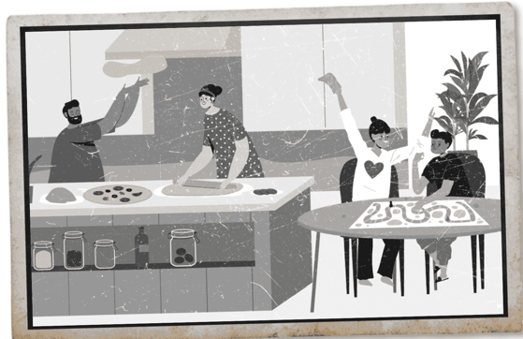
A: What's this photo?
B: That's a cottage we used to go to in the summer.
A: Lucky you. What did you use to do there?
B: We used to make delicious food. I would make pizza, and the children would play board games.
PICTURE 2: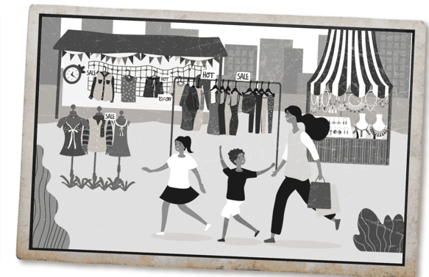
A: What's this photo?
B: That's a market I used to go to near my old house.
A: Oh, I'd love to hear more about it. What did people use to sell there?
B: They used to sell clothes and jewelry. I would go with my niece and nephew. We used to have so much fun.
Task b: Practice again with your own ideas for the information in blue.
-Have pairs take turns practice the conversations using their own ideas. | - Take turns to practice the conversations using their own ideas.
-Have some pairs demonstrate the activity in front of the class. | - Demonstrate the activity in front of the class.
-Give some feedback or correction. | - Listen to feedback.
Suggested answer:
PICTURE 1:
A: What's this photo?
B: That's a park we used to go to in the spring.
A: Lucky you. What did you use to do there?
B: We used to have picnics. I would prepare sandwiches, and the kids would fly kites.
PICTURE 2:
A: What's this photo?
B: That's a spring fair I used to go to near my grandparents' house.
A: Oh, I'd love to hear more about it. What did customers use to buy there?
B: They used to buy fresh fruits and vegetables. I would go with my grandmother. We used to pick out our favorite apples.

3. Production (Speaking) (10’)
a. Objectives: To help Ss practice talking about photos of a memorable day, using used to express past situations.
b. Content: Tasks a, b and c.
c. Expected outcomes: Ss can talk about a memorable day, using used to express past situations.
d. Organization:
Teacher’s activities | Students’ activities
Task a: In pairs: Student A, you're the grandparent. Talk about memorable things you did using the photos and your own ideas. Student B, you're the grandchild. Listen and ask questions.
-Demonstrate the activity by practicing with a student. | -Watch the demonstration.
-Divide the class into pairs. | - Work in pairs.
-Ask student A to tell student B about memorable things using the photos and their own ideas. | - Student A tells student B about memorable things using the photos and their own ideas.
- Ask Student B to listen and ask questions. | - Student B listens and asks questions
-Have some pairs demonstrate the activity in front of the class. | - Demonstrate the activity in front of the class.
-Give some feedback or correction. | - Listen to feedback.
Suggested answer:
Picture 1:
Student A: I used to fly a kite in the park when I was a child.
Student B: Who did you use to fly a kite with in the park?
Student A: I used to fly a kite with my father in the park.
Picture 2:
Student A: My father used to hold me high when I was a baby.
Student B: Where did your father use to hold you high?
Student A: He used to hold me high in the kitchen.
Picture 3:
Student A: I used to travel around on a tuk-tuk when I was younger.
Student B: Who did you use to travel with?
Student A: I used to travel with my sister.
Task b: Swap roles and repeat. Student A, you're the grandchild. Student B, you're the grandparent.
- Have pairs swap roles and repeat. | - Swap roles and repeat.
-Ask some students to share their ideas with the class. | - Share the ideas with the class.
-Give some feedback or correction. | - Listen to feedback.
Suggested answer:
Picture 1:
Student A: Back then, I used to eat ice cream with my parents.
Student B: Where did you use to eat ice cream?
Student A: I used to eat ice cream at the amusement park.
Picture 2:
Student A: I used to go for a picnic with my parents and my sister when I was a child.
Student B: Where did you use to go for a picnic?
Student A: I used to go for a picnic in front of my old house.
Picture 3:
Student A: Back then, I used to watch movies outdoors.
Student B: Who did you use to watch movies with?
Student A: I used to watch movies with my friends
Task c: What about you? Tell your partner about memorable things you used to do.
- Have pairs take turns telling their partners about memorable things that they used to do. | -take turns telling their partners about memorable things that they used to do.
-Ask some students to share their ideas with the class. | - Share the ideas with the class.
-Give some feedback or correction | - Listen to feedback.
Suggested answer:
Well, when I was younger, I used to play outside a lot with my friends. We would ride bikes around the neighborhood.

C. Consolidation and homework assignments (5’)
- Speaking: Ask and answer the question below with your partner about a memorable day
What did you use to do with your family during holidays when you were younger?
Suggested answers: When I was younger, my family and I used to go on road trips to explore new places during holidays.
- Practice intonation for exclamations.
- Prepare for the next lesson (Reading - page 22 - SB).
- Play the consolidation games on www.eduhome.com.vn

5. Reflection
a. What I liked most about this lesson today:
…………………………………………………………………………………………
b. What I learned from this lesson today:
…………………………………………………………………………………………
c. What I should improve for this lesson next time:
…………………………………………………………………………………………

