School: ……………………………………….. | Date:……………………………………..
Class: ……………………………..................... | Period: ………………………………….

UNIT 2: Life in the past
Lesson 2.2: Grammar (Pages 19 & 20)
1. Objectives
By the end of this lesson, students will be able to…
1.1. Language knowledge/ skills
- learn and use “used to”.
- produce sentences using “used to”
- improve Grammar and Speaking.
1.2. Competences
- improve Ss’ communication, collaboration, analytical, and critical thinking skills.
1.3. Attributes
- cultivate a heightened curiosity for diverse learning methodologies.

2. Teaching aids and materials
- Teacher’s aids: Student’s book and Teacher’s book, class CDs, DCR– Phần mềm tương tác trực quan, DHA – Ứng dụng trò chơi tương tác, projector / interactive whiteboard /TV (if any), PowerPoint slides.
- Students’ aids: Student’s book, Workbook, Notebook.
3. Assessment Evidence
Performance Tasks | Performance Products | Assessment Tools
- Unscramble the sentences. | - Ss’ answers. | - Observation/feedback.
- Read about used to, and fill in the blanks. | - Ss’ answers. | - Observation.
- Listen, check, and repeat. | - Ss’ answers. | - Observation/feedback.
- Identify the mistakes | - Ss’ answers. | - Observation/feedback.
- Write complete sentences. | - Ss’ answers. | - Observation/feedback.
- In pairs: Talk about things students used to do when they were younger, then use would to give additional information. | - Ss’ answers/ presentations. | - Observation/feedback.
- Share the ideas with the class. | - Ss’ answers. | - Observation/feedback

4. Procedures
A. Warm-up: 5 minutes
a. Objectives: To introduce the grammar point: “used to”.
b. Content: Share the ideas with the class.
c. Expected outcomes: Ss can unscramble the sentences with “used to”.
d. Organization

Teacher’s activities | Students’ activities
Warm-up activities: Competition time:
- Ask Ss to form groups of 5. | - Form groups of 5.
- Give Ss instructions and one example. | - Follow the instructions.
- Give Ss some sentences to unscramble. | - Unscramble the sentences in a team/group.
- Check the answers. | - Check the answers.
Unscramble sentences:  1. very long. /short hair now, / Liz has got /but it used to be  2. she was a child./Helen / a piano / used to have /when /  3. When /I didn't use to/I was younger, /like tomatoes.  4. I used to eat/ I was a kid./broccoli /when  5. I don't read / read a lot of books, /but /much these days./ I used to | Suggested answers  1. Liz has got short hair now, but it used to be very long.  2. Helen used to have a piano when she was a child.  3. When I was younger, I didn't use to like tomatoes.  4. I used to eat broccoli when I was a kid.  5. I used to read a lot of books, but I don't read much these days.

B. New Lesson (35’)
1. Presentation (15’)
a. Objectives: To help Ss understand how to use “used to”.
b. Content: Tasks a and b.
c. Expected outcomes: Ss can make sentences using “used to”.
d. Organization

Teacher’s activities | Students’ activities
Task a: Read about used to, then fill in the blanks.
- Ask Ss to work individually and complete the task (using the DCR/ PPTs slides). | - Fill in the blanks.
- Ask Ss to compare the answers with a partner. | - Compare the answers with a partner.
- Check Ss’ answers around the class. | - Check the answers
- Explain the use of “used to” (using the DCR/ PPTs slides.  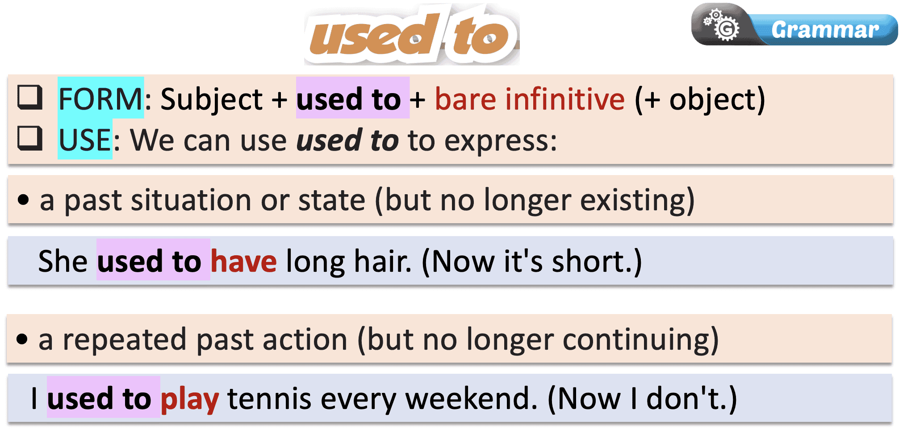 | - Listen to the teacher’s instructions and take notes.
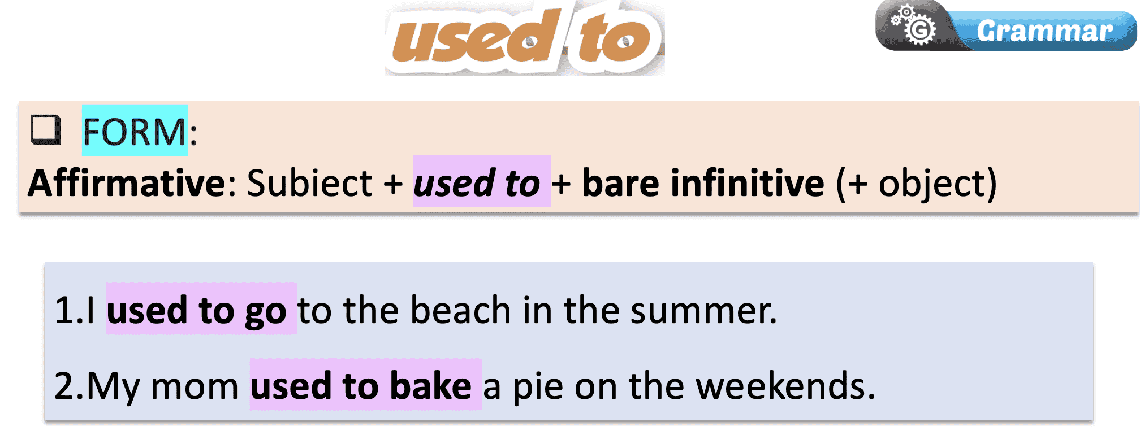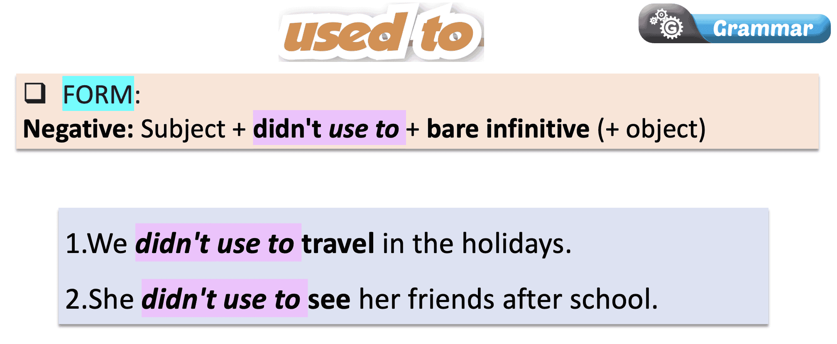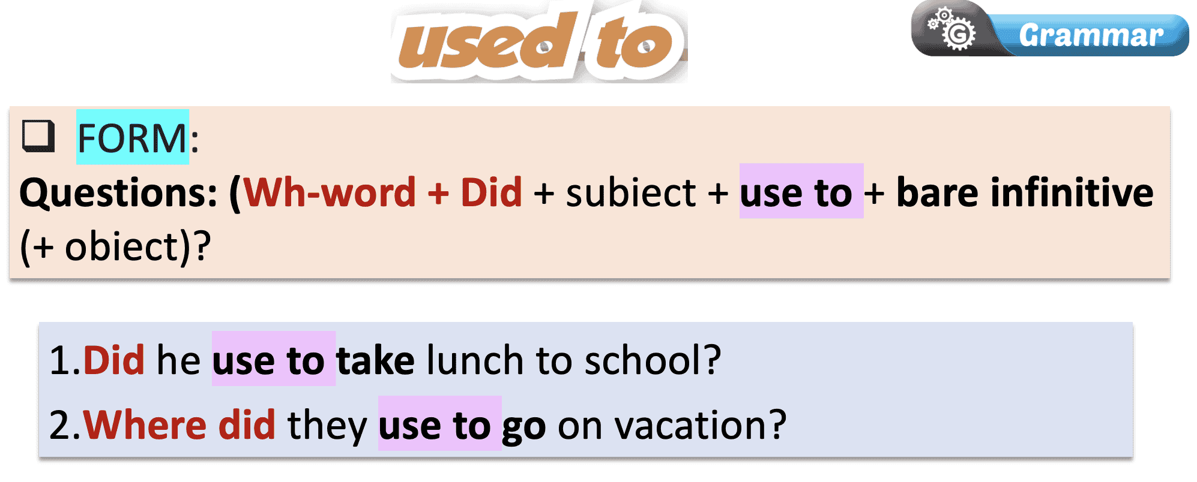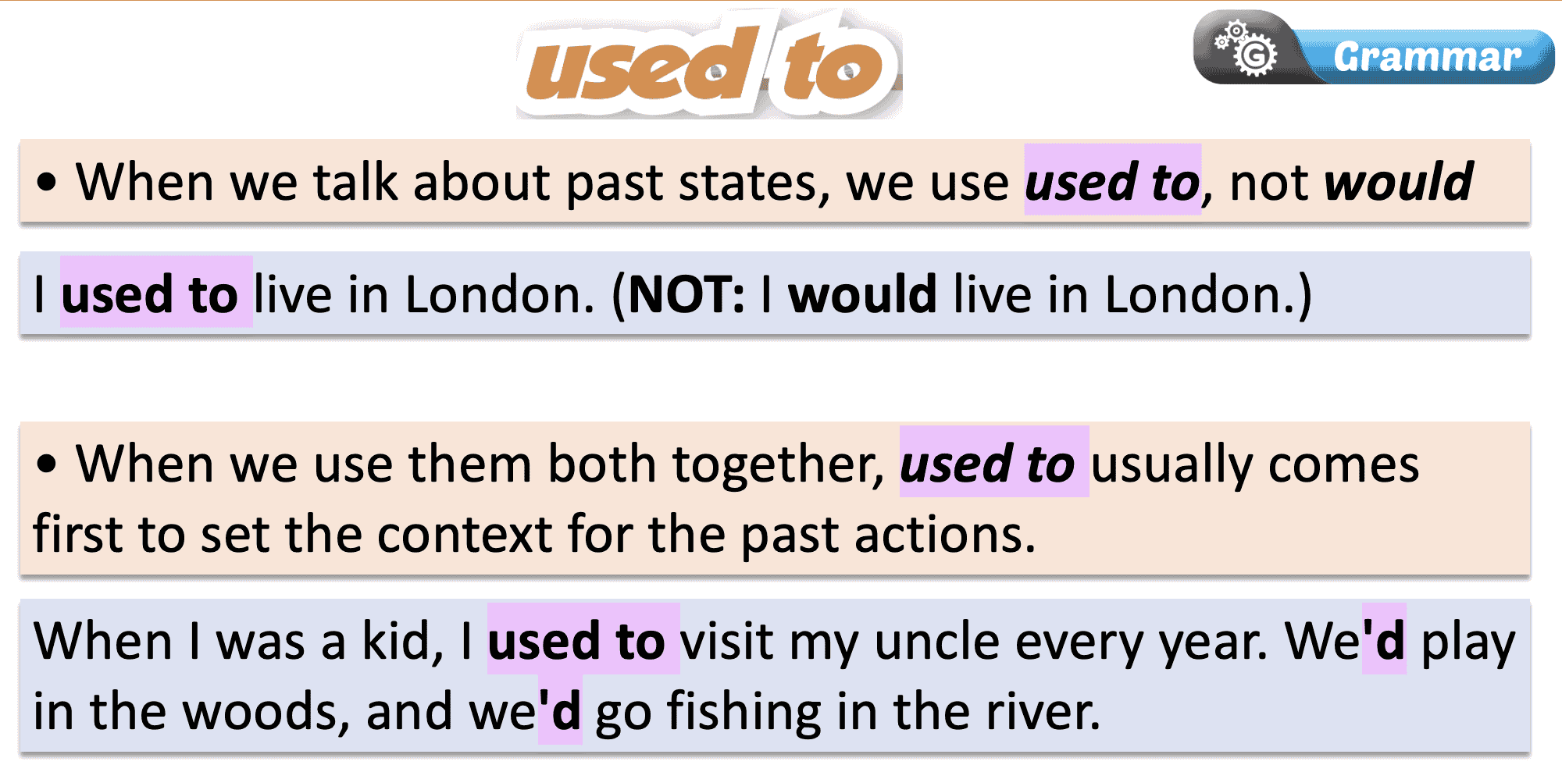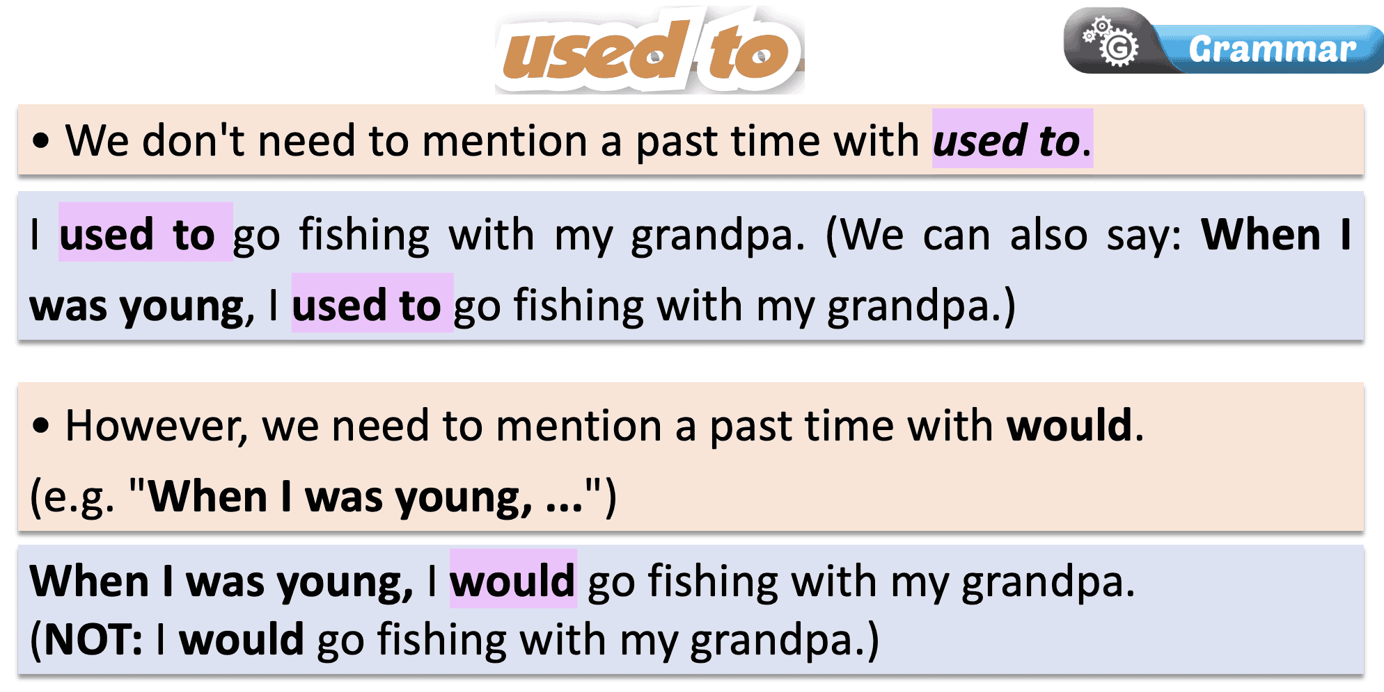

Task b: Listen and check. Listen again and repeat.
- Play audio. Ask students to listen and check their answers. | - Listen and check.
Answer Keys:
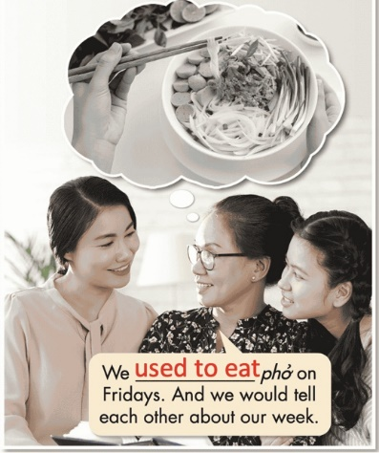

- Play audio again. Ask students to listen again and repeat. | - Listen and repeat.

2. Practice (15’)
a. Objectives: To help Ss practice the use of “used to”.
b. Content: Tasks c and d.
c. Expected outcomes: Ss can practice the use of “used to” and when to use them.
d. Organization:
Teacher’s activities | Students’ activities
Task c: Underline the mistakes and write the correct words on the lines
- Demonstrate the activity using the example. | - Listen to the instructions
- Ask Ss to underline the mistakes and write the correct words on the lines. | - Complete the task.
- Have pairs check each other's work. | - Compare the answers with a partner.
- Pick some Ss to share their answers with the class. | - Read the sentences out loud.
- Check and correct Ss’ answers. | - Correct the answers
Answer Keys:
1. to used -> used to
2. used -> use
3. traveled -> travel
4. used -> used to
5. went -> go
6. use to loved -> used to love
Task d: Write sentences using the information in the table with either used to (if there's no past time phrase) or would (if there's a past time phrase).
- Demonstrate the activity using the example. | - Listen to the instructions.
- Ask Ss to write sentences using the table | - Complete the exercise and write full sentences.
- Have pairs check each other's work. | - Check the answers with a partner.
- Ask some Ss to share their answers with the class. | - Read the sentences out loud.
- Check Ss’ answers. | - Correct the answers.
Answer Keys:
1. I used to live in Tokyo.
2. My sister used to work in a market stall.
3. I would do arts and crafts in the yard when I was little.
4. I used to have a dog called Twiglet.
5. My brother would travel to the beach every summer back then.
3. Production (5’)
a. Objectives: To help Ss produce sentences using “would”.
b. Content: Different methods to study English.
c. Expected outcomes: Ss can compare and contrast their study methods with other students, using “would” for repeated past actions.
d. Organization

Teacher’s activities | Students’ activities
Task e. In pairs: Ask and answer questions about things you used to do after school, on the weekends, and during holidays when you were younger, then use would to give additional information.
- Divide the class into pairs. | - Work in pairs.
- Have students ask and answer questions about things they used to do and give additional information... | - Ask and answer questions.
- Have some students demonstrate the activity in front of the class. | - Watch the demonstration.
- Monitor the class and help them if necessary. | - Work in pairs to share the ideas/ sentences.
- Ask some Ss to share their ideas. | - Share the ideas with the class.
Suggested answers:
1. What did you use to do after school when you were younger?
I often used to walk around the park with my mom. I would play on the playgrounds too.
2. What did you use to do on the weekends when you were younger?
I used to stay at my grandma's. She would sometimes buy me ice cream.
3. What did you use to do during holidays when you were younger?
I used to go on trips with my cousins. We would sing and play games.

C. Consolidation and homework assignments (5’)
- Speaking: Ask and answer the question below with your partner, using “used to”
What did you use to eat on your birthday when you were younger?
Suggested answers: When I was younger, I used to eat chocolate cupcakes on my birthday.
- Review “used to”
- Make sentences using “used to” in SB.
- Prepare for the next lesson (Pronunciation & Speaking - pages 20 & 21 - SB).
- Play the consolidation games on www.eduhome.com.vn

5. Reflection
a. What I liked most about this lesson today:
…………………………………………………………………………………………
b. What I learned from this lesson today:
…………………………………………………………………………………………
c. What I should improve for this lesson next time:
…………………………………………………………………………………………

