School: ……………………………………….. | Date:……………………………………..
Class: ……………………………..................... | Period: ………………………………….

UNIT 2: Life in the past
Lesson 1.2: Grammar (Pages 15 & 16)
1. Objectives
By the end of this lesson, students will be able to…
1.1. Language knowledge/ skills
- learn and use “would” for repeated past actions
- produce sentences using “would”
- improve Grammar and Speaking.
1.2. Competences
- improve Ss’ communication, collaboration, analytical, and critical thinking skills.
1.3. Attributes
- cultivate a heightened curiosity for diverse learning methodologies.
2. Teaching aids and materials
- Teacher’s aids: Student’s book and Teacher’s book, class CDs, DCR– Phần mềm tương tác trực quan, DHA – Ứng dụng trò chơi tương tác, projector / interactive whiteboard /TV (if any), PowerPoint slides.
- Students’ aids: Student’s book, Workbook, Notebook.
3. Assessment Evidence
Performance Tasks | Performance Products | Assessment Tools
- Read about would, and fill in the blanks.  - Listen, check, and repeat.  - Unscramble the sentences.  - Write complete sentences.  - Share the ideas with the class. | - Ss’ answers.  - Ss’ answers.  - Ss’ answers.  - Ss’ answers.  - Ss’ answers/presentation. | - Observation.  - Observation/feedback.  - Observation/feedback.  - Observation/feedback  - Observation/feedback.
4. Procedures
A. Warm-up: 5 minutes
a. Objectives: To introduce the grammar point: “would”.
b. Content: Share the ideas with the class.
c. Expected outcomes: Ss can talk about repeated past actions
d. Organization
Teacher’s activities | Students’ activities
Warm-up activities: Work in pairs and answer these questions.  - Divide Ss into pairs.  - Give Ss instructions and one example.  - Show questions for Ss to discuss.  - Call some pairs to give their answers.  - Give feedback.  Questions:  1. What activities would you regularly do with your friends when you were younger?  2. What special routines would you have before going to bed as a child?  3. What sports or games would you play with friends in your neighborhood?  4. What foods or snacks would you always eat when you were a child? | - Work in pairs.  - Follow the instructions.  - Discuss the questions.  - Read the sentences out loud.  - Listen to some answers.  Suggested answers  1. When I was younger, I would regularly play jump rope with my friends.  2. Before going to bed, I would brush my teeth and put on my pyjamas.  3. In my neighborhood, we would often play soccer.  4. When I was a child, I would always eat ice cream.

B. New Lesson (35’)
1. Presentation (15’)
a. Objectives: To help Ss understand how to use “would” for repeated past actions
b. Content: Tasks a and b.
c. Expected outcomes: Ss can make sentences using “would” for repeated past actions
d. Organization

Teacher’s activities | Students’ activities
Task a: Read about would, then fill in the blanks.  - Ask Ss to work individually and complete the task (using the DCR/ PPTs slides).  - Ask Ss to compare the answers with a partner.  - Check Ss’ answers around the class.  - Explain the use of “would” (using the DCR/ PPTs slides)  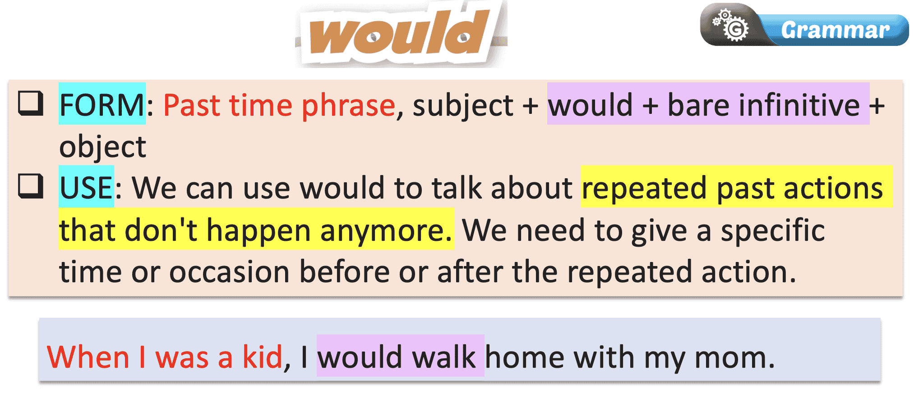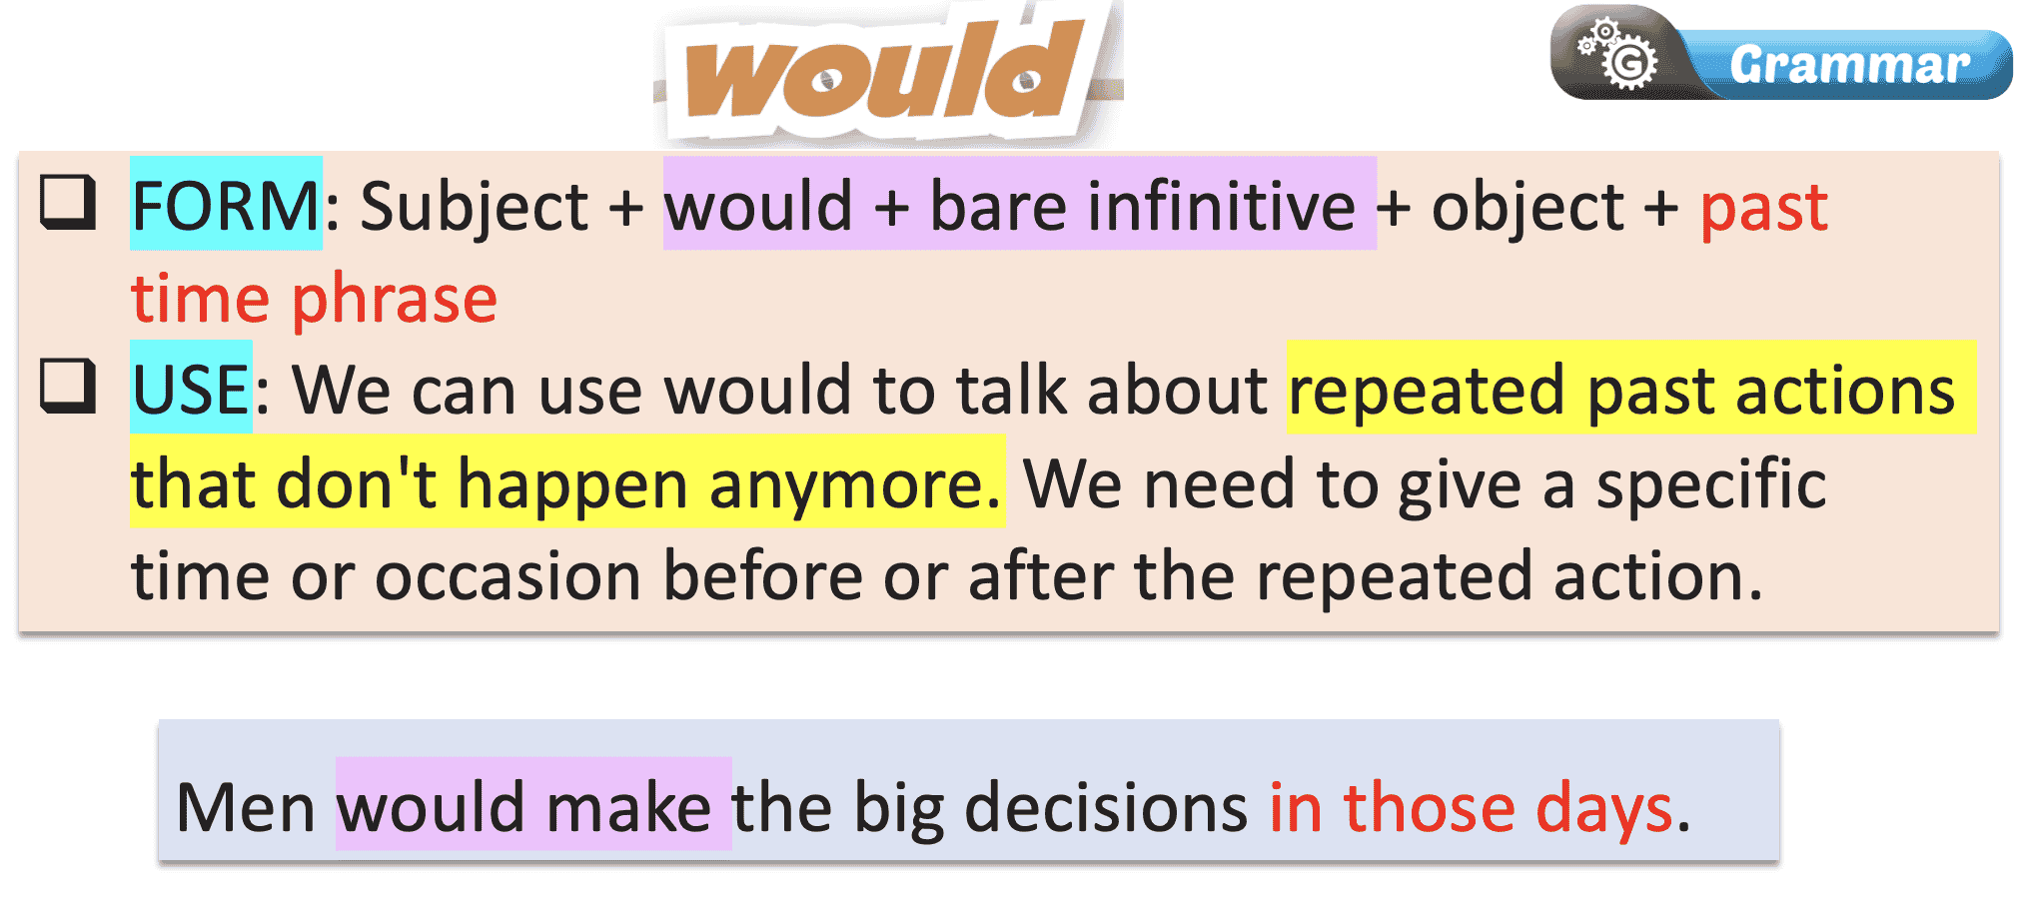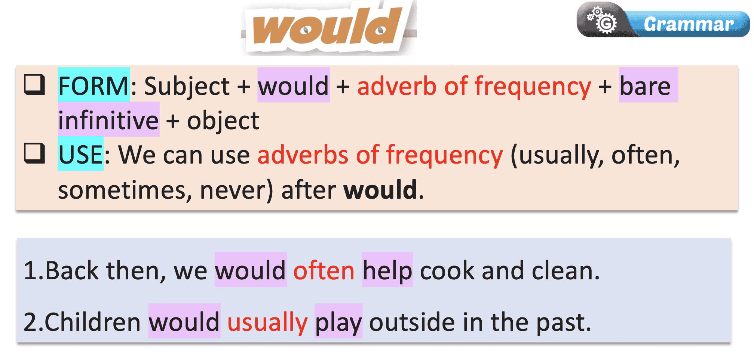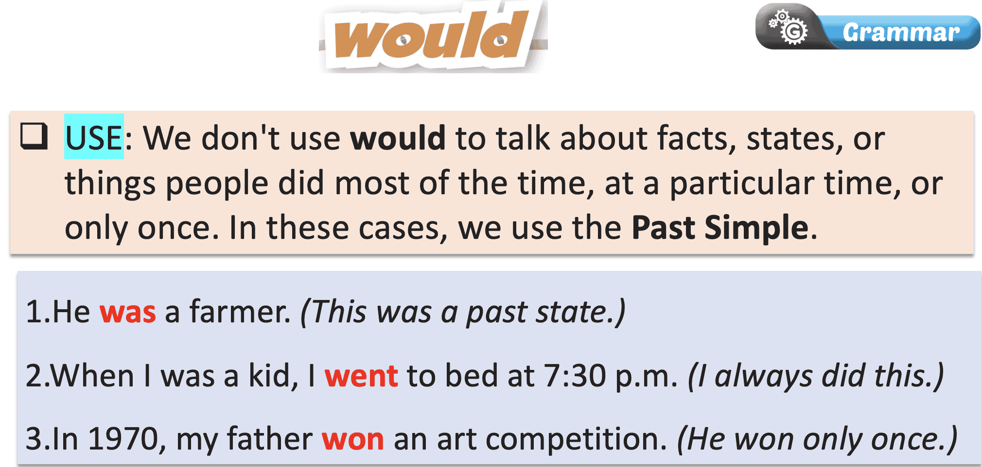 | - Fill in the blanks.  - Compare the answers with a partner.  - Listen to the teacher’s instructions and take notes.
Task b: Listen and check. Listen again and repeat.  - Check Ss’ answers around the class. | - Listen and check.  Answer Keys:  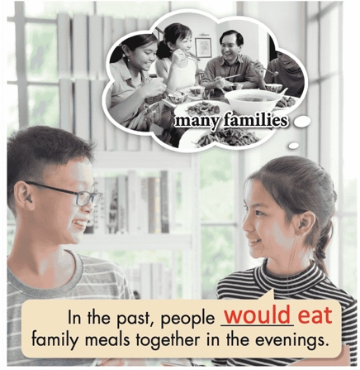  - Listen and repeat.
2. Practice (15’)
a. Objectives: To help Ss practice the use of “would”.
b. Content: Tasks c and d.
c. Expected outcomes: Ss can practice the use of “would” and when to use them.
d. Organization:
Teacher’s activities | Students’ activities
Task c: Unscramble the sentences.  - Demonstrate the activity using the example.  - Ask students to unscramble the sentences.  - Have pairs check each other's work.  - Pick some Ss to read the sentence(s) out loud.  - Check and correct Ss’ answers. | - Listen to the instructions  - Complete the task.  - Compare the answers with a partner.  - Read the sentences out loud.  - Correct the answers  Answer Keys:  1. In the past, people would usually be home for family meals.  2. Back then, people would usually have five to ten children.  3. Fifty years ago, people would often live in extended  families.  4. A hundred years ago, the husband would often be the breadwinner.  5. Back then, women would become housewives after  getting married.  6. In the past, the mother would cook for the whole family.
Task d: Read the statements about life in the past and complete the sentences below using would or the Past Simple.  - Demonstrate the activity using the example.  - Ask students to complete the sentences using the statements and would or Past Simple.  - Have pairs check each other's work.  - Ask some students to share their answers with the class.  - Check Ss’ answers (using the DCR). | - Listen to the instructions.  - Complete the exercise and write full sentences.  - Check the answers with a partner.  - Read the sentences out loud.  - Correct the answers.  Answer Keys:  1. In the past, people often didn't live in nuclear families.  2. In the past, women would live with their families their whole lives.  3. Parents would make their children do a lot of chores back then.  4. People would only meet their husband or wife a few  times before getting married in the past.  5. Back then, my wife had a small bakery and was busy, so I became a househusband.  6. Back then, children would often skip school if they  had to do chores at home.
3. Production (5’)
a. Objectives: To help Ss produce sentences using “would”.
b. Content: Different methods to study English.
c. Expected outcomes: Ss can compare and contrast their study methods with other students, using “would” for repeated past actions.
d. Organization
Teacher’s activities | Students’ activities
Task e. In pairs: Use the topics below to talk about things that happened regularly when you were a kid.  - Divide the class into pairs.  - Have students take turns talking about things that happened regularly when they were kids.  - Have some students demonstrate the activity in front of the class.  - Monitor the class and help them if necessary.  - Ask some Ss to share their ideas. | - Work in pairs  - Make new sentences based on the prompts in task e.  - Watch the demonstration.  - Work in pairs to share the ideas/ sentences.  - Share the ideas with the class.  Suggested answers:  1. My mom would walk me to school every morning when I was a kid.  2. Back then, I would play with my sisters after school. 3. In the past, my family would sometimes go to Vũng Tàu on holidays.  4. When I was little, my classmates and I would often play jump rope during break time at school.  5. I would stay at my grandmother's house on the weekends when I was younger.  6. My parents would sometimes take me to the country in the summer back then.

C. Consolidation and homework assignments (5’)
- Speaking: Ask and answer the question below with your partner, using “would” for repeated past actions: Which places would you often visit with your family during holidays when you were younger?
Suggested answers: My family and I would often visit my grandparents' house in the countryside during holidays when I was younger.
- Review “would” for repeated past actions.
- Make sentences using “would” in SB.
- Prepare for the next lesson (Pronunciation & Speaking - pages 16 & 17 - SB).
- Play the consolidation games on www.eduhome.com.vn

5. Reflection
a. What I liked most about this lesson today:
…………………………………………………………………………………………
b. What I learned from this lesson today:
…………………………………………………………………………………………
c. What I should improve for this lesson next time:
…………………………………………………………………………………………

