School: ……………………………………….. | Date:……………………………………..
Class: ……………………………..................... | Period: ………………………………….

UNIT 2: Life in the past
Lesson 1.1: Vocabulary and Reading (Pages 14 & 15)

1. Objectives
By the end of this lesson, students will be able to…
1.1. Language knowledge/ skills
- learn vocabulary related to life in the past.
- read and understand an interview about family life in the past.
- practice reading for gist and details.
1.2. Competences
- improve Ss’ communication, collaboration, analytical, and critical thinking skills.
1.3. Attributes
- cultivate a heightened curiosity for diverse learning methodologies.
2. Teaching aids and materials
- Teacher’s aids: Student’s book and Teacher’s book, class CDs, DCR– Phần mềm tương tác trực quan, DHA – Ứng dụng trò chơi tương tác, projector / interactive whiteboard /TV (if any), PowerPoint slides.
- Students’ aids: Student’s book, Workbook, Notebook.
3. Assessment Evidence
Performance Tasks | Performance Products | Assessment Tools
- Match words to the definitions. | - Ss’ answers. | - Observation/feedback.
-Talk about your family or people you know | - Ss’ answers. | - Observation/feedback.
- Read the interview and answer the questions. | - Ss’ answers. | - Observation/feedback.
- Read and circle True, False, or Doesn't say. | - Ss’ answers. | - Observation/feedback.
- Listen and read. | - Ss’ answers. | - Observation/feedback
- Say what changes mentioned in the interview you see in your family. | - Ss’ answers. | - Observation/feedback.

4. Procedures
A. Warm-up: 5 minutes
a. Objectives: to introduce the topic.
b. Content: Let’s talk.
c. Expected outcomes: Ss can talk about Vietnamese family traditions and customs based on the title and the picture.
d. Organization

Teacher’s activities | Students’ activities
Let’s talk: Look at the title of the unit and the picture. Answer these questions:
What are the relationships between these people? What Vietnamese family traditions and customs do you know?
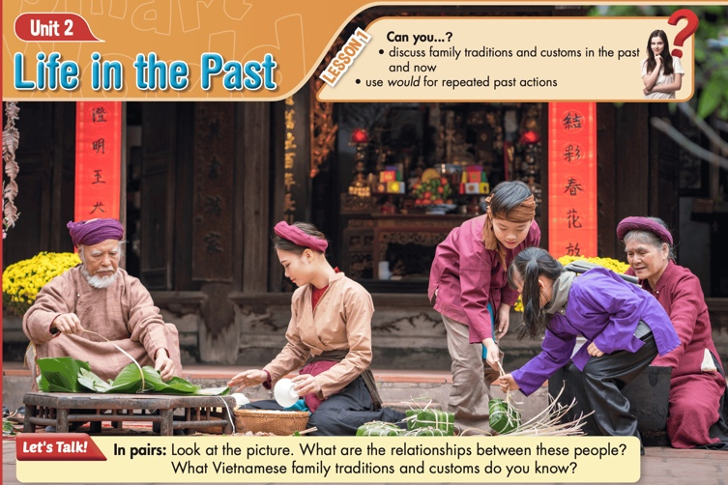
- Ask Ss to work in pairs, look at the title and the picture, and answer the questions (using the DCR/ PPTs slides). | - Work in pairs, look at the title and the picture and answer the questions.
- Call some pairs to give their answers. | - Read the answers out loud.
- Give feedback. | - Share/exchange the answers with the class.
Suggested answers
-They are family members.
-I know about Lunar New Year festivities and customs, family meals and gatherings on special occasions.

B. New Lesson (35’)
1. Pre-reading (Vocabulary - 15’)
a. Objectives: To help Ss improve their collocations/ new words related to life in the past.
b. Content: tasks a and b.
c. Expected outcomes: Ss can learn some new collocations/ new words related to life in the past.
d. Organization
Teacher’s activities | Students’ activities
Task a: Match the underlined words with the definitions. Listen and repeat.
CD1-Track 14
- Demonstrate the activity using the example. | -Watch the demonstration.
- Ask Ss to work by themselves and match the words (using the DCR/ PPTs slides). | - Match the words to the definitions.
- Ask Ss to compare the answers with a partner. | - Check the answers with a partner.
- Check Ss’ answers around the class. | - Listen to feedback.
- Play audio. Ask Ss to listen and repeat. | - Listen and repeat.
Answer Keys:
1. b 2. e 3. h 4. c 5. J
6. d 7. f 8. a 9. g 10. i
Task b: In pairs: Use the new words to talk about your family or people you know.
- Explain and model the activity. | - Listen to the instructions.
- Ask Ss to work in pairs, sharing their ideas about family or people they know | - Work in pairs, sharing the ideas.
- Check Ss’ answers around the class. | - Listen to feedback.
-Pick some Ss to share their ideas. | - Share the ideas with the whole class.
New words:  - nuclear family  - relatives  - single  - extended family  - house husband  - generation  - breadwinner  - marriage  - divorced  - housewife | Suggested answers:  - My cousin lives in a nuclear family with his wife and two children.  - We often have gatherings with our relatives during the holidays.  - My brother is single.  - My friend lives in an extended family  - My father is a house husband.  - The older generation in our family often shares stories about their childhood.  - My uncle is the breadwinner of his family.  - My parents are in a happy marriage  - My sister got divorced last year.  - My aunt chose to become a housewife to focus on raising her children.

2. While - reading (Reading – 15’)
a. Objectives: To help Ss practice reading for details.
b. Content: Tasks a, b, and c.
c. Expected outcomes: Ss can read for specific information and know about family life in the past.
d. Organization:

Teacher’s activities | Students’ activities
Task a: Read the interview with Mrs. Nguyễn about her memories of family life in the past. What does it mainly discuss?
1. why families in the past were better
2. the differences between now and then
- Ask Ss to read the questions and underline the key words | - Read the questions and underline the key words.
- Ask Ss to read the interview and choose the correct answer. | - Read the interview, underline the evidence, and circle the correct answer.
- Ask Ss to compare the answer with a partner and show the evidence to justify the answer. | - Compare the answer with a partner and show the evidence to justify the answer.
-Check the answers. | -Correct the answers.
Answer Key: 2. the differences between now and then
Evidence:
Mrs Nguyễn: Back then, three or four generations would live together in extended families. Most people have a nuclear family now. Most of my children don't live with me anymore.
Task b: Now, read and circle True, False, or Doesn't Say.
- Ask Ss to read the questions and underline the key words | - Read the questions and underline the key words.
-Ask students to read the interview again and circle True, False, or Doesn't say. | - Read the interview again and circle True, False, or Doesn't say.
- Ask Ss to check the answers with a partner. | - Compare the answer with a partner and show the evidence to justify the answer.
- Check Ss’ answers (using the DCR). | - Correct the answers.
Answer Keys
1. False 2. True 3. Doesn't say 4. False
5. True

SENTENCES | ANSWERS | EVIDENCE
1. All of Mrs Nguyễn's children still live with her. | False | Mrs Nguyễn: Back then, three or four generations would live together in extended families. Most people have a nuclear family now. Most of my children don't live with me anymore.
2. She says having fewer people living together sometimes affects family connections. | True | Mrs Nguyễn: Hmm, the smaller family size allows people to be more independent. But sometimes it makes the connections between relatives weaker.
3. In the past, most men weren't single. | Doesn't say | Mrs Nguyễn: In the past, married people would live together their whole lives. There weren't many single women, and they often had a difficult life.  => Doesn't say whether “most men weren't single.”
4. Mrs Nguyễn thinks being a single parent now isn't a good thing. | False | Interviewer: Now, some people choose to be single parents or single because they aren't afraid of getting divorced or living alone.  Mrs. Nguyễn: I think that's a positive thing, mostly. Some people just can't live together.
5. She says men went to work, and women did the housework in the past. | True | Mrs. Nguyễn: Yes. The husband was the breadwinner in the past, and the wife would stay at home. Now, many men help their wives do housework

Teacher’s activities | Students’ activities
Task c: Listen and read.
CD1- Track 15
- Play the CD and ask Ss to listen and read along. | - Listen and read along.
- Pick two students to role-play the interview and correct their pronunciation if necessary. | - Practice the interview.

3. Post-reading (5’)
a. Objectives: To help Ss discuss the changes in family traditions and customs
b. Content: Tasks d
c. Expected outcomes: Ss can talk about the changes in family traditions and customs.
d. Organization
Teacher’s activities | Students’ activities
Task d: In pairs: What changes mentioned in the interview can you see in your family? What things do you agree or disagree with Mrs. Nguyễn about? Why?
- Divide the class into pairs. | - Work in pairs.
- Ask Ss to discuss the questions. | - Discuss the questions.
- Check Ss’ answers and give feedback. | - Listen to feedback.
Suggested answer:
A: What changes mentioned in the interview can you see in your family?
A: In my family, I've noticed a shift towards smaller nuclear families. However, we still prioritize maintaining strong connections with extended relatives through regular communication and gatherings.
A: What things do you agree or disagree with Mrs. Nguyễn about? Why?
B: I agree with Mrs. Nguyễn that smaller family sizes can foster independence but may weaken connections between relatives because fewer family members mean less frequent interactions and fewer opportunities for shared experiences and support.

C. Consolidation and homework assignments (5’)
- Speaking: Ask and answer the question below with your partner about family traditions and customs in the past:
What are your favorite family traditions and customs?
Suggested answers:
I like the tradition of giving and receiving Lucky Money during the Tet holiday.
- Vocabulary:
1. nuclear family 2. relatives 3. single 4. extended family 5. house husband
6. generation 7. breadwinner 8. marriage 9. divorced 10. housewife

HOMEWORK:
- Learn vocabulary related to life in the past.
- Make sentences using vocabularies in SB.
- Prepare for the next lesson (Grammar - pages 15 & 16 - SB).
- Play the consolidation games on www.eduhome.com.vn
5. Reflection
a. What I liked most about this lesson today:
…………………………………………………………………………………………
b. What I learned from this lesson today:
…………………………………………………………………………………………
c. What I should improve for this lesson next time:
…………………………………………………………………………………………

