School: ……………………………………….. | Date:……………………………………..
Class: ……………………………..................... | Period: ………………………………….

UNIT 1: ENGLISH IN THE WORLD
Review Unit 1.2 (Pages 85 - 86)

1. Objectives
By the end of this lesson, students will be able to…
1.1. Language knowledge/ skills
- review the use of “to-infinitive” to give purposes.
- practice pronouncing words with different stressed syllables.
- practice talking and writing about English study methods.
- practice test-taking skills: read for details.
1.2. Competences
- Improve Ss’ communication, collaboration, analytical, and critical thinking skills.
1.3. Attributes
- Cultivate a heightened curiosity for diverse learning methodologies.
2. Teaching aids and materials
- Teacher’s aids: Student’s book and Teacher’s book, class CDs, DCR– Phần mềm tương tác trực quan, DHA – Ứng dụng trò chơi tương tác, projector / interactive whiteboard /TV (if any), PowerPoint slides.
- Students’ aids: Student’s book, Workbook, Notebook.
3. Assessment Evidence
Performance Tasks | Performance Products | Assessment Tools
- Make sentences based on given words (Group work).  - Use the correct form of the given word or phrase in each sentence.  - Circle the word that differs from the other three in the position of primary stress.  - Circle the word that has the underlined part pronounced differently from the others.  - Look at the signs from an airport. Choose the best answers.  - Choose the correct answer (A, B, C, or D).  - Talk about study methods  - Write about English study methods.  - Read the passages about learning English. Choose the correct answer (A, B, or C). | - Ss’ answers/performance.  - Ss’ answers.  - Ss’ answers.  - Ss’ answers/performance.  - Ss’ answers.  - Ss’ answers.  - Ss’ answers/performance.  - Ss’ answers/performance.  - Ss’ answers. | - Observation and feedback.  - Observation and feedback.  - Observation and feedback.  - Observation and feedback.  - Observation and feedback.  - Observation and feedback.  - Observation and feedback.  - Observation and feedback.  - Observation and feedback.
4. Procedures
A. Warm-up: 5 minutes
a. Objectives: to review vocabulary about different ways to learn English.
b. Content: Sentence Making
c. Expected outcomes: Ss can review vocabulary about different ways to learn English in Unit 1.
d. Organization
Teacher’s activities | Students’ activities
- Group work: Competition time  - Ask Ss to work in groups, and write 8 sentences based on 8 given words/phrases (using the DCR/ PPTs slides).  Words:  - Note down  - Go over  - Come across  - Opportunities  - Look up  - Turn on  - Because of  - Overseas  Definitions:  - To write or record information for future reference.  - Chances or possibilities for doing something.  - The words of a song.  - To search for information in a reference source, such as a dictionary or the internet.  - Texts displayed at the bottom of a screen that translate the dialogue of a film or TV show into another language.  - In or to a foreign country or countries, especially across the sea.  - Information such as text, images, videos, etc., that is published or presented online or in other media.  - Necessary or extremely important or crucial.  - Give feedback. | - Work in groups, and write 8 sentences based on 8 given words/phrases.  Answer keys:  - Note down: Remember to note down important things you learn during English lessons.  - Go over: You should go over your English notes regularly to make sure you understand everything.  - Come across: Sometimes you'll come across new words when reading English books or articles.  - Opportunities: Learning English opens up lots of opportunities to communicate with people from different countries.  - Look up: If you don't know the meaning of a word, you can look it up in a dictionary.  - Turn on: Turn on English movies or TV shows to practice listening to English.  - Because of: Because of good English, you can travel overseas and communicate with people from other countries.  - Overseas: English can help you communicate when you travel overseas to places where people speak English.

B. New Lesson (35’)
1. Grammar (5’)
a. Objectives: To help Ss review the use of “to-infinitive” to give purposes.
b. Content: Grammar
c. Expected outcomes: Ss can review the use of “to-infinitive” to give purposes.
d. Organization
Teacher’s activities | Students’ activities
- Instruction: Use the correct form of the given word or phrase in each sentence.  1. I read a lot of books in English ___________ my skills. (improve)  2. My English is getting better because I ___________ a lot. (practice)  3. I was reading yesterday, and I _____________ lots of new words. (come across)  4. I looked up the lyrics of English songs ___________ what the singer was saying. (know)  5. It's a good idea ____________ subtitles when you watch TV in English. (use)  6. You should study English ____________ yourself more opportunities. (give)  7. I showed my brother some study methods, and now he ____________ new words. (note down)  8. When he finished his homework, he ____________ it to check for mistakes. (go over)  - Ask Ss to check their answers with a partner.  - Give feedback and explain. | - Listen and choose the correct answers.  - Check the answers with a partner.  Answer keys:  1. to improve  2. practice  3. came across  4. to know  5. to use  6. to give  7. notes down  8. went over
2. Pronunciation (5’)
a. Objectives: To practice pronouncing words with different stressed syllables.
b. Content: Pronunciation Task a and b
c. Expected outcomes: Ss can practice pronouncing words with different stressed syllables.
d. Organization:
Teacher’s activities | Students’ activities
Task a: Circle the word that differs from the other three in the position of primary stress in each of the following questions.  - Ask Ss to work individually and circle the correct answers.  1. A. subtitles B. essential C. newspapers D. studying  2. A. career B. method C. lyrics D. content  - Ask Ss to check the answers with a partner. | - Work individually and circle the correct answers.  - Check the answers with a partner.  Answer Keys:  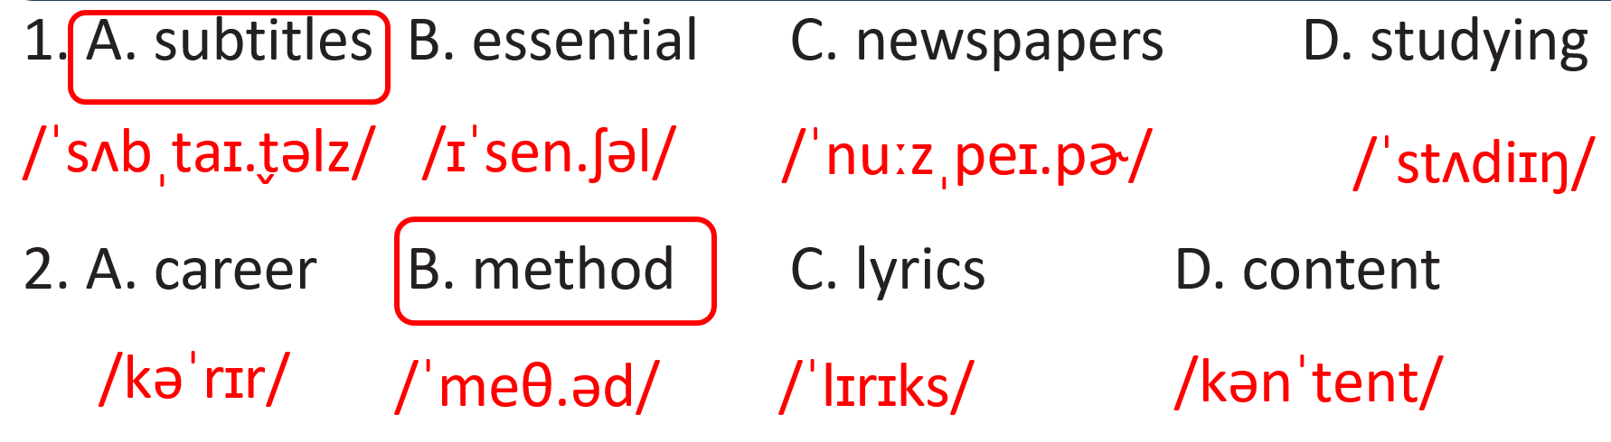
Task b: Circle the word that has the underlined part pronounced differently from the others.  - Ask Ss to work individually and circle the correct answers.  1. A. note down B. go over C. come across D. overseas  2. A. lyrics B. subtitles C. worldwide D. find  - Ask Ss to check the answers with a partner. | - Work individually and circle the correct answers.  - Check the answers with a partner.  Answer Keys:  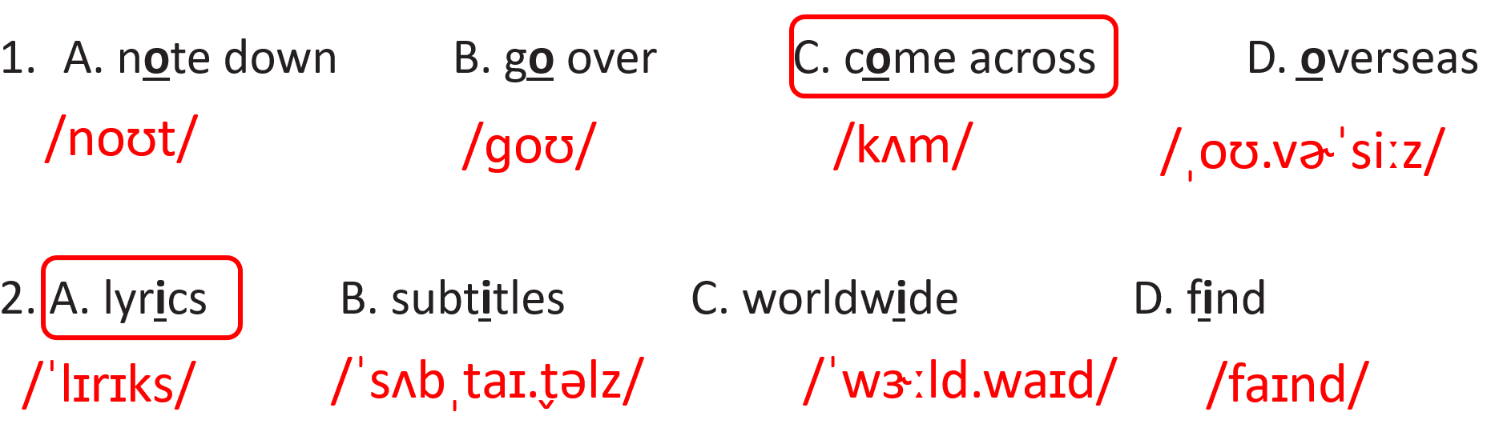
3. In the real world (5’)
a. Objectives: To help Ss learn more about signs in English.
b. Content: In the real world
c. Expected outcomes: Ss can learn more about signs in English.
d. Organization

Teacher’s activities | Students’ activities
Instruction: Look at the signs from an airport. Choose the best answers.  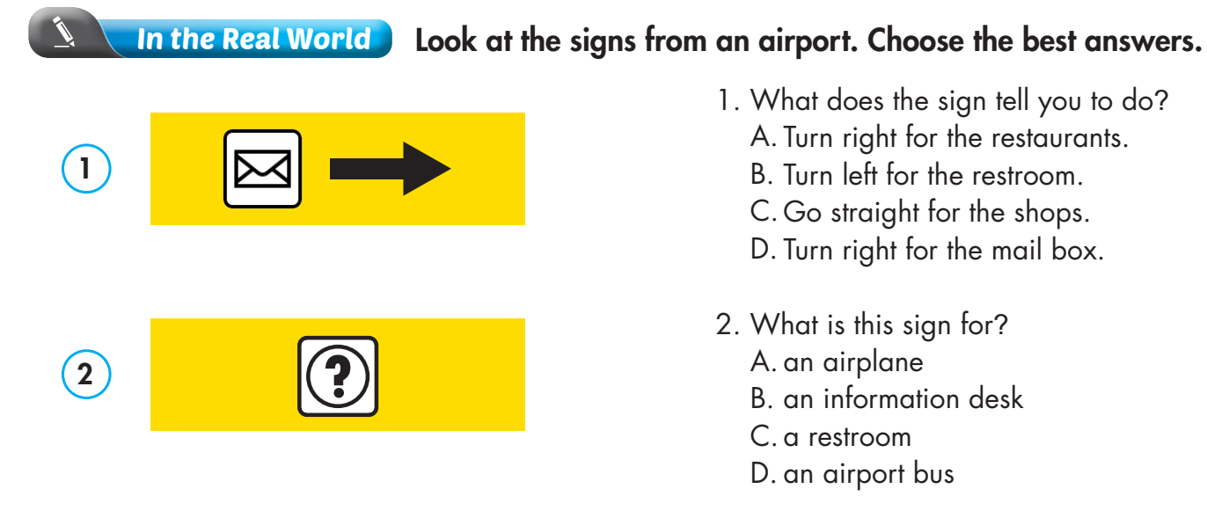  - Ask Ss to finish the task individually.  - Ask Ss to check the answers with a partner. | - Work individually and circle the correct answers.  - Check the answers with a partner.  Answer Keys:  1.D  2. B
4. Conversation (5’)
a. Objectives: To help Ss review different purposes of learning English.
b. Content: Conversation
c. Expected outcomes: Ss review different purposes of learning English.
d. Organization
Teacher’s activities | Students’ activities
Instruction: Choose the correct answer (A, B, C, or D).  1. Khang: "What's your favorite study method, Trang?"  Trang: "When I watch TV in English, I always ______________ the subtitles."  A. come across B. look up C. turn on D. note down  2. Trang: "Why are you learning English, Khang?"  Khang: "I'm learning English ______________ I want to study overseas in the future."  A. since B. because of C. however D. really  3. Trang: "Why do you want to study overseas?"  Khang: "I want to have more ______________ for my future career."  A. essential B. content C. overseas D. opportunities  4. Trang: "What's your favorite study method, Khang?"  Khang: "________________."  A. I note down new words B. I study a lot C. I'm good at English D. It's English.  - Ask Ss to finish the task individually.  - Ask Ss to check the answers with a partner. | - Work individually and circle the correct answers.  - Check the answers with a partner.  Answer Keys:  1. C  2. A  3. D  4. A

5. Speaking (5’)
a. Objectives: To help Ss practice talking about different purposes of learning English.
b. Content: Conversation
c. Expected outcomes: Ss can practice talking about different purposes of learning English.
d. Organization
Teacher’s activities | Students’ activities
Instruction: In pairs: Talk about study methods you already use and why you use them.  1. Khang: "What's your favorite study method, Trang?"  Trang: "When I watch TV in English, I always ______________ the subtitles."  A. come across B. look up C. turn on D. note down  2. Trang: "Why are you learning English, Khang?"  Khang: "I'm learning English ______________ I want to study overseas in the future."  A. since B. because of C. however D. really  3. Trang: "Why do you want to study overseas?"  Khang: "I want to have more ______________ for my future career."  A. essential B. content C. overseas D. opportunities  4. Trang: "What's your favorite study method, Khang?"  Khang: "________________."  A. I note down new words B. I study a lot C. I'm good at English D. It's English.  - Ask Ss to finish the task individually.  - Ask Ss to check the answers with a partner. | - Ask and answer the questions in pairs.  - Check the answers with a partner.  Suggested answers:  - I read short stories and articles in English because reading enhances my vocabulary and writing style.  - I play vocabulary games and puzzles since they make learning fun and engaging.  - I join group discussions and debates. Debates can help me promote communication skills and confidence.

6. Writing (10’)
a. Objectives: To help Ss practice writing about different purposes of learning English.
b. Content: Conversation
c. Expected outcomes: Ss can practice writing about different purposes of learning English.
d. Organization
Teacher’s activities | Students’ activities
Instruction: Write about your favorite English study method. Write 100 to 120 words.  1. Khang: "What's your favorite study method, Trang?"  Trang: "When I watch TV in English, I always ______________ the subtitles."  A. come across B. look up C. turn on D. note down  2. Trang: "Why are you learning English, Khang?"  Khang: "I'm learning English ______________ I want to study overseas in the future."  A. since B. because of C. however D. really  3. Trang: "Why do you want to study overseas?"  Khang: "I want to have more ______________ for my future career."  A. essential B. content C. overseas D. opportunities  4. Trang: "What's your favorite study method, Khang?"  Khang: "________________."  A. I note down new words B. I study a lot C. I'm good at English D. It's English.  - Ask Ss to finish the task individually.  - Ask Ss to exchange their writing with a partner and give some feedback if possible.  - Give feedback and correction. | - Write about a favorite English study method.  - Exchange the writing with a partner and give feedback if possible.  Suggested answer:  My favorite English study method is reading aloud. I choose a book or an article and read it out loud, paying attention to how I pronounce words and use intonation. Reading aloud helps me improve my speaking and pronunciation skills. It also helps me understand the meaning of words better. When I read aloud, I feel more confident and comfortable using English. So, whenever I want to study English, I grab a book and start reading out loud. It's simple, but it really works for me!

C. Consolidation and homework assignments (5’)
- Fill in the gaps with (a) suitable word(s)/ phrase(s)
- Remember to important things you learn during English lessons.
- You should your English notes regularly to make sure you understand everything.
- Sometimes you’ll new words when reading English books or articles.
- Learning English opens up lots of to communicate with people from different countries.
- English can help you communicate when you travel to places where people speak English.

Answers:
- Note down
- Go over
- Come across
- Opportunities
- Overseas
- Practice making sentences with the words in the Consolidation.
- Prepare for the next lesson (Unit 2 – Lesson 1.1 – Vocabulary & Reading – pages 14 & 15 – SB).
- Play the consolidation games on www.eduhome.com.vn

5. Reflection

a. What I liked most about this lesson today:
…………………………………………………………………………………………
b. What I learned from this lesson today:
…………………………………………………………………………………………
c. What I should improve for this lesson next time:
…………………………………………………………………………………………

