School: ……………………………………….. | Date:……………………………………..
Class: ……………………………..................... | Period: ………………………………….

UNIT 1: ENGLISH IN THE WORLD
Lesson 3.2: Writing & Speaking (Page 13)

1. Objectives
By the end of this lesson, students will be able to…
1.1. Language knowledge/ skills
- Learn how to use sequence words to organize writing.
- Talk about different fun activities to practice English at home.
- Write an email to a pen pal to give advice on how to practice English.
1.2. Competences
- Improve Ss’ communication, collaboration, analytical, and critical thinking skills.
1.3. Attributes
- Cultivate a heightened curiosity for diverse learning methodologies.
2. Teaching aids and materials
- Teacher’s aids: Student’s book and Teacher’s book, class CDs, DCR– Phần mềm tương tác trực quan, DHA – Ứng dụng trò chơi tương tác, projector / interactive whiteboard /TV (if any), PowerPoint slides.
- Students’ aids: Student’s book, Workbook, Notebook.
3. Assessment Evidence
Performance Tasks | Performance Products | Assessment Tools
- Put sentences in the right order (Group work).  - Read the email and circle the sequence words.  - Write numbers in the boxes to put the sentences in order of importance, then write sequence words in the blanks.  - In pairs, discuss different fun activities you can do to practice English at home.  - Complete the table.  - Write an email to advise on how to practice English. | - Ss’ answers/performance.  - Ss’ answers.  - Ss’ answers.  - Ss’ answers/performance.  - Ss’ answers/presentation.  - Ss’ answers/performance. | - Observation and feedback.  - Observation and feedback.  - Observation and feedback.  - Observation and feedback.  - Observation and feedback.  - Observation and feedback.
4. Procedures
A. Warm-up: 5 minutes
a. Objectives: to introduce sequence words.
b. Content: Put sentences in the right order.
c. Expected outcomes: Ss can put sentences in the right order and learn some sequence words.
d. Organization
Teacher’s activities | Students’ activities
Group work: Ask students to put 8 sentences in the right order  - Ask Ss to work in groups, and put the sentences in the right order (using the DCR/ PPTs slides).  - Next, preheat the oven to 350°F to ensure it's ready for baking.  - After that, add the wet ingredients and stir well until smooth.  - Place the pan in the preheated oven and bake for approximately 25 minutes, or until a toothpick inserted into the center comes out clean.  - First, gather all the necessary ingredients.  - Then, mix the dry ingredients in a bowl.  - Once the mixture is well mixed, carefully pour it into the prepared baking pan.  - Finally, slice and serve the cake.  - When done, let it cool for 10 minutes.  - Give feedback. | - Work in groups, and put the sentences in the right order.  - Share/exchange the answers with the class.  Suggested answers:  - First, gather all the necessary ingredients.  - Next, preheat the oven to 350°F to ensure it's ready for baking.  - Then, mix the dry ingredients in a bowl.  - After that, add the wet ingredients and stir well until smooth.  - Once the mixture is well mixed, carefully pour it into the prepared baking pan.  - Place the pan in the preheated oven and bake for approximately 25 minutes, or until a toothpick inserted into the center comes out clean.  - When done, let it cool for 10 minutes.  - Finally, slice and serve the cake.

B. New Lesson (35’)
1. Writing (10’)
a. Objectives: To help Ss learn sequence words to organize their writing.
b. Content: Task a and b
c. Expected outcomes: Ss can learn sequence words to organize their writing.
d. Organization
Teacher’s activities | Students’ activities
- Task a: Writing skill: Ask students to take notes on how to use sequence words:  - To show the order or importance of ideas, you can use the ordinal numbers first, second, third,… and the adverb finally.  First, learn how to say some new English words.  Second, practice saying the words to a partner.  Third, practice listening to your partner say them.  Finally, try to use them in a real-life English conversation.  - Use them at the beginning of a sentence and write a comma after them.  - Explain how to use sequence words and ask Ss to take notes. | - Listen and take notes.
Task b: Read the sentences about keeping a vocabulary notebook. Write numbers in the boxes to put the sentences in order of importance, then write sequence words in the blanks.  ________, you can arrange the new words in your notebook by topic if you want to. Some students like doing this to quickly find the new words again.  ________, you should select a bright color for the cover to help you find it when you need it.  ________, you need to write your name on the notebook. If you leave it somewhere, you can get it back easily.  ________, it's a good idea to go over your notes a few times to help you remember better.  - Ask Ss to complete the task individually.  - Ask Ss to share the answers with a partner.  - Give feedback. | - Complete the task.  - Share the answers with a partner.  Suggested answers:  3. Third  1. First  2. Second  4. Finally

2. Speaking(15’)
a. Objectives: To help students talk about different fun activities to practice English at home.
b. Content: Tasks a and b
c. Expected outcomes: Ss can talk about different fun activities to practice English at home.
d. Organization:
Teacher’s activities | Students’ activities
Task a: In pairs: Discuss different fun activities you can do to practice English at home. For each activity, describe a study method you can use to improve your English.  - Ask Ss to work in pairs and discuss different fun activities to practice English at home.  - Ask Ss to exchange their ideas with another pair.  - Ask Ss to share ideas with the whole class. | - Work in pairs and discuss different fun activities to practice English at home.  - Exchange ideas with another pair.  - Share ideas with the whole class.  Suggested answers:  1. Writing in a Journal or Blog: You can keep a daily journal in English, where you can write about your thoughts, experiences, or daily activities. Additionally, you can start a blog to share your writings with others and receive feedback from readers. Writing regularly helps improve vocabulary, grammar, and overall writing proficiency.  2. Engaging in Language Exchange Clubs: You can join online language exchange groups where you can interact with native English speakers or other English learners. You can participate in discussions, share your thoughts, and receive feedback on your language skills. Engaging in regular conversations helps improve speaking and listening abilities and builds confidence in using English in real-life situations.  3. Listening to English Podcasts or Music: You can listen to English podcasts on topics you enjoy or English-language music. You can focus on understanding the content, identifying keywords, and noting down unfamiliar words or phrases. After listening, you can try to summarize the podcast episode or song lyrics in your own words, improving listening comprehension and vocabulary.
Task b: Choose three activities you can do and decide the order of importance, then complete the table.  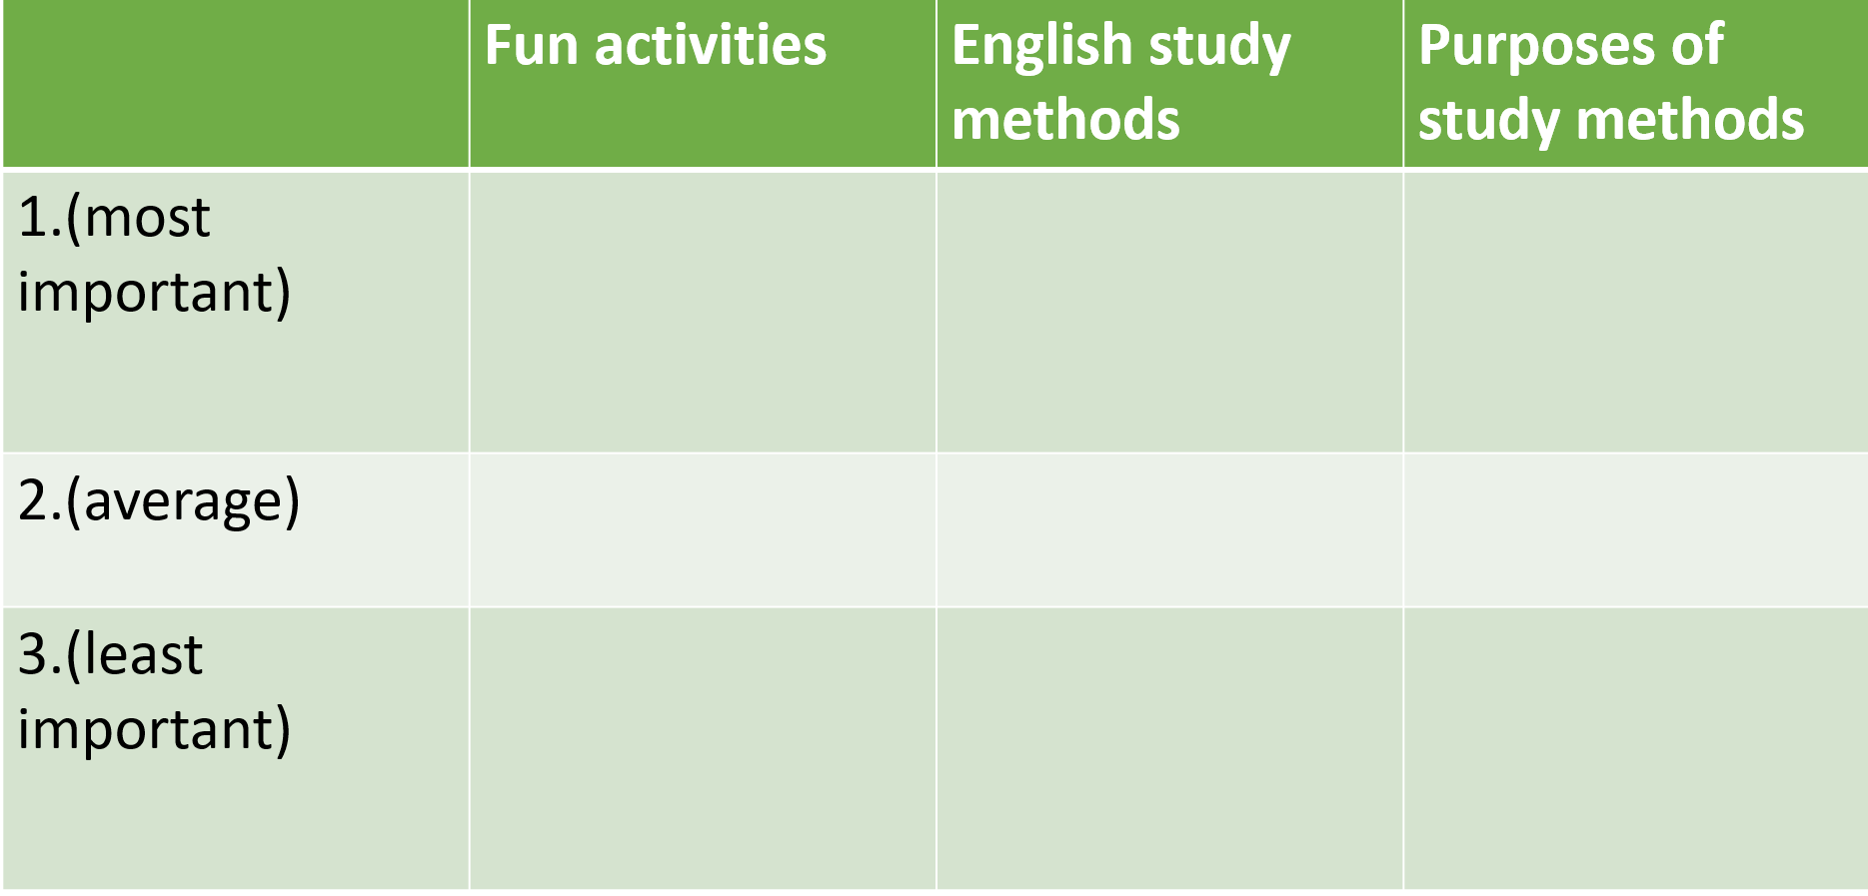  - Ask Ss to complete the table individually.  - Set the time and monitor the class.  - Ask Ss to share the answers with a partner.  - Give Ss feedback (using the DCR). | - Complete the table individually.  - Share the answers with a partner.  Suggested answers:  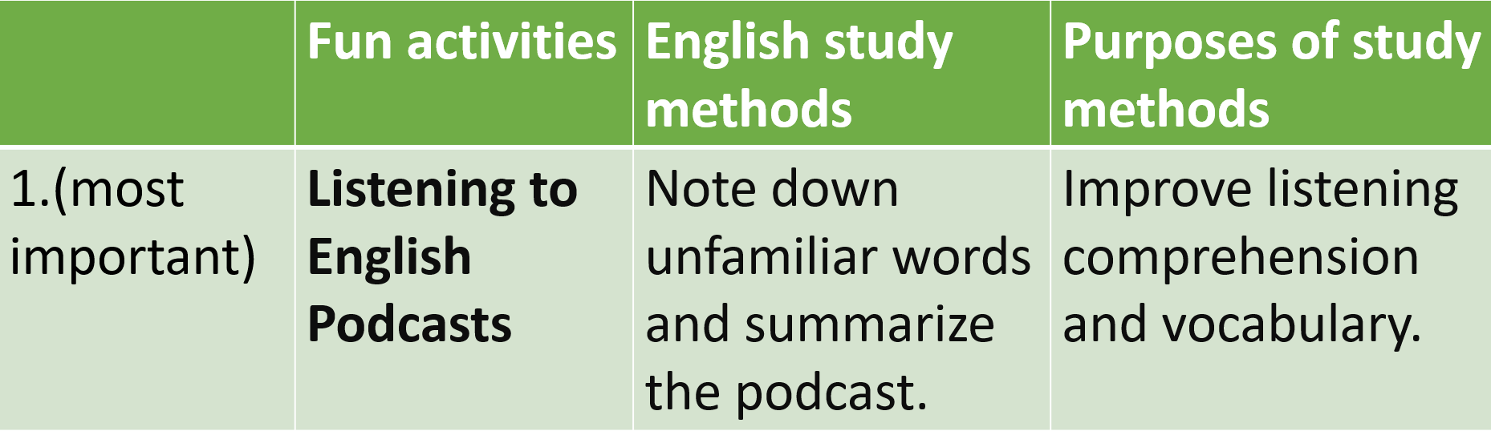  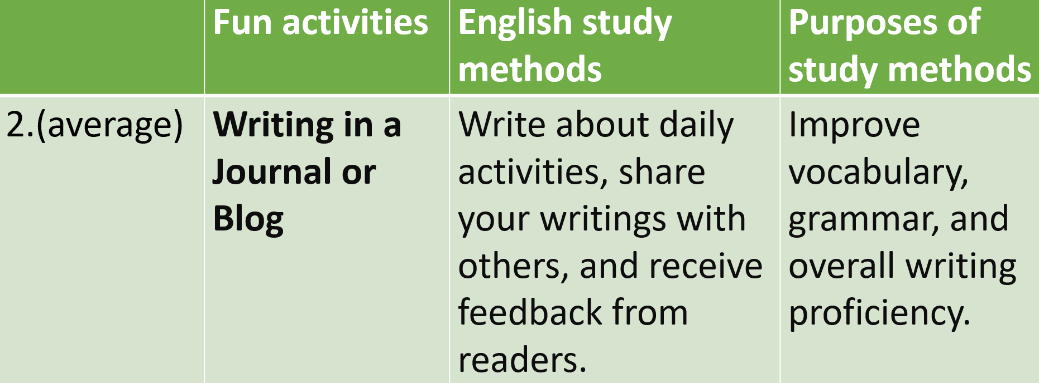  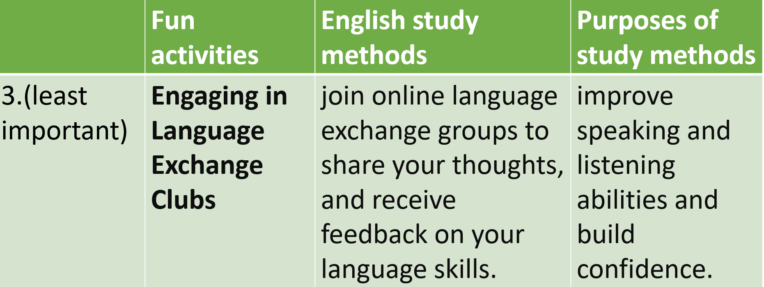
3. Let’s write (10’)
a. Objectives: To help Ss write an email to a pen pal to give advice on how to practice English and use sequence words.
b. Content: Let’s write
c. Expected outcomes: Ss can write an email to a pen pal to give advice on how to practice English and use sequence words.
d. Organization

Teacher’s activities | Students’ activities
Let’s write: Write an email to your pen pal to give advice on how to practice English. Use the Writing Skill box, the reading model, and your speaking notes to help you. Write 100 to 120 words.  Note: Remember to use sequencing words: First, Second, and Finally.  - Ask Ss to brainstorm ideas and write an email individually.  - Monitor the class and help them if necessary.  - Ask Ss to share their ideas with a partner and give feedback based on the notes given.  - Give feedback. | - Brainstorm ideas and write an email.  - Share their ideas with a partner and give feedback based on the notes given.  Suggested answers:  To: Tom@English-Speaking-Pen-Pal.com  From: David@English-Speaking-Pen-Pal.com  Subject: _____________________________  Hi Tom,  Thanks for your email. Check out these fun activities you can do in English and the study methods you can use. First, you can watch movies or TV shows in English. It's a great way to learn new words. Don't forget to turn on the English subtitles to understand the new words clearly.  Second, you can read stories in English. You can read anything you like. Remember to choose a text a bit above your language level to learn some new words each time.  Finally, you can listen to your favorite English music. Just make sure you use the lyrics to read the singer's words.  Let me know if you have any questions about anything.  Bye for now.  David

C. Consolidation and homework assignments (5’)
- Make 4 sentences with “first, second, third, and finally” on the topic: fun ways to learn English. Then read these sentences to your partner.
Suggested answers:
- First, keep yourself fun in learning English by watching entertaining TV shows or movies with subtitles.
- Second, engage in interactive language learning apps that offer games and quizzes to make learning enjoyable.
- Third, join online conversation clubs or language exchange groups to practice speaking English with native speakers.
- Finally, challenge yourself to write in English regularly, whether it's keeping a journal, starting a blog, or participating in creative writing activities.

- Practice making sentences with sequence words in the Writing skill - SB.
- Prepare for the next lesson (Review Unit 1- pages 84 & 85 - SB).
- Play the consolidation games on www.eduhome.com.vn

5. Reflection

a. What I liked most about this lesson today:
…………………………………………………………………………………………
b. What I learned from this lesson today:
…………………………………………………………………………………………
c. What I should improve for this lesson next time:
…………………………………………………………………………………………

