School: ……………………………………….. | Date:……………………………………..
Class: ……………………………..................... | Period: ………………………………….

UNIT 1: ENGLISH IN THE WORLD
Lesson 3.1: Reading (Pages 12 & 13)

1. Objectives
By the end of this lesson, students will be able to…
1.1. Language knowledge/ skills
- Practice reading for gist and detail.
- Discuss the most interesting ways to study English.
- Improve reading skills.
1.2. Competences
- Improve Ss’ communication, collaboration, analytical, and critical thinking skills.
1.3. Attributes
- Cultivate a heightened curiosity for diverse learning methodologies.
2. Teaching aids and materials
- Teacher’s aids: Student’s book and Teacher’s book, class CDs, DCR– Phần mềm tương tác trực quan, DHA – Ứng dụng trò chơi tương tác, projector / interactive whiteboard /TV (if any), PowerPoint slides.
- Students’ aids: Student’s book, Workbook, Notebook.
3. Assessment Evidence
Performance Tasks | Performance Products | Assessment Tools
- Look at the pictures. Ask and answer (Pair work)  - Read the email between two pen pals. Choose the best subject for the email.  - Read and choose the correct answers.  - Listen and read.  - In pairs, ask and answer.  - Listen to a brother and sister talking. What are they mostly talking about?  - Listen and answer the questions. | - Ss’ answers/performance.  - Ss’ answers.  - Ss’ answers.  - Ss’ answers/performance.  - Ss’ answers/presentation.  - Ss’ answers/performance.  - Ss’ answers. | - Observation and feedback.  - Observation and feedback.  - Observation and feedback.  - Observation and feedback.  - Observation and feedback.  - Observation and feedback.  - Observation and feedback.
4. Procedures
A. Warm-up: 5 minutes
a. Objectives: to introduce the topic “pen pal”.
b. Content: Discuss in pairs.
c. Expected outcomes: Ss can talk about pen pals and activities they can do with their pen pals.
d. Organization
Teacher’s activities | Students’ activities
Pair work: Ask and answer the questions below:  - How often do you communicate with your online friends or pen pals?  - What activities do you enjoy doing together with your online friends or pen pals?  - Have you ever learned anything new from your online friends or pen pals?  - Ask Ss to work in pairs, and ask and answer the questions (using the DCR/ PPTs slides).  - Call some pairs to give their answers.  - Give feedback. | - Work in pairs, ask and answer the questions.  - Share/exchange the answers with the class.  Suggested answers:  - Some friends I chat with daily, while others I talk to once a week or even less.  - We play online games, watch movies or shows together while chatting, share music playlists, or even work on projects together like writing stories or planning trips.  - Definitely! They've taught me about their cultures, shared cool facts, and recommended books or movies I wouldn't have found otherwise.

B. New Lesson (35’)
1. Pre-Reading (Let’s talk - 10’)
a. Objectives: To help Ss discuss different ways of communicating with friends.
b. Content: Let’s talk.
c. Expected outcomes: Ss can discuss different ways of keeping in touch with friends.
d. Organization
Teacher’s activities | Students’ activities
Let’s talk: In pairs: Look at the pictures. Ask and answer:  - What are these people doing?  - Do you communicate like this?      - Ask Ss to work in pairs asking and answering the questions (using the DCR/ PPTs slides).  - Check Ss’ answers around the class.  - Ask Ss to share their answers. | - Work in pairs, asking and answering the questions.  - Share the answers with the class.  Suggested answers:  - They are communicating with their friend(s) face to face and by email.  - Yes, I often keep in touch with my friends by email.

2. While Reading (Reading – 15’)
a. Objectives: To help Ss read for gist and detail.
b. Content: Tasks a, b, and c.
c. Expected outcomes: Ss can read for general and specific information about some fun ways to learn English.
d. Organization:
Teacher’s activities | Students’ activities
Task a: Read the email between two pen pals. Choose the best subject for the email.  - Ideas for a party  - Ideas for this weekend  - Ideas for learning at home  - Ask Ss to read the email and choose the correct answer.  - Ask Ss to compare the answer with a partner and show the evidence to justify the answer.  - Check Ss’ answer. | - Read the email, underline the evidence, and circle the correct answer.  - Compare the answer with a partner and show the evidence to justify the answer.  Answer Key: C  Evidence: Hi Tom,  Thanks for your email. You asked me if I knew some fun ways to learn English – yes, I do! Check out these awesome activities you can do – just pay attention to the study methods.
Task b: Now, read and choose the correct answers.  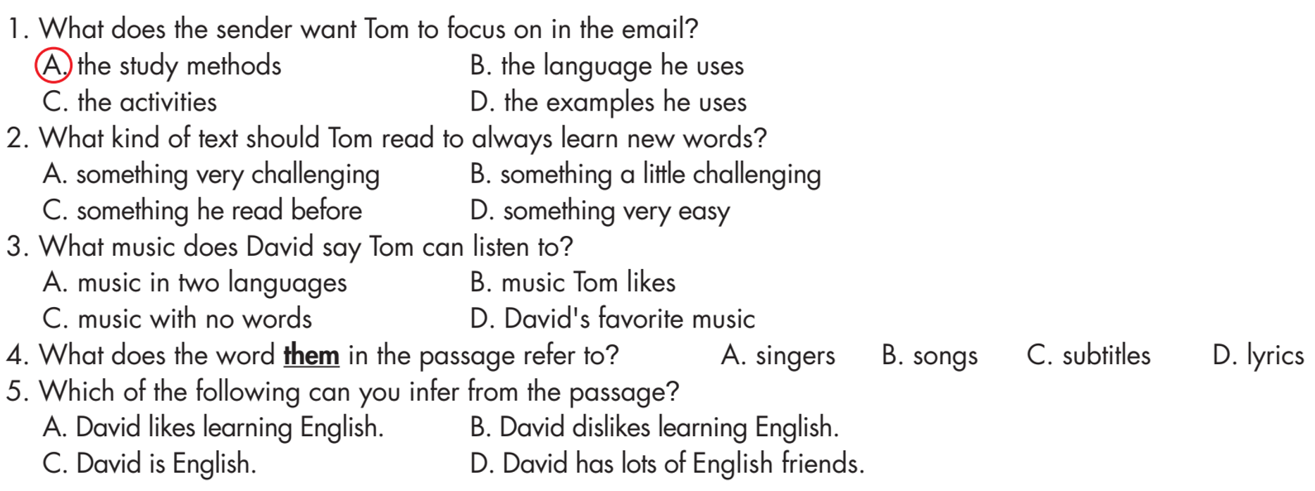  - Ask Ss to read the sentences and choose the correct answers.  - Set the time and monitor the class.  - Ask Ss to check the answers with a partner.  - Check Ss’ answers (using the DCR). | - Read the questions and choose the correct answers.  - Compare the answer with a partner.  Answer Keys  - B (CLUE: read something a little above your language level)  - B (CLUE: listen to your favorite English songs)  - D (CLUE: Search for the lyrics online and use them)  - A (CLUE: Check out these awesome activities)
Task c: Listen and read.  - Play the CD and ask Ss to listen and read along.  - Pick four Ss to read the email aloud and correct their pronunciation if necessary. | - Listen and read along.

3. Post-reading (10’)
a. Objectives: To help Ss discuss interesting ways of learning English from the email.
b. Content: Task d
c. Expected outcomes: Ss can discuss and share interesting ways of learning English from the email.
d. Organization

Teacher’s activities | Students’ activities
Pair work: In pairs, ask and answer:  - Which activity in the email do you think is the most interesting?  - Why?  - Ask Ss to ask and answer the question in pairs.  - Monitor the class and help them if necessary.  - Elicit answers from some students. | - Work in pairs to share their ideas.  - Share their ideas with the class.  Suggested answers:  1. "I think reading stories in English, particularly comics is the most interesting activity as they offer both relaxation and enjoyment, while at the same time allowing me to expand my vocabulary."  2."I think watching movies makes learning English more enjoyable since movies show you different parts of the English-speaking world, so you learn about their culture, customs, and way of life."

C. Consolidation and homework assignments (5’)
- Read the explanation below and tell your partner: What kind of friend is it?
“A friend you keep in touch by writing letters, emails or sending online messages to each other, instead of talking face-to-face.”
Answer: Pen pal
- Prepare for the next lesson (Writing & Speaking - page 13 - SB)
- Play the consolidation games on www.eduhome.com.vn

5. Reflection

a. What I liked most about this lesson today:
…………………………………………………………………………………………
b. What I learned from this lesson today:
…………………………………………………………………………………………
c. What I should improve for this lesson next time:
…………………………………………………………………………………………

