School: ……………………………………….. | Date:……………………………………..
Class: ……………………………..................... | Period: ………………………………….

UNIT 1: FREE TIME
Lesson 2.2: Grammar (Pages 9 & 10)

1. Objectives
By the end of this lesson, students will be able to…
1.1. Language knowledge/ skills
- Practice and use adverbial clauses and phrases of reason.
- Make conversations about reasons to study English using phrases of reason.
- Improve speaking skills.
1.2. Competences
- improve Ss’ communication, collaboration, analytical, and critical thinking skills.
1.3. Attributes
  - Gain a holistic understanding of why people around the world learn English and how English can positively impact various aspects of life.
  - Foster a sense of motivation for learning English.
2. Teaching aids and materials
- Teacher’s aids: Student’s book and Teacher’s book, class CDs, DCR– Phần mềm tương tác trực quan, DHA – Ứng dụng trò chơi tương tác, projector / interactive whiteboard /TV (if any), PowerPoint slides.
- Students’ aids: Student’s book, Workbook, Notebook.
3. Assessment Evidence
Performance Tasks | Performance Products | Assessment Tools
- Match sentence endings.  - Read about adverbial clauses/phrases of reason, then fill in the blanks.  - Listen and check. Listen again and repeat.  - Fill in the blanks with as/since/because or because of.  - Use the prompts to write replies using as/since/because or because of.  - In pairs: Talk about reasons for learning English using the prompts. | - Ss’ answers/performance.  - Ss’ answers.  - Ss’ performance.  - Ss’ answers.  - Ss’ answers.  - Ss’ answers/presentation. | - Observation and feedback.  - Observation and feedback.  - Observation and feedback.  - Observation and feedback.  - Observation and feedback.  - Observation and feedback.

4. Procedures
A. Warm-up: 5 minutes
a. Objectives: to introduce the grammar points of adverbial clauses and phrases of reason.
b. Content: Matching sentence endings.
c. Expected outcomes: Ss can get to know adverbial clauses and phrases of reason.
d. Organization
Teacher’s activities | Students’ activities
Competition time:  - Ask Ss to form groups of 5.  - Give Ss instructions.  - Give Ss some time to match sentence beginnings and endings.  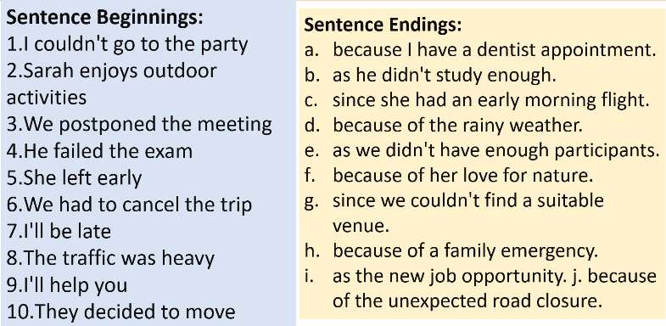  - Check Ss’ answers. | - Form groups of 5.  - Follow the instructions.  - Match sentence beginnings and endings in a team/group.  Answer Keys  - I couldn't go to the party h. because of a family emergency.  - Sarah enjoys outdoor activities f. because of her love for nature.  - We postponed the meeting g. since we couldn't find a suitable venue.  - He failed the exam b. as he didn't study enough.  - She left early c. since she had an early morning flight.  - We had to cancel the trip e. as we didn't have enough participants.  - I'll be late a. because I have a dentist's appointment.  - The traffic was heavy j. because of the unexpected road closure.  - I'll help you i. as the new job opportunity.  - They decided to move d. because of the rainy weather.

B. New Lesson (35’)
1. Presentation (15’)
a. Objectives: To help Ss understand how to use adverbial clauses and phrases of reason.
b. Content: Tasks a and b.
c. Expected outcomes: Ss can use adverbial clauses and phrases of reason in different contexts.

d. Organization
Teacher’s activities | Students’ activities
Task a: Read about adverbial clauses/phrases of reason, then fill in the blanks.  - Ask Ss to work individually and complete the task (using the DCR/ PPTs slides).  - Ask Ss to compare the answers with a partner.  - Check Ss’ answers around the class.  - Explain the use of “adverbial clauses/phrases of reason” (using the DCR/ PPTs slides)  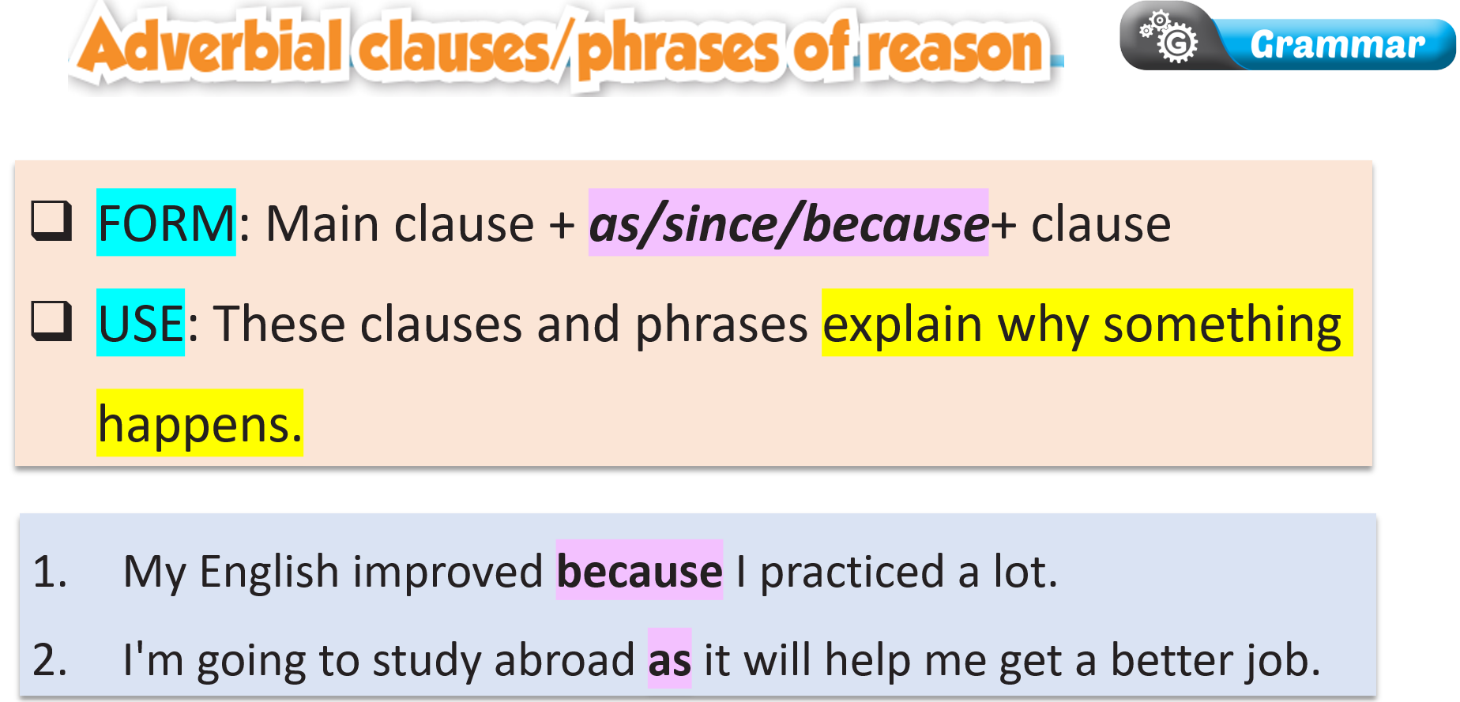  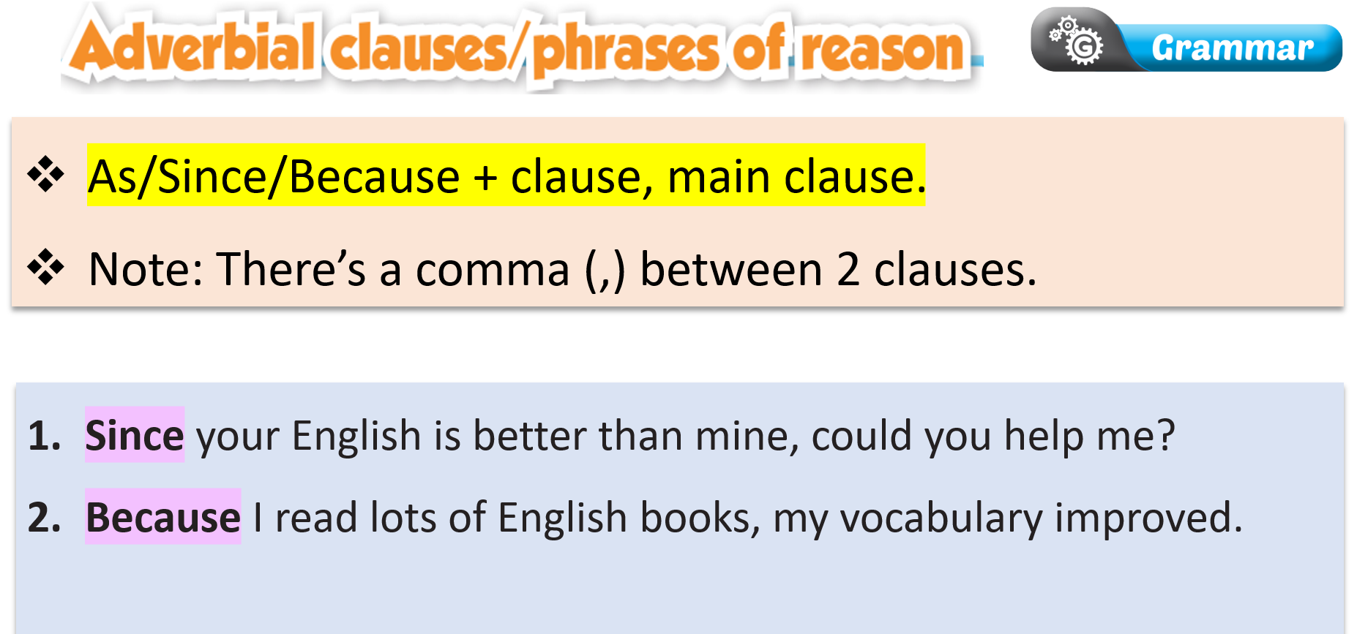  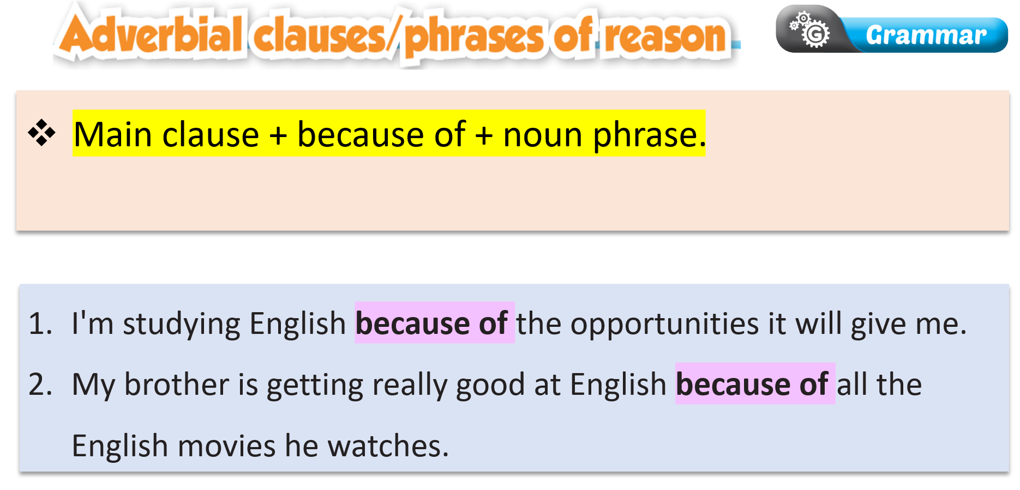  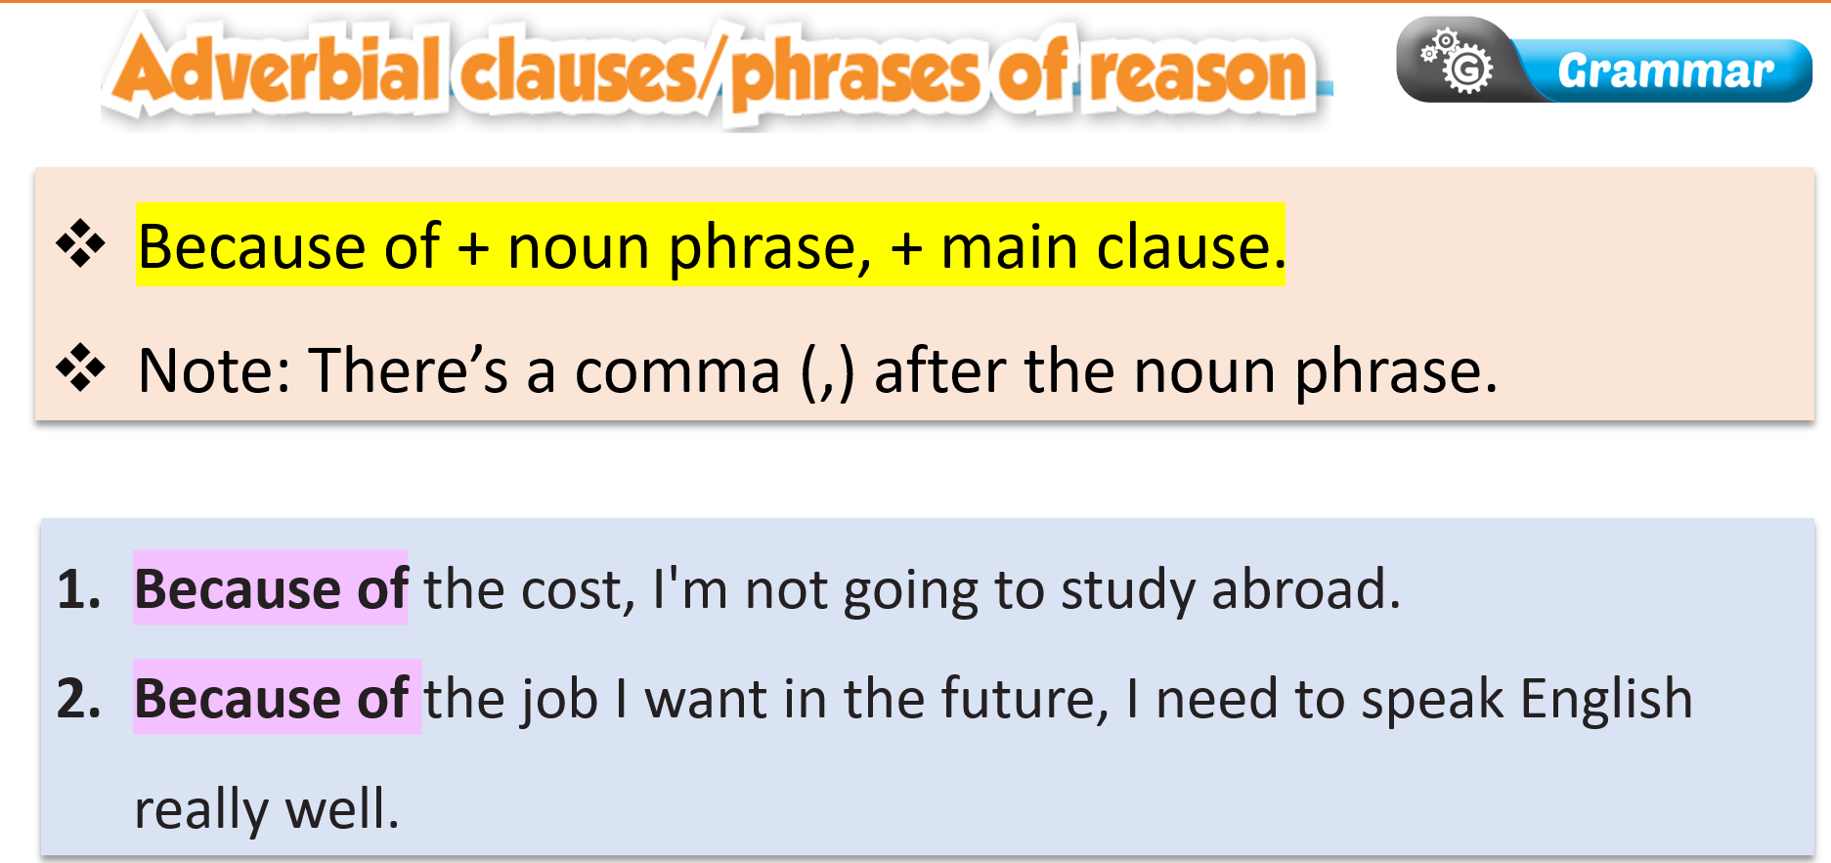 | - Fill in the blanks.  - Compare the answers with a partner.  - Listen to the teacher’s instructions and take notes.  - Listen to the teacher’s instructions and take notes.
Task b: Listen and check. Listen again and repeat.  - Check Ss’ answers around the class.  - Ask students to listen again and repeat. | - Listen and check.  Answer Keys:  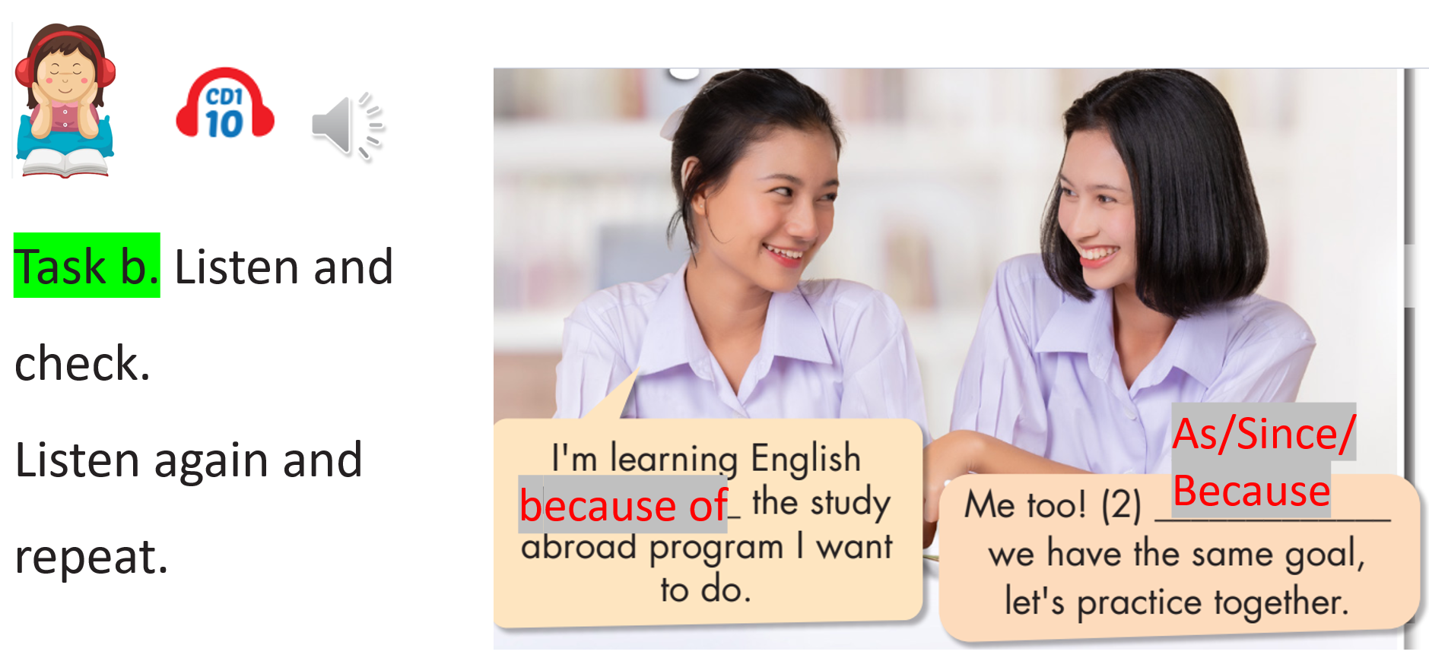  - Listen and repeat.

2. Practice (15’)
a. Objectives: To help Ss practice the use of “adverbial clauses/phrases of reason”.
b. Content: Tasks c and d.
c. Expected outcomes: Ss can use “adverbial clauses/phrases of reason” by making sentences.
d. Organization:
Teacher’s activities | Students’ activities
Task c: Fill in the blanks with as/since/because or because of.  - Ask Ss to complete the task individually.  - Ask Ss to check the answers with a partner.  - Pick some Ss to read the sentence(s) out loud.  - Check and correct Ss’ answers. | - Complete the task.  - Compare the answers with a partner.  - Read the sentences out loud.  Answer Keys:  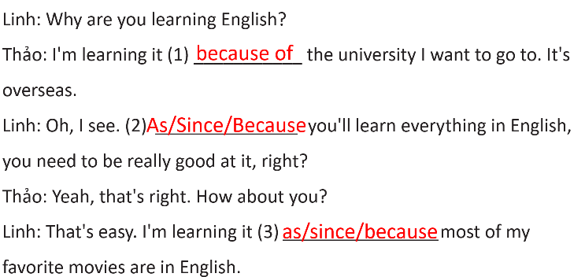  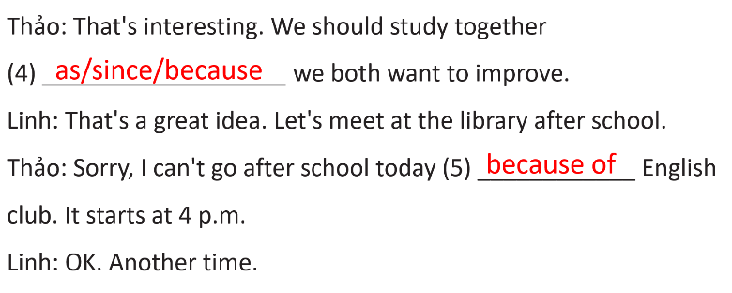
Task d: Use the prompts to write replies using as/since/because or because of.  - Ask Ss to write complete replies using the prompts.  - Set the time and monitor the class.  - Ask Ss to compare the answers with a partner.  1. Friend: I love English songs.  You: We both like English songs/do you want/sing karaoke?  Sample answer: As/Since/Because we both like English songs, do you want to sing karaoke?  2. New girl in class: How is your class so good at English?  You: We are very good/how much/read and listen/English content every day  3. Sister: English is spoken all around the world.  You: Yes/English/help you with international travel/people speak it worldwide  4. Teacher: Why do you want to improve your English?  You: English is/language of overseas study/it/essential to be good/it  5. Friend: You seem to really like learning English.  You: I/learning English/career opportunities/it will give me/future  - Check Ss’ answers (using the DCR). | - Write full replies using the prompts.  - Check the answers with a partner.  Answer Key  - We are very good because of how much we read and listen to English content every day.  - Yes. English can/will help you with international travel as/since/because people speak it worldwide.  - As/Since/Because English is the language of overseas study, it's essential to be good at it.  - I'm learning English because of the career opportunities it will give me in the future.

3. Production (5’)
a. Objectives: To help Ss produce sentences using “adverbial clauses/phrases of reason”.
b. Content: Task e
c. Expected outcomes: Ss can compare and contrast their reasons for studying English with other students, using adverbial clauses/phrases of reason.
d. Organization
Teacher’s activities | Students’ activities
Task e: In pairs: Talk about English using the prompts.  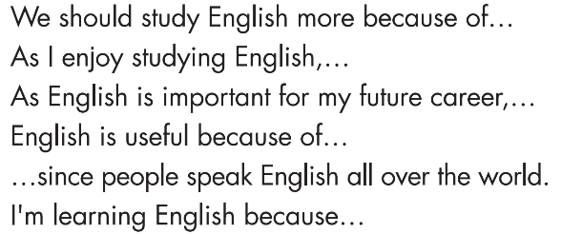  - Ask Ss to make conversations using the prompts in task e.  - Monitor the class and help them if necessary.  - Ask some Ss to share their ideas. | - Make conversations based on the prompts in task e.  - Share the ideas with the class.  Suggested answers:  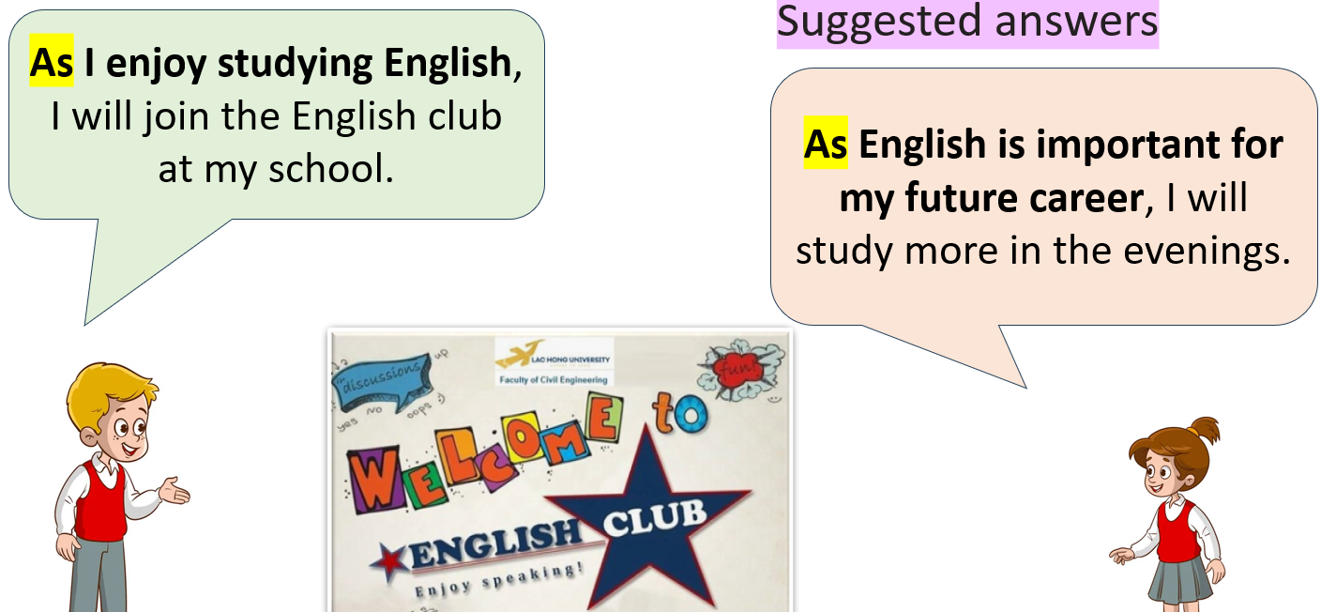  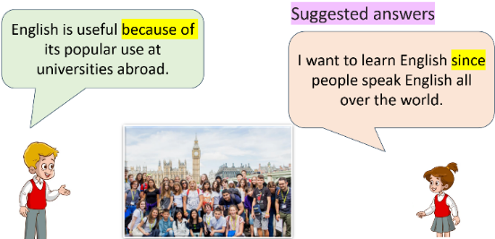  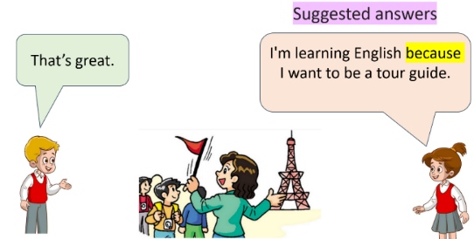

C. Consolidation and homework assignments (5’)
- Speaking: Ask and answer the question below with your partner, using “because, as, since, because of” to give reasons: Why do you learn English?
- Review adverbial clauses and phrases of reason.
- Prepare for the next lesson (Pronunciation & Speaking - pages 10 & 11 - SB).
- Play the consolidation games on www.eduhome.com.vn
5. Reflection

a. What I liked most about this lesson today:
…………………………………………………………………………………………
b. What I learned from this lesson today:
…………………………………………………………………………………………
c. What I should improve for this lesson next time:
…………………………………………………………………………………………

