School: ……………………………………….. | Date:……………………………………..
Class: ……………………………..................... | Period: ………………………………….

UNIT 1: ENGLISH IN THE WORLD
Lesson 2.1: Vocabulary and Listening (Pages 8 & 9)

1. Objectives
By the end of this lesson, students will be able to…
1.1. Language knowledge/ skills
- Learn and use more new words about the topic English in the World.
- Practice listening for specific information.
- Practice conversation skills: Asking for a reason.
- Improve listening and speaking skills.

1.2. Competences
- improve Ss’ communication, collaboration, analytical, and critical thinking skills.
1.3. Attributes
  - gain a holistic understanding of why learning English is valuable and how it can positively impact various aspects of life.
  - Foster a sense of motivation for learning English.
2. Teaching aids and materials
- Teacher’s aids: Student’s book and Teacher’s book, class CDs, DCR– Phần mềm tương tác trực quan, DHA – Ứng dụng trò chơi tương tác, projector /interactive whiteboard /TV (if any), PowerPoint slides.
- Students’ aids: Student’s book, Workbook, Notebook.
3. Assessment Evidence
Performance Tasks | Performance Products | Assessment Tools
- Look at the picture and discuss questions.  - Fill in the blanks with the new words.  - Listen and repeat.  - Use the new words to talk about how you can use English in your country and around the world.  - Listen to two friends talking about learning English and answer the question (s).  - Listen and fill in the blanks.  - Listen to the conversation and circle the phrase mentioned.  - Pair-work: Which of Linh's and Duy's reasons for learning English do you like the most? Why? | - Ss’ answers/performance.  - Ss’ answers.  - Ss’ performance.  - Ss’ answers/ presentation.  - Ss’ answers.  - Ss’ answers.  - Ss’ answers.  - Ss’ answers/presentation. | - Observation and feedback.  - Observation and feedback.  - Observation and feedback.  - Observation and feedback.  - Observation and feedback.  - Observation and feedback.  - Observation and feedback.  - Observation and feedback.
4. Procedures
A. Warm-up: 5 minutes
a. Objectives: to introduce the topic.
b. Content: Let’s talk.
c. Expected outcomes: Ss can talk about different English learning methods based on the title and the picture.
d. Organization
Teacher’s activities | Students’ activities
Let’s talk: In pairs: Look at the picture, ask and answer the questions below:  - What is the woman doing?  - How can English help her on her trip?    - Ask Ss to work in pairs, look at the picture, and answer the questions (using the DCR/ PPTs slides).  - Call some pairs to give their answers.  - Give feedback. | - Work in pairs, look at the picture and answer the questions.  - Share/exchange the answers with the class.  Answer Keys  - She’s holding a map and she’s traveling to London.  - English can help her ask for directions when traveling.

B. New Lesson (35’)
1. Pre-Listening (Vocabulary - 15’)
a. Objectives: To help Ss enhance their vocabulary capacity and prepare them some new words for the listening tasks.
b. Content: tasks a and b.
c. Expected outcomes: Ss can learn some new words about the roles of English around the world.
d. Organization
Teacher’s activities | Students’ activities
Task a: Read the definitions, then fill in the blanks with the new words. Listen and repeat.  - Ask Ss to work by themselves and fill in the blanks (using the DCR/ PPTs slides).  - Ask Ss to compare the answers with a partner.  - Check Ss’ answers around the class.  - Ask Ss to listen and repeat. | - Read the definitions and fill in the blanks.  - Check the answers with a partner.  - Listen and repeat.  Answer Keys:  1. international 2. opportunity  3. content 4. career  5. overseas 6. worldwide  7. foreign 8. essential
Task b: In pairs: Use the new words to talk about how you can use English in your country and around the world.  - Explain and model the activity.  - Ask Ss to work in pairs, sharing their ideas about their English learning methods.  - Check Ss’ answers around the class.  -Pick some Ss to talk about their partner. | - Listen to the instructions.  - Work in pairs, sharing ideas.  - Share the ideas with the whole class.  Suggested answers:  - We can use English as an international language to talk to people from various countries around the world.  - Learning English opens up exciting opportunities for communication and collaboration on a global scale.  - English can contribute to my future career prospects, as many international companies value bilingual employees.  - In my studies, I've discovered that English-language content provides a wealth of perspectives from diverse cultures.  - As I learn English, I realize its significance in connecting with people worldwide, and fostering friendships and understanding across borders.  - English proficiency can create opportunities for overseas travel and cultural exchange.  - Learning a foreign language like English broadens my horizons, allowing me to appreciate different cultures and perspectives.  - I see English as an essential tool for effective communication in today's interconnected world, making it a valuable skill for personal and professional growth.

2. While Listening (10’)
a. Objectives: To help Ss listen for specific information.
b. Content: Tasks a and b.
c. Expected outcomes: Ss can read for specific information and know some new methods of learning English.
d. Organization:
Teacher’s activities | Students’ activities
Task a: Listen to two friends talking about learning English. Where are they?  - at home  - at school  - at work  - Ask Ss to listen and choose the correct answer.  - Ask Ss to compare the answer with a partner and show the evidence to justify the answer.  - Check Ss’ answers. | - Listen and circle the correct answer.  - Compare the answer with a partner and show the evidence to justify the answer.  Answer Key: number 2  Clues:  Duy: Hi, Linh.  Linh: Oh, hi, Duy.  Duy: You're in my English class, want to walk with me?  Linh: Sure!
Task b: Now, listen and fill in the blanks.  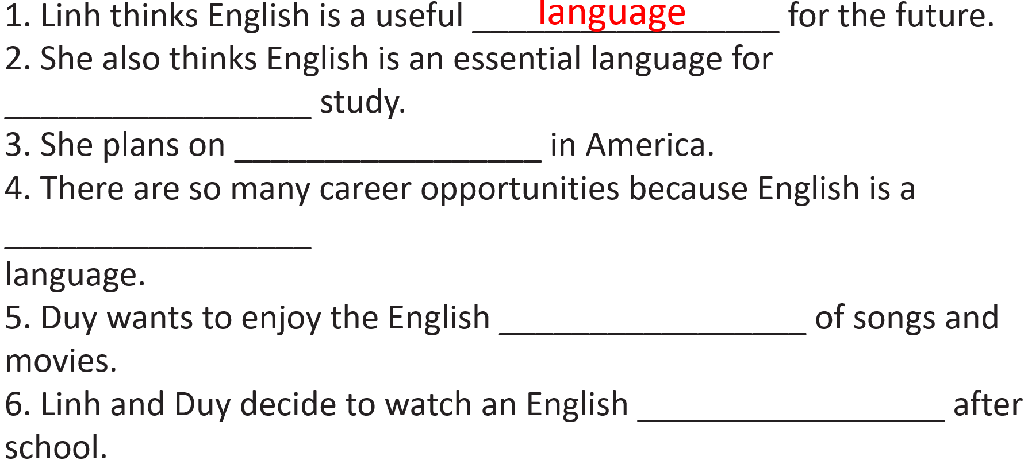  - Ask Ss to read through the sentences, listen, and fill in the blanks.  - Ask Ss to check the answers with a partner.  - Check Ss’ answers (using the DCR). | - Read through the sentences, listen, and fill in the blanks.  - Compare the answer with a partner.  Answer Keys  1. language 2. overseas  3. studying 4. worldwide  5. content 6. movie

3. Post-listening (10’)
a. Objectives: To help Ss practice asking for reasons and talk about the important roles of English.
b. Content: Task c, d and e.
c. Expected outcomes: Ss can make conversations asking for reasons about the important roles of English.
d. Organization

Teacher’s activities | Students’ activities
Task c: Read the Conversation Skill box, then listen and repeat.  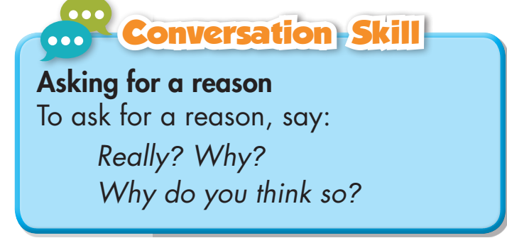  - Play the CD and ask Ss to listen and repeat.  - Pick some Ss to read the sentences aloud and correct their intonation if necessary. | - Listen and repeat. Copy the intonation.
Task d: Now, listen to the conversation again and circle the phrase that you hear.  - Ask students to listen and choose the correct answer. | - Listen and circle the correct answer.  Answer key:  Why do you think so?
Task e: In pairs: Which of Linh's and Duy's reasons for learning English do you like the most? Why?  - Ask students to work in pairs and discuss the questions. | - Work in pairs and discuss the questions.  - Suggested answers:  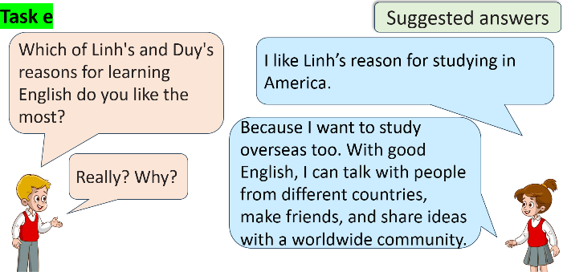

C. Consolidation and homework assignments (5’)
- Vocabulary: international, opportunity, content, career, overseas, worldwide, foreign, essential
- Learn the new words and make eight sentences using them.
- Prepare for the next lesson (Grammar - pages 9 & 10 - SB).
- Play the consolidation games on www.eduhome.com.vn

5. Reflection

a. What I liked most about this lesson today:
…………………………………………………………………………………………
b. What I learned from this lesson today:
…………………………………………………………………………………………
c. What I should improve for this lesson next time:
…………………………………………………………………………………………

