School: ……………………………………….. | Date:……………………………………..
Class: ……………………………..................... | Period: ………………………………….

UNIT 1: ENGLISH IN THE WORLD
Lesson 1.3: Pronunciation & Speaking (Pages 6 & 7)

1. Objectives
By the end of this lesson, students will be able to…
1.1. Language knowledge/ skills
- practice stressing content words in a sentence.
- talk about fun ways/methods to learn English.
- improve speaking skills.
1.2. Competences
- improve Ss’ communication, collaboration, analytical, and critical thinking skills.
1.3. Attributes
- cultivate a heightened curiosity for diverse learning methodologies.
2. Teaching aids and materials
- Teacher’s aids: Student’s book and Teacher’s book, class CDs, DCR– Phần mềm tương tác trực quan, DHA – Ứng dụng trò chơi tương tác, projector / interactive whiteboard /TV (if any), PowerPoint slides.
- Students’ aids: Student’s book, Workbook, Notebook.
3. Assessment Evidence
Performance Tasks | Performance Products | Assessment Tools
- Listen to the sentences and focus on the underlined words.  - Listen and cross out the sentence that doesn’t follow the note.  - Read the sentences focusing on the content words.  - Take turns asking and answering about English study methods. (Pair work)  - Practice with your own ideas.  - Look at the pictures and say what the activities are and discuss the purpose of the study methods. (Pair work)  - Join another pair and tell them about your favorite study method. | - Ss’ performance.  - Ss’ answers.  - Ss’ performance.  - Ss’ performance.  - Ss’ answers/presentation.  - Ss’ answers/presentation.  - Ss’ answers/presentation. | - Observation.  - Observation and feedback.  - Observation and feedback.  - Observation and feedback.  - Observation and feedback.  - Observation and feedback.  - Observation and feedback.
4. Procedures
A. Warm-up: 5 minutes
a. Objectives: to introduce the stress in words.
b. Content: Pronunciation game: The stressed syllables.
c. Expected outcomes: Ss can underline the stressed syllable(s) in words.
d. Organization
Teacher’s activities | Students’ activities
COMPETITION TIME:  - Create groups/teams of 5 students.  - You will be given some English words with unusual stressed syllables.  - You have to underline the stress syllable (s) in these words.  - The team(s) with the most correct answers win(s).  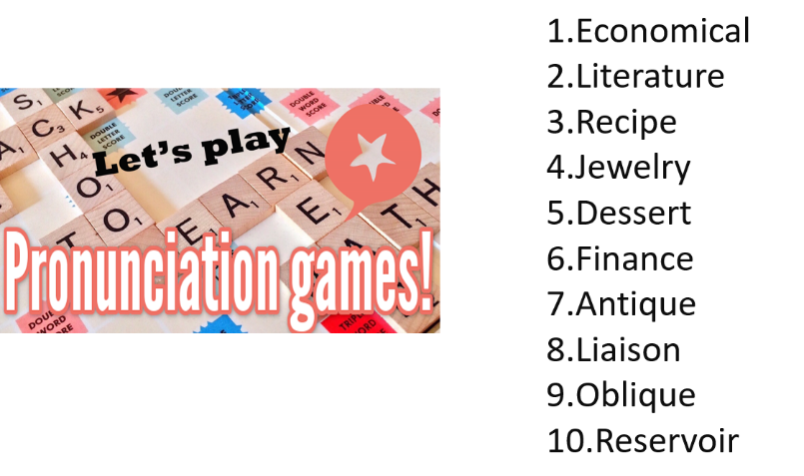 | - Listen to the instructions.  - Work in groups and underline the stressed syllable.  - Ss’ answers  Answer Keys  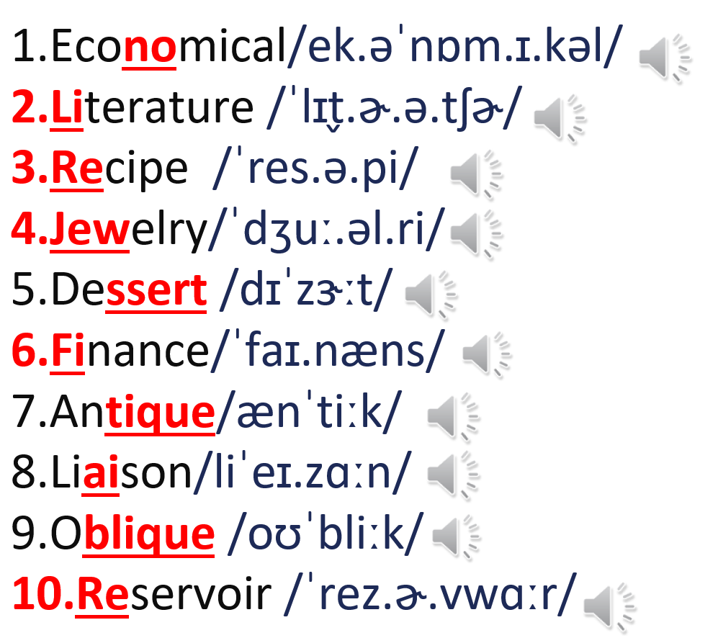

B. New Lesson (35’)
1. Pronunciation (15’)
a. Objectives: To help Ss practice stressing content words in a sentence.
b. Content: Tasks a, b, c and d.
c. Expected outcomes: Ss can improve their pronunciation by stressing content words in sentences.
d. Organization
Teacher’s activities | Students’ activities
Task a: Notes:  - Content words in a sentence are often stressed.  - Content words can be nouns, verbs, adjectives, or adverbs.  - Ask Ss to take notes. | - Listen and take some notes.
Task b: Listen to the sentences and focus on the underlined words.  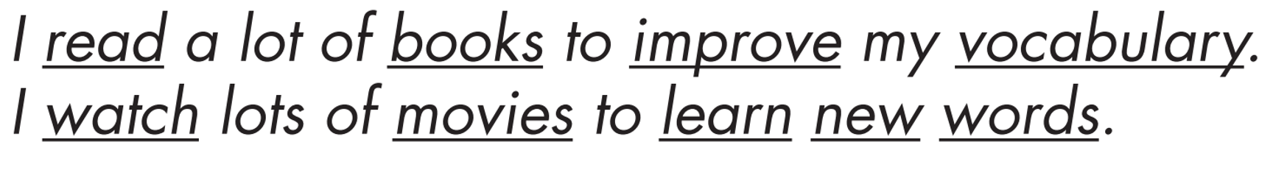 | - Listen to the sentences and focus on the underlined words.
Task c: Listen and cross out the sentence that doesn't follow the note in Task a.  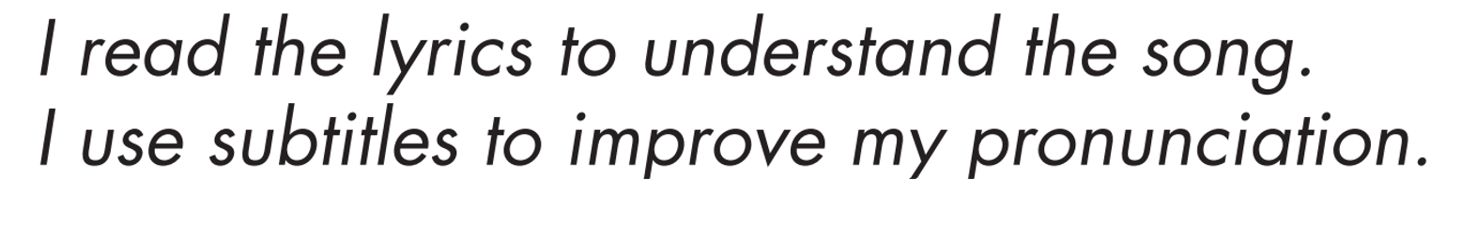 | - Listen and choose the correct answer.  Answer:  - I use subtitles to improve my pronunciation.
Task d: Read the sentences with the rhythm noted in Task a. to a partner.  - Ask some students to read the sentences out loud.  - Give some feedback or correction. | - Practice saying the sentences with a partner.  - Read the sentences out loud.

2. Practice (10’)
a. Objectives: To help Ss practice stressing content words to discuss some different study methods.
b. Content: Tasks a and b.
c. Expected outcomes: Ss can discuss study methods with content words stressed.
d. Organization:
Teacher’s activities | Students’ activities
Task a: In pairs: Look at the pictures of fun ways to learn English. Say what the activities are and discuss the purpose of the study methods below and your own ideas.  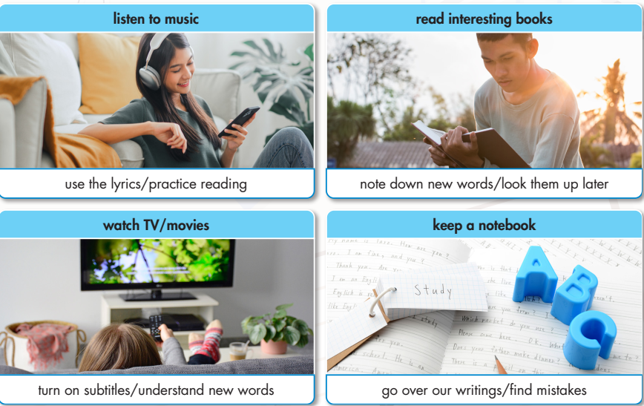  - Ask Ss to share their ideas with the class.  - Check SS’s answers and give feedback. | - Answer the questions with a partner.  - Share the ideas with the class.
Task b: Practice with your own ideas.  - Ask Ss to work in pairs and share their own study methods.  - Check Ss’ answers and give feedback (using the DCR/ PPT slides). | - Share the ideas with a partner.  Suggested answer:  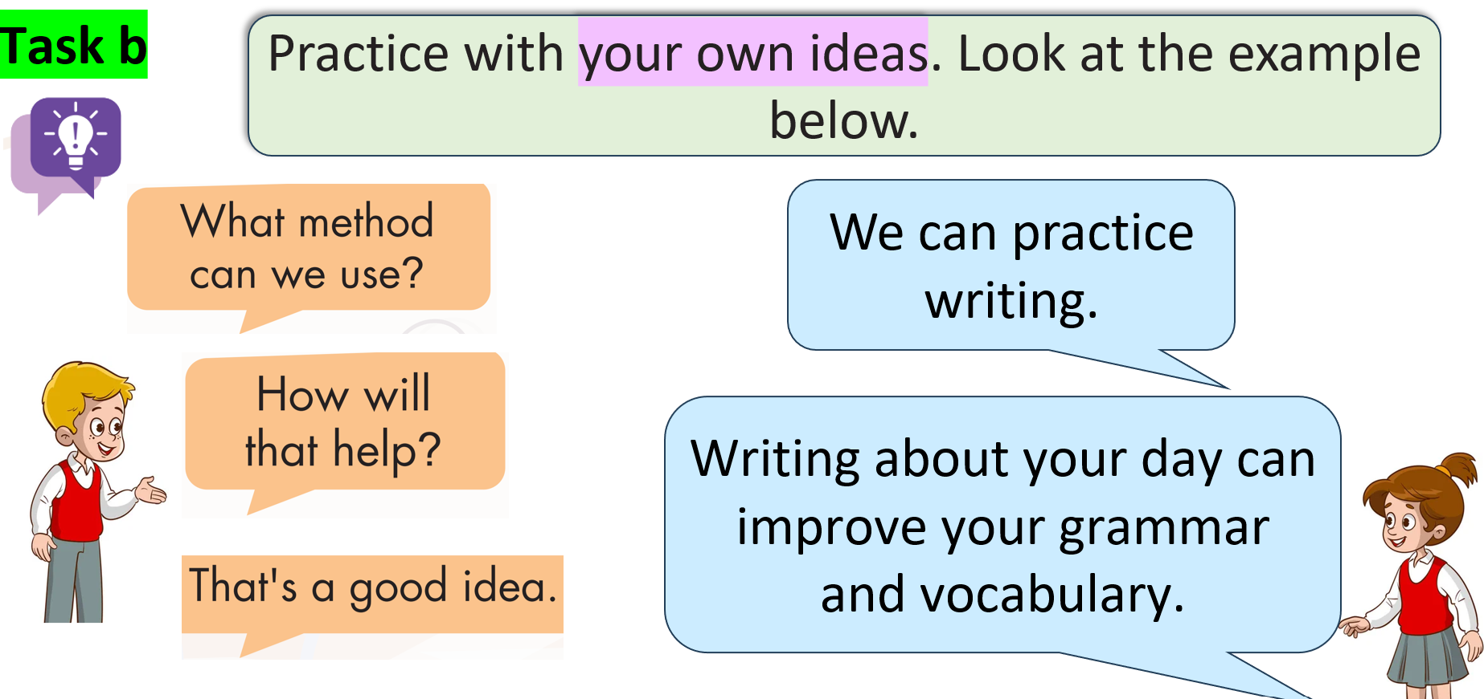

3. Speaking (10’)
a. Objectives: To help Ss further practice stressing content words to discuss some different study methods.
b. Content: Tasks a and b.
c. Expected outcomes: Ss can discuss their own study methods with content words stressed.
d. Organization
Teacher’s activities | Students’ activities
Task a: In pairs: Look at the pictures of fun ways to learn English. Say what the activities are and discuss the purpose of the study methods below and your own ideas.    - Ask Ss to work in pairs and discuss the new study methods.  - Monitor the class and help them if necessary.  - Elicit answers from some students. | - Work in pairs to share their ideas.  - Share their ideas with the class.  Suggested answers:  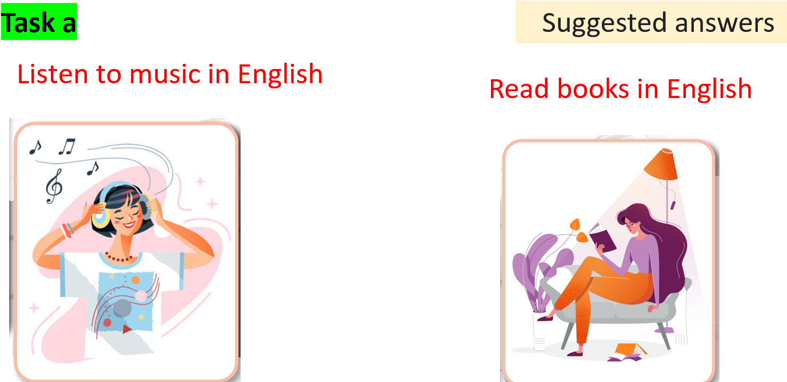  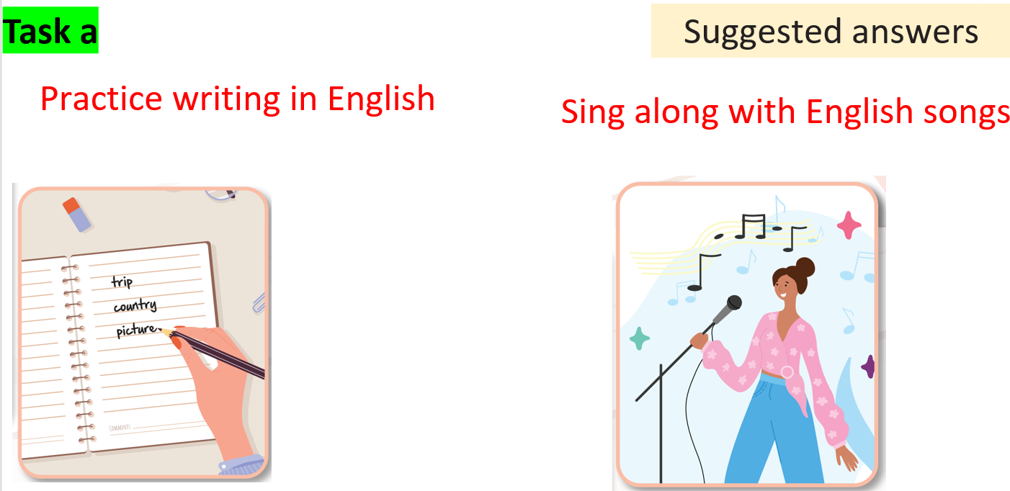
Task b: Now, join another pair and tell them about your favorite fun study method.  - Ask Ss to work in pairs and discuss the new study methods.  - Monitor the class and help them if necessary.  - Elicit answers from some students. | - Discuss in pairs.  - Share their ideas with the class.  Suggested answer:  Our favorite fun study method is creating comic strips to tell a short story.

C. Consolidation and homework assignments (5’)
Practice saying these sentences by stressing the underlined words.
I read a lot of books to improve my vocabulary.
I watch lots of movies to learn new words.
- Practice saying sentences in the Pronunciation (SB) by stressing content words.
- Prepare for the next lesson (Vocabulary & Listening - pages 8 & 9 - SB).
- Play the consolidation games on www.eduhome.com.vn

5. Reflection
a. What I liked most about this lesson today:
…………………………………………………………………………………………
b. What I learned from this lesson today:
…………………………………………………………………………………………
c. What I should improve for this lesson next time:
…………………………………………………………………………………………

