School: ……………………………………….. | Date:……………………………………..
Class: ……………………………..................... | Period: ………………………………….

UNIT 1: ENGLISH IN THE WORLD
Lesson 1: Vocabulary and Reading (Pages 4 & 5)

1. Objectives
By the end of this lesson, students will be able to…
1.1. Language knowledge/ skills
- learn and use phrasal verbs/words for different ways to learn English.
- practice reading for details: Study methods.
- present their ideas about Study Methods.
- improve reading skills.
1.2. Competences
- improve Ss’ communication, collaboration, analytical, and critical thinking skills.
1.3. Attributes
- cultivate a heightened curiosity for diverse learning methodologies.
2. Teaching aids and materials
- Teacher’s aids: Student’s book and Teacher’s book, class CDs, DCR– Phần mềm tương tác trực quan, DHA – Ứng dụng trò chơi tương tác, projector / interactive whiteboard /TV (if any), PowerPoint slides.
- Students’ aids: Student’s book, Workbook, Notebook.
3. Assessment Evidence
Performance Tasks | Performance Products | Assessment Tools
- Match words to the definitions.  - Talk about different ways of reading, watching, or listening to English.  - Read the text and choose the best answer.  - Read the text and fill in the blanks.  - Say which English methods (in the text) you want to try. | - Ss’ answers.  - Ss’ answers/ presentation.  - Ss’ answers.  - Ss’ answers.  - Ss’ answers/presentation. | - Observation and feedback.  - Observation and feedback.  - Observation and feedback.  - Observation and feedback.  - Observation and feedback.
4. Procedures
A. Warm-up: 5 minutes
a. Objectives: to introduce the topic.
b. Content: Let’s talk.
c. Expected outcomes: Ss can talk about different English learning methods based on the title and the picture.
d. Organization
Teacher’s activities | Students’ activities
Let’s talk: Look at the title of the unit and the picture. What are these people doing to improve their English? What do you do to improve your English in your free time?  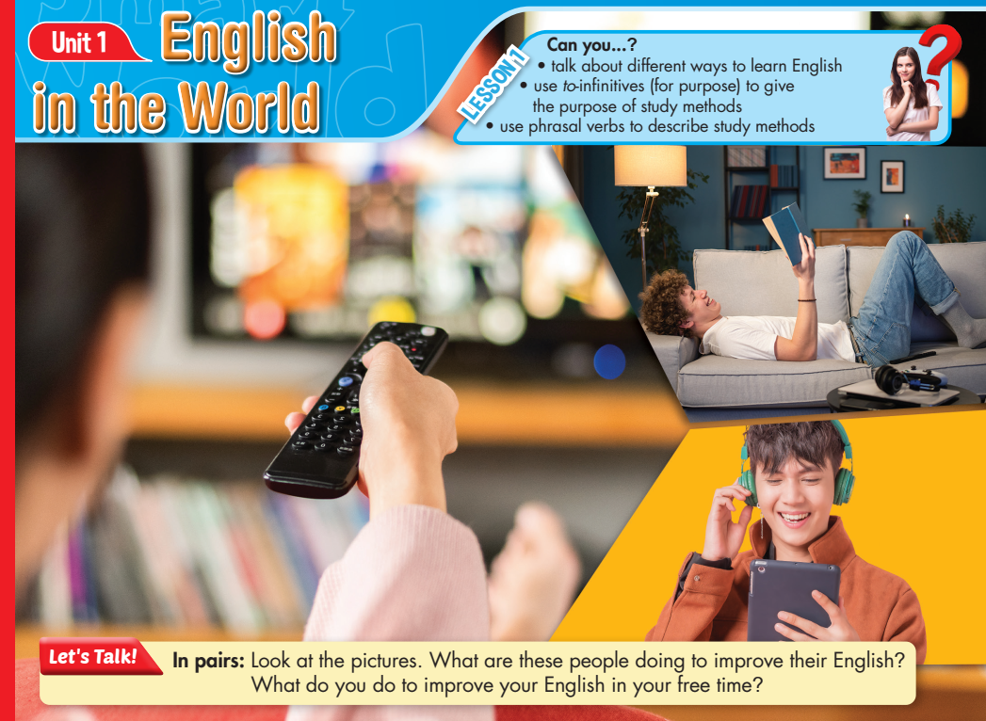  - Ask Ss to work in pairs, look at the title and the picture, and answer the questions (using the DCR/ PPTs slides).  - Call some pairs to give their answers.  - Give feedback. | - Work in pairs, look at the title and the picture and answer the questions.  - Share/exchange the answers with the class.  Answer Keys  - Reading books in English  - Listening to English music  - Watching TV or movies in English  Ss’ answers

B. New Lesson (35’)
1. Pre-Reading (Vocabulary - 15’)
a. Objectives: To help Ss improve their phrasal verbs/new words about the topic: different English study methods.
b. Content: tasks a and b.
c. Expected outcomes: Ss can learn some new phrasal verbs/words to talk about different study methods.
d. Organization
Teacher’s activities | Students’ activities
Task a: Match the words to the definitions. Listen and repeat.  - Ask Ss to work by themselves and match the words (using the DCR/ PPTs slides).  - Ask Ss to compare the answers with a partner.  - Check Ss’ answers around the class.  - Ask Ss to listen and repeat. | - Match the words to the definitions.  - Check the answers with a partner.  - Listen and repeat.  Answer Keys:  1. turn on  2. method  3. look up  4. come across  5. go over  6. note down  7. subtitles  8. lyrics
Task b: In pairs: Use the new words to talk about the ways you read, watch, or listen to English.  - Explain and model the activity.  - Ask Ss to work in pairs, sharing their ideas about their English learning methods.  - Check Ss’ answers around the class.  -Pick some Ss to talk about their partner. | - Listen to the instructions.  - Work in pairs, sharing the ideas.  - Share the ideas with the whole class.  Suggested answers:  1. I turn on my computer to watch English videos.  2. My favorite method of learning English is through reading books.  3. When I don't understand a word, I look it up in the dictionary.  4. While browsing the internet, I come across interesting English articles.  5. I go over my English notes before exams to review the information.  6. During English class, I note down important points in my notebook.  7. When watching movies, I like to use subtitles to understand better.  8. I enjoy listening to English songs and often read the lyrics to improve my vocabulary.

2. While Reading (Reading – 15’)
a. Objectives: To help Ss read for details.
b. Content: Tasks a, b, and c.
c. Expected outcomes: Ss can read for specific information and know some new methods of learning English.
d. Organization:
Teacher’s activities | Students’ activities
Task a: Read the online article about English study methods. What is the passage mainly about?  1. writing good texts 2. taking difficult exams 3. learning in fun ways  - Ask Ss to read the passages and choose the correct answer.  - Ask Ss to compare the answer with a partner and show the evidence to justify the answer.  - Check Ss’ answers. | - Read the passages, underline the evidence, and circle the correct answer.  - Compare the answer with a partner and show the evidence to justify the answer.  Answer Key: number 3  Evidence: You already know learning English is useful, but do you know there are fun ways to learn?
Task b: Now, read and fill in the blanks.  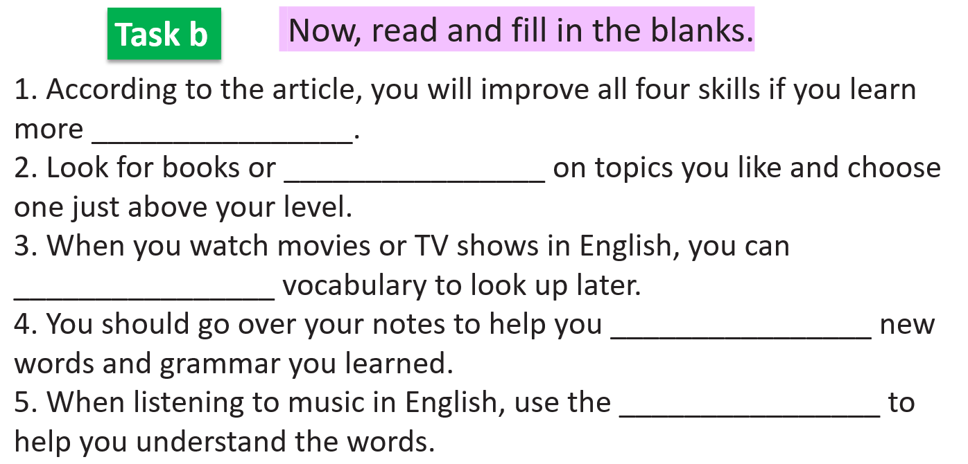  - Ask Ss to read the sentences and fill in the blanks.  - Set the time and monitor the class.  - Ask Ss to check the answers with a partner.  - Check Ss’ answers (using the DCR). | - Read the text and fill in the blanks.  - Compare the answer with a partner.  Answer Keys  1. vocabulary  2. websites  3. note down  4. remember  5. lyrics
Task c: Listen and read.  - Play the CD and ask Ss to listen and read along.  - Pick four Ss to read the four learning methods aloud and correct their pronunciation if necessary. | - Listen and read along.

3. Post-reading (5’)
a. Objectives: To help Ss broaden their methods of learning English.
b. Content: Four different learning methods from the text.
c. Expected outcomes: Ss can pick up the English study method(s) they want to try.
d. Organization
Teacher’s activities | Students’ activities
Pair work: Which English study methods do you want to try? Why?  - Ask Ss to ask and answer the question in pairs.  - Monitor the class and help them if necessary.  - Elicit answers from some students. | - Work in pairs to share their ideas.  - Share their ideas with the class.

C. Consolidation and homework assignments (5’)
- Vocabulary:
1. turn on 2. method 3. look up 4. come across 5. go over
6. note down 7. subtitles 8. lyrics

- Review phrasal verbs/words to describe study methods.
- Make sentences using the phrasal verbs in SB.
- Prepare for the next lesson (Grammar - pages 5 & 6 - SB).
- Play the consolidation games on www.eduhome.com.vn
5. Reflection

a. What I liked most about this lesson today:
…………………………………………………………………………………………
b. What I learned from this lesson today:
…………………………………………………………………………………………
c. What I should improve for this lesson next time:
…………………………………………………………………………………………

