School: ……………………………………….. | Date:……………………………………..
Class: ……………………………..................... | Period: ………………………………….

UNIT 8: Jobs in the future
Lesson 3.1: Reading (Page 82)

1. Objectives
By the end of this lesson, students will be able to…
1.1. Language knowledge/ skills
- learn vocabulary related to jobs in the future.
- practice reading for main ideas and specific information.
1.2. Competences
- improve Ss’ communication, collaboration, analytical, and critical thinking skills.
1.3. Attributes
- cultivate a heightened curiosity for diverse learning methodologies.

2. Teaching aids and materials
- Teacher’s aids: Student’s book and Teacher’s book, class CDs, DCR– Phần mềm tương tác trực quan, DHA – Ứng dụng trò chơi tương tác, projector / interactive whiteboard /TV (if any), PowerPoint slides.
- Students’ aids: Student’s book, Workbook, Notebook.
3. Assessment Evidence
Performance Tasks | Performance Products | Assessment Tools
- Read the article and choose the best title | - Ss’ answers. | - Observation/feedback.
- Read and choose the correct answers. | - Ss’ answers. | - Observation/feedback.
- Listen and read. | - Ss’ answers. | - Observation/feedback.
- Talk about the most important job in the article. | - Ss’ answers. | - Observation/feedback.

4. Procedures
A. Warm-up: 5 minutes
a. Objectives: to introduce the topic.
b. Content: Let’s talk.
c. Expected outcomes: Ss can talk about what things robots will do in the future.
d. Organization

Teacher’s activities | Students’ activities
Let’s talk: Look at the title of the unit and the picture. Answer these questions:
1. What is the robot doing?
2. What things do you think robots will do in the future?
3. What won't they be able to do?
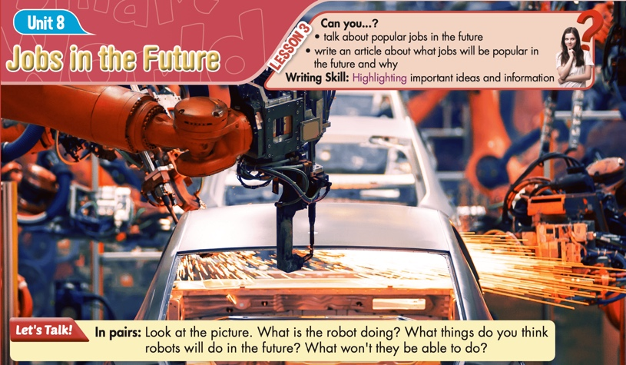
- Ask Ss to work in pairs, look at the title and the picture, and answer the questions (using the DCR/ PPTs slides). | - Work in pairs, look at the title and the picture and answer the questions
- Call some pairs to give their answers. | - Read the answers out loud.
- Give feedback. | - Share/exchange the answers with the class.
Suggested answers
1. What is the robot doing?
The robot is fixing the car.
2. What things do you think robots will do in the future?
I think in the future, robots might do many tasks like cleaning, cooking, and helping with daily chores.
3. What won't they be able to do?
I think they won’t be able to think creatively or feel emotions like humans do.

B. New Lesson (35’)
1. Pre-reading (Vocabulary - 10’)
a. Objectives: To help Ss improve their new words related to jobs in the future.
b. Content: new words from the text
c. Expected outcomes: Ss can learn some new words related to jobs in the future.
d. Organization

Teacher’s activities | Students’ activities
Task: In pairs: Use the new words to talk about jobs in the future.
- Ask Ss to look at the new words on the slides. | - Look at the new words on the slides.
- Explain and model the activity. | - Listen to the instructions.
- Ask Ss to work in pairs, sharing their ideas about childhood memories | - Work in pairs, sharing the ideas.
- Check Ss’ answers around the class. | - Listen to feedback.
-Pick some Ss to share their ideas. | - Share the ideas with the whole class.
New words:  1. faraway (adj)  2. highlight (v)  3. manual (adj)  4. planet (n)  5. surgery (n)  6. vaccine (n) | Suggested answers:  - Some jobs in the future might involve traveling to faraway places, like exploring new planets.  - Robots could highlight important information for doctors during surgeries.  - Manual jobs, like assembling products, might be done by robots in the future.  - Scientists might study distant planets for potential job opportunities.  - Surgeons might use advanced technology to perform surgery more accurately.  - Developing a vaccine for new diseases could become an essential job in the future

2. While - reading (Reading- 20)
a. Objectives: To help Ss practice reading for main ideas and specific information.
b. Content: Tasks a, b, and c.
c. Expected outcomes: Ss can read for reading for main ideas and specific information.
d. Organization:
Teacher’s activities | Students’ activities
Task a: Read the article. What is the best title?
1. Future of Work: Three New Jobs You Need to Know
2. Top Jobs of the Future
- Ask Ss to read the questions and underline the key words | - Read the questions and underline the key words.
- Ask Ss to read the text and choose the correct answer. | - Read the text, underline the evidence, and circle the correct answer.
- Ask Ss to compare the answer with a partner and show the evidence to justify the answer. | - Compare the answer with a partner and show the evidence to justify the answer.
-Check the answers. | -Correct the answers.
Answer Key:
2. Top Jobs of the Future
Evidence:
The most popular jobs around the world may not always be so popular. Some jobs will become very important in the future, while others may disappear all together. Here are three jobs that I think will be very popular in the future.
Task b: Now, read and choose the correct answers.
- Ask Ss to read the questions and underline the key words | - Read the questions and underline the key words.
-Ask students to read the article again and choose the correct answers. | - Read the article again and choose the correct answers.
- Ask Ss to check the answers with a partner. | - Compare the answer with a partner and show the evidence to justify the answer.
- Check Ss’ answers | -Correct the answers.
Answer Keys
1. B
2. D
3. A
4. C
5. B

ANSWERS | EVIDENCE
1. What will astronauts explore?  A. the moon  B. Mars  C. space  D. the sun | One job that will become more popular is being an astronaut. I think we will want to travel to and explore faraway planets someday, in particular Mars. For this reason, we will need more astronauts.
2. Which of the following can you infer from paragraph 3?  A. Scientists aren't very important now.  B. We have cured most of the illnesses now.  C. Medicines now won't be useful.  D. There will be new illnesses in the future. | Another job that I believe will become more important is being a scientist. In my opinion, we will need new kinds of medicines and vaccines to protect people from new illnesses
3. The word this in paragraph 3 refers to ____.  A. the need for medicines  B. old vaccines  C. a medical scientist  D. a new illness | In my opinion, we will need new kinds of medicines and vaccines to protect people from new illnesses. Because of this, being a scientist, mainly a medical scientist, will become more popular.
4. Where will people spend a lot of time in the future?  A. in university  B. on Mars  C. in virtual reality  D. in meetings | Virtual reality designers will also be a popular job. I believe we will spend a lot more time in virtual reality. We will do lots of things in it, especially practicing surgery, doing experiments, and having meetings. As a result, we will need more people to design these virtual spaces.
5. According to paragraph 5, what should young people do?  A. become astronauts, scientists, or virtual reality designers  B. think about the jobs we'll need in the future  C. change jobs when we need people to do different things  D. choose their future careers now | The world is changing, and so are the jobs we need people to do. Young people should think about this when they plan their future careers.

Teacher’s activities | Students’ activities
Task c: Listen and read.
CD2- Track 36
- Play the CD and ask Ss to listen and read along. | - Listen and read along.
- Pick two students to read the reading passage and correct their pronunciation if necessary. | - Practice reading the passage.

3. Post-reading (5’)
a. Objectives: To help Ss practice talking about the most important job in the article.
b. Content: Tasks d
c. Expected outcomes: Ss can talk about the most important job in the article.
d. Organization
Teacher’s activities | Students’ activities
Task d: In pairs: Which do you think is the most important job in the article? Why?
- Divide the class into pairs. | - Work in pairs.
- Ask Ss to discuss the questions. | - Discuss the questions.
- Check Ss’ answers and give feedback. | - Listen to feedback.
Suggested answer:
The most important job in the article is a scientist. The author believes new medicines and vaccines will be needed to protect people from future illnesses, making scientists, especially medical scientists, crucial.
C. Consolidation and homework assignments (5’)
- Speaking: Ask and answer the question below with your partner about jobs in the future
How will robots assist in healthcare jobs in the future?
Suggested answers:
I think robots will assist in healthcare by performing surgeries, automating routine tasks, and providing support in patient care.
- Vocabulary:
1. faraway (adj) 2. highlight (v) 3. manual (adj) 4. planet (n) 5. surgery (n) 6. vaccine (n)
HOMEWORK:
- Learn vocabulary related to jobs in the future.
- Make sentences using vocabulary in SB.
- Prepare for the next lesson (Speaking & Writing - Page 83 - SB)
- Play the consolidation games on www.eduhome.com.vn
5. Reflection
a. What I liked most about this lesson today:
…………………………………………………………………………………………
b. What I learned from this lesson today:
…………………………………………………………………………………………
c. What I should improve for this lesson next time:
…………………………………………………………………………………………

