School: ……………………………………….. | Date:……………………………………..
Class: ……………………………..................... | Period: ………………………………….

UNIT 8: Jobs in the future
Lesson 2.1: Vocabulary and Reading (Pages 78 & 79)

1. Objectives
By the end of this lesson, students will be able to…
1.1. Language knowledge/ skills
- Learn and use vocabulary related to jobs in the future.
- Practice reading for main ideas and specific information.
1.2. Competences
- improve Ss’ communication, collaboration, analytical, and critical thinking skills.
1.3. Attributes
- cultivate a heightened curiosity for diverse learning methodologies.

2. Teaching aids and materials
- Teacher’s aids: Student’s book and Teacher’s book, class CDs, DCR– Phần mềm tương tác trực quan, DHA – Ứng dụng trò chơi tương tác, projector / interactive whiteboard /TV (if any), PowerPoint slides.
- Students’ aids: Student’s book, Workbook, Notebook.
3. Assessment Evidence
Performance Tasks | Performance Products | Assessment Tools
- Match the underlined words to the definitions. | - Ss’ answers. | - Observation/feedback.
- Read the article about entertainment and media. | - Ss’ answers. | - Observation/feedback.
- Read and answer the questions. | - Ss’ answers. | - Observation/feedback.
- Listen and read. | - Ss’ answers. | - Observation/feedback.
- Discuss if they agree with the writer's opinions about the future of entertainment and media | - Ss’ answers. | - Observation/feedback.

4. Procedures
A. Warm-up: 5 minutes
a. Objectives: to introduce the topic.
b. Content: Let’s talk.
c. Expected outcomes: Ss can talk about different kinds of entertainment and media jobs in the future
d. Organization

Teacher’s activities | Students’ activities
Let’s talk: Look at the title of the unit and the picture. Answer these questions:
1. What are the people in the picture doing?
2. What jobs can create an experience like in the picture above?
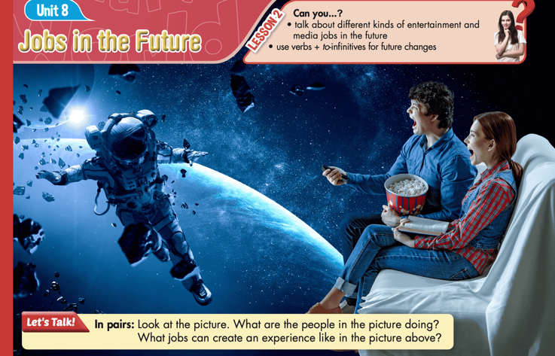
- Ask Ss to work in pairs, look at the title and the picture, and answer the questions (using the DCR/ PPTs slides). | - Work in pairs, look at the title and the picture and answer the questions
- Call some pairs to give their answers. | - Read the answers out loud.
- Give feedback. | - Listen to feedback.
Suggested answers
1. What are the people in the picture doing?
They are watching a virtual reality film about astronauts.
2. What jobs can create an experience like in the picture above?
Jobs that can create a similar experience include virtual reality developers, filmmakers, astronauts, or educators in space science.

B. New Lesson (35’)
1. Pre-reading (Vocabulary - 15’)
a. Objectives: To help Ss improve their new words related to jobs in the future.
b. Content: tasks a and b.
c. Expected outcomes: Ss can learn some new words related to jobs in the future.
d. Organization

Teacher’s activities | Students’ activities
Task a: Read the sentences, then match the underlined words to the definitions. Listen and repeat.
CD2-Track 31
- Demonstrate the activity using the example. | -Watch the demonstration.
- Ask Ss to work by themselves and match the  underlined words to the definitions. (using the DCR/ PPTs slides). | - Match the words to the definitions.
- Ask Ss to compare the answers with a partner. | - Check the answers with a partner.
- Check Ss’ answers around the class. | - Listen to feedback.
- Play audio. Ask Ss to listen and repeat. | - Listen and repeat.
CD2-Track 31- SCRIPT  1. M: innovation  2. M: media  3. M: producer  4. M: audience  5. M: personalized  6. M: virtual reality  7. M: podcast  8. M: demand | Answer Keys:  1. innovation  2. media  3. producer  4. Audience  5. personalized  6. virtual reality  7. podcast  8. demand
Task b. In pairs: Use the new words to talk about digital media you read, watch, or listen to, and jobs related to media.
- Explain and model the activity. | - Listen to the instructions.
- Ask pairs to discuss digital media they read, watch, or listen to, and jobs related to media using the new words. | - Work in pairs and share the ideas.
- Check Ss’ answers around the class. | - Listen to feedback.
-Pick some Ss to share their ideas. | - Share the ideas with the whole class.
New words:  1. innovation  2. media  3. producer  4. audience  5. personalized  6. virtual reality  7. podcast  8. demand | Suggested answers:  - New technology brings innovation to how we watch shows.  - Book writers and journalists are jobs related to media.  - A producer pays for movies and TV shows to be made.  - The audience eagerly waits for new episodes of their favorite series.  - I like to watch virtual reality movies.  - Streaming services offer personalized recommendations.  - Many people enjoy listening to podcasts about different topics on their way to work.  - There is high demand for new and exciting media content

2. While - reading (Reading – 15’)
a. Objectives: To help Ss practice reading for main ideas and specific information.
b. Content: Tasks a, b, and c.
c. Expected outcomes: Ss can read for main ideas and specific information.
d. Organization:

Teacher’s activities | Students’ activities
Task a: Read the article about entertainment and media. What's it mainly about?
1. why the media business will be very different
2. how technology will affect jobs in the media

- Ask Ss to read the questions and underline the key words | - Read the questions and underline the key words.
- Ask Ss to read the article and choose the correct answer. | - Read the article, underline the evidence, and circle the correct answer.
- Ask Ss to compare the answer with a partner and show the evidence to justify the answer. | - Compare the answer with a partner and show the evidence to justify the answer.
-Check the answers. | -Correct the answers.
Answer Key:
2. how technology will affect jobs in the media
Evidence:
If you read articles about popular jobs in the future, you will see that new innovations will play an important role in almost every field, including the media business. Here is what we think you can expect to see in the future of entertainment and media jobs.

Task b: Now, read and answer the questions.
- Ask Ss to read the questions and underline the key words | - Read the questions and underline the key words.
-Ask students to read the article again and answer the questions. | - Read the article again and answer the questions.
- Ask Ss to check the answers with a partner. | - Compare the answer with a partner and show the evidence to justify the answer.
- Check Ss’ answers (using the DCR). | - Correct the answers.
Answer Keys
1. new innovations
2. VR content
3. exactly what their audience wants
4. job opportunities in media
5. podcasts and videos
ANSWERS | EVIDENCE
1. What will play an important role in most businesses in the future?  - new innovations | If you read articles about popular jobs in the future, you will see that new innovations will play an important role in almost every field, including the media business. Here is what we think you can expect to see in the future of entertainment and media jobs.
2. What content will there be high demand for?  - VR content | Virtual reality (VR) will be everywhere. It is already common in video games, and some museums and amusement parks have virtual experiences.
3. What will newer technology let producers know?  - exactly what their audience wants | Personalized content will be the new normal. Newer technology will let producers know exactly what their audience wants.
4. What do we expect data scientists to have more of in the future?  - job opportunities in media | To do that, companies and producers will need lots of data. We expect to see more job opportunities in media for data scientists.
5. Which two types of content are mentioned to attract an audience?  - podcasts and videos | Everyone will be a producer. We are already seeing it today: anyone can put content online, whether it is a podcast or video, and attract an audience. Technology will make this even easier

Teacher’s activities | Students’ activities
Task c: Listen and read.
CD2- Track 32
- Play the CD and ask Ss to listen and read along. | - Listen and read along.
- Pick some students to read some parts of the article and correct their pronunciation if necessary.  CD2- Track 32- SCRIPT  If you read articles about popular jobs in the future, you will see that new innovations will play an important role in almost every field, including the media business. Here is what we think you can expect to see in the future of entertainment and media jobs.  Virtual reality (VR) will be everywhere. It is already common in video games, and some museums and amusement parks have virtual experiences. In the future, you can expect to attend a virtual concert or play virtual soccer. This means virtual reality designers will be a job of the future.  Personalized content will be the new normal. Newer technology will let producers know exactly what their audience wants. To do that, companies and producers will need lots of data. We expect to see more job opportunities in media for data scientists.  Everyone will be a producer. We are already seeing it today: anyone can put content online, whether it is a podcast or video, and attract an audience. Technology will make this even easier. And as people start creating more professional content, the demand for good content writers and producers will rise.  The world of work in media will keep changing. Can you keep up? | - Read some parts of the article and listen to some feedback.

3. Post-reading (5’)
a. Objectives: To help Ss discuss the future of entertainment and media
b. Content: Tasks d
c. Expected outcomes: Ss can talk about the future of entertainment and media
d. Organization

Teacher’s activities | Students’ activities
Task d: In pairs: Do you agree with the writer's opinions about the future of entertainment and media? What changes do you think we will see?
- Divide the class into pairs. | - Work in pairs.
- Ask Ss to discuss the questions. | - Discuss the questions.
- Check Ss’ answers and give feedback. | - Listen to feedback.
Suggested answer:
Yes, I agree with the writer. We will see more virtual reality experiences, personalized content, and more jobs for data scientists. More people will create their own content, increasing the demand for writers and producers

C. Consolidation and homework assignments (5’)
- Speaking: Ask and answer the question below with your partner about the future of entertainment and media :
What are some examples of virtual reality experiences you have heard about?
Suggested answers:

Some examples of virtual reality experiences are virtual concerts, virtual museums, and virtual sports games.

Vocabulary
1. Innovation
2. Personalized
3. Producer
4. Podcast
5. Demand
6. Virtual reality
7. Media
8. Audience
HOMEWORK:
- Learn vocabulary related to jobs in the future.
- Make sentences using vocabularies in SB.
- Prepare for the next lesson (Grammar - pages 79 & 80 - SB)
- Play the consolidation games on www.eduhome.com.vn
5. Reflection
a. What I liked most about this lesson today:
…………………………………………………………………………………………
b. What I learned from this lesson today:
…………………………………………………………………………………………
c. What I should improve for this lesson next time:
…………………………………………………………………………………………

