School: ……………………………………….. | Date:……………………………………..
Class: ……………………………..................... | Period: ………………………………….

UNIT 8: Jobs in the future
Lesson 1.1: Vocabulary and Listening (Pages 74 & 75)

1. Objectives
By the end of this lesson, students will be able to…
1.1. Language knowledge/ skills
- Learn and use vocabulary related to jobs in the future.
- Practice listening for specific information.
- Practice functional English – Showing thanks.
1.2. Competences
- improve Ss’ communication, collaboration, analytical, and critical thinking skills.
1.3. Attributes
- cultivate a heightened curiosity for diverse learning methodologies.
2. Teaching aids and materials
- Teacher’s aids: Student’s book and Teacher’s book, class CDs, DCR– Phần mềm tương tác trực quan, DHA – Ứng dụng trò chơi tương tác, projector / interactive whiteboard /TV (if any), PowerPoint slides.
- Students’ aids: Student’s book, Workbook, Notebook.
3. Assessment Evidence
Performance Tasks | Performance Products | Assessment Tools
- Read the words and definitions, then fill in the blanks. | - Ss’ answers. | - Observation/feedback.
- Listen and repeat. | - Ss’ answers. | - Observation/feedback.
- Talk about which jobs you think are interesting and why. | - Ss’ answers. | - Observation/feedback.
- Listen to a teacher and a student talking about future jobs and choose the correct answers | - Ss’ answers. | - Observation/feedback.
- Listen and answer the questions. | - Ss’ answers. | - Observation/feedback
- Read the Conversation Skill box, then listen and repeat. | - Ss’ answers. | - Observation/feedback.
- Listen to the conversation again and number the phrases in the correct order. | - Ss’ answers. | - Observation/feedback.

4. Procedures
A. Warm-up: 5 minutes
a. Objectives: to introduce the topic.
b. Content: Let’s talk.
c. Expected outcomes: Ss can talk about skills they need to be good at to get the jobs in the picture.
d. Organization

Teacher’s activities | Students’ activities
Let’s talk: Look at the title of the unit and the picture. Answer these questions:
1. What jobs can you see?
2. Which skills do you need to be good at to get these jobs?
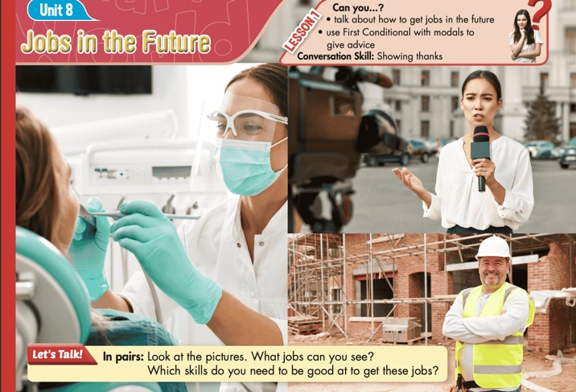
- Ask Ss to work in pairs, look at the title and the picture, and answer the questions (using the DCR/ PPTs slides). | - Work in pairs, look at the title and the picture and answer the questions.
- Call some pairs to give their answers. | - Read the answers out loud.
- Give feedback. | - Share/exchange the answers with the class.
Suggested answers
1. What jobs can you see?
I can see a dentist, a construction worker and a reporter.
2. Which skills do you need to be good at to get these jobs?
- To be a dentist, you need skills in dental care, precision, communication, and patience.
- To be a construction worker, you need skills in physical strength, teamwork, problem-solving, and safety awareness.
- To be a reporter, you need skills in writing, research, interviewing, and communication.

B. New Lesson (35’)
1. Pre-listening (Vocabulary - 15’)
a. Objectives: To help Ss improve their collocations/ new words related to jobs in the future.
b. Content: tasks a and b.
c. Expected outcomes: Ss can learn some new collocations/ new words related to jobs in the future.
d. Organization
Teacher’s activities | Students’ activities
Task a: Read the words and definitions, then fill in the blanks. Listen and repeat.
CD2-Track 25
- Demonstrate the activity using the example. | -Watch the demonstration.
- Ask Ss to read the words and definitions, then fill in the blanks. | - Read the words and definitions, then fill in the blanks.
- Divide the class into pairs and ask Ss to compare the answers with a partner. | - Work in pairs to check their answers with their partners.
- Check Ss’ answers around the class. | - Listen to feedback.
- Play audio. Ask Ss to listen and repeat. | - Listen and repeat.
CD2-Track 25  SCRIPT  1. M: psychologist  2. M: skincare specialist  3. M: mechanic  4. M: tutor  5. M: research  6. M: apprenticeship  7. M: plumber | Answer Keys:  1. psychologist  2. skincare specialist  3. mechanic  4. tutor  5. research  6. apprenticeship  7. plumber
Task b: In pairs: Use the new words to talk about which jobs you think are interesting and why.
- Explain and model the activity. | - Listen to the instructions.
- Ask Ss to work in pairs, sharing their ideas about family or people they know | - Work in pairs, sharing the ideas.
- Check Ss’ answers around the class. | - Listen to feedback.
-Pick some Ss to share their ideas. | - Share the ideas with the whole class.
New words:  1. psychologist  2. skincare specialist  3. mechanic  4. tutor  5. research  6. apprenticeship  7. plumber | Suggested answers:  - Being a psychologist would be great. I think helping people feel better would be great.  - Being a skincare specialist would be interesting. I love making my face and skin look nice.  - Being a mechanic would be interesting. I like fixing cars and making them run well.  - I think I'd find being a tutor interesting. I like helping people understand things better.  - Doing research would be interesting. I like finding out new things and learning more.  - Doing an apprenticeship would be interesting. I can learn a job by working with someone skilled.  - Being a plumber would be interesting. I enjoy solving problems and fixing things in houses.

2. While - listening (Listening- 15’)
a. Objectives: To help Ss listen for specific information.
b. Content: Tasks a, b, c and d.
c. Expected outcomes: Ss can listen for specific information.
d. Organization:
Teacher’s activities | Students’ activities
Task a: Listen to a teacher and a student talking about future jobs. What job does the teacher imply would be a better choice for the student?
CD2- Track 26
1. a psychologist
2. a mechanic
3. both jobs equally
- Ask Ss to read the questions and underline the key words | - Read the questions and underline the key words.
- Play audio. Ask students to listen and circle the correct answer. | - listen and circle the correct answer.
- Ask Ss to compare the answer with a partner and show the evidence to justify the answer. | - Compare the answer with a partner and show the evidence to justify the answer.
- Check the answers. | -Correct the answers.
Answer Key:
2. a mechanic
Evidence:
W: You could also start researching mental illnesses. There's a lot to learn.
B: That's a really good idea. Thanks. How about being a mechanic?
W: If you want to be a mechanic, you should find a good apprenticeship. I think you'll find that quite easy.
B: Yeah, OK.
Task b: Now, listen and answer the questions.
CD2- Track 26
- Ask Ss to read the questions, and underline the key words. | - Read the questions, and underline the key words.
- Demonstrate the activity using the example. | - Watch the demonstration.
- Play audio. Have students listen and fill in the blanks. | - listen and fill in the blanks.
- Ask Ss to compare the answer with a partner and show the evidence to justify the answer. | - Compare the answer with a partner and show the evidence to justify the answer.
- Check the answers. | - Correct the answers.
CD2- Track 26- SCRIPT  W: Hello, Paul.  B: Hi, Miss White. Thanks for helping me. I appreciate it.  W: You're welcome. So, what jobs are you interested in?  B: I think a psychologist and maybe a mechanic. I love cars and motorbikes, and mental health is interesting.  W: OK. Do you know what you need to do to get those jobs?  B: No, not really.  W: Well, if you want to be a psychologist, you should start to study harder.  B: I see.  W: You have to get really good grades. I think it will be difficult.  B: Yeah, I know that. Is there anything I can do?  W: Well, if you want to get better grades, you should get a tutor. And you can't keep staying up all night playing video games.  B: I know. I know.  W: You could also start researching mental illnesses. There's a lot to learn.  B: That's a really good idea. Thanks. How about being a mechanic?  W: If you want to be a mechanic, you should find a good apprenticeship. I think you'll find that quite easy.  B: Yeah, OK.  W: You could also go to car shows and meet other mechanics. You could learn a lot about cars and motorbikes there.  B: OK.  W: You should also start researching apprenticeships and the different tools you might use.  B: Great. Thank you so much, Miss White. | Answer key:  1. He loves cars and motorbikes.  2. start to study harder  3. get a tutor  4. a good apprenticeship  5. apprenticeships and the different tools he might use
ANSWERS | EVIDENCE
1. Why does Paul want to be a mechanic?  - He loves cars and motorbikes. | W: Hello, Paul.  B: Hi, Miss White. Thanks for helping me. I appreciate it.  W: You're welcome. So, what jobs are you interested in?  B: I think a psychologist and maybe a mechanic. I love cars and motorbikes, and mental health is interesting.
2. What should Paul do if he wants to be a psychologist?  - start to study harder | W: OK. Do you know what you need to do to get those jobs?  B: No, not really.  W: Well, if you want to be a psychologist, you should start to study harder.  B: I see.
3. What does the teacher suggest Paul do to improve his grades?  - get a tutor | W: You have to get really good grades. I think it will be difficult.  B: Yeah, I know that. Is there anything I can do?  W: Well, if you want to get better grades, you should get a tutor. And you can't keep staying up all night playing video games.  B: I know. I know.
4. What should Paul find if he wants to be a mechanic?  - a good apprenticeship | W: You could also start researching mental illnesses. There's a lot to learn.  B: That's a really good idea. Thanks. How about being a mechanic?  W: If you want to be a mechanic, you should find a good apprenticeship. I think you'll find that quite easy.  B: Yeah, OK.
5. What should he start researching about?  - apprenticeships and the different tools he might use | W: You could also go to car shows and meet other mechanics. You could learn a lot about cars and motorbikes there.  B: OK.  W: You should also start researching apprenticeships and the different tools you might use.  B: Great. Thank you so much, Miss White.

Teacher’s activities | Students’ activities
Task c. Read the Conversation Skill box, then listen and repeat.
CD2- Track 27
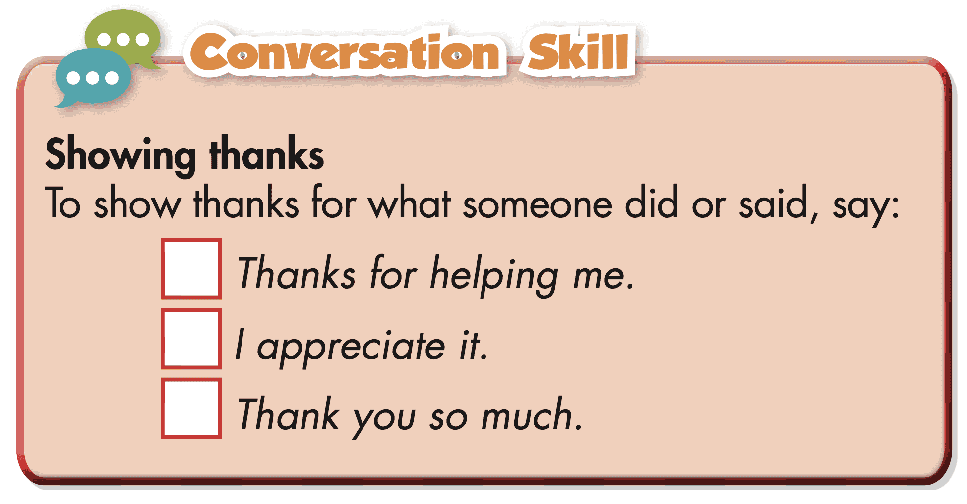
- Have students read the Conversation Skill box. | - Read the Conversation Skill box
- Clarify the use of the conversation skill. | - Listen to instructions.
- Play audio. Have students listen and repeat.  CD2-Track 27- SCRIPT  M: Thanks for helping me.  M: I appreciate it.  M: Thank you so much. | - Listen and repeat.
Task d. Now, listen to the conversation again and number the phrases in the correct order.
CD2- Track 26
-Play audio. Have students listen and number the phrases in the correct order. | - Listen and number the phrases in the correct order.
- Check answers as a whole class. | - Correct answers.
Answer key:
1. Thanks for helping me.
2. I appreciate it.
3. Thank you so much.
Evidence:
W: Hello, Paul.
B: Hi, Miss White. Thanks for helping me. I appreciate it.
……
W: You should also start researching apprenticeships and the different tools you might use.
B: Great. Thank you so much, Miss White.

3. Post - listening (5’)
a. Objectives: To help Ss practice talking about jobs they think they would be better at.
b. Content: Tasks e
c. Expected outcomes: Ss can talk about jobs they think they would be better at.
d. Organization

Teacher’s activities | Students’ activities
Task e: In pairs: Which job do you think you would be better at? Which sounds more interesting? Why?
- Divide the class into pairs. | - Work in pairs.
- Ask Ss to discuss the questions. | - Discuss the questions.
- Check Ss’ answers and give feedback. | - Listen to feedback.
Suggested answer:
- I think I would be better at being a mechanic because I love cars and motorbikes. Being a mechanic sounds more interesting because I enjoy fixing things and working with my hands.

C. Consolidation and homework assignments (5’)
- Speaking: Ask and answer the question below with your partner :
What resources are you using to learn about your future job?
Suggested answers:
I am using books and online courses to learn about my future job.
- Vocabulary:
1. plumber (n)
2. mechanic (n)
3. psychologist (n)
4. skincare specialist (n)
5. tutor (n)
6. apprenticeship (n)
7. research (v)
HOMEWORK:
- Learn vocabulary related to jobs in the future.
- Make sentences using vocabularies in SB.
- Prepare for the next lesson (Grammar - pages 75 & 76 - SB).
- Play the consolidation games on www.eduhome.com.vn
5. Reflection
a. What I liked most about this lesson today:
…………………………………………………………………………………………
b. What I learned from this lesson today:
…………………………………………………………………………………………
c. What I should improve for this lesson next time:
…………………………………………………………………………………………

