School: ……………………………………….. | Date:……………………………………..
Class: ……………………………..................... | Period: ………………………………….

UNIT 7: URBAN LIFE
Lesson 1.3: Pronunciation & Speaking (Pages 66 & 67)

1. Objectives
By the end of this lesson, students will be able to…
1.1. Language knowledge/ skills
- pronounce the /dʒ/ sound.
- talk about problems in a city and solutions to them.
1.2. Competences
- improve Ss’ communication, collaboration, analytical, and critical thinking skills.
1.3. Attributes
- foster Ss’ patience and attention to detail for consistent practice and repetition to reinforce learning and build fluency.
2. Teaching aids and materials
- Teacher’s aids: Student’s book and Teacher’s book, class CDs, DCR– Phần mềm tương tác trực quan, DHA – Ứng dụng trò chơi tương tác, projector / interactive whiteboard /TV (if any), PowerPoint slides.
- Students’ aids: Student’s book, Workbook, Notebook.
3. Assessment Evidence
Performance Tasks | Performance Products | Assessment Tools
- Listen to the words and focus on the underlined letters.  - Listen and circle the words you hear.  - Take turns saying the words.  - Practice the conversation. Swap roles and repeat.  - Make two more conversations using the provided ideas.  - In pairs, talk about problems and solutions. | - Ss’ performance.  - Ss’ answers.  - Ss’ performance.  - Ss’ performance.  - Ss’ answers/presentation.  - Ss’ answers/presentation. | - Observation.  - Observation and feedback.  - Observation and feedback.  - Observation and feedback.  - Observation and feedback.  - Observation and feedback.
4. Procedures
A. Warm-up: 5 minutes
a. Objectives: to introduce the /dʒ/ sound in words.
b. Content: Word guessing game.
c. Expected outcomes: Ss can find out the target words.
d. Organization
Teacher’s activities | Students’ activities
COMPETITION TIME: WORD GUESSING GAME  - Create groups of 5 students.  - Instruct Ss to play the game.  - Demonstrate the game using an example.  - Check the group’s answers.  Example: Teacher says: a thing/structure that connects two places over a gap, like a river, a valley. People or vehicles cross from one side to the other safely.  1. It's the sixth month of the year, usually when summer begins.  2. A place where people go to exercise and stay fit, often equipped with different equipment like weights.  3. Someone who listens to both sides of a story in a court and decides who is right or wrong.  4. A thick and sweet spread made from fruit, often eaten on bread or toast.  5. To give someone support or confidence to do something.  6. Crossing a busy road without looking is …………………..  7. A person who serves in the military and protects their country.  8. To make something different or to replace one thing with another.  9. The part of a machine that uses fuel or electricity to produce power and make things move, like in cars or trains.  10. very large or big in size, like a giant elephant or a massive building. | - Form groups of 5  - Listen to the instructions.  - Work in groups and write the answers.  - Write the answer: bridge  Answer Keys  1. June  2. Gym  3. Judge  4. Jam  5. Encourage  6. Dangerous  7. Soldier  8. Change  9. Engine  10. Huge

B. New Lesson (35’)
1. Pronunciation (15’)
a. Objectives: To help Ss practice stressing content words in a sentence.
b. Content: Tasks a, b, c and d.
c. Expected outcomes: Ss can improve their pronunciation by stressing content words in sentences.
d. Organization
Teacher’s activities | Students’ activities
Task a: Focus on the /dʒ/ sound.  - Explain the combination of the stop sound /d/ as in ‘dog’ and the fricative sound /ʒ/ as in ‘vision’ to make an affricate sound /dʒ/ as in ‘encourage’.  - Explain what an affricate sound is.  ‘An affricate sound is a sound made by stopping the airstream and releasing it with an audible friction.’  - Demonstrate how to pronounce the /dʒ/ sound.  - Have Ss repeat the sound. | - Listen and take notes.  - Listen and repeat the sound.
Task b: Listen to the words and focus on the underlined letters.  - Play the audio. Have Ss listen and notice the /dʒ/ sound.  - Have Ss listen and repeat the words.  Encourage  Traffic jam | - Listen and focus on the underlined letters.  - Listen and repeat the words.
Task c: Listen and circle the words you hear.  - Play the audio. Have Ss listen and circle the words they hear.  - Play the audio again and check answers as a whole class. | - Listen and choose the correct answer.  Answers:  - Jerrry  - Choice  - Joke
Task d: Take turns saying the words in Task c. while your partner points to them.  - Have some students read the words aloud.  - Give some feedback or correction. | - Practice saying the words with a partner.  - Read the words aloud.

2. Practice (10’)
a. Objectives: To help Ss practice some words with the /dʒ/ sound in the conversation.
b. Content: Tasks a and b.
c. Expected outcomes: Ss can pronounce some words with the /dʒ/ sound.
d. Organization:
Teacher’s activities | Students’ activities
Task a: In pairs: Practice the conversation Swap roles and repeat.  - Have Ss practice the conversation in pairs and swap roles.  - Have some pairs demonstrate the conversation in front of the class.  - Give feedback or any correction on their pronunciation. | - Practice the conversation with a partner and swap roles.  - Perform in front of the class.
Task b: Make two more conversations using the ideas on the right.  - Have Ss make two more conversations with other partners.  - Invite two pairs of Ss to perform in front of the class.  - Give feedback or any correction on their pronunciation. | - Make two more conversations with different partners.  - Perform in front of the class.

3. Speaking (10’)
a. Objectives: To help Ss further practice their pronunciation and speaking skills.
b. Content: Tasks a and b.
c. Expected outcomes: Ss can talk about problems and solutions in city life.
d. Organization
Teacher’s activities | Students’ activities
Task a: Choose an event below that you experienced. In pairs: Student A, tell your partner about it.  Talk about the context and what happened, then say if it's a problem in your city and give solutions to it.  Student B, listen and ask questions.  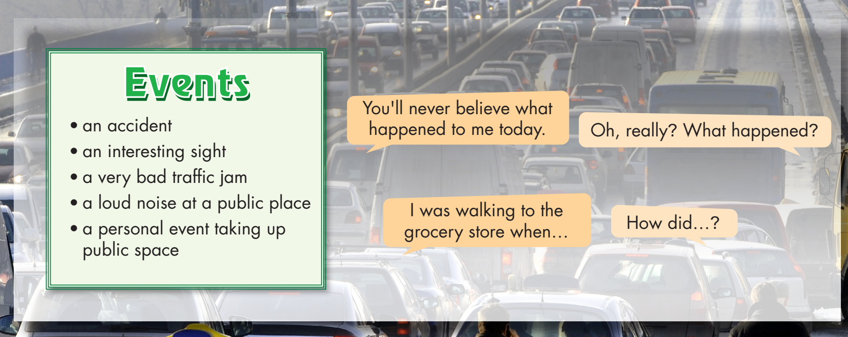  - Have Ss work in pairs and choose an event to talk about.  - Monitor the class and help them if necessary.  - Invite some pairs to perform in front of the class.  - Give feedback to encourage Ss. | - Work in pairs to talk about an event.  - Perform in front of the class.  Suggested answers:  A: You’ll never believe what happened to me today.  B: Oh, really. What happened?  A: I was walking to the grocery when there was a car accident at the intersection.  B: Was anyone hurt?  A: Luckily! no one injured. But there’s quite a bit damage to both cars.  B: How did you feel?  A: It’s scary. I think the city should do something about this intersection.  B: You’re right. Maybe they should reduce the speed limit in this area.
Task b: What other problems does your city have? How can the city fix them?  - Have Ss work with a different partner and discuss other problems in the city and how to fix them.  - Monitor the class and help them if necessary.  - Elicit answers from some students. | - Discuss in pairs.  - Share their ideas with the class.  Suggested answer:  The pollution is bad. I think our city should plant more trees and build more parks.

C. Consolidation and homework assignments (5’)
- Practice the /dʒ/ sound.

1. Encourage
2. June
3. Gym
4. Judge
5. Dangerous
6. Soldier
7. Change
8. Engine
9. Huge
10. Traffic jam

- Do the writing exercise on page 39 - WB
- Prepare for the next lesson (Vocabulary & Listening - pages 68 & 69 - SB).
- Play the consolidation games on www.eduhome.com.vn

5. Reflection
a. What I liked most about this lesson today:
…………………………………………………………………………………………
b. What I learned from this lesson today:
…………………………………………………………………………………………
c. What I should improve for this lesson next time:
…………………………………………………………………………………………

