School: ……………………………………….. | Date:……………………………………..
Class: ……………………………..................... | Period: ………………………………….

UNIT 7: URBAN LIFE
Lesson 2.2: Grammar (Pages 69 & 70)

1. Objectives
By the end of this lesson, students will be able to…
1.1. Language knowledge/ skills
- use adverbial clauses of result in speaking and writing.
1.2. Competences
- improve Ss’ listening and communication, collaboration, analytical, critical thinking skills, and creativity.
1.3. Attributes
- foster Ss’ patience and attention to detail for consistent practice and repetition to reinforce learning and build fluency.
2. Teaching aids and materials
- Teacher’s aids: Student’s book and Teacher’s book, class CDs, DCR– Phần mềm tương tác trực quan, DHA – Ứng dụng trò chơi tương tác, projector / interactive whiteboard /TV (if any), PowerPoint slides.
- Students’ aids: Student’s book, Workbook, Notebook.
3. Assessment Evidence
Performance Tasks | Performance Products | Assessment Tools
- Match sentence endings.  - Read about adverbial clauses of result, then fill in the blanks.  - Listen and check. Listen again and repeat.  - Circle the underlined part that needs correction.  - Rewrite the sentences with adverbial clauses using so…that or such…that.  - In pairs: Use the prompts to talk about problems and predict their future results. | - Ss’ answers/performance.  - Ss’ answers.  - Ss’ performance.  - Ss’ answers.  - Ss’ answers.  - Ss’ answers/presentation. | - Observation and feedback.  - Observation and feedback.  - Observation and feedback.  - Observation and feedback.  - Observation and feedback.  - Observation and feedback.

4. Procedures
A. Warm-up: 5 minutes
a. Objectives: To introduce the grammar points of adverbial clauses of result.
b. Content: Matching sentence beginnings and endings.
c. Expected outcomes: Ss can get to know adverbial clauses of result.
d. Organization
Teacher’s activities | Students’ activities
Competition time:  - Have Ss form groups of 4-5.  - Give the instructions.  - Some groups do numbers 1-4, and the other groups do numbers 5-8  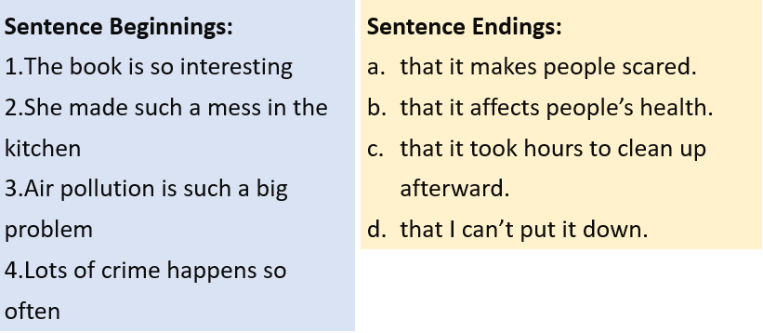  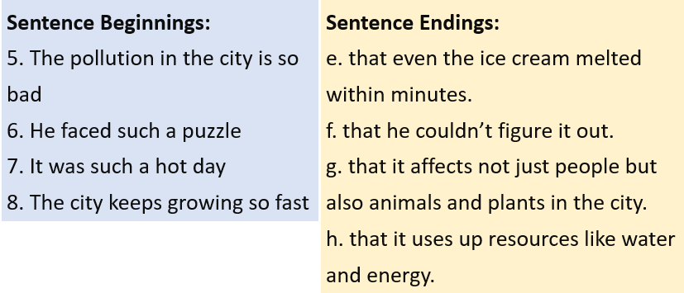  - Check Ss’ answers. | - Form groups of 4- 5.  - Follow the instructions.  - Match sentence beginnings and endings in a team/group.  Answer Keys  - d  - c  - b  - a  - g  - f  - e  - h

B. New Lesson (35’)
1. Presentation (15’)
a. Objectives: To help Ss understand how to use adverbial clauses of result.
b. Content: Tasks a and b.
c. Expected outcomes: Ss can understand how to use adverbial clauses of result in different contexts.
d. Organization
Teacher’s activities | Students’ activities
Task a: Read about adverbial clauses of result, then fill in the blanks.  - Have Ss look at the grammar explanation box and read the examples.  - Have some Ss read the examples aloud.  - Explain the form and use of “adverbial clauses of result” (using the DCR/ PPTs slides)  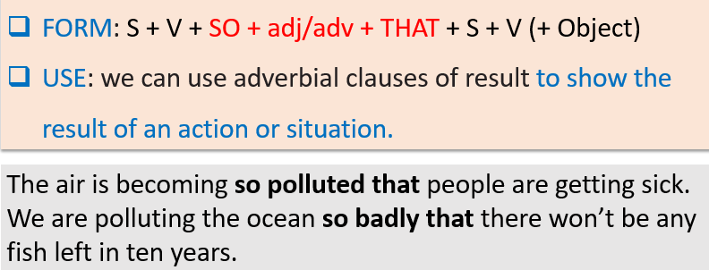  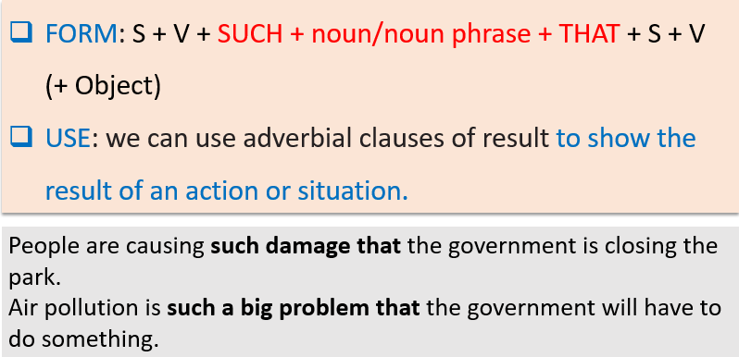  - Have Ss work individually and complete the task (using the DCR/PPT slides).  - Have Ss check the answers with a partner.  - Check Ss’ answers around the class | - Read the grammar explanation box.  - Read the examples aloud.  - Listen to the teacher’s instructions and take notes.  - Fill in the blanks.  - Check the answers with a partner.
Task b: Listen and check. Listen again and repeat.  - Play the audio. Have Ss listen again and check.  - Check Ss’ answers around the class.  - Have Ss listen again and repeat.  - Invite some Ss to read the sentence aloud. | - Listen and check.  Answer Keys: so – that – will  - Listen and repeat.  - Read the sentence aloud.

2. Practice (15’)
a. Objectives: To help Ss practice the use of the adverbial clauses of result.
b. Content: Tasks c and d.
c. Expected outcomes: Ss can remember and know how to use the adverbial clauses of reason.
d. Organization:
Teacher’s activities | Students’ activities
Task c: Circle the underlined part that needs correction.  - Demonstrate the activity using the example.  - Have Ss complete the task individually.  - Have Ss check the answers with a partner.  - Invite some Ss to read the sentence(s) aloud.  - Check and correct Ss’ answers. | - Listen to the instructions.  - Complete the task.  - Check the answers with a partner.  - Read the sentences aloud.  Answer Keys:  1. B  2. B  3. C  4. A  5. A  6. B
Task d: Rewrite the sentences with adverbial clauses using so…that or such…that.  - Demonstrate the activity using the example.  - Have Ss rewrite the sentences with adverbial clauses using so…that or such…that.  - Set the time and monitor the class.  - Have Ss check the answers with a partner.  - Check Ss’ answers (using the DCR).  - Have some Ss read the answers aloud. | - Listen to the instructions.  - Complete the task.  - Check the answers with a partner.  - Read the sentences aloud.  Answer Keys  1. The number of homeless people is so high that the  government will have to build cheap housing.  2. People are damaging the land so quickly that we won't be able to grow crops soon.  3. Water pollution is such a big problem that the fish  the population will drop very quickly.  4. Skateboarding accidents in the city center are  becoming such a serious issue that the government  will have to ban it.  5. The population is rising so fast that the government  will need to attract more business to the area.  6. People are causing so much noise that animals are  leaving the area.  7. The city has such huge traffic jams in rush hour that the government will have to do something.

3. Production (5’)
a. Objectives: To help Ss produce some sentences using the adverbial clauses of result.
c. Expected outcomes: Ss can use the adverbial clauses of result in writing and speaking.
d. Organization
Teacher’s activities | Students’ activities
Task e: In pairs: Use the prompts to talk about problems and predict their future results.  - Divide the class into pairs.  - Have Ss talk about problems and predict their future results.  - Monitor the class and help them if necessary.  - Have some Ss demonstrate the activity in front of the class.  - Feedback on Ss’ answers. | - Talk about problems and predict their future results with a partner.  - Share the ideas with the class.  Suggested answers:  1. The city has such big traffic jams that the government will have to build a subway system.  2. The air is so polluted that the city will have to ban vehicles in the city center.  3. Business owners are leaving so quickly that the city will have to attract new businesses.

C. Consolidation and homework assignments (5’)
- Grammar: Adverbial clauses of result.
We can use the adverbial clauses of result to show the result of an action or situation.
S + V + SO + adj/adv + THAT + S + V (+ Object)
S + V + SUCH + noun/noun phrase + THAT + S + V (+ Object)
- Review adverbial clauses of result.
- Do homework: writing on page 41 - WB
- Prepare for the next lesson (Pronunciation & Speaking - pages 70 & 71 - SB).
- Play the consolidation games on www.eduhome.com.vn
5. Reflection

a. What I liked most about this lesson today:
…………………………………………………………………………………………
b. What I learned from this lesson today:
…………………………………………………………………………………………
c. What I should improve for this lesson next time:
…………………………………………………………………………………………

