School: ……………………………………….. | Date:……………………………………..
Class: ……………………………..................... | Period: ………………………………….

UNIT 6: NATURAL WONDERS
Review: Listening. Reading & Vocabulary (Pages 103 & 104)

1. Objectives
By the end of this lesson, students will be able to…
1.1. Language knowledge/ skills
- To practice and review the target language learned in the unit
- To practice test-taking skills
- Improve listening and reading skills.
1.2. Competences
- improve Ss’ communication, collaboration, analytical, and critical thinking skills.
1.3. Attributes
  - Gain more information about natural wonders in Vietnam and around the world.
  - Foster a sense of preserving and protecting our nature.
2. Teaching aids and materials
- Teacher’s aids: Student’s book and Teacher’s book, class CDs, DCR– Phần mềm tương tác trực quan, DHA – Ứng dụng trò chơi tương tác, projector / interactive whiteboard /TV (if any), PowerPoint slides.
- Students’ aids: Student’s book, Workbook, Notebook.
3. Assessment Evidence
Performance Tasks | Performance Products | Assessment Tools
- Listen to 5 conversations and choose the correct answers.  - Listen and practice 5 conversations in pairs.  - Underline key words in questions  - Read the article and choose the correct answers.  - Read sentences and choose the correct words relating to natural wonders. | - Ss’ answers/performance.  - Ss’ answers/performance.  - Ss’ answers.  - Ss’ answers.  - Ss’ answers. | - Observation and feedback.  - Observation and feedback.  - Observation and feedback.  - Observation and feedback.  - Observation and feedback.

4. Procedures
A. Warm-up: 5 minutes
a. Objectives: review vocabulary Ss studied about natural wonders.
b. Content: Warm-up activity – Reveal pictures that show vocabulary Ss studied, which team says first, win the game.
c. Expected outcomes: Ss can review words related to natural wonders that they studied in the Unit.
d. Organization
Teacher’s activities | Students’ activities
Task: Work in groups of 4. Look at pictures that were covered, and they will be revealed slowly in order if the group knows and says the answers first wins.  - Ask Ss to work in groups of 4 to say aloud the words they know.  - Give Ss some time to do the activity.  - Check Ss’ answers.  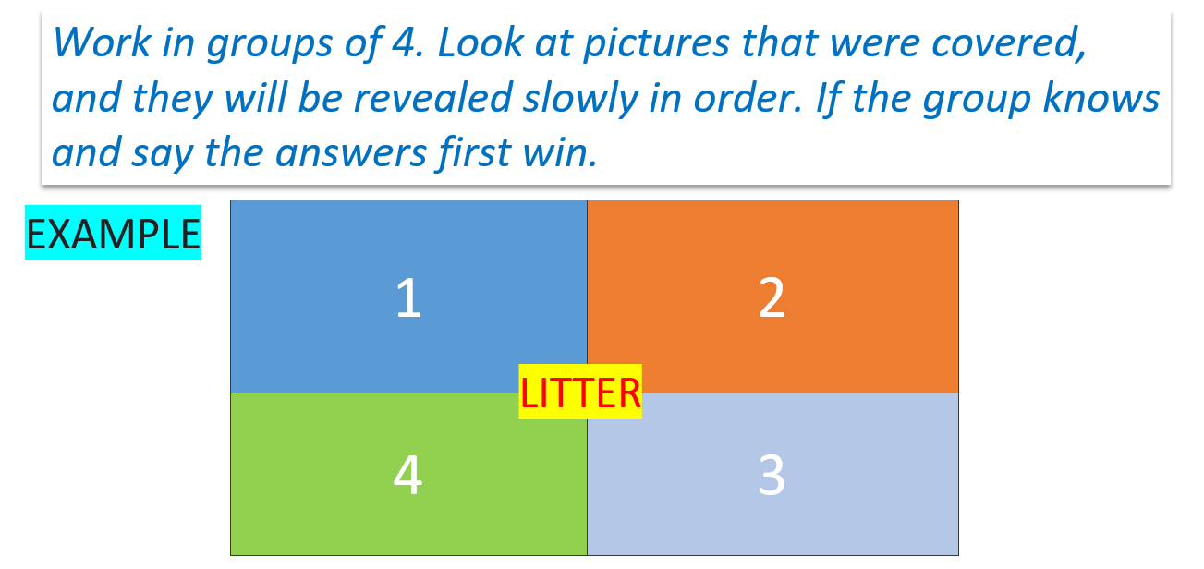 | - Work in groups of 4 to do the activity.  - Ask and answer the questions.  Suggested answers  - hunt  - rangers  - fine  - government  - cave  - waterfall  - island

B. New Lesson (35’)
1. Listening (15’)
a. Objectives: To help Ss improve testing skills in listening.
b. Content: Tasks a, b and c.
c. Expected outcomes: Ss can improve their testing skills in listening.
d. Organization
Teacher’s activities | Students’ activities
Task a: Look at questions and underline key words.  - Ask Ss to underline key words in questions individually.  - Give Ss some time to do the activity.  - Ask Ss to compare answers with partners.  - Elicit answers from some Ss.  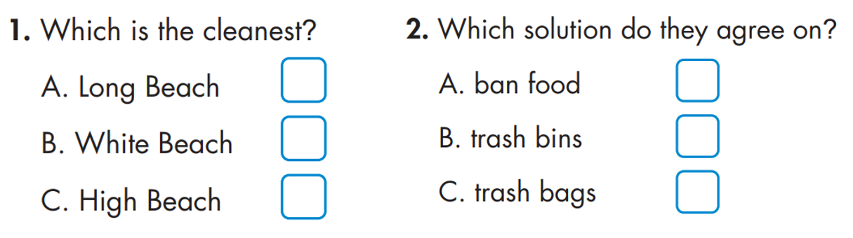  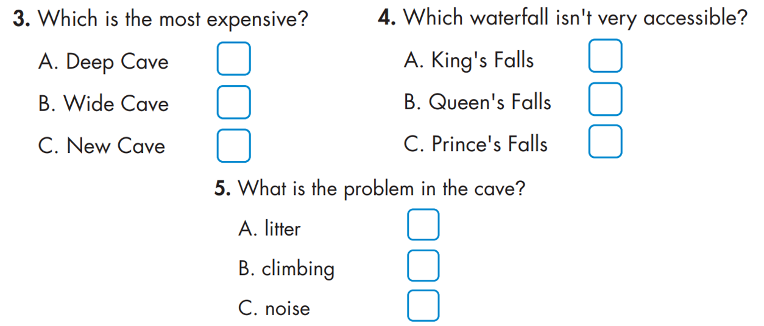 | - Underline key words in questions alone.  - Compare answers with partners.  - Ss give answers.  Suggested answers:  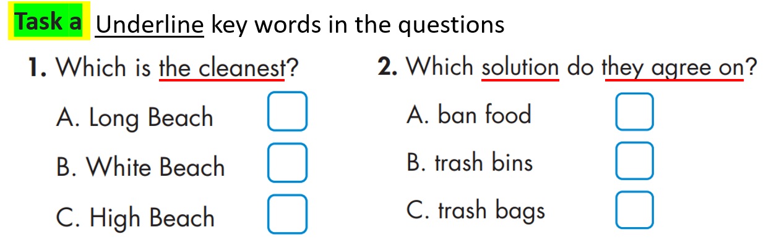  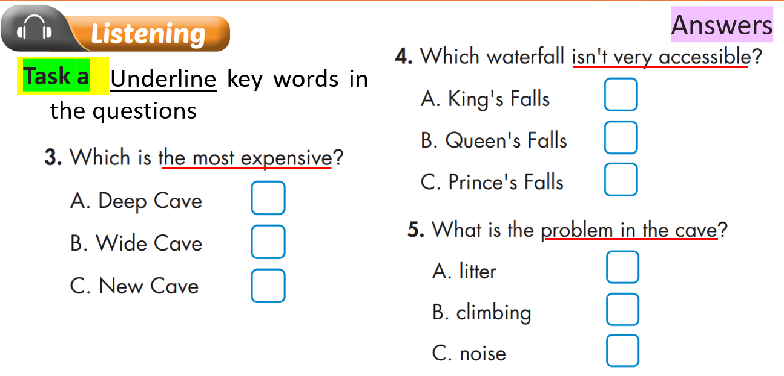
Task b: Listen to conversations and choose the correct answers.  - Ask Ss to listen and choose the correct answers individually.  - Give Ss some time to do the activity.  - Ask Ss to compare answers with partners.  - Elicit answers from some Ss. | - Do the activity alone.  - Compare answers with partners.  - Ss give answers.  Answer Keys:  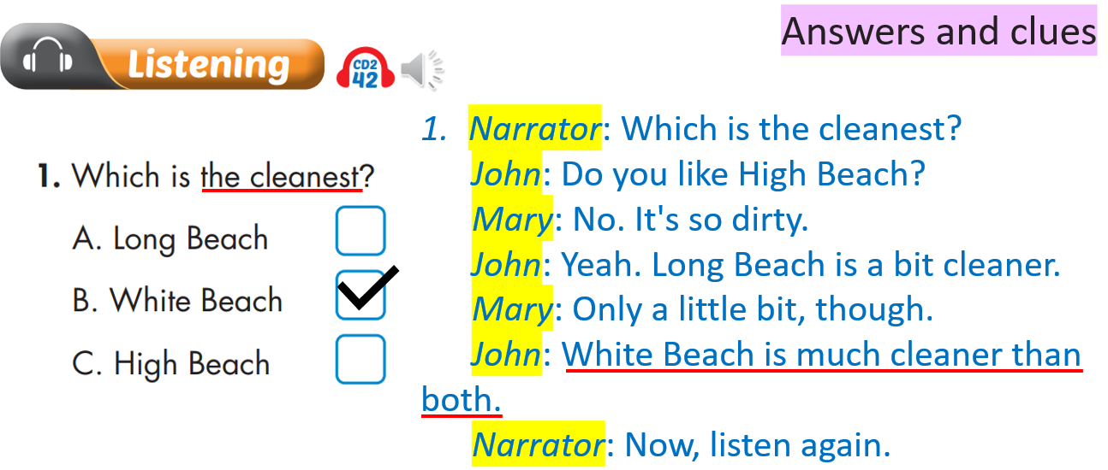  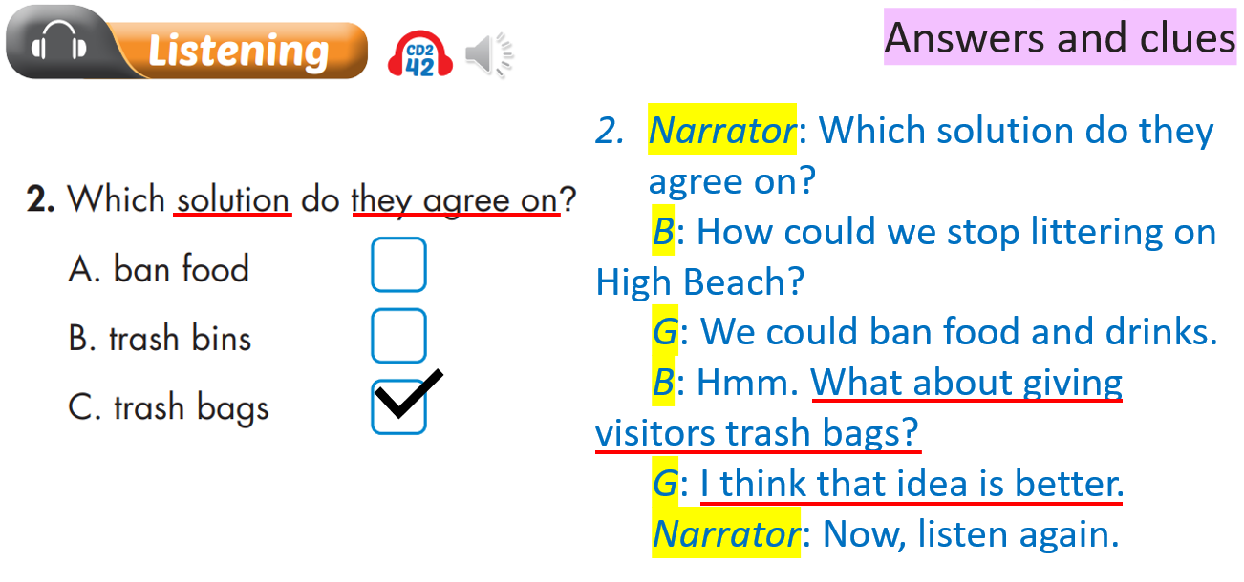  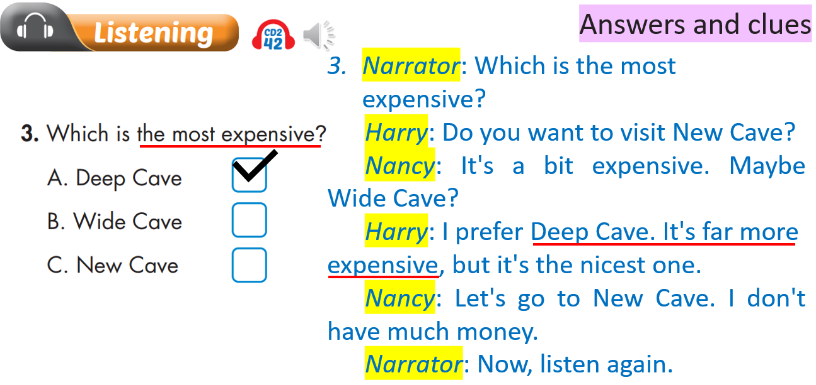  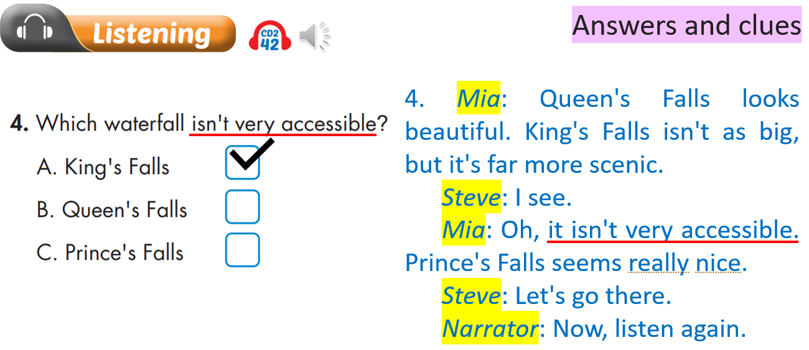  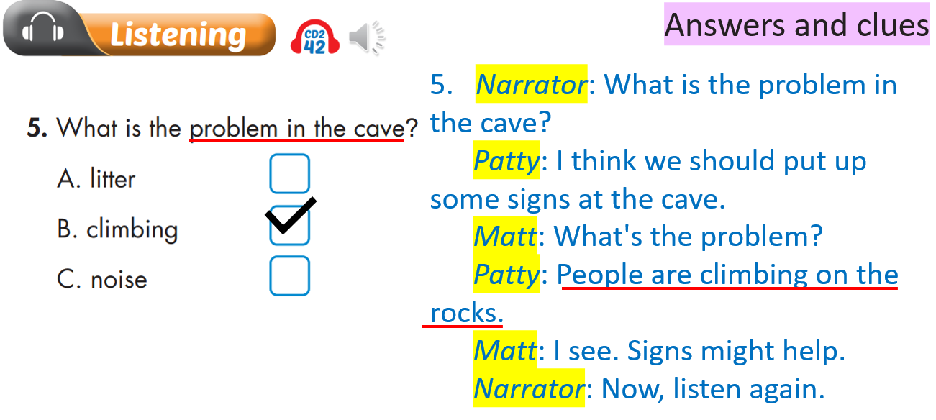
Task c: Listen and practice conversations in pairs.  - Ask Ss to practice conversations with partners in pairs.  - Check Ss’ answers around the class.  - Ask some Ss to practice conversations in front of the class.  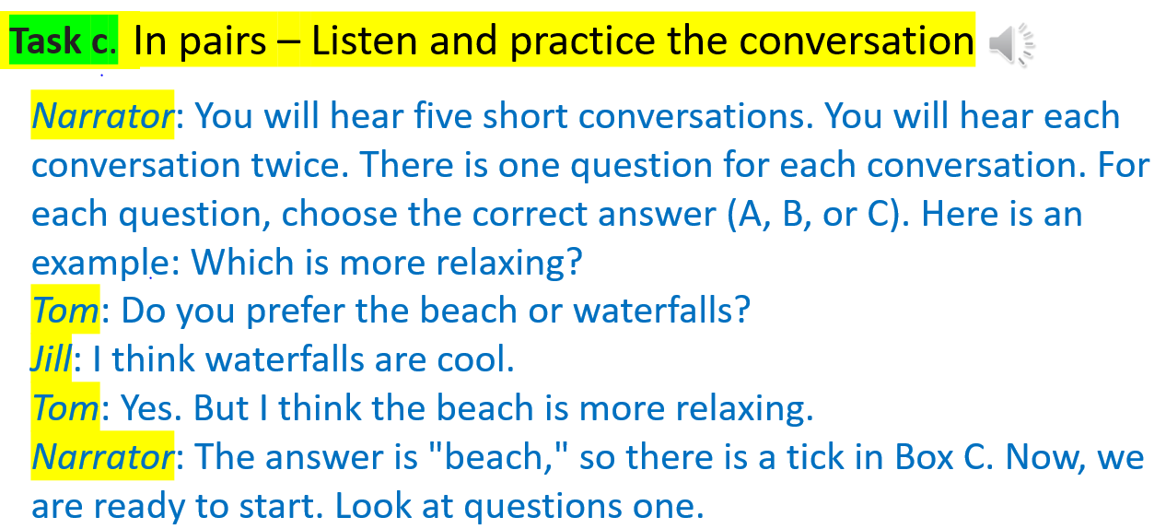  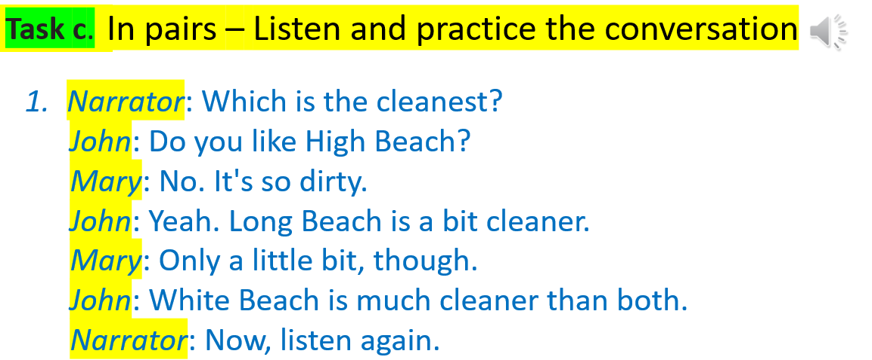  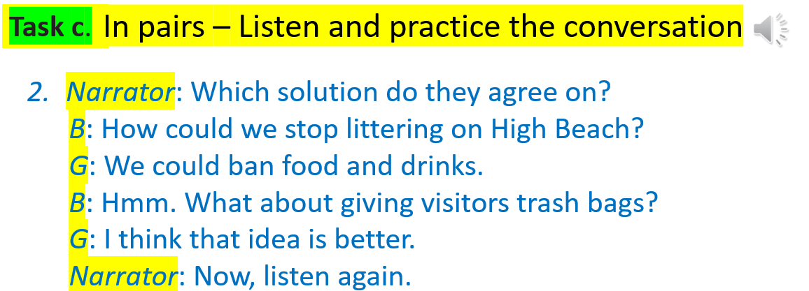  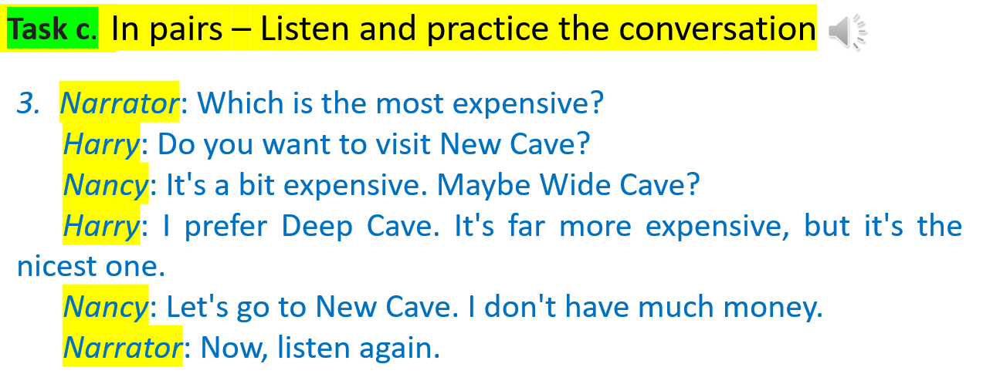  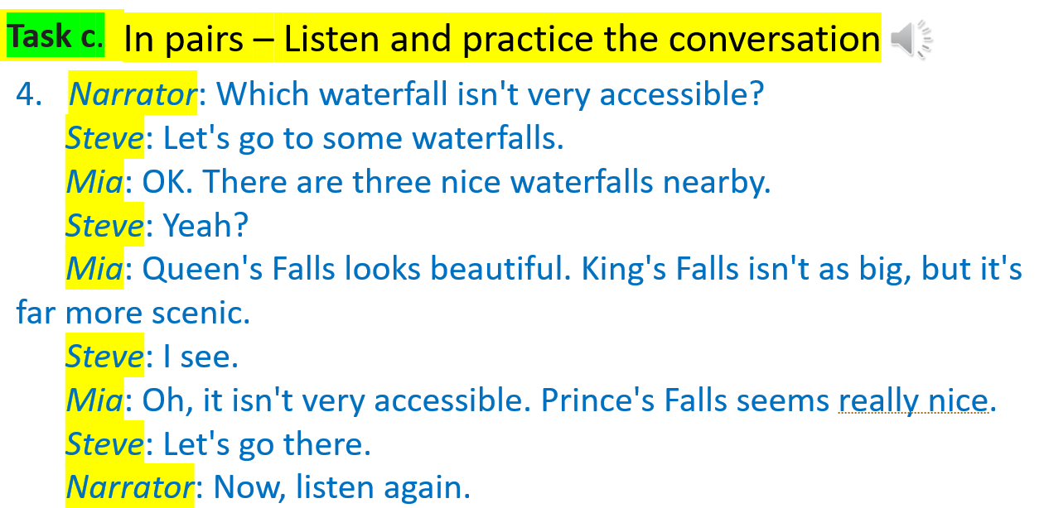  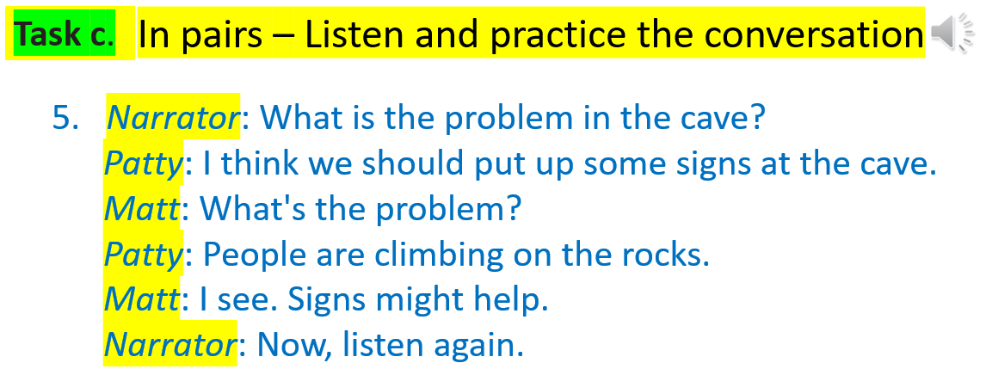 | - Practice conversations in pairs.  - Ss practice conversations in front of the class

2. Reading (15’)
a. Objectives: To help Ss practice testing skills for reading.
b. Content: Tasks a, and b.
c. Expected outcomes: Ss can improve reading skills for testing.
d. Organization:
Teacher’s activities | Students’ activities
Task a: Look at questions and underline key words.  - Ask Ss to read and underline key words in questions individually.  - Give Ss some time to do the activity.  - Ask Ss to compare answers with partners.  - Elicit answers from Ss. | - Complete the task.  - Compare the answers with a partner.  - Share answers in front of the class.  Suggested answers:  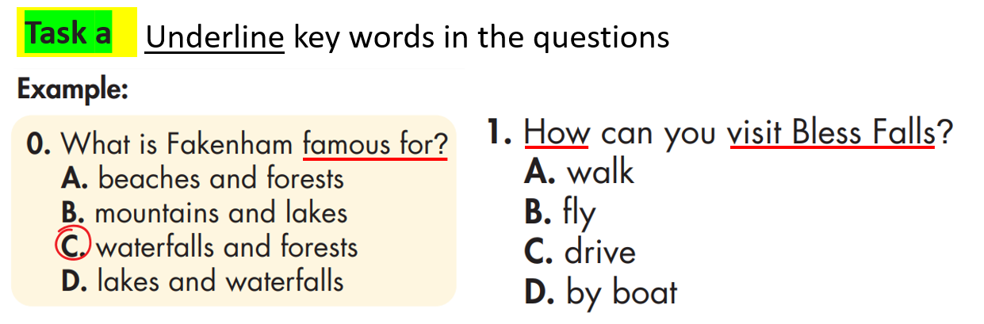  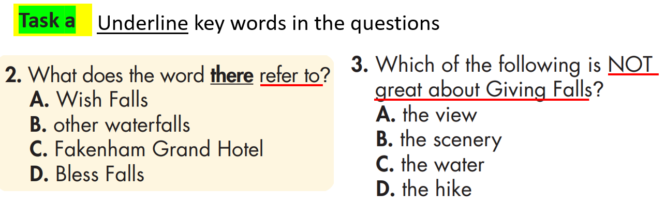  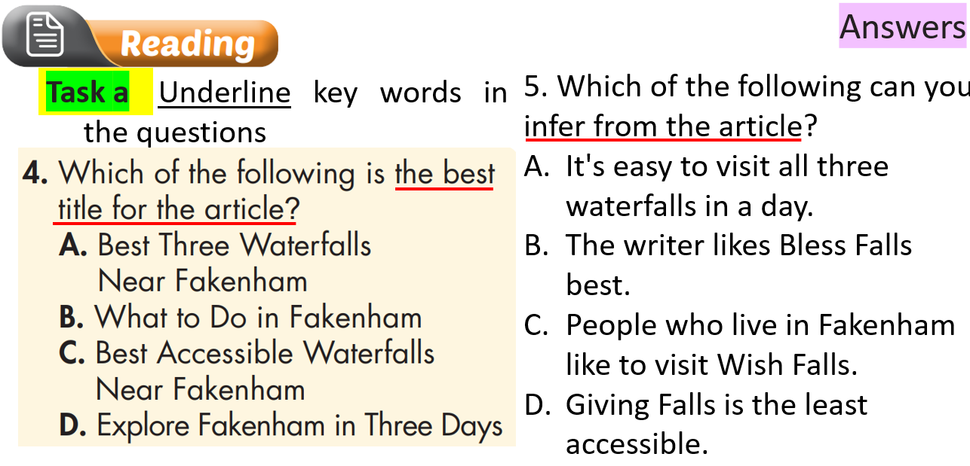
Task b: Read the article and choose the correct answers.  - Ask Ss to read and choose the correct answers.  - Set the time and monitor the class.  - Ask Ss to compare the answers with a partner.  - Pick some Ss to answer.  - Check Ss’ answers (using the DCR).  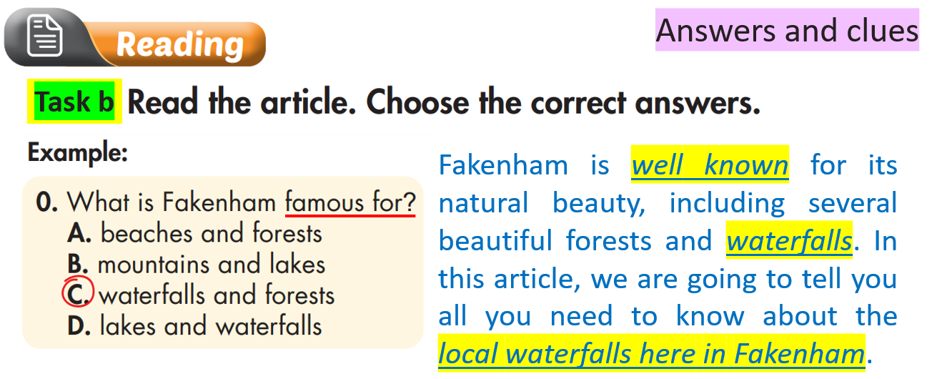 | - Complete the task.  - Compare the answers with a partner.  - Share answers in front of the class.  Answer Key  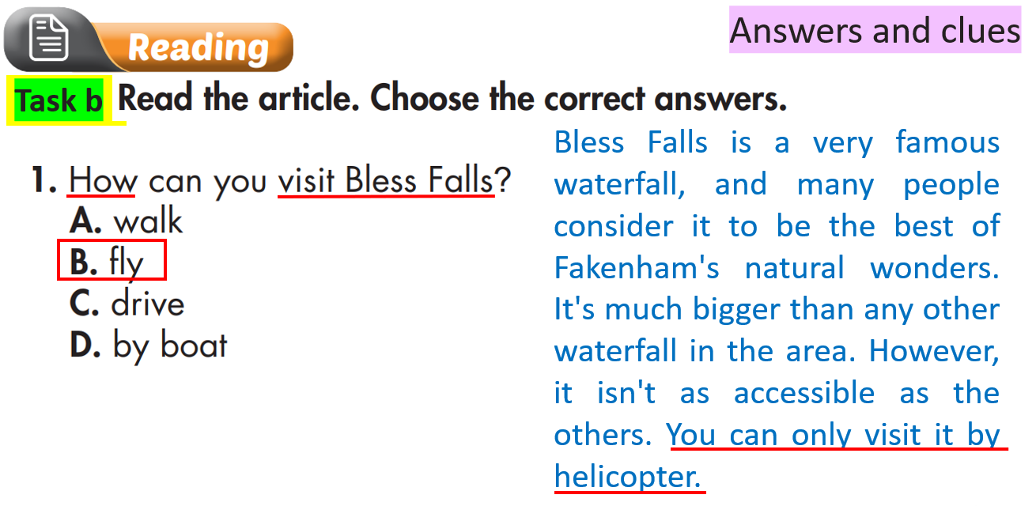  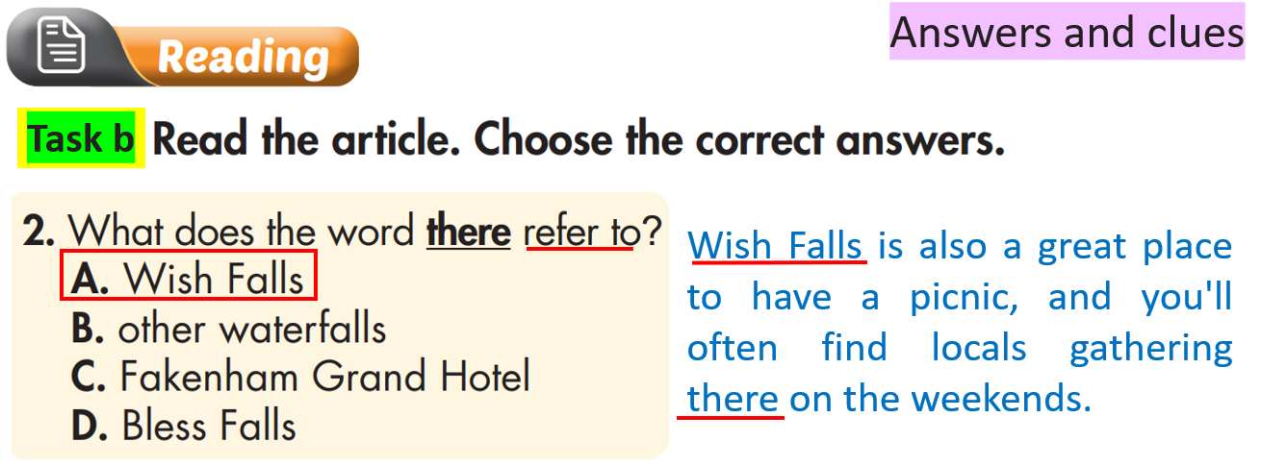  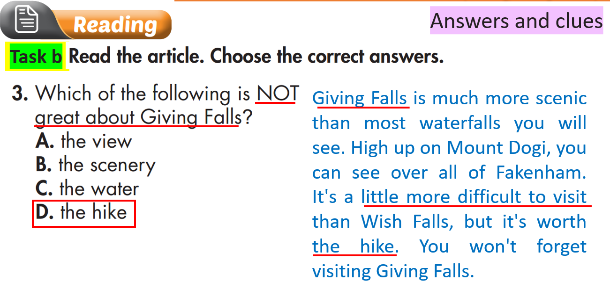  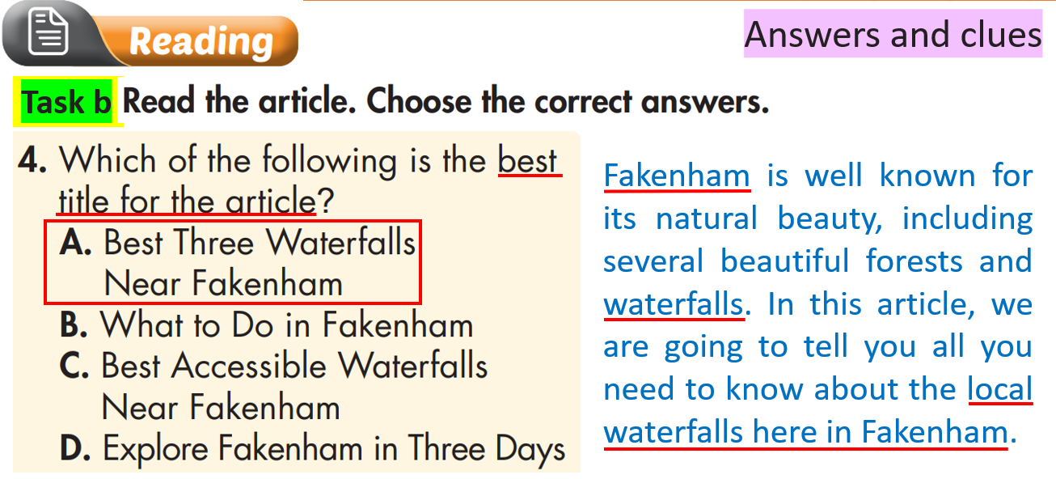  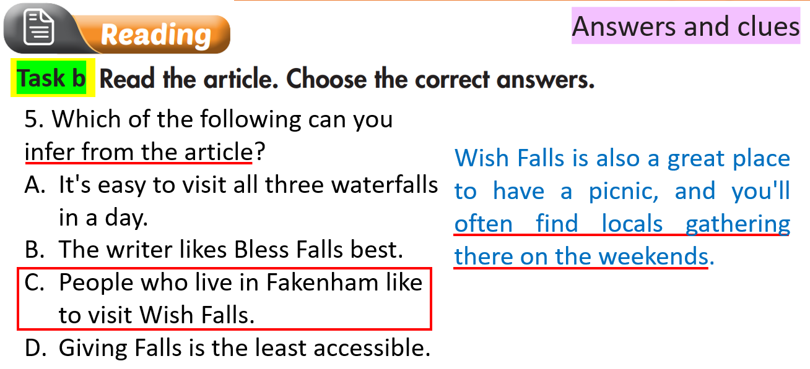

3. Vocabulary (5’)
a. Objectives: To help Ss review and practice testing skills for vocabulary they have studied in the Unit.
b. Content: Task vocabulary.
c. Expected outcomes: Ss can review words in the Unit and improve testing skills.
d. Organization
Teacher’s activities | Students’ activities
Task: Read sentences and circle the correct answers.  - Ask Ss to read and circle the correct answers.  - Monitor the class and help them if necessary.  - Ask Ss to compare their answers in pairs.  - Elicit answers from Ss.  1. The water running through the cave created the rocky _________.  - outcrops B. summits  - C. rangers D. government  2. The biggest problem is that people ___________ in the park. There are plastic bottles everywhere.  - fine B. spoil  C. create D. litter  3. I climbed all the way to the __________ of Mount Snowdon. There was a great view from the top.  A. beach B. formation  C. summit D. nature  4. Rangers shouldn't let people ___________ animals in the national park.  - fine B. hunt  - C. consider D. litter  5. The view from the top of the mountain is ____________.  - spectacular B. accessible  C. tall D. close  6. So many animals live in the ___________.  A. ranger B. Mount  C. wildlife D. rainforest  7. If people ___________ the wildlife, it could have a bad effect.  - consider B. keep  - C. float D. disturb  8. I hate littering. Don't people know that it _________ the natural beauty here?  A. explores B. reaches  C. spoils D. climbs | - Do the activity.  - Share answers with partners.  - Share answers in front of the class  Answer keys:  - A – outcrops  - D – litter  - C – summit  - B – hunt  - A – spectacular  - D – rainforest  - D – disturb  - C – spoils

C. Consolidation and homework assignments (5’)
- Practice testing skills for listening and reading.
- Review and practice testing skills in vocabulary in this Unit.
- Prepare for the next lesson (Review - pages 104 & 105 - SB).
- Play the consolidation games on www.eduhome.com.vn
5. Reflection

a. What I liked most about this lesson today:
…………………………………………………………………………………………
b. What I learned from this lesson today:
…………………………………………………………………………………………
c. What I should improve for this lesson next time:
…………………………………………………………………………………………

