School: ……………………………………….. | Date:……………………………………..
Class: ……………………………..................... | Period: ………………………………….

UNIT 6: NATURAL WONDERS
Lesson 2.3: Pronunciation & Speaking (Pages 60 & 61)

1. Objectives
By the end of this lesson, students will be able to…
1.1. Language knowledge/ skills
- practice intonation for contrasting sentences.
- discuss how to preserve and protect our natural wonders.
- improve speaking and problem-solving skills.
1.2. Competences
- improve Ss’ communication, collaboration, analytical, and critical thinking skills.
1.3. Attributes
- cultivate an awareness of preserving and protecting natural wonders.
2. Teaching aids and materials
- Teacher’s aids: Student’s book and Teacher’s book, class CDs, DCR– Phần mềm tương tác trực quan, DHA – Ứng dụng trò chơi tương tác, projector / interactive whiteboard /TV (if any), PowerPoint slides.
- Students’ aids: Student’s book, Workbook, Notebook.
3. Assessment Evidence
Performance Tasks | Performance Products | Assessment Tools
- Listen to the sentences and focus on the intonation falls, then rises and falls again.  - Listen and cross out the intonation that doesn’t follow the note.  - Read the sentences focusing on the intonations.  - Take turns asking and answering about how to preserve and protect natural wonders. (Pair work)  - Practice with your own ideas.  - Join another group and tell them about your ideas. | - Ss’ performance.  - Ss’ answers.  - Ss’ performance.  - Ss’ performance.  - Ss’ answers/presentation.  - Ss’ answers/presentation. | - Observation.  - Observation and feedback.  - Observation and feedback.  - Observation and feedback.  - Observation and feedback.  - Observation and feedback.
4. Procedures
A. Warm-up: 5 minutes
a. Objectives: to introduce how to make contrasting sentences.
b. Content: Sentence completion game.
c. Expected outcomes: Ss can understand and give contrasting ideas to complete sentences.
d. Organization
Teacher’s activities | Students’ activities
COMPETITION TIME:  - Create groups/teams of 5 students.  - You will be given incomplete sentences.  - You have to complete the sentences with your ideas.  - The team(s) with the most similar correct answers win(s).  - Time limit: 5 minutes  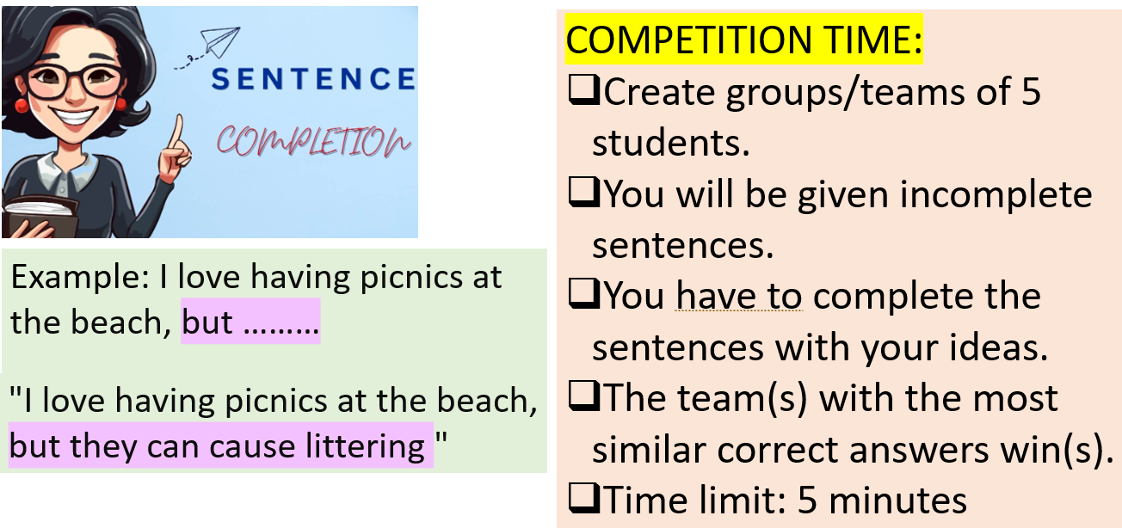  - I like you a lot, but ……….  - People know that plastic bags can harm the environment, but ………..  - People know that they shouldn’t disturb animals, but .............  - It’s a great idea, but …………  - Smoking is not good for people’s health, but ……  - 6. Cheating is not a good thing, but ………  - 7. The government put more trash cans in national parks, but ………………….  - 8. It’s a good idea to fine people who litter in public places, but ……. | - Listen to the instructions.  - Work in groups and give contrasting ideas to complete sentences.  - Ss’ answers  Suggested answers:  - I like you a lot, but I don’t love you.  - People know that plastic bags can harm the environment, but they still use them daily.  - People know that they shouldn’t disturb animals, but they still feed them.  - It’s a great idea, but not many people like it.  - Smoking is not good for people’s health, but a lot of people still smoke.  - Cheating is not a good thing, but many students often do it.  - The government put more trash cans in national parks, but people still litter.  - It’s a good idea to fine people who litter in national parks, but rangers are too busy to do it.

B. New Lesson (35’)
1. Pronunciation (15’)
a. Objectives: To help Ss understand the rules of intonation in contrasting sentences.
b. Content: Tasks a, b, c and d.
c. Expected outcomes: Ss can improve their pronunciation by saying contrasting sentences with correct intonation.
d. Organization
Teacher’s activities | Students’ activities
Task a: Notes:  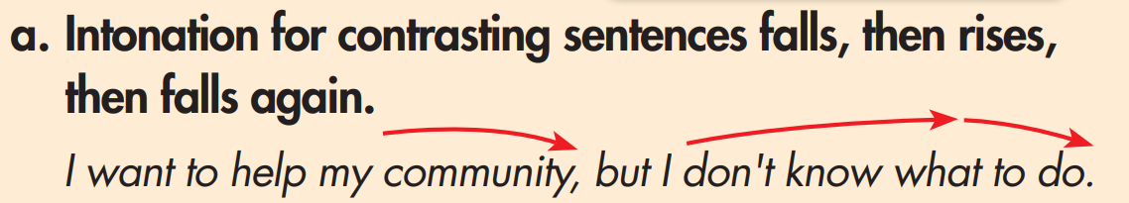  - Ask Ss to take notes. | - Listen and take some notes.
Task b: Listen to the sentences and notice how the intonation falls, then rises and falls again.  - Ask Ss to listen and focus on the intonations.  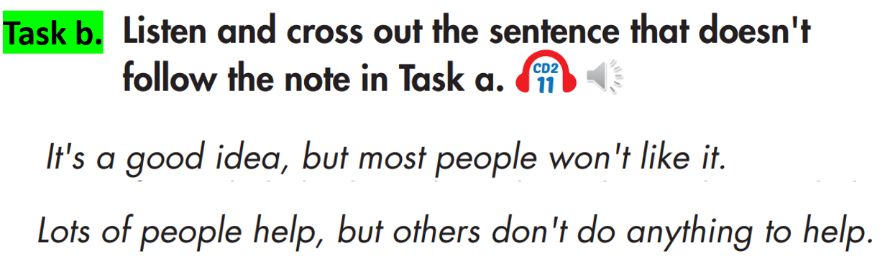 | - Listen to the sentences and focus on the intonation in contrasting sentences.  Answer:  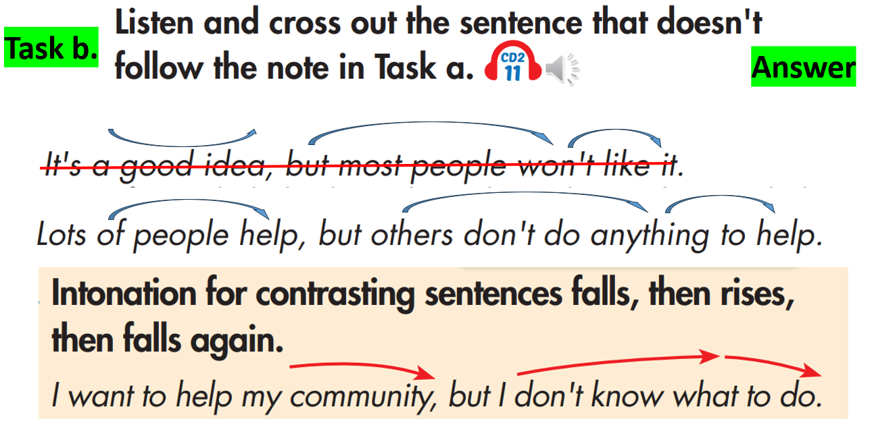
Task c: Read the sentences with the correct intonation to a partner.  - Ask Ss to read the sentences with the correct intonation to a partner.  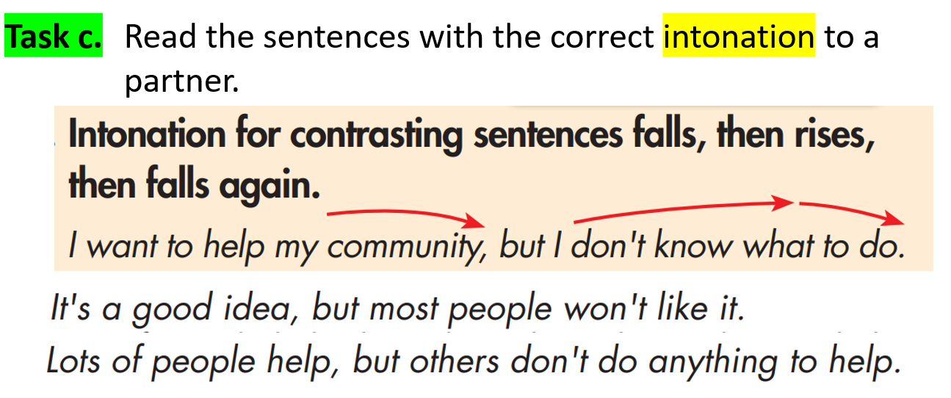 | - Read and practice saying the sentences in pairs.
Task d: Practice saying the sentences with correct intonation in the “warm up” activity.  - Ask Ss to practice saying the sentences out loud in pairs.  - Monitor the class and help them if necessary.  - Ask some Ss to say sentences out loud and give some feedback to correct the intonation.  - I like you a lot, but I don’t love you.  - People know that plastic bags can harm the environment, but they still use them daily.  - People know that they shouldn’t disturb animals, but they still feed them.  - It’s a great idea, but not many people like it.  - Smoking is not good for people’s health, but a lot of people still smoke.  - Cheating is not a good thing, but many students often do it.  - The government put more trash cans in national parks, but people still litter.  - It’s a good idea to fine people who litter in national parks, but rangers are too busy to do it. | - Practice saying the sentences with a partner.  - Read the sentences out loud.

2. Practice (10’)
a. Objectives: To help Ss practice saying sentences with correct intonation to talk about how they feel about the actions and suggest solutions, then politely disagree and give the next solution.
b. Content: Task a
c. Expected outcomes: Ss can share how they feel about the actions and suggest solutions, then politely disagree and give the next solution with the correct intonation.
d. Organization:
Teacher’s activities | Students’ activities
Task a: In pairs: Take turns asking and answering about how you feel about the actions and suggesting solutions, then politely disagree and give the next solution.  - Ask Ss to work in pairs and share their ideas.  - Ask Ss to share their ideas with the class.  - Check some SS’s answers and give feedback.  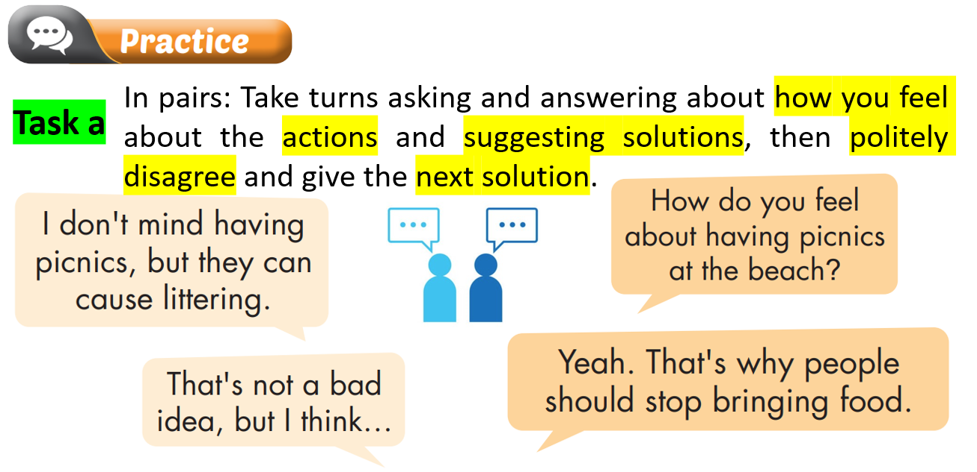  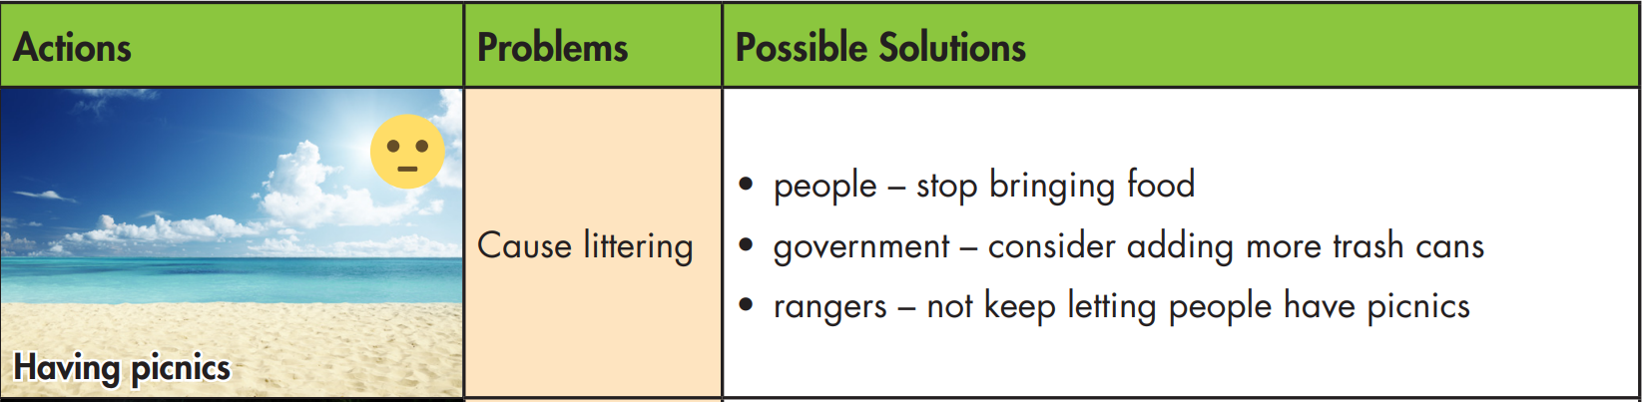  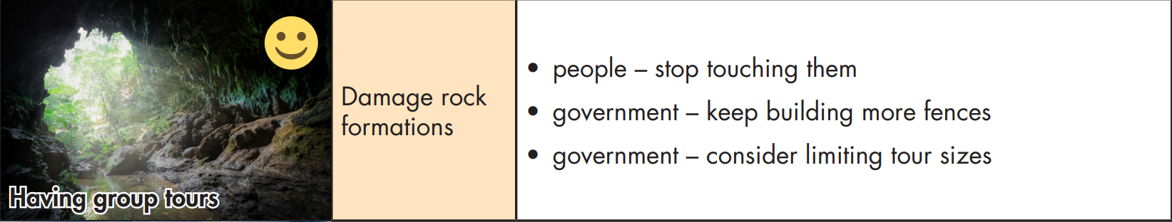  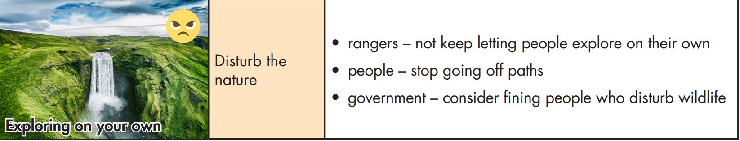 | - Get and share ideas with a partner.  - Share the ideas with the class.  - Share ideas in front of the class.  Suggested answers:  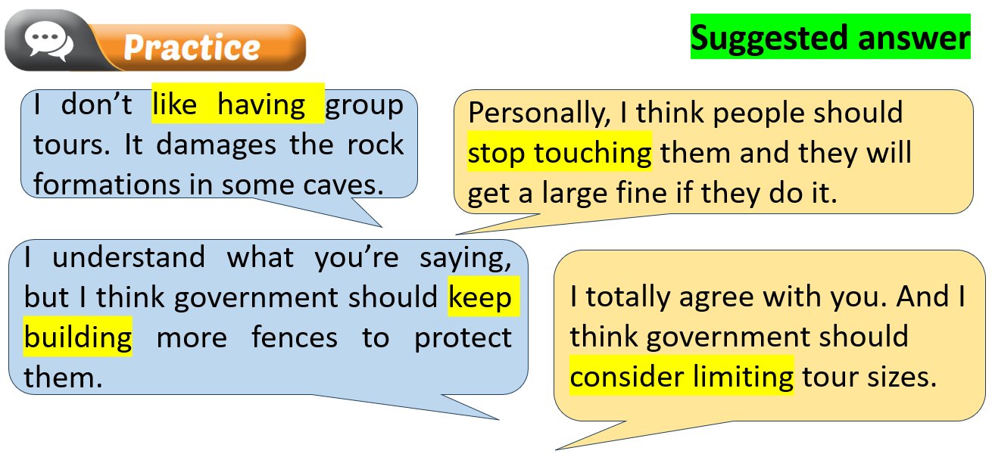  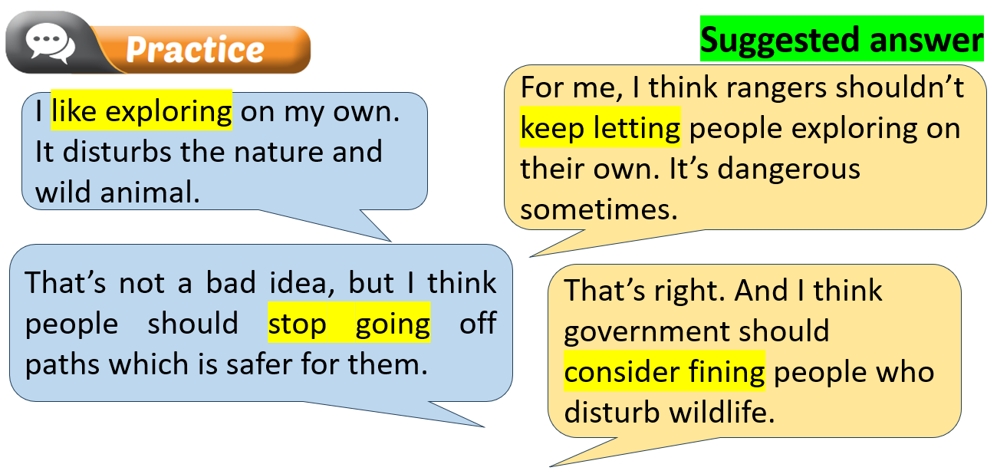

3. Speaking (10’)
a. Objectives: To help Ss further practice intonation to discuss how to preserve and protect natural wonders.
b. Content: Tasks and b.
c. Expected outcomes: Ss can discuss how to preserve and protect natural wonders.
d. Organization
Teacher’s activities | Students’ activities
Task a: In pairs: Asking and answering this question “What problems might these wonders have?  - Ask Ss to work in in pairs and discuss the problems might these wonders have.  - Monitor the class and help them if necessary.  - Elicit answers from some students.  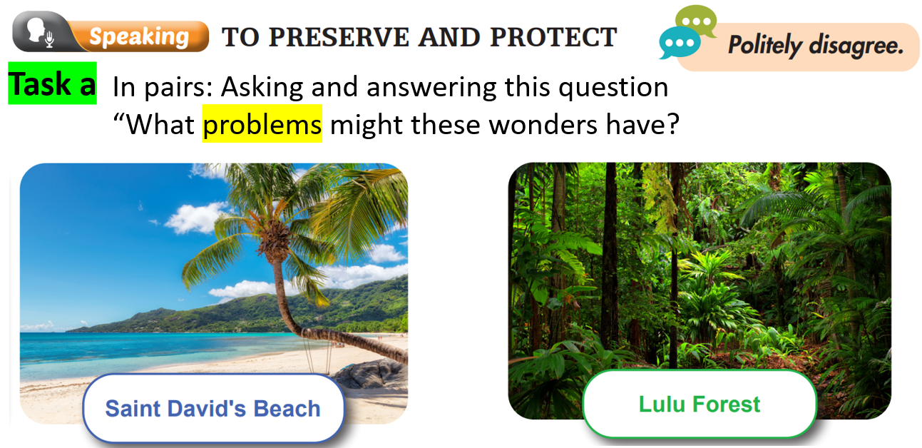 | - Work in pairs to share their ideas.  - Share their ideas with the class.  Suggested answers:  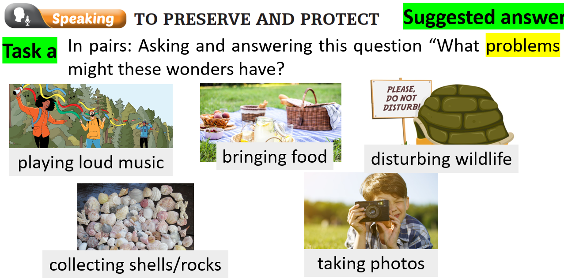
Task b: In pairs: Discuss your feelings about the actions, any potential problems they could cause, and solutions to them.  - Ask Ss to work in pairs.  - Monitor the class and help them if necessary.  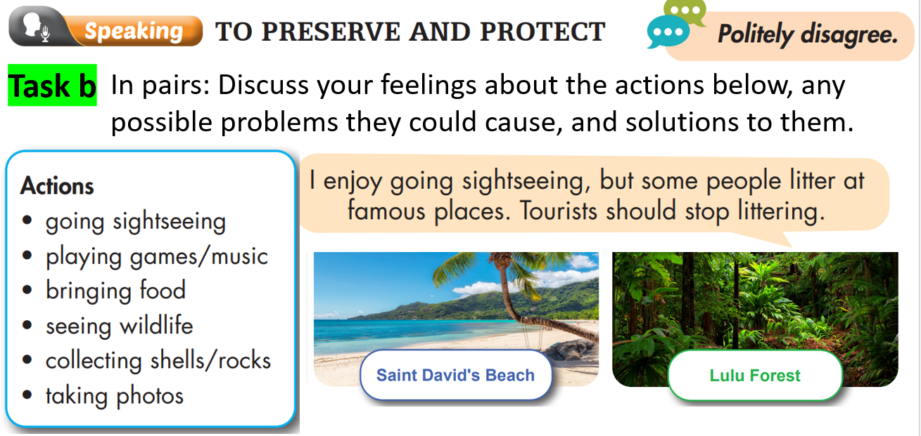 | - Work in pairs.
Task c: Join another pair. Tell them how you feel about each of the actions, then share the solutions you discussed.  - Ask Ss to join other pairs to share ideas.  - Monitor the class and help them if necessary.  - Elicit some ideas from some Ss. | - Work in pairs to share their ideas.  - Share their ideas with the class.  Suggested answer:  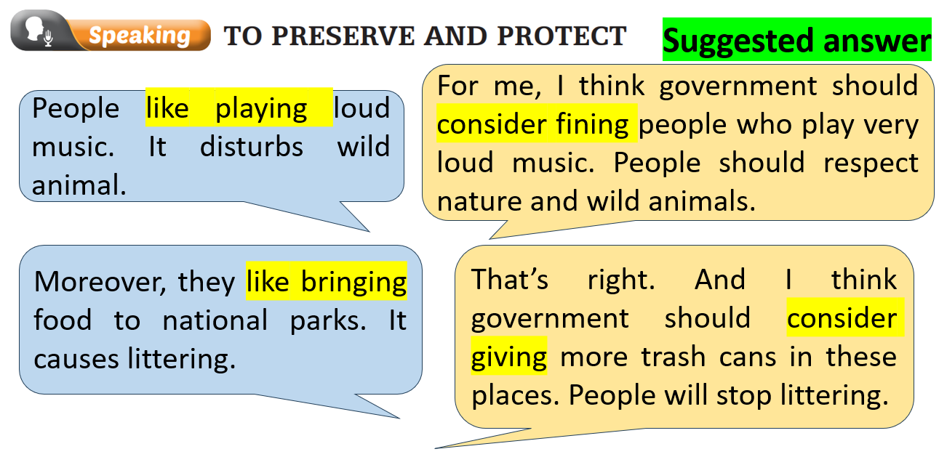  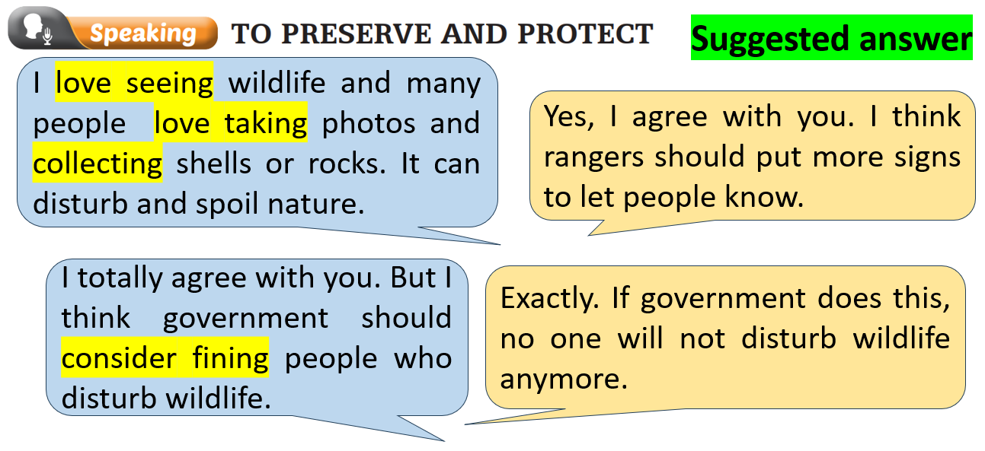

C. Consolidation and homework assignments (5’)
- Practice saying the contrasting sentences with correct intonation in the Pronunciation (SB) and in the “warm-up” activity.
- Practice speaking about how to preserve and protect our natural wonders.
- Prepare for the next lesson (Reading - page 62 - SB).
- Play the consolidation games on www.eduhome.com.vn

5. Reflection
a. What I liked most about this lesson today:
…………………………………………………………………………………………
b. What I learned from this lesson today:
…………………………………………………………………………………………
c. What I should improve for this lesson next time:
…………………………………………………………………………………………

