School: ……………………………………….. | Date:……………………………………..
Class: ……………………………..................... | Period: ………………………………….

UNIT 6: NATURAL WONDERS
Lesson 2: Grammar (Pages 55 & 56)

1. Objectives
By the end of this lesson, students will be able to…
1.1. Language knowledge/ skills
- learn and use comparative structures with intensifiers correctly.
- produce sentences using comparative structures with intensifiers.
- improve Grammar and Speaking.
1.2. Competences
- improve Ss’ communication, collaboration, analytical, and critical thinking skills.
1.3. Attributes
- cultivate a heightened curiosity for more natural places around the world.
2. Teaching aids and materials
- Teacher’s aids: Student’s book and Teacher’s book, class CDs, DCR– Phần mềm tương tác trực quan, DHA – Ứng dụng trò chơi tương tác, projector / interactive whiteboard /TV (if any), PowerPoint slides.
- Students’ aids: Student’s book, Workbook, Notebook.
3. Assessment Evidence
Performance Tasks | Performance Products | Assessment Tools
- Read about comparative structures with intensifiers, and fill in the blanks.  - Listen, check, and repeat.  - Choose the correct answers  - Write complete sentences.  - Make new sentences using different ideas for the purposes.  - Share the ideas with the class. | - Ss’ answers.  - Ss’ answers.  - Ss’ answers.  - Ss’ answers.  - Ss’ answers.  - Ss’ answers.  - Ss’ answers/presentation. | - Observation.  - Observation/feedback.  - Observation/feedback.  - Observation/feedback.  - Observation/feedback.  - Observation/feedback.  - Observation/feedback.

4. Procedures
A. Warm-up: 5 minutes
a. Objectives: To introduce the grammar point: “comparative structures with intensifiers”.
b. Content: Compare and talk about three caves that students studied in the last lesson.
c. Expected outcomes: Ss can make sentences with “comparative structures with intensifiers”.
d. Organization
Teacher’s activities | Students’ activities
Competition time:  - Ask Ss to form groups of 5.  - Give Ss instructions and one example.  - Give Ss three pictures of 3 caves and some adjectives  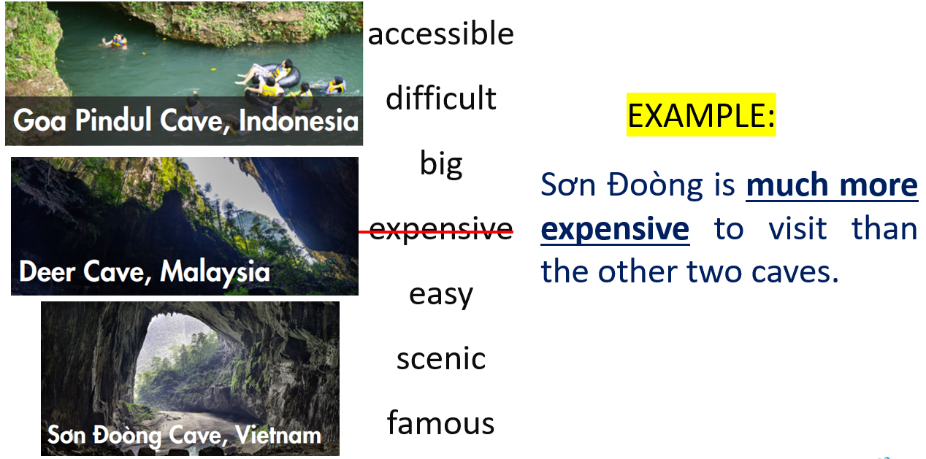  - Check Ss’ answers. | - Form groups of 5.  - Follow the instructions.  - Make the sentences with some adjectives in a team/group  Answer Keys  1. Sơn Đoòng Cave is far bigger than both the others.  2. Goa Pindul Cave is more famous for its river than the others.  3. Deer Cave is a bit more difficult to reach than Goa Pindul Cave.  4. Sơn Đoòng Cave isn't as accessible as Deer Cave.  5. Goa Pindul Cave is easier for people to get inside and see this cave than the others.  6. Sơn Đoòng is much more scenic than most other caves

B. New Lesson (35’)
1. Presentation (15’)
a. Objectives: To help Ss understand how to use “comparative structures with intensifiers” to compare two things or people.
b. Content: Tasks a and b.
c. Expected outcomes: Ss can make sentences using “comparative structures with intensifiers” to compare things or people.
d. Organization
Teacher’s activities | Students’ activities
Task a: Read about comparative structures with intensifiers, then fill in the blanks.  - Ask Ss to work individually and complete the task (using the DCR/ PPTs slides).  - Ask Ss to compare the answers with a partner.  - Check Ss’ answers around the class.  - Explain the use of “comparative structures with intensifiers” (using the DCR/ PPTs slides)  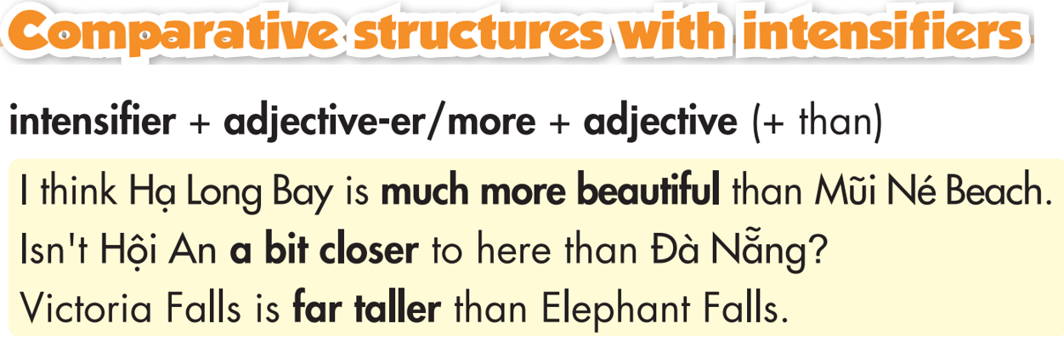  - Explain the use of “comparative structures with intensifiers” (using the DCR/ PPTs slides)  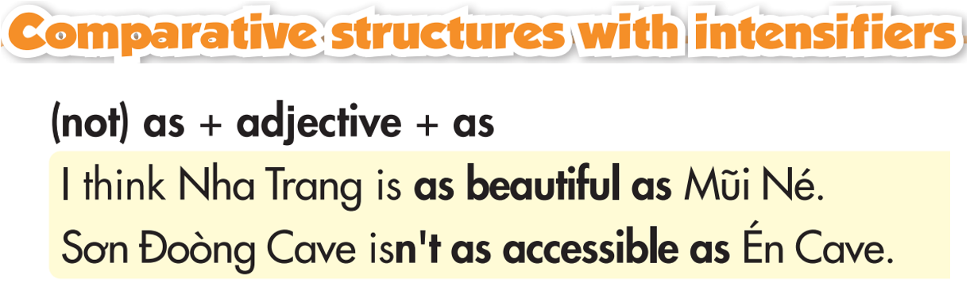  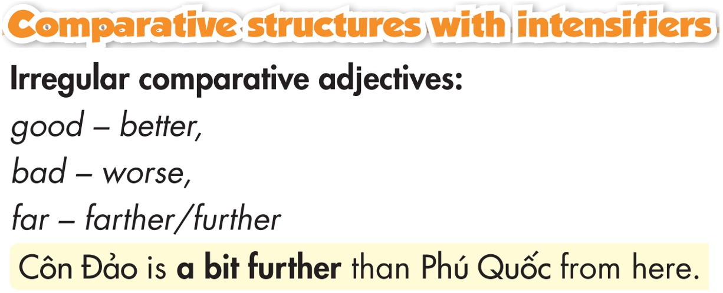 | - Fill in the blanks.  - Compare the answers with a partner.  - Listen to the teacher’s instructions and take notes.  - Listen to the teacher’s instructions and take notes.
Task b: Listen and check. Listen again and repeat.  - Check Ss’ answers around the class.  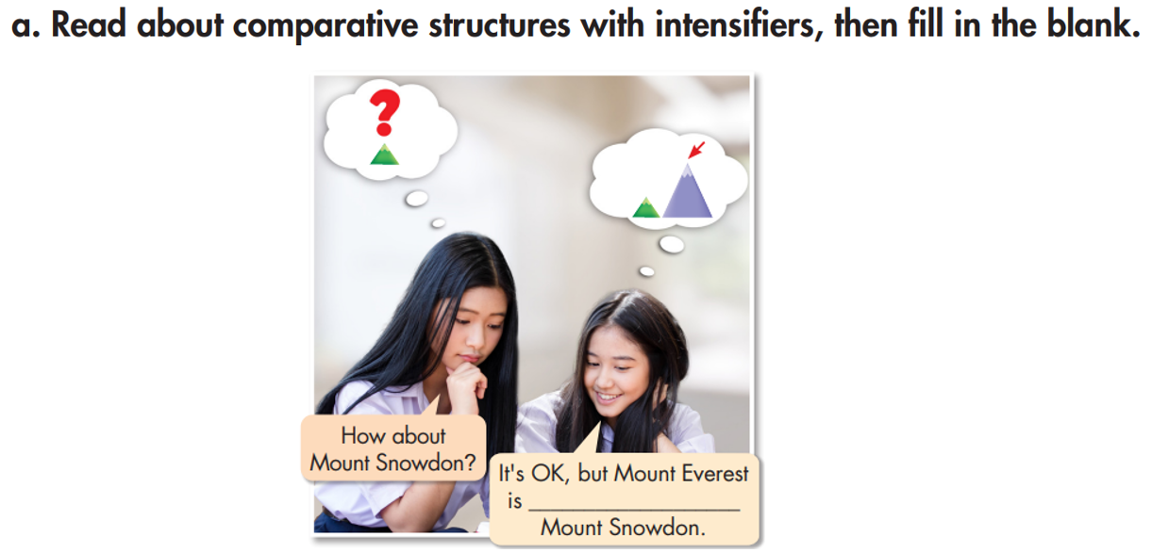 | - Listen and check.  Answer Keys:  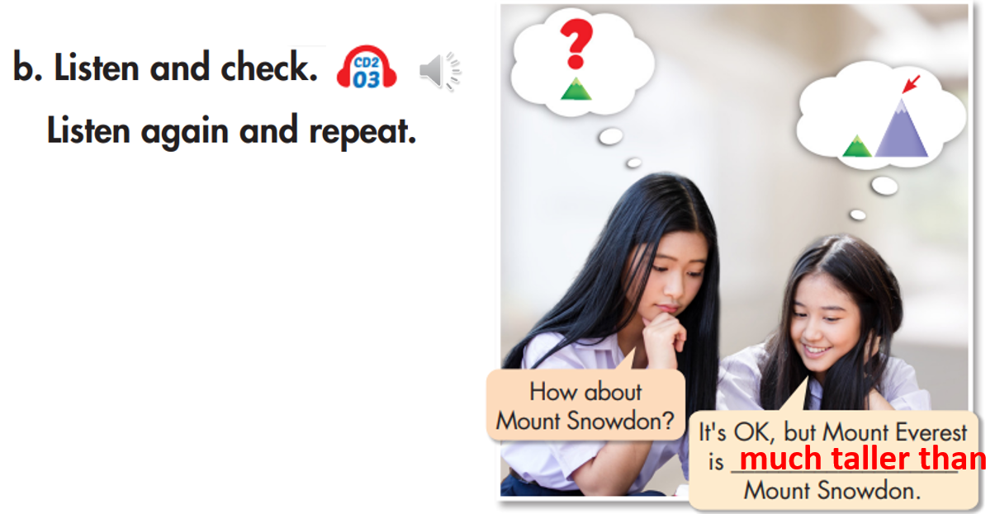  - Listen and repeat.

2. Practice (15’)
a. Objectives: To help Ss practice the use of “comparative structures with intensifiers”.
b. Content: Tasks a, be and c.
c. Expected outcomes: Ss can practice the use of “comparative structures with intensifiers” and when to use them.
d. Organization:
Teacher’s activities | Students’ activities
Task a: Fill the blanks with the correct form of the adjectives.  - Ask Ss to complete the task individually.  - Ask Ss to check the answers with a partner.  - Pick some Ss to read the sentence(s) out loud.  - Check and correct Ss’ answers. | - Complete the task.  - Compare the answers with a partner.  - Read the sentences out loud.  Answer Keys:  1. more beautiful  2. more scenic  3. more interesting  4. more exciting  5. relaxing  6. cleaner/ more famous  7. more accessible  8. taller  9. big  10. more spectacular
Task b: In pairs, compare, write and share these places  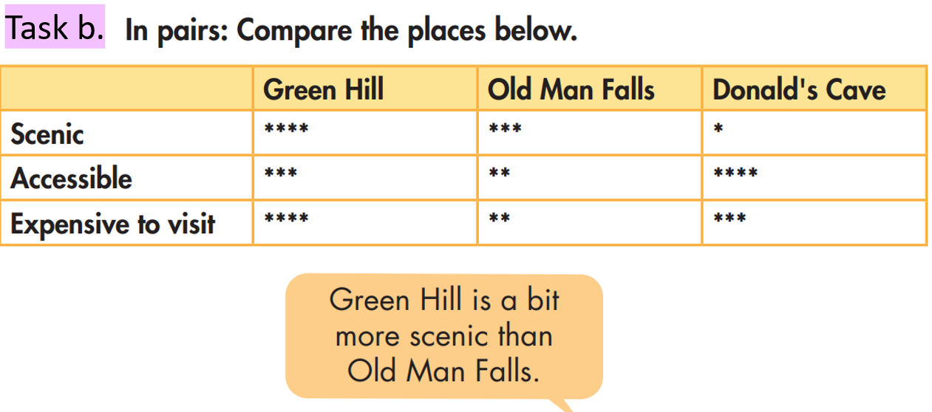  - Ask Ss to look at the places  Purposes: compare and write complete sentences.  - Ask Ss to compare the answers with a partner.  - Set the time and monitor the class.  - Check Ss’ answers (using the DCR). | - Write full sentences  - Check the answers with a partner.  Answer Keys:  - Green Hill is a bit more scenic than Old Man Falls.  - Green Hill is much more scenic than Donald's Cave.  - Donald's Cave isn't as scenic as Old Man Falls.  - Green Hill is a bit more accessible than Old Man Falls.  - Donald's Cave is a bit more accessible than Green Hill.  - Old Man Falls isn't as accessible as Donald's Cave.
Task c: Look at the star ratings, circle the correct intensifiers and write full sentences.  - Ask Ss to look at the star ratings  Purposes: Look at, compare and write complete sentences.  - Ask Ss to compare the answers with a partner.  - Set the time and monitor the class.  - Check Ss’ answers (using the DCR). | - Write full sentences  - Check the answers with a partner.  Answer Keys:  2. Fansipan's summit is a bit higher than Langbiang's summit.  3. Cô Tô is a bit more scenic than Phú Quốc.  4. Sơn Đoòng Cave is far harder to reach than other caves.

3. Production (5’)
a. Objectives: To help Ss produce sentences using “comparative structures with intensifiers”.
b. Content: Use the information about from all places you have studied and been and make new sentences using your own experience.
c. Expected outcomes: Ss can compare and share natural places using “comparative structures with intensifiers”
d. Organization

Teacher’s activities | Students’ activities
In pairs: Use all the places you studied again and some places you have been to and make new sentences using your ideas for the purposes.  - Ask Ss to make new sentences using the prompts in task c.  - Monitor the class and help them if necessary.  - Ask some Ss to share their ideas. | - Write new sentences based on the prompts in task c.  - Work in pairs to share the ideas/ sentences.  - Share the ideas with the class.  Suggested answers:  - I went to Mount Sơn Trà last year and I think it’s far more scenic than Mount Bà Đen.  - I think Lý Sơn island isn’t as accessible as Bình Ba island.

C. Consolidation and homework assignments (5’)
- Speaking: Ask and answer the question below with your partner, using “comparative structures with intensifiers” to give purposes: What what things you studied today?
- Review “comparative structures with intensifiers” to talk about natural wonders.
- Make sentences using this structures in SB.
- Prepare for the next lesson (Pronunciation & Speaking - pages 56 & 57 - SB).
- Play the consolidation games on www.eduhome.com.vn

5. Reflection
a. What I liked most about this lesson today:
…………………………………………………………………………………………
b. What I learned from this lesson today:
…………………………………………………………………………………………
c. What I should improve for this lesson next time:
…………………………………………………………………………………………

