School: ……………………………………….. | Date:……………………………………..
Class: ……………………………..................... | Period: ………………………………….

UNIT 5: HEALTHY LIVING
Review: Grammar, Pronunciation, Speaking & Writing (Pages 101 & 102)

1. Objectives
By the end of this lesson, students will be able to…
1.1. Language knowledge/ skills
- review grammar points:
+ suggest + gerund
+ adverbial clause of concession
- improve word stress /tr/ & / tʃ / sounds.
- talk about health problems
- write a summary paragraph.
1.2. Competences
- improve Ss’ communication, collaboration, analytical, creativity, and critical thinking skills.
1.3. Attributes
- nurture Ss’ attention to detail for consistent practice and repetition to reinforce learning and build fluency.
2. Teaching aids and materials
- Teacher’s aids: Student’s book and Teacher’s book, class CDs, DCR– Phần mềm tương tác trực quan, DHA – Ứng dụng trò chơi tương tác, projector / interactive whiteboard /TV (if any), PowerPoint slides.
- Students’ aids: Student’s book, Workbook, Notebook.
3. Assessment Evidence
Performance Tasks | Performance Products | Assessment Tools
- Finish each of the sentences so they have the same meaning as the sentence before it.  - Choose the correct answer (A, B, C, or D).  - Circle the word that is different from the other three in the position of primary stress in each of the following questions.  - Circle the word that has the underlined part pronounced differently from the others.  - Look at the signs. Choose the best answers.  - Talk about health problems and suggestions  - Write a summary text. | - Ss’ answers.  - Ss’ answers.  - Ss’ answers.  - Ss’ answers.  - Ss’ answers.  - Ss’ performance /presentation.  - Ss’ answers. | - Observation and feedback.  - Observation and feedback.  - Observation and feedback.  - Observation and feedback.  - Observation and feedback.  - Observation and feedback.  - Observation and feedback.
4. Procedures
A. Warm-up: 5 minutes
a. Objectives: To review vocabulary to talk about health problems.
b. Content: mini game
c. Expected outcomes: Ss can completely name some health problems.
d. Organization
Teacher’s activities | Students’ activities
Game: Pass The Ball  - Instruct Ss to play the game.  - Time limit: 5 minutes | - Listen to the instructions.  - Pass the ball and name a problem when the music stops.

B. New Lesson (35’)
1. Grammar (10’)
a. Objectives: To review suggest + gerund, adverbial clauses/phrases of concession.
b. Content: Rearrange the groups of words in the correct order.
c. Expected outcomes: Ss can rearrange the words to make complete sentences.
d. Organization
Teacher’s activities | Students’ activities
Rearrange the groups of words in the correct order to make complete sentences.  - Use questions to review Ss’ prior knowledge of adverbial clauses of concession, suggest + gerund.  - Show the use and structures.  - Have Ss look at the words and complete the task. | - Review grammar points  - Complete the task  Answer Keys:  1. Doctors suggest eating a healthy diet with all the nutrients you need.  2. Many people follow detox diets though some of them are dangerous.  3. Experts suggest starting school later so that children and teens get more sleep.  4. Although there are benefits to doing exercise, people often don't do it enough.  5. We often suggest cutting out soda and chips to start losing weight.  6. Doctors suggest eating bananas, yogurt, and fatty fish to have a healthy diet.  7. Though there are risks on the internet, many parents don't monitor their children.  8. Although he wants a healthier diet, he doesn't want to eat less red meat.
2. Pronunciation (10’)
a. Objectives: To improve word stress and /tr/ & /tʃ/ sounds.
b. Content: Tasks a, b, and in the real world.
c. Expected outcomes: Ss can improve their word stress and /tr/ & /tʃ/ sounds.
d. Organization
Teacher’s activities | Students’ activities
Task a: Circle the word that differs from the other three in the position of primary stress in each of the following questions.  - Have Ss say the words and choose the correct answer.  - Have Ss check their answers with their partner.  - Check Ss’ answers around the class.  - Have Ss read the words aloud. | - Complete the task.  - Check the answers with their partner.  Answer Keys:  1. B 2. C  - Read the sentences aloud.
Task b: Circle the word that has the underlined part pronounced differently from the others.  - Have Ss say the words and choose the correct answer.  - Have Ss check their answers with their partner.  - Check Ss’ answers around the class.  - Have Ss read the words aloud as the whole class or individually. | - Complete the task.  - Check the answers with their partner.  Answer Keys:  1. C 2. A  - Read the sentences aloud.
In the Real World: Look at the signs. Choose the best answers.  - Have Ss look at the signs and choose the best answers.  - Have Ss check their answers with their partner.  - Check Ss’ answers around the class.  - Have Ss read the sentences aloud. | - Complete the task.  - Check the answers with their partner.  Answer Keys:  1. B 2.D  - Read the sentences aloud.

3. Speaking (8’)
a. Objectives: To talk about teens’ health problems and suggestions.
b. Content: Conversation and Speaking
c. Expected outcomes: Ss can talk about problems in a city, future results, and solutions.
d. Organization
Teacher’s activities | Students’ activities
Conversation: Choose the correct answer (A, B, C, or D).  - Have Ss work in pair  - Have Ss read to complete the task  - Go around the class and support those in need.  - Check answers. | - Complete the task.  Answer keys:  1. A  2. A  3. D  4. B
Speaking: In pairs: Discuss and choose five pieces of health advice that you think all teenagers should follow. Share your ideas with another pair. Discuss whether any of the pieces of advice are myths.  - Have Ss work in pairs.  - Have Ss discuss 5 pieces of health advice that Ss should follow.  - Share answers with the class. | - Work in pairs.  - Share the answers.  Suggested answers:  - Maintain 60 minutes to do exercise a day  - Get enough sleep  - Reduce fast food and junk food  - Get enough water a day  - Manage screen time (less than 2 hours a day)

4. Writing (7’)
a. Objectives: To review writing skills about a health problem and suggestion paragraph.
b. Content: Writing
c. Expected outcomes: Ss can write a summary text.
d. Organization
Teacher’s activities | Students’ activities
Write about ways to stay healthy and which ones you do. Write 100 to 120 words.  - Review: How to write a summary  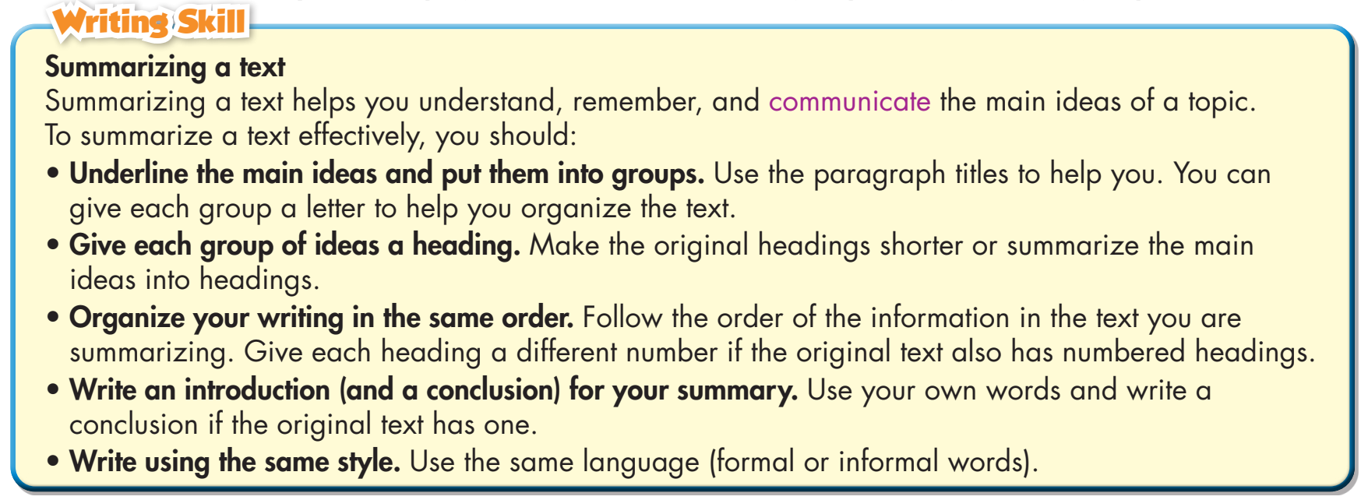  - Ask some questions to review how to write a summary  - Have Ss use the speaking ideas to write.  - Have Ss exchange their writing with a partner and give feedback to one another. | - Answer the questions.  - Write a summary  Suggested answers:  1. Maintain 60 minutes exercise a day  Many people are lazy to work out ever day. They spend too much time on sitting. It's important for more people to understand how exercises help us in good health and stay in shape.  2. Check health regularly  Even if you feel OK, you should check your health often. Only some people do this now. Technology makes it easier to check for health problems.  3. Get enough water a day  Water makes up about 50% to 70% of your body weight. It’s commonly recommended that you drink eight 8-ounce (237-mL) glasses of water per day.

C. Consolidation and homework assignments (5’)
- Review Grammar points and writing skills.
- Prepare for the next lesson (Unit 6: Vocabulary & Listening – pages 54 & 55 - SB)
- Play the consolidation games on www.eduhome.com.vn
5. Reflection
a. What I liked most about this lesson today:
…………………………………………………………………………………………
b. What I learned from this lesson today:
…………………………………………………………………………………………
c. What I should improve for this lesson next time:
…………………………………………………………………………………………

