School: ……………………………………….. | Date:……………………………………..
Class: ……………………………..................... | Period: ………………………………….

UNIT 5: HEALTHY LIVING
Lesson 3.2: Writing & Speaking (Page 53)

1. Objectives
By the end of this lesson, students will be able to…
1.1. Language knowledge/ skills
- write a summary of a text.
- talk about the main ideas of an article on health
- improve writing and speaking skills.
1.2. Competences
- improve Ss’ communication, collaboration, analytical, creativity, and critical thinking skills.
1.3. Attributes
- nurture Ss’ critical thinking on health information.
2. Teaching aids and materials
- Teacher’s aids: Student’s book and Teacher’s book, class CDs, DCR– Phần mềm tương tác trực quan, DHA – Ứng dụng trò chơi tương tác, projector / interactive whiteboard /TV (if any), PowerPoint slides.
- Students’ aids: Student’s book, Workbook, Notebook.
3. Assessment Evidence
Performance Tasks | Performance Products | Assessment Tools
- Read and underline the main ideas.  - Put ideas into groups.  - Label the summary with the different problems.  - Write a summary text.  - Read and give feedback | - Ss’ answers.  - Ss’ answers.  - Ss’ performance.  - Ss’ answers/presentation.  - Ss’ answers. | - Observation.  - Observation and feedback.  - Observation and feedback.  - Observation and feedback.
4. Procedures
A. Warm-up: 5 minutes
a. Objectives: To review vocabulary in lesson 2
b. Content: mini game
c. Expected outcomes: Ss can complete activities.
d. Organization
Teacher’s activities | Students’ activities
INTERACTIVE GAME  - Create 2 teams  - Instruct Ss to play the game.  - Which team has more correct answers wins.  https://eduhome.com.vn/  (DHA phần mềm trò chơi tương tác) | - Form 2 teams  - Listen to the instructions.  - Answer the questions.

B. New Lesson (35’)
1. Writing (10’)
a. Objectives: To help Ss know how to set a layout for summarizing a text
b. Content: Tasks a and b.
c. Expected outcomes: Ss can put information from different texts into groups.
d. Organization
Teacher’s activities | Students’ activities
Task a: Read about summarizing a text. Then, using the summary on the previous page to help you, underline the main ideas in the article (page 45) and the listening questions (page 49). Put the ideas into groups and give each group a letter (A–E).  - Have students read the Writing Skill box and the summary again, then have students underline and group the main ideas in the article (page 45) and the listening questions (page 49).  - Have students check their answers with a partner.  - Check answers as a whole class | - Read the Writing Skill box and underline the main ideas.  - Group the main ideas.  - Check the answers.  Answers:  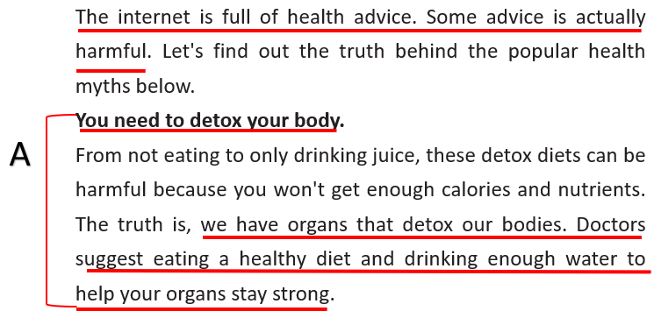  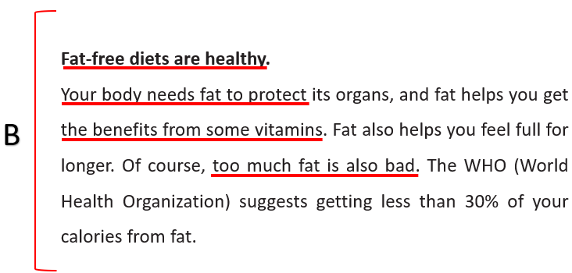  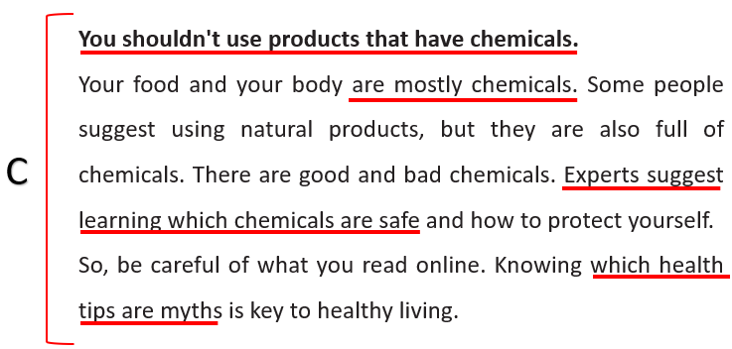  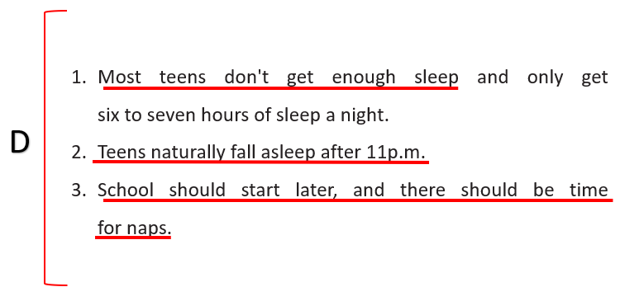  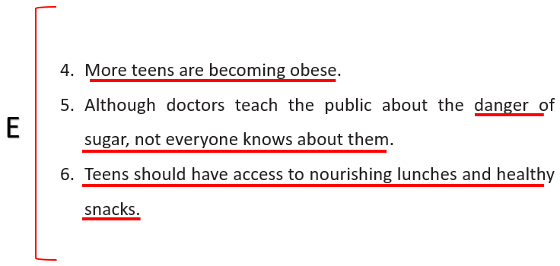
Task b: Look at the example of a bad summary below. Label the summary with the different problems (A–E).  - Have students read the bad summary and fill in the blanks with the letter A–E.  - Have students check their answers with a partner.  - Check answers as a whole class | - Read and underline key words.  - Complete the task.  - Check answers with a partner.  Answers:  1. E  2. D  3. B  4. C  5. A
2. Speaking (10’)
a. Objectives: To help Ss further practice speaking skills.
b. Content: Tasks a and b.
c. Expected outcomes: Ss can talk about how to stay healthy.
d. Organization
Teacher’s activities | Students’ activities
Task a: In pairs: Look at p. 122 File 2 and underline the main ideas in the text. Then, group the ideas together by writing a letter (A–C) beside each part you underlined.  - Have Ss work in pairs in 5 minutes.  - Have SS discuss the main ideas and underline them  - Monitor the class and help them if necessary.  - Have some pairs to perform in front of the class.  - Give feedback to encourage Ss. | - Work in pairs.  - Discuss the main ideas.  - Perform in front of the class.  Students’ answers.
Task b: Complete the table below with your notes, then choose a title for each group of ideas.  - Have Ss choose a title for each group of ideas.  - Have Ss complete the table with the main ideas.  - Monitor the class and help them if necessary.  - Elicit answers from some students. | - Discuss in pairs and complete the table.  - Share their ideas with the class.  Students’ answers.
3. While-writing (10’)
a. Objectives: To help Ss practice writing a summary passage.
b. Content: Let’s write.
c. Expected outcomes: Ss can improve their writing skills.
d. Organization:
Teacher’s activities | Students’ activities
Now, summarize the main information from the text on page 122. Use the Writing Skill box, the reading model, and your speaking notes to help you. Write 100 to 120 words.  - Draw Ss’ attention to the Feedback form.  - Have Ss use their notes to write their summaries.  - Give feedback or any corrections on their writing if possible. | - Write a summary text.  Suggested answers:  The article discusses information about staying healthy. It also suggests asking a health expert for advice about staying healthy.  1. Air pollution at home  Many people use cooking methods that pollute their homes. It's important for more people to understand which cooking methods are safe.  2. Check health regularly  Even if you feel OK, you should check your health often. Only some people do this now. Technology makes it easier to check for health problems.  3. Children's rights to health care  Every child should have the right to access health services. Many children in the world can't access health services. Every child under six years old should have access to health care.
4. Post-writing (5’)
a. Objectives: To help Ss review and edit their passage.
b. Content: Feedback form
c. Expected outcomes: Ss can improve their paragraph writing skills.
d. Organization:
Teacher’s activities | Students’ activities
Now, reread and edit your passage using the feedback box below. Or in pairs: read each other’s passage and give feedback using the feedback box below.  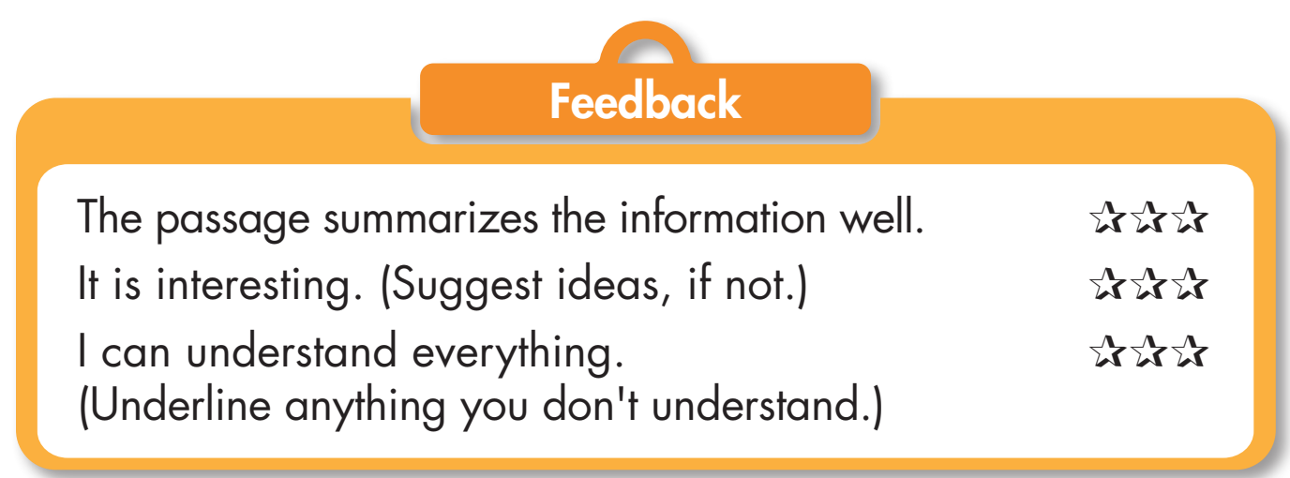  - Have Ss use the feedback box, read their partner’s passage and give feedback.  - Monitor the class and help them if necessary. | - Read a partner’spassage and give feedback.

C. Consolidation and homework assignments (5’)
- Do Writing on WB – page 31.
- Prepare for the next lesson (Unit 5: Review: Listening & Reading, Vocabulary - pages 100 & 101 - SB).
- Play the consolidation games on www.eduhome.com.vn
5. Reflection
a. What I liked most about this lesson today:
…………………………………………………………………………………………
b. What I learned from this lesson today:
…………………………………………………………………………………………
c. What I should improve for this lesson next time:
…………………………………………………………………………………………

